Project | IEEE 802.16 Broadband Wireless Access Working Group <http://ieee802.org/16>
Title | Turbo code buffer comparison on interleaver perspective
Date Submitted | 2009-1-5
Source(s) | ¹Zheng Yan-Xiu, Yu-Chuan Fang, Chang-Lan Tsai, Chung-Lien Ho, Hsi-Min Hsiao, Ren-Jr Chen, ²Richard Li, ITRI | Voice:  ¹+886-3-5914715  ²+886-3-5917596  E-mail:  ¹zhengyanxiu@itri.org.tw  ²richard929@itri.org.tw  *<http://standards.ieee.org/faqs/affiliationFAQ.html>
Re: | 802.16m-08/052, Call for Comments on 802.16m SDD (802.16m-08/003r6)  PHY: Section 11.13.1.3 FEC encoding
Abstract | This contribution compares decoder buffer for CTC with symbol level interleaver, CTC with bit level interleaver and TC. The simulation results also indicate CTC with bit level interleaver can render better performance than CTC with 16e ARP interleaver.
Purpose | For discussion and approval by IEEE 802.16m TGm
Notice | This document does not represent the agreed views of the IEEE 802.16 Working Group or any of its subgroups. It represents only the views of the participants listed in the “Source(s)” field above. It is offered as a basis for discussion. It is not binding on the contributor(s), who reserve(s) the right to add, amend or withdraw material contained herein.
Release | The contributor grants a free, irrevocable license to the IEEE to incorporate material contained in this contribution, and any modifications thereof, in the creation of an IEEE Standards publication; to copyright in the IEEE’s name any IEEE Standards publication even though it may include portions of this contribution; and at the IEEE’s sole discretion to permit others to reproduce in whole or in part the resulting IEEE Standards publication. The contributor also acknowledges and accepts that this contribution may be made public by IEEE 802.16.
Patent Policy | The contributor is familiar with the IEEE-SA Patent Policy and Procedures:  <http://standards.ieee.org/guides/bylaws/sect6-7.html#6> and <http://standards.ieee.org/guides/opman/sect6.html#6.3>.  Further information is located at <http://standards.ieee.org/board/pat/pat-material.html> and <http://standards.ieee.org/board/pat>.
Turbo code buffer comparison on interleaver perspective
Zheng Yan-Xiu, Yu-Chuan Fang, Chang-Lan Tsai, Chung-Lien Ho, Ren-Jr Chen, Richard Li
ITRI

Introduction
This contribution recommends adopting bit level interleaver for convolutional turbo code (CTC) or binary turbo code for 16m to render better performance with less buffer size. Contribution [1] highlights that 16e CTC requires extra 33% buffer for extrinsic information in turbo decoder comparing with CTC applying bit level interleaver. Recently published paper [2] also shows extra 25% due to symbol level interleaver. This contribution will provide a formula to calculate necessary buffer and gives relative performance results to prove lower complexity and better performance can be achieved by choosing binary turbo code or applying bit level interleaver for CTC.

Buffer size evaluation
This section evaluates the required buffer size for binary turbo code, CTC with bit level interleaver and CTC with symbol level interleaver. We evaluate the worst case memory requirement because the worst case must be supported in the baseband. Assume data length is N and code rate is R.
Binary turbo code encoder permutes information by bits. Decoder temporarily stores two extrinsic information sequences with length N and each extrinsic information is stored by bit. Therefore decoder stores 2N(extrinsic information)+N/R(received samples) soft bits. If R=1/3 and N=4800 bits which are the lowest code rate, the required memory is 24000 soft bits.
CTC encoder is a non-binary turbo code. If bit level interleaver is applied, the decoder still stores extrinsic information by bit and therefore the associated storage is the same as binary turbo code.
If symbol level interleaver is applied for CTC, the decoder will store extrinsic information in terms of symbol. Since there are four possibilities for each symbol, at least three values have to be stored to represent log-likelihood ratio of each symbol. The fact has been highlight in reference [4]. The required buffer size is 2×N/2×1/R(received samples)+3×N/2×2(extrinsic information)=2*2400*3+3*2400*2=28800 soft bits. The decoder costs at least 20% more memory space comparing to binary turbo code. The comparison is summarized in Table 1.
Table 1: Buffer calculation for N=4800 bits and R=1/3.
 | Binary turbo code | CTC with bit level interleaver | CTC with symbol level interleaver
Formulae | 2N+N/R | 2N+N/R | 3N+N/R
Buffer Size | 24000 | 24000 | 28800
Extra Memory Percentage to Binary Turbo Code | 0% | 0% | 20%

Performance of CTC applying bit level interleaver
This part evaluates the error rate performance for both symbol- and bit-level interleaving. The symbol-level interleaving is the same as the CTC interleaving defined in IEEE 802.16 [3]. The bit-level interleaving applies the inter-block permutation interleaver with the block interleaver defined in IEEE 802.16 [3]. Our simulation environment is AWGN channel. We compare code rate=1/2 CTC with Linear Log-MAP decoding algorithm and 8 iterations are performed. Packet size 960, 1920, 2880, 3840 and 4800 bits are compared.
Figs. 1-5 illustrates simulation results, the bit-level interleaving outperforms the symbol-level interleaving about 0.3dB at FER=10⁻⁴ except for the case information length=960bits. If CTC with symbol-level interleaver applying the marginalized extrinsic information, the performance further degrades 1.0 dB at FER=10⁻⁴.

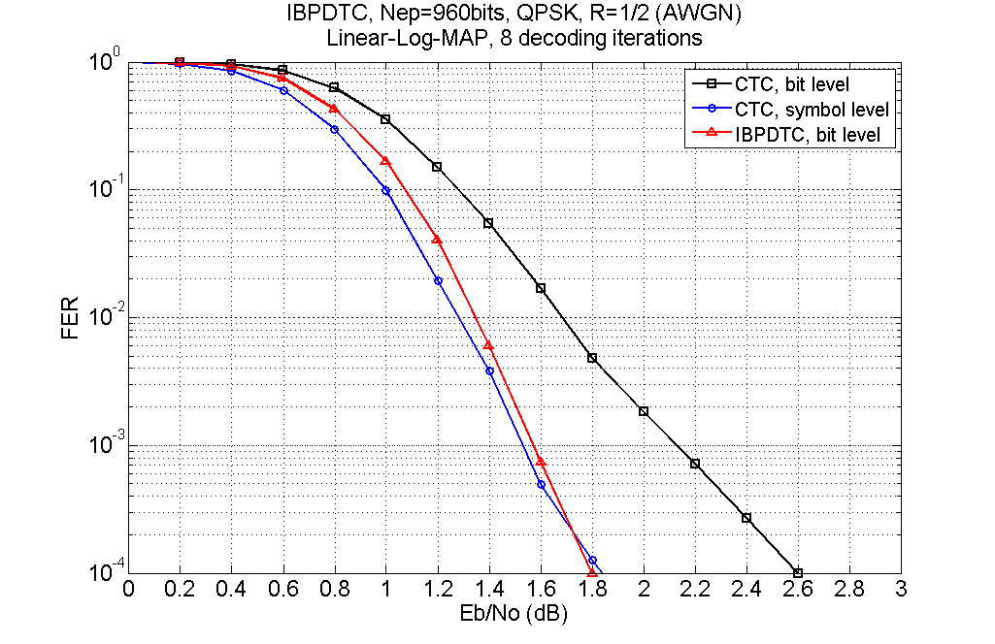
Fig. 1: Frame error rate performance with packet size 960 bits.
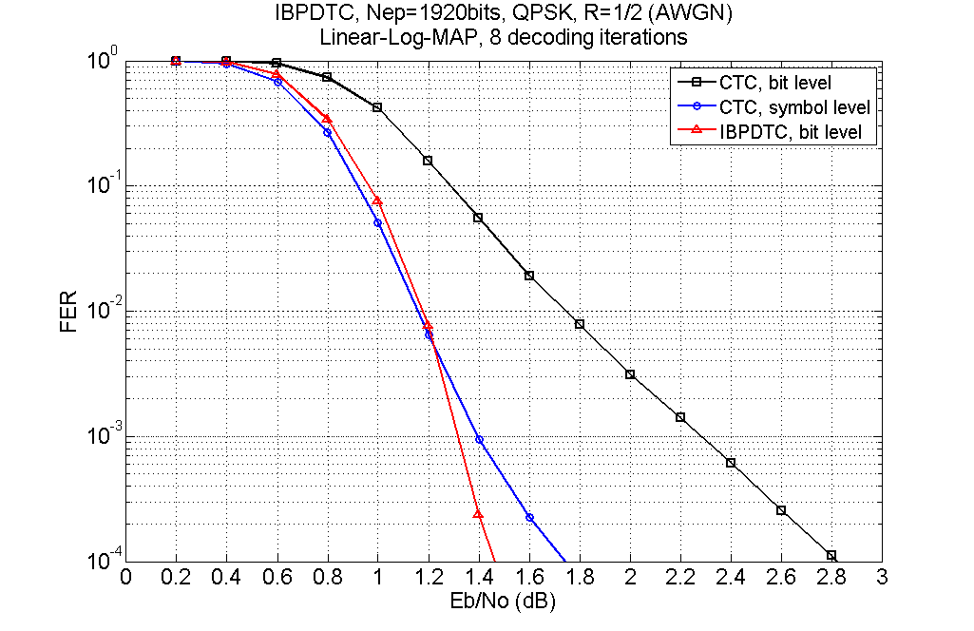
Fig. 2: Frame error rate performance with packet size 1920 bits.
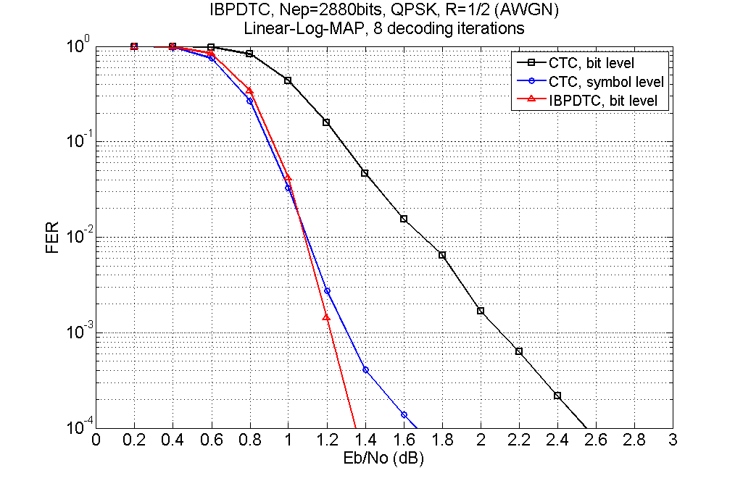
Fig. 3: Frame error rate performance with packet size 2880 bits.
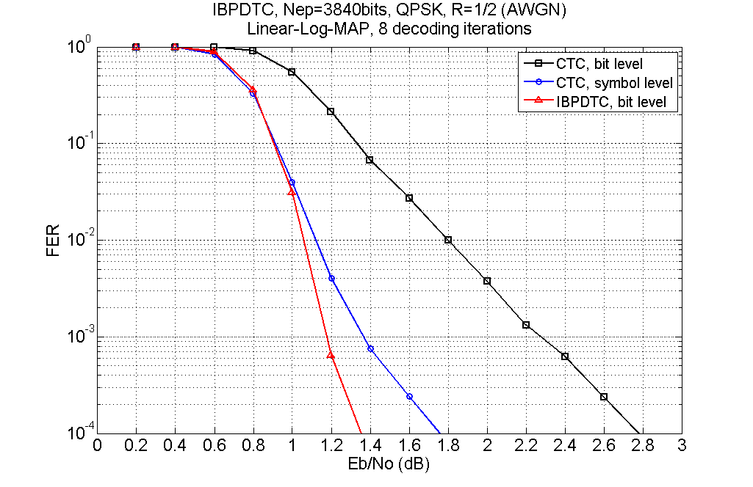
Fig. 4: Frame error rate performance with packet size 3840 bits.
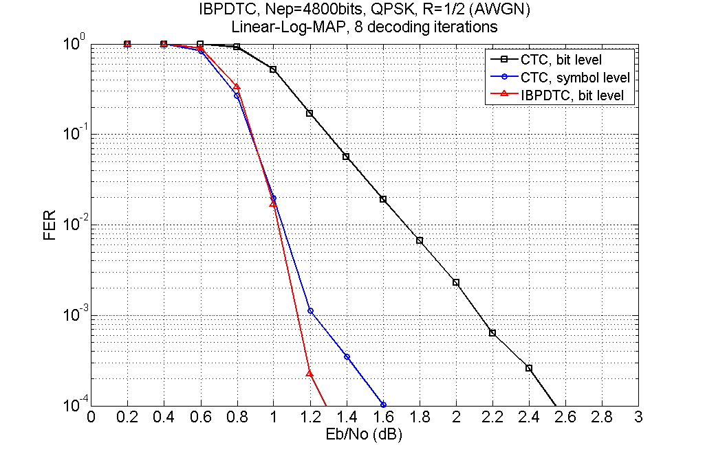
Fig. 5: Frame error rate performance with packet size 4800 bits.

Conclusion
CTC can apply bit level interleaver to improve error rate performance while reduce necessary storage. Turbo code can also apply less storage to render similar performance. We recommend adopting binary turbo code or applying bit level interleaver to CTC to render better error correction capability with less storage.

References
- IEEE C802.16m-07/293r1, “Hybrid ARQ buffer issues,” ITRI, Apr. 2008.
- Ji-Hoon Kim, In-Cheol Park, “A 50 Mbps Double-Binary Turbo Decoder for WiMAX Based on Bit-level Extrinsic Information Exchange,” in Proc. IEEE Asian Solid-State Circuits Conference, pp. 305-308, Nov. 3-5, 2008.
- IEEE DRAFT P802.16, "Part 16: Air interface for fixed broadband wireless access systems," March, 2007.
- Ken Gracie, Marie-Helene Hamon, "Turbo and turbo-like codes: principles and applications in telecommunications," in IEEE Proceeding, vol. 95, no. 6, pp.1228-1254, Jun. 2007.
=============================== TEXT Proposal ===============================
11.13.1.3 FEC encoding
IEEE 802.16m uses the CTC (convolutional turbo code) of code rate 1/3 defined in the IEEE 802.16e standard where the CTC inner interleaver parameters for additional FEC block sizes larger than 60 bytes are FFS while maintaining IEEE 802.16e CTC interleaver. The code rate of the “FEC Encoder” block in Figure 53 is termed mother code rate (RMC). The use of other coding schemes like turbo code, CC and LDPC are FFS. The CTC scheme is extended to support additional FEC block sizes. FEC block sizes larger than the legacy ones are supported. The FEC block sizes are FFS and they are independent of the transmission format, including code rate, modulation order, and resource allocation. Further, the FEC block sizes are regularly increased with pre-determined block size resolutions. The FEC block sizes which are multiple of 7 shall be removed for the tail-biting encoding structure. The encoder block depicted in Figure 53 includes the sub-block interleavers. The interleaving details

