Project | IEEE 802.16 Broadband Wireless Access Working Group <http://ieee802.org/16>
Title | Modeling MBSFN Channels
Date Submitted | 2009-01-08
Source(s) | Kaushik Josiam, Sudhir Ramakrishna, Zhouyue Pi, Farooq Khan  Samsung Telecommunications America*  1301 E. Lookout Dr  Richardson TX 75082  Zheng Yan-Xiu, Richard Li, Jia-Hao Wu,Yu-Tao Hsieh  ITRI  Wookbong Lee, Dongcheol Kim  LG Electronics  Pei-Kai Liao, Chih-Yuan Lin, Paul Cheng  MediaTek Inc.  Wei Xie  Chinese Academy of Broadcasting Sciences  Tao Tao  Timi Technology  Yujian Zhang, Yuan Zhu, Changlong Xu, Jeong Julie Lee, Debdeep Chatterjee, Furuzan Atay, Jong-Kae (JK) Fwu, Huaning Niu, Hujun Yin, Etemad Kamran,  Intel Corporation | Voice: 1-972-761-7437  E-mail: kjosiam@sta.samsung.com  *<http://standards.ieee.org/faqs/affiliationFAQ.html>
Re: | EMD: Change request IEEE C802.16m-08/004r4, Section 3 Channel Models
Abstract | Presents a channel model for evaluating MBSFN test scenarios
Purpose | To discuss and adopt in TGm
Notice | This document does not represent the agreed views of the IEEE 802.16 Working Group or any of its subgroups. It represents only the views of the participants listed in the “Source(s)” field above. It is offered as a basis for discussion. It is not binding on the contributor(s), who reserve(s) the right to add, amend or withdraw material contained herein.
Release | The contributor grants a free, irrevocable license to the IEEE to incorporate material contained in this contribution, and any modifications thereof, in the creation of an IEEE Standards publication; to copyright in the IEEE’s name any IEEE Standards publication even though it may include portions of this contribution; and at the IEEE’s sole discretion to permit others to reproduce in whole or in part the resulting IEEE Standards publication. The contributor also acknowledges and accepts that this contribution may be made public by IEEE 802.16.
Patent Policy | The contributor is familiar with the IEEE-SA Patent Policy and Procedures:  <http://standards.ieee.org/guides/bylaws/sect6-7.html#6> and <http://standards.ieee.org/guides/opman/sect6.html#6.3>.  Further information is located at <http://standards.ieee.org/board/pat/pat-material.html> and <http://standards.ieee.org/board/pat>.

Modeling MBSFN Channels
Kaushik Josiam, Sudhir Ramakrishna, Zhouyue Pi, Farooq Khan
Samsung Telecommunications America
Zheng Yan-Xiu
ITRI

Introduction
In MBSFN, the same signal is transmitted from all BSs in the SFN-zone with symbol level synchronization. The signals from different BSs coherently combine at the MS to provide improved SNR. There is no interference in SFN since all BSs transmit the same desired signal. However, the effect of multipath is magnified due to the very fact that signals from different BSs take different paths and experience larger propagation delays. The propagation delays depend fundamentally on the inter-site distance which in turn is deployment specific. The other factor that would affect propagation delays is the location of the user. In system level simulations, each of the above mentioned effects can be factored in deriving the MBSFN channel model. However, for link level simulations, a power delay profile is sufficient to generate the requisite channel fading statistics. Therefore, some modifications to the ITU power delay profiles for MBSFN link level simulation is necessary. The current IEEE 802.16m evaluation methodology [1] neither indicates a preferred channel model for MBSFN nor does it describe a methodology to derive one. In this contribution, we describe a method to generate a MBSFN channel model and provide some exemplar power delay profiles for MBSFN.

Modeling MBSFN Channel
A simple and intuitive way to generate an MBSFN channel profile is to concatenate several ITU channel profiles mimicking links from many BSs to a single MS as is the case with broadcast. Let’s assume the modified ITU Vehicular-A channel profile [2] as the base channel profile for the link between BS and MS. The location of the MS and those of the BSs are assumed known. The channel profile of Modified Vehicular-A has 24 paths with a total delay spread of 2.62μs. Now, a composite channel model for MBSFN in a 19 cell hexagonal layout would simply be a concatenation of 19 modified Vehicular-A channel profiles offset by appropriate propagation delays and scaled by the appropriate path loss powers. By taking path loss into consideration, we can remove the paths from the cells that do not contribute much to the signal energy at the MS. A rule of thumb used in 3GPP is to limit the concatenation to just 3 profiles [3]. However, restricting attention to just the top 3 energy contributors at the MS seems like an arbitrary rule. Another trouble with this modeling is that it takes just one sample drop. Taking one sample drop to arrive at the channel model is statistically insufficient and leads to misleading results. It does not consider the best case or the worst case or the average propagation loss into account.

The proposed channel model for MBSFN still follows the same philosophy as the 3GPP model, but refrains from imposing a constraint on the number of modified Vehicular A channel profiles to be concatenated. Before we describe the actual channel model itself, we outline the procedure used to arrive at this model.

We perform system level simulations, where the standard set up of 19 cells, hexagonal grid layout is used. We drop 20,000 users in the center cell and for each user collect the values for received energy (computed as the difference of transmit power (43dBm) and the path loss plus penetration loss). The received energy is ordered from the largest to the smallest. So for each of the 20,000 users we have an index of cells ordered from the one that contributed to the most energy to the one that contributed to the least. Using the cell index, we can compute the statistics of the propagation delays (time it takes for the energy to travel from BS to MS) from each cell to the users.

Ideally, for every channel realization in the simulation, we should pick one user at random from this set of 20,000 users and compute a composite channel and pick a different user to generate the delay spread for the next channel realization in the next sub frame. This way, we can cycle through delay spreads seen by a spectrum of users in the cell. Since the power delay profile keeps changing, such a model though accurate will not be able to model Doppler accurately.

A compromise is to use the average of the propagation delays from each cell to the users to compute the composite channel. Given that we have an ordered list of the propagation delays from the cells, we can compute the average propagation delays for the signal with the most energy at the MS, second most energy at the MS and so on so forth, until we have an ordered list of the propagation delays for all the 19 energy contributors. Using this average propagation delay, we can compute the average path loss from each cell by first finding the average distance (from d = c × t_{p}), where c is light speed and t_{p} is the propagation delay, and then using the average distances in the path loss formula. We now use both the average propagation delay as well as the average path loss to generate the composite channel model as follows:
- Compute the relative average propagation delays by subtracting the average propagation delay from each cell with the smallest average propagation delay.
- Compute the relative average path loss by dividing the average path loss from each cell with the largest average path loss.
- Replicate the base channel model as many times as the number of the cells, offset them by relative propagation delays and combine them after scaling by the relative average path loss. If is the base channel model, where is the base channel model and L is the number of multi-paths, then the concatenated matrix is given by
where is the relative average propagation delay of the n^{th} cell and is the relative average path loss of the n^{th} cell.
- Remove paths whose powers are less than a predetermined threshold.
- Normalize the power of the delay spread of the channel.

A few example MBSFN Channel Models

Using the above described procedure, we generated the power delay profile of the MBSFN channel model for different inter-site distances (ISDs) using modified vehicular A as the base channel model. The carrier frequency was assumed to be 2.5GHz and a standard hexagonal 19 cell layout was assumed.
- 500m ISD, threshold = -30dB (delay spread = 4.6μs)
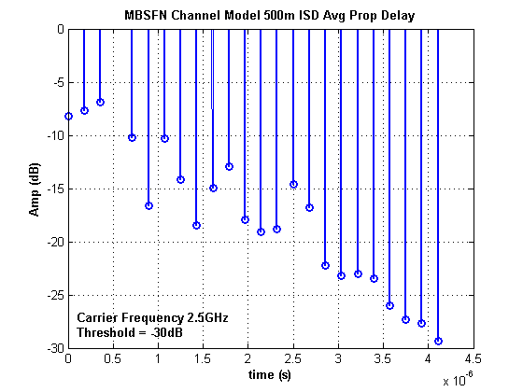

- 1500m ISD, threshold = -30dB
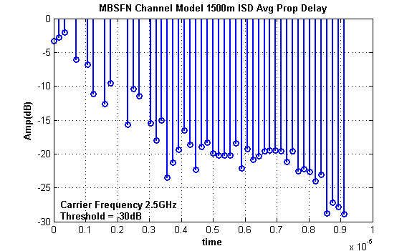
- 5000m ISD, threshold = -30dB
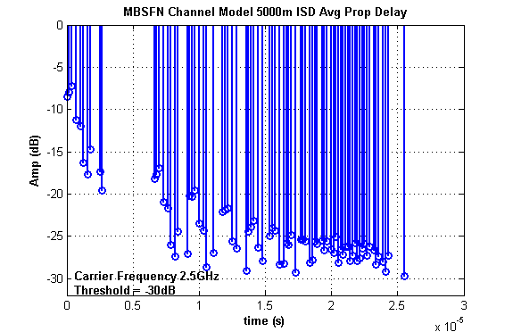

Note that there can be other variants to this procedure too. Instead of computing the average propagation delay to all users from all cells, we can limit the computation to users on the cell edge i.e., users who are beyond the 95th percentile distance from the center cell. However, we found that the length of the power delay profile computed with such restricted user set and a predetermined threshold for the power amplitude did not change much when compared to that computed using average propagation delay. We believe there are two reasons for this:
- Users on the cell edge will see similar path loss components from multiple cells.
- Threshold the amplitude at -30dB which would remove a lot of insignificant paths.
Therefore, factoring in relative path loss into our computation will add a lot more multipath closer to delay 0 and not affect the overall length of the delay spread.

Restricting our computations to users on the cell edge, we generated the power delay profile of the MBSFN channel model for ISD of 1500m and 5000m using modified vehicular A as the base channel model

- 1500m Threshold = -30dB
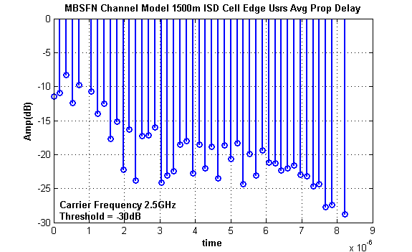
- 5000m Threshold = -30dB
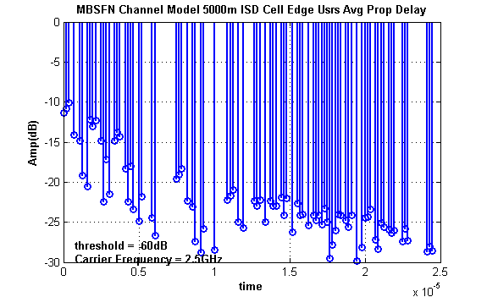

References
- R. Srinivasan et al., “IEEE 802.16m Evaluation Methodology Document (EMD)”, IEEE 802.16m-08/004r4, November 2008
- P. Monogioudis and A. Kogiantis, “Wideband Extension of the ITU profiles with desired spaced-frequency correlation”, IEEE C802.16m-07/181, September 2007
- 3GPP TS 25.102 Technical Specification Group Radio Access Network, “ User Equipment (UE) radio transmission and reception (TDD) (Release 8),” V8.1.0 May 2008

Suggested Text to EVM
Add the following section on Page 60 after Sec 3.2.9

3.2.10 Link Level Channel Model for Baseline MBSFN Test Scenario (Mandatory)
In multicast broadcast single frequency network (MBSFN), the same signal is transmitted from all BSs in the single frequency network (SFN)-zone with symbol level synchronization. The signals from different BSs coherently combine at the MS to provide improved SNR. There is no interference in SFN since all BSs transmit the same desired signal. However, the effect of multipath is magnified due to the very fact that signals from different BSs take different paths and experience larger propagation delays. The propagation delays depend fundamentally on the inter-site distance which in turn is deployment specific. The other factor that would affect propagation delays is the location of the user. In system level simulations, each of the above mentioned effects can be factored in deriving the MBSFN channel model. However, for link level simulations, a power delay profile is sufficient to generate the requisite channel fading statistics. Therefore, some modifications to the ITU power delay profiles for MBSFN link level simulation is necessary.
The default procedure to generate a MBSFN channel profile is to concatenate several ITU channel profiles mimicking links from many BSs to a single MS as is the case with broadcast. Let’s assume the modified ITU Vehicular-A channel profile given in Table 23 as the base channel profile for the link between BS and MS. The location of the MS and those of the BSs are assumed known. Now, a composite channel model for MBSFN in a 19 cell hexagonal layout would simply be a concatenation of 19 modified Vehicular-A channel profiles offset by appropriate propagation delays and scaled by the appropriate path loss powers. We can use the basic system level simulation set up to derive the propagation delays.
Step 1: A standard system level simulation set up of 19 cells, hexagonal grid layout is used. We drop N users (the value of N must be large to get statistically stable values for the propagation delays) in the center cell and for each user collect the values for received power from each cell. The received power is computed as the difference of transmit power (43dBm) and the path loss plus penetration loss. The mandated path loss model is in Section 3.2.3.8. The received energy is ordered from the largest to the smallest. So for each of the N users we have an index of cells ordered from the one that contributed to the most energy to the one that contributed to the least. Using the cell index, we can compute the figures for the propagation delays (time it takes for the energy to travel from BS to MS) from each cell to the users.

Step 2: From Step 1, we have an ordered list of the propagation delays from the cells, based on the energy contributions. Using the ordered list, we can compute the average propagation delays for the signal with the most energy at the MS, second most energy at the MS and so on so forth, until we have an ordered list of the propagation delays for all the 19 energy contributors. Another permitted variation is to limit the average propagation delay computation to the users in the cell edge i.e., users who are beyond the 95th percentile distance from the central cell. Using this average propagation delay, we can compute the average path loss from each cell by first finding the average distance (from d = c × t_{p}), where c is light speed and t_{p} is the propagation delay, and then using the average distances in the path loss formula given in Section 3.2.3.8.
Step 3: Compute the relative average propagation delays by subtracting the average propagation delay from each cell with the smallest average propagation delay.

Step 4: Compute the relative average path loss by dividing the average path loss from each cell with the largest average path loss.

Step 5: Replicate the base channel model as many times as the number of the cells, offset them by relative propagation delays and combine them after scaling by the relative average path loss. If is the base channel model, where is the base channel model and L is the number of multi-paths, then the concatenated matrix is given by
where is the relative average propagation delay of the n^{th} cell and is the relative average path loss of the n^{th} cell. The base channel profiles given in Table 23 are mandatory and either of them can be used here. However, the chosen base model needs to be reported in simulations.

Step 6: Remove paths whose powers are less than a predetermined threshold. The typical threshold value for the power is -30dB.

Step 7: Normalize the powers of the channel delay spread.
A few example MBSFN channel delay profiles which used the modified Vehicular A as the base channel model and averaging based on 20,000 users is presented in Table x.

 | ISD1500m  threshold = -30dB  Carrier Frequency = 2.5GHz |  |  | ISD5000m  threshold = -30dB  Carrier Frequency = 2.5GHz
 | Delay (ns) | Relative Power (dB) |  | Delay (ns) | Relative Power (dB)
1 | 0 | -11.4490628 |  | 0 | -11.3740582
2 | 179 | -10.9084665 |  | 179 | -10.833462
3 | 357 | -8.3406372 |  | 357 | -10.081528
4 | 536 | -12.4633332 |  | 714 | -14.0803359
5 | 714 | -9.75337904 |  | 1070 | -14.8582371
6 | 1070 | -10.7559291 |  | 1250 | -19.1945833
7 | 1250 | -13.9563018 |  | 1610 | -20.5965833
8 | 1430 | -12.5029909 |  | 1790 | -12.1561028
9 | 1610 | -17.7370487 |  | 1960 | -13.088364
10 | 1790 | -15.1363444 |  | 2140 | -12.3364301
11 | 1960 | -22.2264545 |  | 2500 | -14.8459521
12 | 2140 | -16.3332827 |  | 2680 | -22.4733333
13 | 2320 | -23.8307264 |  | 2860 | -17.1131391
14 | 2500 | -17.2968504 |  | 3040 | -21.4494854
15 | 2680 | -17.1954007 |  | 3390 | -14.8523521
16 | 2860 | -16.0102646 |  | 3570 | -13.8095188
17 | 3040 | -24.1032045 |  | 3750 | -14.3093888
18 | 3210 | -23.0282251 |  | 4110 | -18.3081967
19 | 3390 | -22.457144 |  | 4290 | -22.472301
20 | 3570 | -18.5806309 |  | 4460 | -18.0386208
21 | 3750 | -18.0184926 |  | 4640 | -23.4224441
22 | 3930 | -22.7807536 |  | 5000 | -24.8244441
23 | 4110 | -18.5275394 |  | 5180 | -21.7958355
24 | 4290 | -21.9917747 |  | 5890 | -24.4452598
25 | 4460 | -18.8465526 |  | 6070 | -26.7011941
26 | 4640 | -23.4780931 |  | 7500 | -19.6140022
27 | 4820 | -18.6887037 |  | 7680 | -19.0734059
28 | 5000 | -20.6358428 |  | 7860 | -18.321472
29 | 5180 | -18.3215816 |  | 8210 | -22.3202798
30 | 5360 | -24.3514061 |  | 8570 | -23.098181
31 | 5540 | -19.8948111 |  | 8750 | -27.4345273
32 | 5710 | -23.1245407 |  | 9110 | -28.8365273
33 | 5890 | -19.4137505 |  | 9290 | -25.8079187
34 | 6070 | -21.2027588 |  | 10000 | -28.4573429
35 | 6250 | -21.2753119 |  | 10900 | -22.2410927
36 | 6430 | -22.3730786 |  | 11100 | -21.7004964
37 | 6610 | -21.9777622 |  | 11300 | -20.9485625
38 | 6790 | -21.569547 |  | 11600 | -24.9473703
39 | 6960 | -22.9610943 |  | 12000 | -25.7252715
40 | 7140 | -23.1938225 |  | 12700 | -22.308965
41 | 7320 | -24.6286689 |  | 12900 | -22.9831694
42 | 7500 | -24.3724159 |  | 13000 | -22.2312354
43 | 7680 | -27.727038 |  | 13400 | -25.0013015
44 | 7860 | -27.3749393 |  | 13800 | -22.3834939
45 | 8210 | -28.8094026 |  | 13900 | -22.9928176
46 |  |  |  | 14100 | -22.92716
47 |  |  |  | 14500 | -21.8799534
48 |  |  |  | 14600 | -24.1578138
49 |  |  |  | 14800 | -22.0332653
50 |  |  |  | 15200 | -26.2023184
51 |  |  |  | 15500 | -22.7063434
52 |  |  |  | 15700 | -24.1089393
53 |  |  |  | 15900 | -24.0333418
54 |  |  |  | 16300 | -25.4039075
55 |  |  |  | 16600 | -24.1804962
56 |  |  |  | 16800 | -24.7882738
57 |  |  |  | 17000 | -24.1860396
58 |  |  |  | 17100 | -25.3108767
59 |  |  |  | 17300 | -23.2919693
60 |  |  |  | 17500 | -25.0343227
61 |  |  |  | 17700 | -29.4981878
62 |  |  |  | 17900 | -27.7912713
63 |  |  |  | 18000 | -26.0455696
64 |  |  |  | 18200 | -24.0305013
65 |  |  |  | 18400 | -24.1816707
66 |  |  |  | 18800 | -24.7911385
67 |  |  |  | 18900 | -25.6465326
68 |  |  |  | 19100 | -24.1521644
69 |  |  |  | 19500 | -29.8918585
70 |  |  |  | 19800 | -28.1160842
71 |  |  |  | 20000 | -24.4677523
72 |  |  |  | 20200 | -24.3288341
73 |  |  |  | 20400 | -23.3563092
74 |  |  |  | 20700 | -27.1878413
75 |  |  |  | 20900 | -28.3347599
76 |  |  |  | 21100 | -25.0545844
77 |  |  |  | 21300 | -25.5850098
78 |  |  |  | 21600 | -25.9340901
79 |  |  |  | 21800 | -26.3104614
80 |  |  |  | 22000 | -26.007297
81 |  |  |  | 22500 | -27.3900373
82 |  |  |  | 22700 | -25.8394243
83 |  |  |  | 22900 | -27.2724912
84 |  |  |  | 24100 | -28.6710005
85 |  |  |  | 24300 | -28.0417348
86 |  |  |  | 24500 | -28.5688624
Table x: MBSFN Channel Profiles for Wideband Systems.

