Project | IEEE 802.16 Broadband Wireless Access Working Group <http://ieee802.org/16>
Title | Proposed Text of Coding-Rotated-Modulation OFDM System for the IEEE 802.16m Amendment
Date Submitted | 2009-01-05
Source(s) | Dr. Wu Zhanji  Beijing University of post and telecommunication (BUPT)  Luo Zhendong, Du Ying  CATR  Du Yinggang  Huawei Technologies | wuzhanji@bupt.edu.cn  wuzhanji@163.com  luozhendong, duying@mail.ritt.com.cn  duyinggang@huawei.com
Re: | IEEE 802.16m-08/53r1, “Call for Comments and Contributions on Project 802.16m Amendment Working Document”.  Target topic: “Channel Coding and HARQ”
Abstract | Proposed Text of Coding-Rotated-Modulation OFDM System for the IEEE 802.16m Amendment
Purpose | To be discussed and adopted by TGm for the 802.16m amendment.
Notice | This document does not represent the agreed views of the IEEE 802.16 Working Group or any of its subgroups. It represents only the views of the participants listed in the “Source(s)” field above. It is offered as a basis for discussion. It is not binding on the contributor(s), who reserve(s) the right to add, amend or withdraw material contained herein.
Release | The contributor grants a free, irrevocable license to the IEEE to incorporate material contained in this contribution, and any modifications thereof, in the creation of an IEEE Standards publication; to copyright in the IEEE’s name any IEEE Standards publication even though it may include portions of this contribution; and at the IEEE’s sole discretion to permit others to reproduce in whole or in part the resulting IEEE Standards publication. The contributor also acknowledges and accepts that this contribution may be made public by IEEE 802.16.
Patent Policy | The contributor is familiar with the IEEE-SA Patent Policy and Procedures:  <http://standards.ieee.org/guides/bylaws/sect6-7.html#6> and <http://standards.ieee.org/guides/opman/sect6.html#6.3>.  Further information is located at <http://standards.ieee.org/board/pat/pat-material.html> and <http://standards.ieee.org/board/pat>.

Proposed Text of Coding-Rotated-Modulation OFDM System for the IEEE 802.16m Amendment

Wu Zhanji
Beijing University of post and telecommunication (BUPT)

Luo Zhendong, Du Ying

CATR

Du Yinggang
Huawei Technologies

1 Introduction

The rapidly growing need for high data rate transmission has stimulated the interest of rotated MPSK/QAM modulation and OFDM system over fading channels. For example, in 3GPP, the standardizations of LTE+ (long term evolution plus) demand a peak data rate of 100M bps and a spectrum efficiency of 15 bps/Hz. Because broadband transmission causes very severe multipath effect and ISI (inter-symbol-interference) in single-carrier transmissions, much research has been performed on multi-carrier transmissions. Multi-carrier transmissions can be roughly classified into two types, one is OFDM, and another is MC-CDM (multi-carrier code-division multiplexing) with WCM (walsh code multiplexing) [11]. OFDM allocates its transmitted symbols into narrow-band sub-carriers and maintain its orthogonality between the sub-carriers, so that OFDM can avoid ISI due to a frequency selective fading channel. Thus, C-OFDM (coded OFDM) with low-code-rate FEC (forward error correction) codes can obtain the frequency diversity gain by utilizing the likelihood of information and parity bits from different sub-carriers. However, the C-OFDM with high code rates shows poor performance because high-code-rate FEC codes cannot obtain enough frequency diversity.
As for the bandwidth-efficient MPSK/QAM modulation, uncoded rotated multidimensional modulation schemes over independent Rayleigh fading channels are studied in [10]. To distinguish form the other well known diversity (time, frequency, code, space), the rotated modulation schemes have an intrinsic modulation diversity, and the modulation diversity order is the minimum number of distinct components between any two multidimensional constellation points. The schemes are essentially uncoded and enable to achieve very high modulation diversity, which can result in almost Gaussian performance over fading channels. However, the schemes are suitable for independent flat fading channels without time-dispersion and cannot be directly used for frequency selective fading channels with severe ISI. So, it should cooperate with OFDM to make full use of modulation diversity and frequency diversity over the time-dispersion fading channels with ISI.
As for FEC codes, LDPC codes can approach the capacity on various channels at relatively low complexity using iterative decoding algorithm [1-3]. Irregular LDPC codes typically outperform turbo codes, especially for the large block length and high-code-rate. Quasi-Cyclic LDPC codes are a special kind of LDPC codes whose parity-check matrices consist of circulant matrices. Due to its simplified encoding and decoding schemes, QC-LDPC codes are favorable for hardware implementations. Therefore, many the state of the art protocols include QC-LDPC codes as an optional channel-coding scheme, such as Wimax (802.16) and WiFi (802.11) standards. As for the coded modulation technology, TCM (trellis coded modulation) and BICM (bit-interleaved-coded-modulation) are two mainstream schemes. TCM is suitable for the AWGN (Additive White Gaussian Noise) channel, and it becomes a workhorse for the fixed broadband communication systems, such as CCITT V.33 and V.32 standard. BICM is suitable for fading channels, so it is widely used for the wireless communication systems. For example, in 3GPP (3rd generation partnership project ), turbo-coded BICM is the primary coded modulation scheme for all of three protocols , WCDMA, CDMA2000 and TD-SCDMA.
In order to overcome the disadvantage of C-OFDM and MC-CDM, a novel CRM-OFDM (coding- Rotated-Modulation OFDM ) is proposed. CRM-OFDM is a coded-modulation multi-carrier transmission scheme, which can take full advantage of the modulation diversity of rotated MPSK/QAM modulation, the time and frequency diversity of OFDM system and the coding-gain of LDPC (Turbo) codes all together.

2 A novel coding-rotated-modulation OFDM scheme

A novel CRM(coding-rotated-modulation)-OFDM scheme is proposed, as shown in Fig.1.In the transmitter, information bits are firstly sent into a channel encoder, then the coded bits are rotated-modulated after a bit-interleaver. Turbo codes and LDPC codes are studied in this scheme. For the LDPC codes, the bit interleaver can be omitted due to the built-in interleaving effect of LDPC codes. The modulation constellations are decomposed to I (in-phase) component and Q (quadrature ) component. For Q component, a time-frequency 2D (two-dimensional)-interleaver is used to compose new constellations with the original I component. Then, the new constellations are mapped into distributed sub-carriers, and OFDM modulation is performed, including adding CP (cyclic prefix) and IFFT (inverse fast Fourier transform) operations. A multi-path fading channel is assumed, which is the frequency-selective slow fading channel model defined in GSM standards. In the receiver, OFDM demodulation is carried out firstly, including deleting CP, FFT ( fast Fourier transform) and phase-compensation operations. For the OFDM-demodulated signal, the Q component is de-interleaved to composed new constellations. Then, ML (Max-likelihood) demodulation is used to produce the LLRs (Log-likelihood-ratio) of encoded bits from the rotated constellations, so the channel deocoder can utilize the LLRs to decode the information bits. For the decoder, the Log-MAP and Log-BP decoding algorithm is used for the Turbo codes and LDPC codes, respectively. For the LDPC codes, the De-interleaving can be omitted.

Fig.1 Coding-rotated-modulation OFDM scheme

2.1 Rotated Modulation(RM)

As compared with the usual MPSK/QAM, rotated constellation can obtain the modulation diversity by rotating some angle [10] . For example, a usual QPSK constellation （A，B） becomes a new rotated constellation （X，Y）by rotating some angle , as shown in Fig.2. The formula is given by the following:

Fig.2 Rotated-QPSK constellation

By adjusting , the optimum modulation diversity can be obtained to minimize bit error rate. Different from the results of [10], we derive the optimum angle again, and come to the following conclusions:
For two-dimensional rotated QPSK, $θ_{1}=\text{arctan}(\frac{1}{2})$＝0.463648
For two-dimensional rotated 16QAM, $θ_{1}=\text{arctan}(\frac{1}{4})$= 0.244979

2.2 Rotated Constellations mapping into OFDM and a time-frequency 2D-interleaver

A 1024-IFFT OFDM system is assumed, which consists of 1024 sub-carriers in frequency domain and 6 OFDM-symbols in time domain for five users. Each user occupies 6 OFDM-symbols and 200 sub-carriers, so each user takes up 1200 rotated-constellation symbols. We assume user i takes up some frequency-time resource block (f, t), where, f is the sub-carrier No., ，t is the OFDM-symbol No.,. The user i occupies from No.i sub-carrier to No.(995+i) sub-carrier by 5 spacing sub-carriers, where, . [1000,1023] sub-carriers are reserved. So, it is the distributed－OFDM allocation to take advantage of the frequency diversity. For each user, QPSK/QAM modulation symbol is rotated, and then only the Q component of rotated constellations is interleaved to compose new constellations. The Q interleaver is based on time-frequency 2D interleaving, which is important to maximize the modulation diversity and the frequency diversity. We design a low-complexity and efficient time-frequency 2D Q-interleaver. Assuming six Q-component signals （） takes up the time-frequency resource block {（f1，1），（f2，4），（f1，2），（f2，5），（f1,3）,(f2,6)}, after interleaving, they occupy { f2，4），（f1，2），（f2，5），（f1,3）,(f2,6), （f1，1）}, as shown is Fig.3, where, f1=(f2+500) %1000. So, this interleave is the right-cyclic-shift result of the original resource block queue, which can maximize the modulation diversity, the frequency diversity and the time diversity of OFDM system.
Fig.3 time-frequency interleaver mapping

ML demodulation

In the receiver, OFDM demodulation is carried out firstly, including deleting CP, FFT and phase-compensation operations. The phase-compensation operation can be implemented as the follows:
$$r^{'}=\frac{r⋅h^{}}{|h|}$$
Where, $r$is the FFT output, $h$is the channel coefficient in frequency domain. So, we can only consider the amplitude attenuation due to the frequency-selective effect of OFDM system, and do not need to consider the phase distortion. And then, the Q component is de-interleaved to composed new constellations. Afterwards, ML (Max-likelihood) demodulation is used to produce the LLRs (Log-likelihood-ratio) of encoded bits from the rotated constellations. For example, assuming the transmitted rotated QPSK constellation S＝（，）and the corresponding received constellation R＝（，）,as shown in Fig.4, we have the following formula:
Where, and is the amplitude attenuation coefficient on I component and Q component of the constellation R, respectively. The 2D Q-interleaver ensures and as independent as possible. and is the i.i.d. (independent identical distributed) AWGN (additive white Gaussian noise ) $N(0,σ^{2})$with zero mean and variance on I component and Q component of the constellation R, respectively. So, from Fig.4, we can see the reference constellation after Q-interleaving （，）is the scaled version of the transmitted constellation （，）.
Fig.4 Received signal constellation and ML demodulation

Assuming equal a-prior probability of the transmitted rotated constellations S, the probability of received constellation （，）should be in direct proportion to the Gaussian distributed probability density:
Therefore, the LLRs of (a,b) bits can be obtained as the follows:

3 Performance and complexity evaluation

Simulations are carried out to compare our proposed CRM-OFDM with the conventional BICM-OFDM system. Our proposed rate-compatible QC-LDPC codes and 3GPP-LTE Turbo codes are studied in this scheme. The system parameters are listed in Table.1. The fading channel models are three kinds of six-delay-tap models which are defined in GSM standards with classical Doppler spectrum, TU, RA and HT enviroment. The maximum Doppler frequency shift $f_{D}$=56 Hz. We choose the following optimum rotation angle:
For two-dimensional rotated QPSK, $θ_{1}=\text{arctan}(\frac{1}{2})$＝0.5903*(Pi/4)= 0.463648
For two-dimensional rotated 16QAM, $θ_{1}=\text{arctan}(\frac{1}{4})$= 0.3119*(Pi/4)= 0.244979
Fig.5 and Fig.6 compare our proposed LDPC-coded RM-QPSK-OFDM system with the conventional Turbo-coded BICM-QPSK-OFDM for code-rate R=0.75 and R=0.5, respectively. It is easily seen that our proposed CRM-OFDM schemes are much superior to the conventional BICM-OFDM system, and both cases can obtain over 1 dB SNR gain for FER=${\text{10}}^{−4}$. For higher code-rate, the coding-modulation gain is more obvious.
Fig. 7, Fig.8 and Fig.9 compares different-rotated-angle performances for TU, HT and RA channel model, respectively. Three figures are all like U-shape and turn out $θ_{1}=\text{arctan}(\frac{1}{2})$ is the best rotated angle for two-dimensional rotated QPSK constellation. It is very useful that the optimum rotated angle is independent on the fading channel.
Fig.10 and Fig.11 compare Turbo-coded RM-16QAM-OFDM system with the conventional Turbo-coded BICM-16QAM-OFDM for TU and RA channel, respectively. 3GPP-LTE Turbo codes are studied in this scheme, and the code rate is 3/4. It also turns out that our proposed RM-OFDM schemes are much superior to the conventional BICM-OFDM system. The optimum rotated angle $θ_{1}=\text{arctan}(\frac{1}{4})$ works well on both channel types, TU and RA, which is very useful and robust.

As for the complexity, in the transmitter, like the usual QAM/QPSK modulation, the rotated constellation can be set in advance and be implemented by a table, so it has no extra modulation complexity. For Q-interleaving, usual BICM also requires a interleaver so that modulation symbols can be interleaved to different time-frequency resource blocks of OFDMA, so rotated modulation has no extra complexity and delay as well. In receiver, the two-dimensional ML rotated demodulation is the same as that of usual QAM/QPSK, and the only difference lies in the amplitude attenuation of I component is not the same as that of Q component for the rotated demodulation. So, the rotated demodulation has no extra complexity as well. In a word, the transmitting and receiving complexity of rotated modulation is almost the same as that of usual QAM/QPSK. So, it is simple and efficient.

Table.I system configuration

Fig.5 LDPC-RM vs LTE-Turbo-BICM (QPSK，r=3/4)

Fig.6 LDPC-RM vs LTE-Turbo-BICM (QPSK，r=1/2)

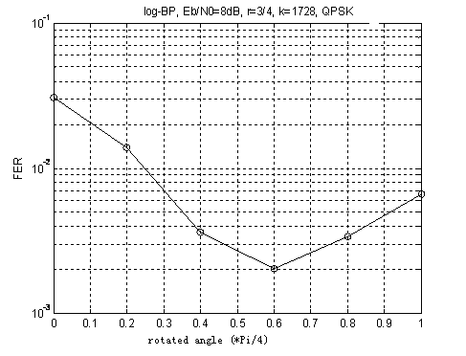

Fig.7 different- rotated-angle performance on TU channel

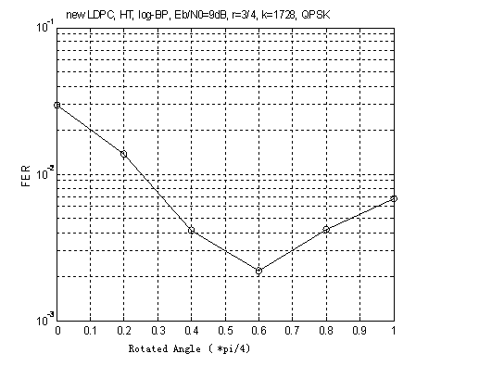
Fig.8 different- rotated-angle performance on HT channel

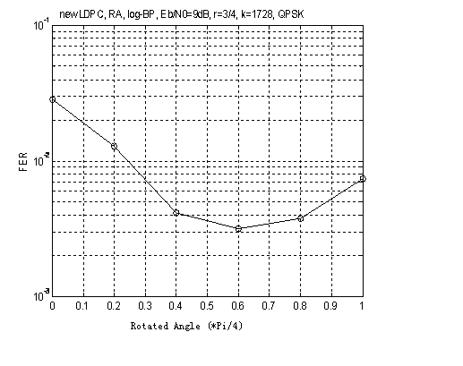
Fig.9 different- rotated-angle performance on RA channel

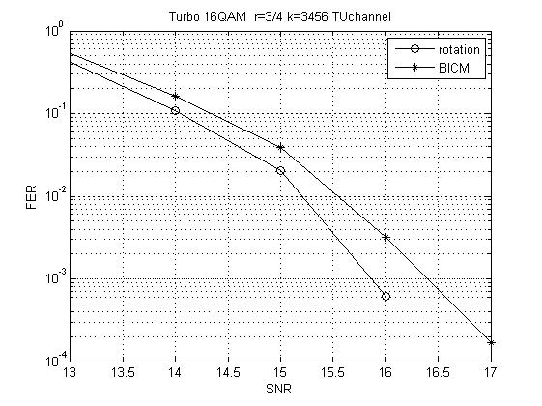

Fig.10 Turbo-RM vs Turbo-BICM on TU channel ( 16QAM,r=3/4)
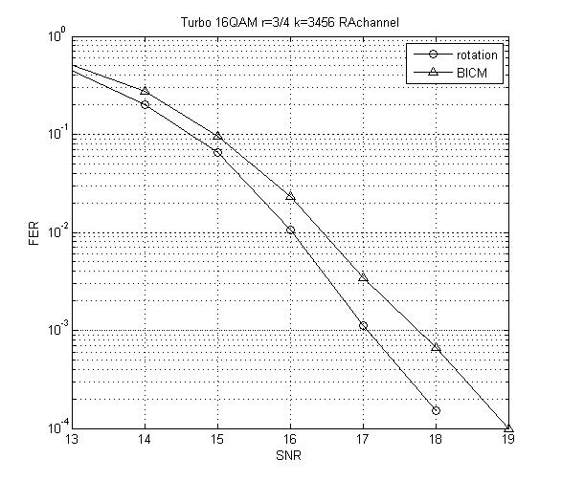
Fig.11 Turbo-RM vs Turbo-BICM on RA channel (16QAM, r=3/4)

4 Conclusions:

A novel CRM(coding-rotated-modulation)-OFDM system is proposed. Our proposed rate-compatible QC-LDPC codes and 3GPP-LTE Turbo codes are studied in this scheme. The new scheme takes full advantage of the modulation diversity of rotated MPSK/QAM modulation, the frequency diversity of OFDM system and the coding-gain of LDPC (Turbo) codes all together. Simulation results have turned out this new coding-modulation scheme for OFDM system can significantly outperform the BICM (bit-interleaved coded modulation) scheme which is used in 3GPP LTE standard. Besides, we derive the optimum rotated angles for two-dimensional rotated QPSK/QAM and prove that it is independent on the fading channel, which is very useful and robust. As for the implementations, the transmitting and receiving complexity of two-dimensional rotated modulation is almost the same as that of usual QAM/QPSK. So, our proposed CRM-OFDM scheme is simple and efficient.

Acknowledgement:
This research is sponsored by the National Natural Science Foundation of China (grant No. 60702050).

Text proposal for inclusion in the 802.16m amendment

------------------------------- Text Start ---------------------------------------------------
15.3.X Channel Coding and HARQ

15.3.X.X CRM(coding-rotated-modulation)-OFDM
CRM(coding-rotated-modulation)-OFDM system is shown in Fig.x. Firstly, information bits are sent into a channel encoder, and the coded bits are rotation-modulated. For the rotation-modulation, the point of the rotated constellation is obtained by applying the rotation matrix to the multidimensional QPSK/QAM constellation. The rotated constellations (complex signal) split into the in-phase (I) and quadrature (Q) Components (real signal). For Q components, a time-frequency two-dimensional interleave is used to maximize the time, frequency and modulation diversity. I components and interleaved Q components are multiplexed into one complex-signal sequence and then allocated into different chunks in the distributed OFDMA system. Rotation angles are as the follows:
For two-dimensional rotated QPSK, $θ_{1}=\text{arctan}(\frac{1}{2})$＝0.463648
For two-dimensional rotated 16QAM, $θ_{1}=\text{arctan}(\frac{1}{4})$= 0.244979

Fig.x CRM(coding-rotated-modulation)-OFDMA

/------------------------- Text End --------------------------------------/

6 References:
- Matthew C. Davey ，PHD Thesis: Error-correction using Low-Density Parity-Check Code， Gonville and Caius College，Cambridge，1999
- D. J. C. MacKay and R. M. Neal. Near Shannon limit performance of low density parity check codes. Electronics Letters, 32(18):1645{1646, August 1996. Reprinted Electronics Letters, vol 33, no 6, 13th March 1997, p.457-458.
- R. G. Gallager. PhD thesis: Low Density Parity Check Codes. MIT, Cambridge, Mass.,September 1962.
- M. C. Davey and D. J. C. MacKay. Low density parity check codes over GF(q). In Proceedings of the 1998 IEEE Information Theory Workshop, pages 70-71. IEEE, June 1998.
- IEEE. IEEE 802.16e/D12－2005, IEEE standard for local and metropolitan area networks－part 16: air interface for fixed broadband wireless access systems - amendment for physical and
- Chen Jinghu, Marc P C Fossorier. Near Optimum Universal Belief Propagation Based Decoding of Low-Density Parity Check Codes[J], IEEE Trans Communication, March 2002, vol.50(No.3):pp.406-414.
- Hu Xiao Yu , Evangelos Eleftheriou, Dieter-Michael Arnold. Efficient implementations of the Sum-Product Algorithm for Decoding LDPC Codes[J]. GLOCOM, Nov 2001,vol.2:pp:1036-1036E
- Efficient difference-based decoding implementations of LDPC，Wu Zhanji, Peng Mugen, Wang Wenbo, IEEE Communication Letter,May,2008，Vol.12，No.5, pp:383-385
- A new parity-check stopping criterion for Turbo decoding, Wu Zhanji, Peng Mugen, Wang Wenbo, IEEE Communication Letter，April，2008, Vol.12，No.4 ,pp:304-306
- J.Boutros, E.Viterbo, Signal Space Diversity: a power and bandwidth efficient diversity technique for the Rayleigh fading channel. IEEE Trans. Inform.Theory, bol.44. pp.1453-1467, July1998 .
- KDDI , “Further Evaluation of R-OFDM”, 3GPP TSG RAN WG1 Meeting, R1-060507, Denver, USA, 13 – 17 Feburary, 2006
- H. Zhang and T. Zhang, “Design of VLSI implementation-oriented LDPC codes,” in Proc. IEEE Vehicular Technology Conference, Oct. 2003, pp. 670–673.
- M. P. C. Fossorier, “Quasi-cyclic low-density parity-check codes from circulant permutation matrices,” IEEE Trans. Inform. Theory, vol. 50, no. 8, pp. 1788–1794, Aug. 2004.
- R. M. Tanner, D. Sridhara, A. Sridharan, T. E. Fuja, and D. J. Costello,Jr., “LDPC block and convolutional codes based on circulant matrices,”IEEE Trans. Inform. Theory, vol. 50, no. 12, pp. 2966–2984, Dec. 2004.
- J. L. Fan, “Array codes as low-density parity-check codes,” in Proc. 2nd Int. Symp. on Turbo Codes, Sept. 2000, pp. 543–546.
- R. Smarandache and P. O. Vontobel, “On regular quasi-cyclic LDPC codes from binomials,” in Proc. IEEE Int. Symp. Inf. Theory,, 2004, p.274.
- J. A. McGowan and R. C. Williamson, “Loop removal from LDPC codes,” in Proc. IEEE Information Theory Workshop, 2003, p. 274.
- X. Wu, X. You, and C. Zhao, “An efficient girth-locating algorithm for quasi-cyclic LDPC codes,” in Proc. IEEE Int. Symp. Inf. Theory,, 2006, pp. 817–820.
- X. Y. Hu, E. Eleftheriou, and D. M. Arnold, “Progressive edge-growth Tanner graphs,” in Proc. IEEE Global Telecommun. Conf., Nov. 2001,pp. 995–1001.

