Project | IEEE 802.16 Broadband Wireless Access Working Group <http://ieee802.org/16>
Title | Update to Access State Diagram
Date Submitted | 2009-01-05
Source(s) | Ranga Reddy  US Army | E-mail: Ranga.Reddy@us.army.mil  *<http://standards.ieee.org/faqs/affiliationFAQ.html>
Re: | “Call for Comments on Project 802.16m System Description Document (SDD)”
Abstract | Provides an update for Access State Diagram
Purpose | Review, discuss, and incorporate into 802.16m SDD
Notice | This document does not represent the agreed views of the IEEE 802.16 Working Group or any of its subgroups. It represents only the views of the participants listed in the “Source(s)” field above. It is offered as a basis for discussion. It is not binding on the contributor(s), who reserve(s) the right to add, amend or withdraw material contained herein.
Release | The contributor grants a free, irrevocable license to the IEEE to incorporate material contained in this contribution, and any modifications thereof, in the creation of an IEEE Standards publication; to copyright in the IEEE’s name any IEEE Standards publication even though it may include portions of this contribution; and at the IEEE’s sole discretion to permit others to reproduce in whole or in part the resulting IEEE Standards publication. The contributor also acknowledges and accepts that this contribution may be made public by IEEE 802.16.
Patent Policy | The contributor is familiar with the IEEE-SA Patent Policy and Procedures:  <http://standards.ieee.org/guides/bylaws/sect6-7.html#6> and <http://standards.ieee.org/guides/opman/sect6.html#6.3>.  Further information is located at <http://standards.ieee.org/board/pat/pat-material.html> and <http://standards.ieee.org/board/pat>.

Update to Access State Diagram
Ranga Reddy
US Army

Introduction
In Session 58 in Dalls, the Security RG had consensus on executing authentication processes prior to capability negotiation (pg 48, line 7-8 of [1]). This requires changes to the Access State diagram that is Figure 6 on page 19 of [2].

Text Proposal
[------------------------------------------------------Start of Text Proposal-----------------------------------------]
[replace Figure 6 on pg 19, with the following figure] 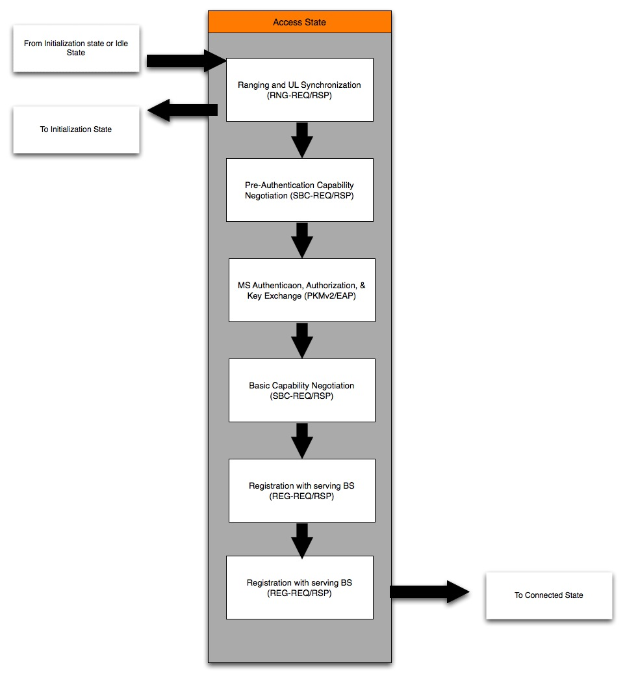

[------------------------------------------------------End of Text Proposal-----------------------------------------]

References
[1] Hamiti, Shkumbin, “IEEE 802.16m System Description Document [Draft]”, IEEE 802.16m-08/003r6
[2] “Call for Comments on P802.16m System Description Document”, IEEE 802.16m-08/052.

