Project | IEEE 802.16 Broadband Wireless Access Working Group <http://ieee802.org/16>
Title | Modified Text for the UL HARQ Feedback Channel Section of SDD
Date Submitted | 2009-01-05
Source(s) | Xin Chang, Yunsong Yang, Chuangming Zheng  Huawei Technologies | xin.chang@huawei.com  yunsongyang@huawei.com
Re: | IEEE 802.16m-08/052: Call for Comments on Project 802.16m System Description Document (SDD)  Section: UL HARQ Feedback Channel
Abstract | The contribution proposes the modified text for the UL HARQ Feedback Channel section to resolve remaining FFS.
Purpose | To be discussed and adopted by TGm for the 802.16m SDD.
Notice | This document does not represent the agreed views of the IEEE 802.16 Working Group or any of its subgroups. It represents only the views of the participants listed in the “Source(s)” field above. It is offered as a basis for discussion. It is not binding on the contributor(s), who reserve(s) the right to add, amend or withdraw material contained herein.
Release | The contributor grants a free, irrevocable license to the IEEE to incorporate material contained in this contribution, and any modifications thereof, in the creation of an IEEE Standards publication; to copyright in the IEEE’s name any IEEE Standards publication even though it may include portions of this contribution; and at the IEEE’s sole discretion to permit others to reproduce in whole or in part the resulting IEEE Standards publication. The contributor also acknowledges and accepts that this contribution may be made public by IEEE 802.16.
Patent Policy | The contributor is familiar with the IEEE-SA Patent Policy and Procedures:  <http://standards.ieee.org/guides/bylaws/sect6-7.html#6> and <http://standards.ieee.org/guides/opman/sect6.html#6.3>.  Further information is located at <http://standards.ieee.org/board/pat/pat-material.html> and <http://standards.ieee.org/board/pat>.

Modified Text for the UL HARQ Feedback Channel Section of SDD

Xin Chang, Yunsong Yang, Chuangming Zheng
Huawei Technologies

- Introduction
The contribution proposes modified text for the UL HARQ Feedback Channel section included in the 802.16m SDD (IEEE 802.16m-08/003r6) [1]. The proposed text is compliant to the 802.16m SRD [2]], and it follows the style and format guidelines in [3].

- Definition
FMT Feedback Mini Tile

- Scheme Description
Based on the 802.16m SDD [1], the UL control structure consists of the UL Fast Feedback Channel, UL HARQ Feedback Channel, UL Sounding Channel, Ranging Channel, Bandwidth Request Channel. In this contribution, we focus primarily on the PHY structure of UL HARQ Feedback Channel.
In current SDD text, UL FMT of 6 contiguous subcarriers by 2 OFDM symbols is still under consideration. This proposal gives detailed transmission scheme and simulation result at first and the conclusion is drawn subsequently. For simplicity, FMT of 6 contiguous subcarriers by 2 OFDM symbols and 2 contiguous subcarriers by 6 OFDM symbols are called 6*2 FMT and 2*6 FMT respectively in following description.
The DFT orthogonal sequence is recommended as spreading sequence for HARQ feedback channel. Two schemes are adopted for the contribution: coherent detection and non-coherent detection. For coherent detection, the same 6-ray DFT sequence is used for both of pilot and ACK signaling. The de-spreading of pilot signaling can be used as channel estimation for coherent detection of de-spreading ACK signaling. For non-coherent detection, two different 12-ray DFT sequence are used separately for ACK and NAK feedback. The receiver will measure the de-spreading power of each sequence to determine the signaling. On each tile, the sequence mapping is shifted to achieve diversity
The resource mapping scheme of non-coherent and coherent detection for two different FMT is shown in following figure.
Figure 1a: the resource mapping of coherent detection for 2*6 FMT
Figure 1b: the resource mapping of non-coherent detection for 2*6 FMT.
Figure 1c: the resource mapping of coherent detection for 6*2 FMT
Figure 1d: the resource mapping of non-coherent detection for 6*2 FMT
The transmit processing of coherent detection and non-coherent detection for UL HARQ feedback is shown as following figure:
Figure 2a: transmit processing of coherent detection for UL HARQ feedback
Figure 2b: transmit process of non-coherent detection for UL HARQ feedback

- Simulation
24-tap PB3 and VA120 channel model are employed in order to evaluate the performance of different FMT structure. The simulation parameter is listed as following table:
Parameter | Value
FMT Type | distributed 2*6 and 6*2
FMT Number | 3
Receiver | coherent and non-coherent MLD
Channel Model | PB3 and VA120
Bandwidth | 10MHz
CP Ratio | 1/8
Sequence | 6/12-ray DFT
Antenna Configuration | 1Tx * 2Rx
HARQ Feedback Channel Number | 6

The simulation result is shown in following figure:
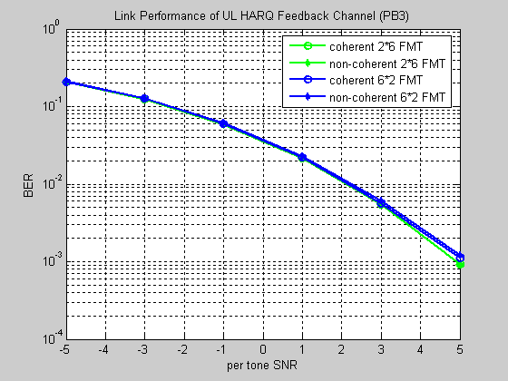
Figure 3a: link performance of different FMT under PB3
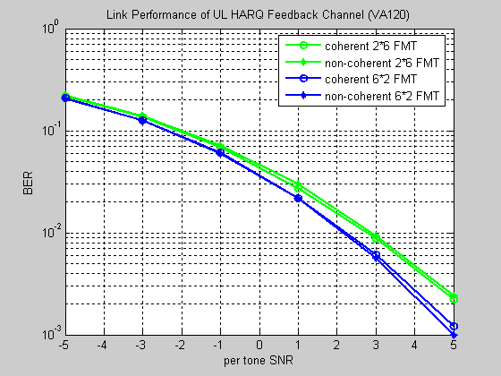
Figure 3a: link performance of different FMT under VA120

- Conclusion
From simulation result in previous section, the 2*6 FMT outperforms the 6*2 FMT very slight at high SNR range under PB3 channel model. However, the 6*2 FMT outperforms the 2*6 FMT at high SNR range (i.e. about 0.7dB@10⁻²). Hence, we recommend 6*2 FMT structure with consideration of performance and simplicity of single design.

- References
[1] IEEE 802.16m-08/003r6, “The Draft IEEE 802.16m System Description Document”
[2] IEEE 802.16m-07/002r6, “802.16m System Requirements”
[3] IEEE 802.16m-08/052, “Call for Comments on Project 802.16m System Description Document (SDD)”

- Text proposal for the 802.16m SDD

--------------------------------------- Text Start ---------------------------------------------------
      - UL HARQ Feedback Channel
This channel is used to carry HARQ feedback information.
        - Multiplexing with other control channels and data channels
The UL HARQ feedback channel starts at a pre-determined offset with respect to the corresponding DL transmission.

The UL HARQ feedback channel is FDM with other control and data channels.

Orthogonal signaling is used to multiplex multiple HARQ feedback channels.
        - PHY structure
The UL HARQ feedback channel is comprised of three distributed UL feedback mini-tiles (FMT), where the UL FMT is defined as 2 contiguous subcarriers by 6 OFDM symbols. A UL FMT of 6 contiguous subcarriers by 2 OFDM symbols is FFS. One LRU consists of 9 FMTs and can be shared by multiple HARQ feedback channels.

--------------------------------------- Text End ---------------------------------------------------

