Project | IEEE 802.16 Broadband Wireless Access Working Group <http://ieee802.org/16>
Title | SDD Text Proposal for E-MBS Operation With Link Adaptation
Date Submitted | 2009-01-05
Source(s) | Hung-Yu Wei, Ching-Chun Chou,  Shih-Lung Chao  Department of Electrical Engineering, National Taiwan University  No. 1, Sec. 4, Roosevelt Road, Taipei, 10617 Taiwan(R.O.C) | Voice: [Telephone Number (optional)]]  E-mail: hywei@cc.ee.ntu.edu.tw
Re: | In response to the TGm call for Comments on Project 802.16m SDD, IEEE 802.16m-08/052 for Session #59
Abstract | This contribution proposes link adaptation mechanism design for the E-MBS operation section in the SDD text.
Purpose | To be discussed and adopted by TGm for use in the IEEE 802.16m SDD
Notice | This document does not represent the agreed views of the IEEE 802.16 Working Group or any of its subgroups. It represents only the views of the participants listed in the “Source(s)” field above. It is offered as a basis for discussion. It is not binding on the contributor(s), who reserve(s) the right to add, amend or withdraw material contained herein.
Release | The contributor grants a free, irrevocable license to the IEEE to incorporate material contained in this contribution, and any modifications thereof, in the creation of an IEEE Standards publication; to copyright in the IEEE’s name any IEEE Standards publication even though it may include portions of this contribution; and at the IEEE’s sole discretion to permit others to reproduce in whole or in part the resulting IEEE Standards publication. The contributor also acknowledges and accepts that this contribution may be made public by IEEE 802.16.
Patent Policy | The contributor is familiar with the IEEE-SA Patent Policy and Procedures:  <http://standards.ieee.org/guides/bylaws/sect6-7.html#6> and <http://standards.ieee.org/guides/opman/sect6.html#6.3>.  Further information is located at <http://standards.ieee.org/board/pat/pat-material.html> and <http://standards.ieee.org/board/pat>.
SDD Text Proposal for E-MBS Operation with Link Adaptation
Hung Yu-Wei, Ching-Chun Chou, and Shih-Lung Chao
Department of Electrical Engineering, National Taiwan University

Introduction
This contribution provides SDD text comments for link adaptation mechanism design for IEEE 802.16m-08/003r6-delta System Description Document (SDD). It proposes a reporting mechanism, both positive and negative, for the MCS adaptation of E-MBS system.

Link Adaptation for E-MBS – Negative MCS Reporting
It is essential for E-MBS to have link adaptation mechanism. Using appropriate modulation and coding scheme (MCS), the transmission rate could be raised and the system throughput is therefore improved. To adjust the MCS, feedback mechanism is necessary. We proposed possible feedback mechanism for the ABS and AMS to adaptively adjust their MCS.
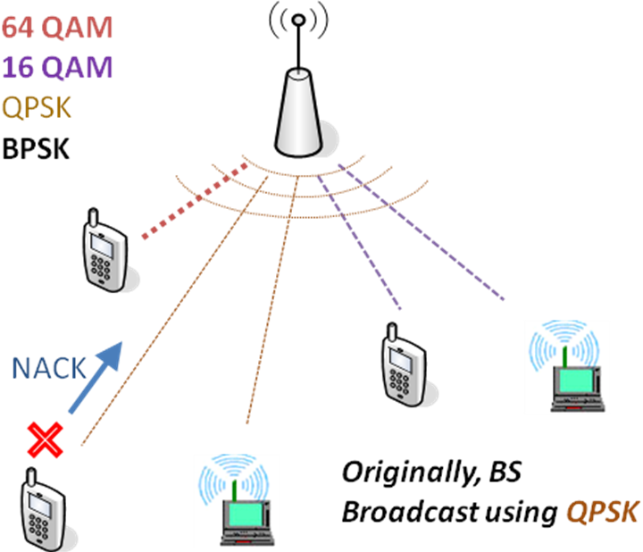
Figure 1: Example: One of the AMS failed to receive a data block
As shown in Figure 1, ABS is broadcasting data to 5 AMSs. Each AMS has its own channel states, and different MCS could be applied to the transmission. Due to the MBS characteristics, ABS has to pick the lowest rate and use the most robust MCS for the subordinate MBS group. Therefore, QPSK is selected and the BS is broadcasting using it.
However, channel states are varying, and the MCS might become inadequate for current transmission. One of the AMS is under poor channel condition, and is suffering from high error rate using the current MCS. Therefore, Negative MCS Reporting is sent back to the ABS. Receiving the negative MCS feedback, ABS has to change the MCS profile to a more robust one, which means BPSK in this case. Figure 2 illustrates the result of this negative MCS adaptation.
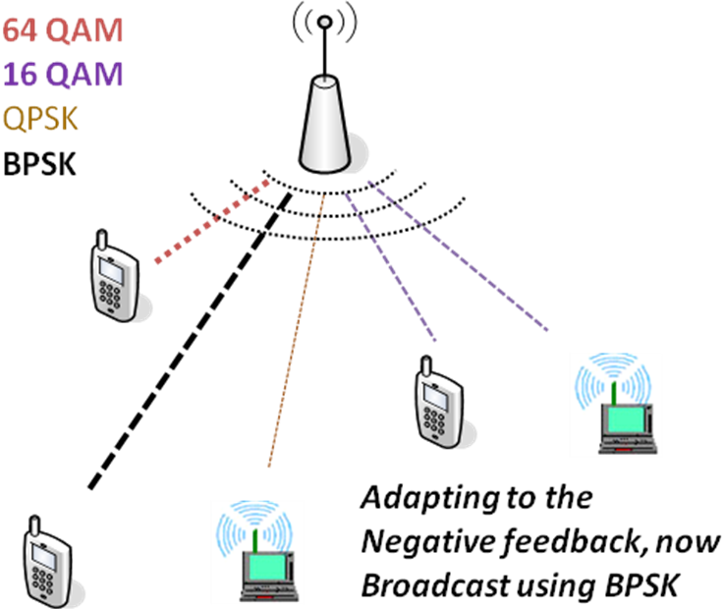
Figure 2: MCS is changed to BPSK to adapt to the current channel condition.

Link Adaptation for E-MBS – Positive MCS Reporting
If we use only negative feedback and MCS adaptation process, as wireless transmission is prone to error, the MBS system throughput will be very low. Hence, we will need a mechanism to increase the MCS rate.
Such phenomenon could be avoided by the Positive MCS feedback. ABS may ask AMSs to report the desirable MCS through Positive MCS Reporting. This poll-and-reply process could be done periodically or whenever the ABS considers it necessary. If all the subordinate AMSs of the MBS group report good channel conditions, the ABS could change to the higher-rate MCS. Figure 3 shows the process for the positive feedback.
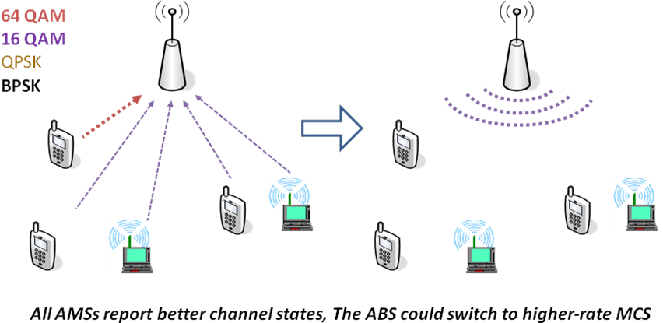
Figure 3: Positive MCS Reporting
- Link Adaptation Broadcast for E-MBS
In order to further improve the effectiveness of MCS reporting, ABS could broadcast MCS related parameters to its MBS receivers. For example, feedback policies and parameters, link adaptation parameters, available MCS profiles, and E-MBS services could be broadcast by the ABS. ABS could also provide uplink radio resources blocks for the AMSs to report their channel condition parameters. This process could inform the AMSs of the possible service parameter settings, and would be critical for the E-MBS initiation and update with more adequate MCS.
- Proposed Text for SDD
----------------------------------------------------Start of the Proposed Text---------------------------------------------------

14.3.5 E-MBS Operation with Link Adaptation
Details on E-MBS Operation with Link Adaptation is FFS.
Upon receiving Negative MCS Reporting message from the E-MBS common feedback channel, ABS may select a more robust MCS for E-MBS transmission. To achieve accurate link adaptation in E-MBS, ABS may ask AMS to update the desirable MCS through Positive MCS Reporting.
----------------------------------------------------End of the Proposed Text---------------------------------------------------

