Project | IEEE 802.16 Broadband Wireless Access Working Group <http://ieee802.org/16>
Title | Proposed text for E-MBS Zone Specific Pilot Structure for MBSFN
Date Submitted | 2009-01-05
Source(s) | Takaaki KISHIGAMI,  Isamu YOSHII  Panasonic Corporation | Voice: + 81-46-840-5123  E-mail: kishigami.takaaki@jp.panasonic.com  yoshii.isamu@jp.panasonic.com
Re: | IEEE802.16m-08/052 – Call for Comments on Project 802.16m System Description Document(SDD), Section 11.5.3.1
Abstract | We propose the E-MBS zone specific CDM pilot for MBSFN.
Purpose | For 802.16m discussion and adoption
Notice | This document does not represent the agreed views of the IEEE 802.16 Working Group or any of its subgroups. It represents only the views of the participants listed in the “Source(s)” field above. It is offered as a basis for discussion. It is not binding on the contributor(s), who reserve(s) the right to add, amend or withdraw material contained herein.
Release | The contributor grants a free, irrevocable license to the IEEE to incorporate material contained in this contribution, and any modifications thereof, in the creation of an IEEE Standards publication; to copyright in the IEEE’s name any IEEE Standards publication even though it may include portions of this contribution; and at the IEEE’s sole discretion to permit others to reproduce in whole or in part the resulting IEEE Standards publication. The contributor also acknowledges and accepts that this contribution may be made public by IEEE 802.16.
Patent Policy | The contributor is familiar with the IEEE-SA Patent Policy and Procedures:  <http://standards.ieee.org/guides/bylaws/sect6-7.html#6> and <http://standards.ieee.org/guides/opman/sect6.html#6.3>.  Further information is located at <http://standards.ieee.org/board/pat/pat-material.html> and <http://standards.ieee.org/board/pat>.

Proposed text for E-MBS Zone Specific Pilot Structure for MBSFN

Takaaki KISHIGAMI, Isamu YOSHII
Panasonic Corporation

Introduction
In SDD[1], the E-MBS zone specific pilot is defined such as common inside one E-MBS zone but different between neighboring E-MBS zones for improving channel estimation accuracy.
In order to avoid inter- E-MBS zones interference, following multiplexing schemes could be useful [2].
  - CDM pilot scheme : E-MBS zone-specific orthogonal sequence is multiplied to the basic pilot pattern.
  - Interlaced pilot scheme : E-MBS zone-specific frequency/time offset is applied to the basic pilot pattern.
In following discussions, we show the performance gain comparing between those schemes by the link level simulation based on the Pilot Evaluation criteria[3].

E-MBS Zone Specific Pilot structure
2.1 CDM pilot scheme
Figure 1 shows the CDM pilot scheme. The example is an orthogonal sequence using phase rotation in a E-MBS zone with three E-MBS zones and a basic pilot pattern based on the 802.16e Downlink PUSC[4]. In the zone specific orthogonal sequence, frequency domain spreading is used by adding phase rotation. In the figure, the phase rotation for P_{k} illustrates the pilot symbol transmitted for stream #k. The maximum number of streams within the E-MBS zone is two[2]. The phase rotation(φ) of 0, 2π/3, and 4π/3 is added every adjacent pilot subcarrier to the E-MBS zone #1, #2, and #3, respectively.
When the proposed CDM pilot scheme is used, the inter-E-MBS zone interference on the pilot channel from the neighboring E-MBS zones can be avoided by dispreading among neighbor pilot subcarrier, leading to accurate channel estimation.

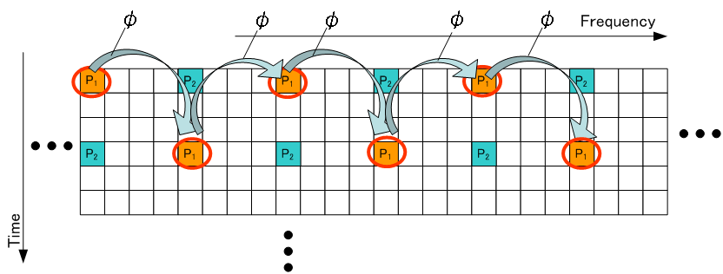$φ=\left\{\begin{matrix} 0 (\text{for} \text{Zone} & 1)\begin{matrix} \\ \\ \end{matrix}2) \\ \frac{4π}{3} (\text{for} \text{Zone} & 3)\end{matrix}\right.$

Figure 1 – Example of CDM pilot scheme for E-MBS specific pilot

2.2 Interlaced pilot scheme
Figure 2 shows the interlaced pilot scheme. The E-MBS zone specific offset is applied to the basic pilot pattern in the E-MBS zone #1. The offset in the E-MBS zone #k is (k-1)ΔSC. (Figure 2 shows the case of ΔSC =1.) The offset of pilot positions is given in frequency/time direction for the basic pilot pattern as shown in Figure 1 . The E-MBS zone specific offset is applied to all pilot symbols for up to two streams(P₁, P₂).
In the non-orthogonal pilot channel structure using the E-MBS zone specific offset, the inter-E-MBS zone interference on the pilot signals, especially power boosted pilot case, can be reduced compared to the no offset case, although the interference from the pilot channel to the data channel is increased at the same time.
E-MBS Zone
#1
E-MBS Zone
#2
E-MBS Zone
#3
Figure 2 – Example of interlaced pilot scheme for E-MBS specific pilot

Simulation Evaluations
We compared three pilot scheme(CDM, interlaced and non zone-specific pilots) as shown in Figure 3. The CDM pilots, interlaced pilots are as same as descried in Section 2.1 and 2.2. For interlaced pilots, we evaluated the case with specific frequency offset (ΔSC =1). The position of the basic pilot pattern is shown in Figure 1. The transmission power of the pilot symbol is set to 3dB higher than that of the data symbol.
E-MBS Zone
#k
E-MBS Zone
#(k+1)
(a)CDM pilots (b)Non zone-specific pilots (c)Interlaced pilots
Figure 3– Evaluated pilot scheme
We investigated the effect of the E-MBS zone specific pilots from the viewpoint of the throughput performance in a E-MBS zone with three E-MBS zone. Table 1 lists the radio parameters assumed in the link-level simulations. Figure 4 shows the interference model among E-MBS zones. The parameter of inter-E-MBS zone interference [ΔΙ = P_{zone#1}/ (P_{zone#2} + P_{zone#3})] represents the difference in the average received signal power at a MS in E-MBS zone #1, corresponding to the difference in the distances from the neighboring BSs in two E-MBS zones(#2, #3).
Figure 5 plots the throughput performance in case of ΔΙ =6,9,12,15 dB. We find that the CDM pilots scheme is better throughput performance compared to that of the interleaved pilot scheme.
Figure 4 – Simulation model considering inter-E-MBS zones interference
Table 1 – Simulation Parameters
Parameter | Value
Carrier frequency | 2.5Ghz
System bandwidth | 10MHz
FFT size | 1024
Sub-carrier frequency spacing(f_{s}) | 10.94kHz
Useful symbol interval (T_{s}=1/f_{s}) | 91.4usec
Guard interval (T_{g}=T_{s}/8) | 11.4usec
Pilot power boost level | 3dB
Resource unit(RU) | 2 Localized RU  [1RU: (Psc, Nsym)=(18,6)]
Antenna configuration | 1Tx–2Rx (MRC)
Channel coding | Turbo coding (original rate = 1/3)
Turbo decoding | Max-Log-Map (8 iterations)
MCS | QPSK, R=1/2,3/4;  16QAM, R=1/2,3/4
Channel model | Vehicular A (VA) 120km/h
Channel estimation | MMSE
Antenna pattern of each sector (horizontal) | 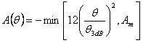  $θ_{3\text{dB}}$ = 70 degrees, A_{m} = 20 dB
The inter-E-MBS zone interference (ΔΙ) | ΔΙ=6, 9 , 12, 15 dB
Non zone specific pilots
Interlaced pilots
CDM pilots
ΔΙ=15dB
ΔΙ=12dB
ΔΙ=9dB
ΔΙ=6dB
Figure 5 – Throughput performance (1x2 SIMO, VA120km/h)

Conclusions
We presented the improved performance of the E-MBS zone-specific CDM pilot scheme compared to the interlaced pilots scheme by link-level simulation evaluation considering inter-E-MBS zone interference.
Hence, We propose to include the CDM-pilot scheme for E-MBS zone specific pilot in TGm SDD.

Proposed SDD Text change
Section 11.5.3.1 E-MBS zone specific pilot for MBSFN, page 80, line 18
- Replace the following text
“The definitions of the E-MBS zone specific pilots are FFS.”
with
“The E-MBS zone specific pilots use orthogonal sequence(or CDM ) to reduce the inter-E-MBS zone interference.”

References
[1]IEEE 802.16m-08/003r6, “The Draft IEEE 802.16m System Description Document”
[2]IEEE C802.16mDL_PHY-08/716, Panasonic, “Sector-Specific Common Pilot Structure in IEEE802.16m Downlink.”
[3]IEEE C80216m-08/518, “Rapporteur Group for Project 802.16m Downlink Physical Structure Chairs Report.”
[4]IEEE Std 802.16e-2005.

