Project | IEEE 802.16 Broadband Wireless Access Working Group <http://ieee802.org/16>
Title | A new Bit-Rearrangement scheme for channel coding
Date Submitted | 2009-01-07
Source(s) | Xianwei Gong, Bo Sun  ZTE Corporation | E-mail: gong.xianwei@zte.com.cn,  sun.bo1@zte.com.cn  *<http://standards.ieee.org/faqs/affiliationFAQ.html>
Re: | IEEE 802.16m-08/053r1 –Call for Comments and Contributions on Project 802.16m Amendment Working Document; Channel Coding and HARQ
Abstract | This document proposes a new Bit-Rearrangement scheme for channel coding. With using this scheme, it can achieve good balance between complexity and performance, and can smooth performance in different scenario.
Purpose | To be discussed and adopted by TGm for use in the IEEE 802.16m Amendment Working Document
Notice | This document does not represent the agreed views of the IEEE 802.16 Working Group or any of its subgroups. It represents only the views of the participants listed in the “Source(s)” field above. It is offered as a basis for discussion. It is not binding on the contributor(s), who reserve(s) the right to add, amend or withdraw material contained herein.
Release | The contributor grants a free, irrevocable license to the IEEE to incorporate material contained in this contribution, and any modifications thereof, in the creation of an IEEE Standards publication; to copyright in the IEEE’s name any IEEE Standards publication even though it may include portions of this contribution; and at the IEEE’s sole discretion to permit others to reproduce in whole or in part the resulting IEEE Standards publication. The contributor also acknowledges and accepts that this contribution may be made public by IEEE 802.16.
Patent Policy | The contributor is familiar with the IEEE-SA Patent Policy and Procedures:  <http://standards.ieee.org/guides/bylaws/sect6-7.html#6> and <http://standards.ieee.org/guides/opman/sect6.html#6.3>.  Further information is located at <http://standards.ieee.org/board/pat/pat-material.html> and <http://standards.ieee.org/board/pat>.
A new bit re-arrangement scheme for channel coding
Xianwei Gong, Bo Sun
ZTE Corporation

Instructions

In IEEE 802.16m SDD, Incremental Redundancy (IR) is a mandatory operation for Hybrid ARQ (HARQ) while Chase-Combing (CC) is a special case of IR HARQ. Bit-Rearrangement (BitRe) which contains a bit-level interleaver and an inverter is supported in 16m. For each transmitted burst, the BitRe-version is selected by the transmission number of this burst. The specific bit-level interleaver and inverter mechanism is FFS.

In known BitRe solutions, for each transmitted burst, the BitRe version is selected by the transmission number as defined in SDD r6 or CoRe-version is selected for each bit in the single HARQ re-transmission [1]. The method in [1] averages out the bit reliability over various transmissions by using different CoRe version in the overlapping QAM symbols. However, if the MAP is missing, the MS can’t know the CoRe-version for each transmitted bit. In IR and adaptive HARQ operation, this problem is critical. For each transmitted bit, the CoRe-version may be indicated, but the overhead is large [2]

This document proposes a new BitRe solution which employs two CoRe-version in each transmission. The first half of the subpacket uses the different CoRe-version with the second half. Since the overlapping section is generally located at the front or the rear part of the transmitted subpacket. This proposed solution can average out unequal bit reliabilities without depending on transmission numbers for IR HARQ.A good balance between complexity and performance can be achieved.

Proposed scheme
In this scheme, each sub-packet after rate matching has 2 CoRe-versions. For IR HARQ, in each sub-packet, the first half part of the subpacket uses CoRe-version 1(for example, uses the constellation in [3],), and the second half of the subpacket uses CoRe-version 2(for example, swapping the MSB and LSB within each QAM symbol). Figure 1 shows the bit rearrangement within a sing transmission (Here is the example for 16QAM.).
Figure 1 bit rearrangement within a sing transmission for IR HARQ

Figure 2 interprets the proposed scheme within re-transmissions for IR HARQ. For IR combining, the transmission number is not necessary to inferring the CoRe-version because every transmission uses the same bit reordering method. The miss-detection of one map would not screw up the whole session.
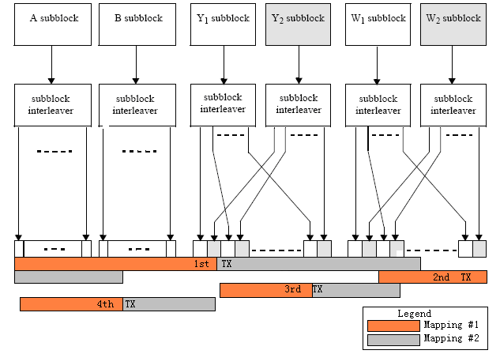
Figure 2 Transmissions in IR mode for proposed bit re-arrangement scheme
As for Chase combining, the CoRe version should be inverted between 2 continual transmissions. for example, in the odd transmissions, the first half part of the subpacket uses CoRe-version 1, and the second half of the subpacket uses CoRe-version 2; while in the even transmissions, the first half part of the subpacket uses CoRe-version 2, and the second half of the subpacket uses CoRe-version 1. Figure 3 gives an explanation for Chase mode.
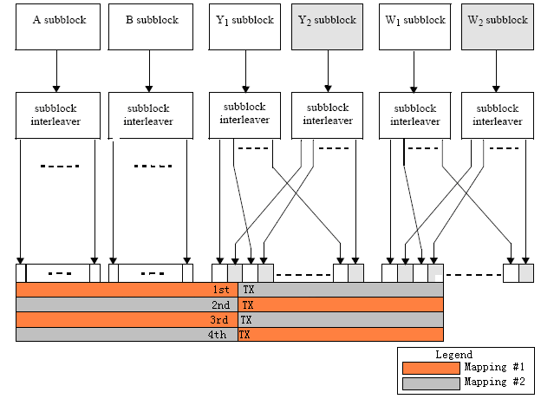
Figure 3 Transmissions in Chase mode for proposed bit re-arrangement scheme
The bit re-arrangement pattern is changed between continual transmissions in Chase mode. It counts on successful reception of MAP information, and the situation might be serious in case of miss-detection for one map. However, this is a common problem for CoRe used in Chase mode. The protection mechanism should be FFS.
The mapping of bits to the constellation points depends on the CoRe-version used for HARQ re-transmission. Figure 4 (a) and Figure 5 (a) give the constellation used for CoRe-version 1, which is the same as in [3]; Figure 4 (b) and Figure 5 (b) give the constellation used for CoRe-version 2, the location of MSB and LSB has been exchanged for each mapping point (QAM symbol).
(a) Constellation before BitRe (b) Constellation after BitRe
Figure 4 Constellations before and after BitRe for 16QAM
(a) Constellation before BitRe
(b) Constellation after BitRe
Figure 5 Constellations before and after BitRe for 64QAM

Feature
➢ The best performance at the first re-transmission.
➢ Performance improvement at the second/third re-transmission.
➢ Almost no extra complexity in transmitter and receiver.
➢ No extra signaling expense.
➢ No extra testing cost.
➢ Widely available.

Simulation results
This part evaluates the error rate performance for No Bit-Rearrangement scheme, the proposed scheme and the scheme in reference [1]. Fixed HARQ is evaluated here. The simulations assume =0, 1, 2, 3 for k=0, 1, 2, 3. =384 is considered. The simulation environment is AWGN channel, Max-Log-MAP algorithm with maximum 8 iterations with early stopping.

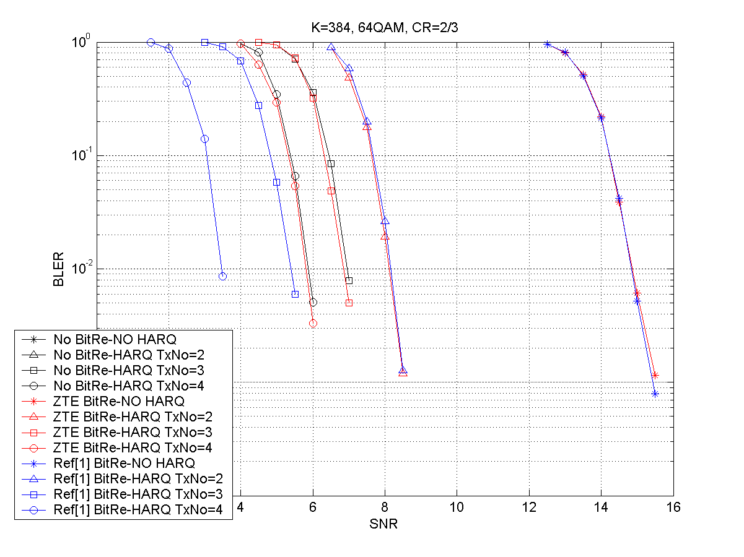

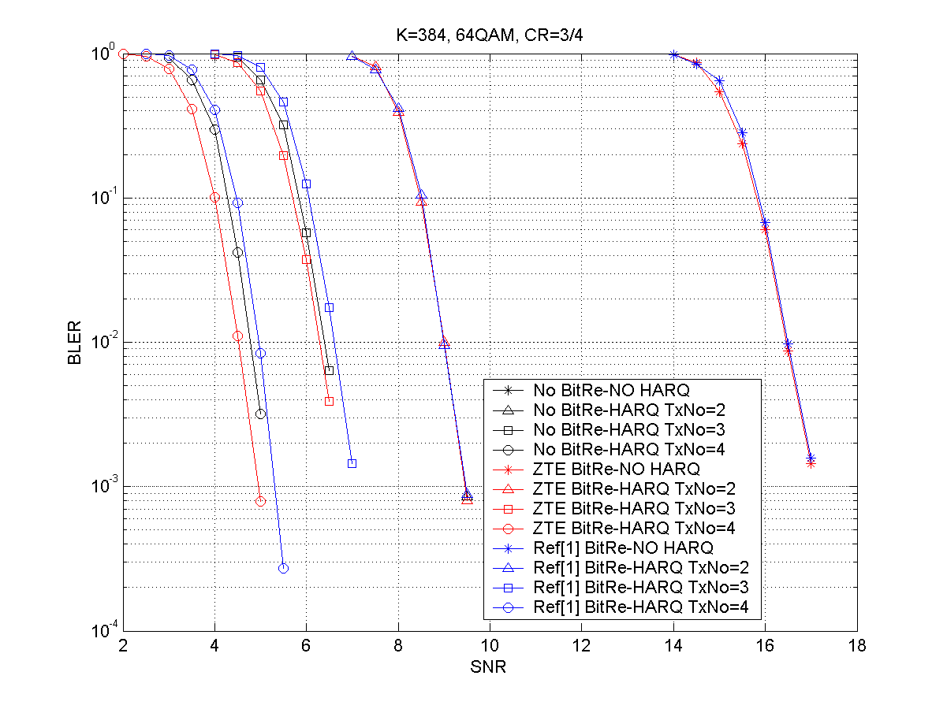

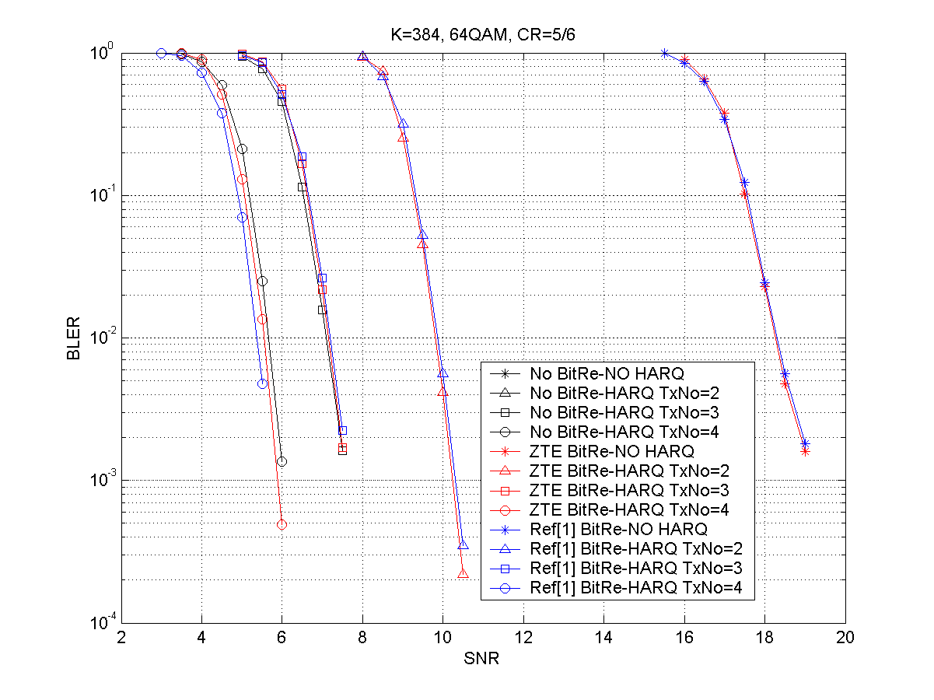

Conclusion
In the scenario of =384, code rate= 2/3, 3/4, 5/6 and modulation mode= 64QAM, No Bit-Rearrangement scheme, the proposed scheme and the scheme in reference [1] are compared. Simulation results show that the performance of the proposed scheme is closed to the method in [1] for 1st and 2nd transmissions. Since the first two transmissions is much more important for HARQ performance than the third and forth transmissions, and considering the None extra signaling expense for IR HARQ, we suggest this proposed Bit Rearrangement scheme be considered for 16m HARQ.

References
[1] IEEE C802.16m-08/606, "SDD text proposal for IEEE 802.16m HARQ and FEC"
[2] IEEE C802.16m-08/1333r1, "Proposal for Constellation Re-arrangement in IR HARQ"
[3] P80216Rev2_D7, "Part 16: Air interface for fixed broadband wireless access systems," October, 2008.
.

Text Proposal to Amendment work document
------------------------------------Start text proposal------------------------------------

15.3.x Channel Encoding and HARQ
15.3.x.x HARQ
15.3.x.x .x Bit Re-arrangement
Bit Re-arrangement changes the bit mapping in transmission for 16-QAM and 64-QAM. There are two BitRe versions in a single subpacket.

Assuming:
L be the length of the sub-packet.
be the bits in the sub-packet, where
be the index of the transmitted QAM symbol, which is indexed from 0.
be the bits mapping to the th symbol, where for 16-QAM and for 64-QAM.
be the modulation order (for 16-QAM and for 64-QAM)
be the transmission number, which is indexed from 0.

In case of IR combining, the bit level interleaver is performed as:

for from to ,
,
for from to ,
,
;

In case of Chase Combining, the bit level interleaver is performed as:
If is even
for from to ,
,
for from to ,
,
.
Elseif is odd
for from to ,
,
.
for from to ,
Endif
------------------------------------End text proposal------------------------------------

