Project | IEEE 802.16 Broadband Wireless Access Working Group <http://ieee802.org/16>
Title | The Bit Selection Method of CTC IR HARQ for IEEE 802.16m
Date Submitted | 2009-01-07
Source(s) | Jin Xu, Bo Sun  ZTE Corporation  Xiaolu Dong, Ying Du, Daning Gong  CATR | E-mail: xu.jin7@zte.com.cn,  sun.bo1@zte.com.cn,  dongxiaolu@mail.ritt.com.cn, duying@mail.ritt.com.cn, gongdaning@mail.ritt.com.cn  *<http://standards.ieee.org/faqs/affiliationFAQ.html>
Re: | IEEE 802.16m-08/053r1 –Call for Comments and Contributions on Project 802.16m Amendment Working Document; Channel Coding and HARQ
Abstract | This proposal gives a description about HARQ Bit Selection method.
Purpose | To be discussed and adopted by TGm for use in the IEEE 802.16m Amendment Working Document
Notice | This document does not represent the agreed views of the IEEE 802.16 Working Group or any of its subgroups. It represents only the views of the participants listed in the “Source(s)” field above. It is offered as a basis for discussion. It is not binding on the contributor(s), who reserve(s) the right to add, amend or withdraw material contained herein.
Release | The contributor grants a free, irrevocable license to the IEEE to incorporate material contained in this contribution, and any modifications thereof, in the creation of an IEEE Standards publication; to copyright in the IEEE’s name any IEEE Standards publication even though it may include portions of this contribution; and at the IEEE’s sole discretion to permit others to reproduce in whole or in part the resulting IEEE Standards publication. The contributor also acknowledges and accepts that this contribution may be made public by IEEE 802.16.
Patent Policy | The contributor is familiar with the IEEE-SA Patent Policy and Procedures:  <http://standards.ieee.org/guides/bylaws/sect6-7.html#6> and <http://standards.ieee.org/guides/opman/sect6.html#6.3>.  Further information is located at <http://standards.ieee.org/board/pat/pat-material.html> and <http://standards.ieee.org/board/pat>.
The Bit Selection Method of CTC IR HARQ for IEEE 802.16m
Jin Xu, Bo Sun
ZTE Corporation
Xiaolu Dong, Ying Du, Daning Gong
CATR

Introduction
As defined in IEEE 802.16m SDD_r6 [1], IR HARQ is supported with bit selection.
This proposal is to suggest a bit selection solution to further reduce the possibility of overlapping between HARQ retransmission sub-packets of the same packet.

Problem Definition and Analysis
In 16e system, the starting position of IR sub-packet is calculated by SPID value defined by BS and the subpacket length [2]. For the first transmission, SPID is always 0 (SPID_{k=0} = 0) by default. For any retransmission, the value of SPID (SPID_{k=2,3,4} , where k is the subpacket index and k=0, 1, 2, 3) is randomly selected among 0, 1, 2 and 3.
Assume the length of subpacket k is L_{k} which is derived from the number of allocated subchannel N_{SCH} and the modulation order m_{k} as:
,
Then, the starting position is calculated by
,
where N_{m} denotes the length of mother code.
If L_{k} is invariable during transmissions (which might be the case when fixed HARQ is adopted.), and if different SPIDs are used in each transmission, overlapping between subpackets can be reduced to the lowest degree. However, once L_{k} changes during transmissions (which is likely to be happened when adaptive HARQ is employed), or SPIDs does not change between transmissions, overlapping would be serious.
Since the first two transmissions is much more important for HARQ performance than the third and forth transmissions, for IR HARQ, more mother code bits need to be covered within the first two transmissions as far as possible. Too many overlapping bits may descend combining gain, and decoding performance might also drop down, especially when overlapping is occurred between the first and second HARQ subpacket.
Figure 1 and figure 2 interpret the undesired situation mentioned above, in which 16e’s bit selection method is employed. The black circle denotes mother code bit sequence with circular buffer rate matching. Note that only the first two HARQ subpackets are showed here. Both figure 1 and figure 2 are drawn under the circumstance of using different subpacket size.
Figure 1 The first and Second subpacket have the same SPID value, SPID_{k =0,1}=0.
Figure 2 The first subpacket is much longer than the second subpacket

Proposed Bit Selection Method
We propose a new bit selection method to guarantee the performance of IR HARQ in 16m. This method renews the definition of HARQ subpackets’ starting position as:
The first transmitting subpacket starts from the beginning of mother code. It contains the first L₀ bits of the mother code, where L₀ denotes the first subpacket length.
The second subpacket contains the last L₁ bits of the mother code. The starting position is N_{m} - L₁-1, where N_{m} and L₁ denote the mother code length and the second subpacket length respectively. The mother code bits are indexed from 0 to L-1.
The third subpacket starts from the beginning of the first parity bit branch (or named “Y parity bits”). The starting position is N_{ep}-1, where N_{ep} denotes the number of bits in the encoder packet (before encoding).
The forth subpacket starts from the beginning of the second parity bit branch (or named “W parity bits”). The starting position is 2*N_{ep}-1.

The N_{ep} are determined by BS. L₁ can be calculated by modulation order and number of allocated resource units. So, this starting position determining method would not bring any additional control information overhead.
Figure 3 interprets the proposed method. We can see that the first two HARQ transmission subpackets covered the mother code bits as many as possible. No mater what the subpacket size is, the proposed bit selection method reduces the overlapping bits comparing to 16e’s method.
Figure 3 The interpretation of proposed bit selection method

Feature
- Performance enhancement at the second/third transmission（the first/second retransmission）.
- Almost no extra complexity in transmitter and receiver.
- Do not need DTX to indicate the missing of transmission subpacket.
- More suitable for adaptive HARQ.
- No extra signaling.
- Widely available.

Simulation
This part evaluates the error rate performance for proposed and 16e’s CTC IR HARQ bit selection method. Adaptive HARQ is evaluated here. N_{EP}=384 are considered. The simulation environment is AWGN channel, Max-Log-MAP algorithm with maximum 8 iterations with early stopping.
The subpacket length changes for every transmission. Noted that the black, red, green and blue lines show the BLER-SNR performance of the first, second, third and fourth transmission respectively from figure 4 to figure 7.
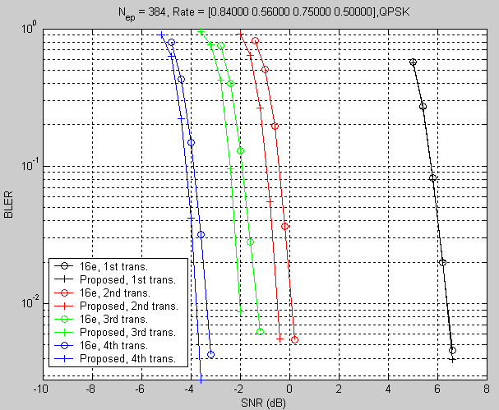
Figure 4
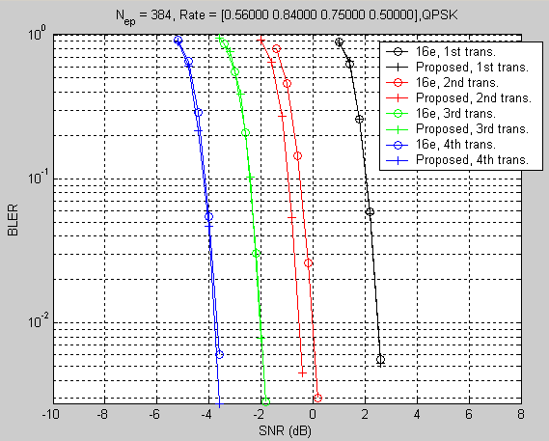
Figure 5
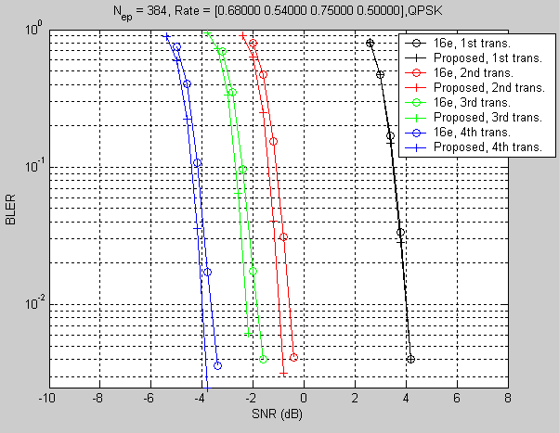
Figure 6
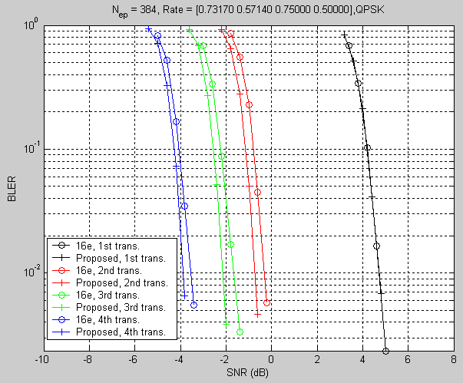
Figure 7

Conclusion
From the analysis and simulation, we find that the proposed bit selection method could improve the performance of retransmission and its implementation is very simple. So we suggest this new bit selection method should be considered by CTC IR HARQ.

Reference
[1] IEEE 802.16-08/003r6, “The Draft IEEE 802.16m System Description Document,” December 12, 2008
[2] P80216Rev2_D7, "Part 16: Air interface for fixed broadband wireless access systems," October, 2008.

Text Proposal for IEEE 802.16m Amendment Working Document
============================== Start of Proposed Text ================================
15.3.x Channel Encoding and HARQ
15.3.x.x HARQ
15.3.x.x 1 HARQ Type
Incremental redundancy Hybrid-ARQ (HARQ IR) is used in 802.16m by determining the starting position of the bit selection for HARQ retransmissions. Chase combining is supported and treated as a special case of IR.
15.3.x.x 1.1 Bit Selection
Bit selection is performed to generate the subpacket. Mother code is transmitted with one of the subpacket. The bits in a subpacket are formed by selecting specific sequence begin with the starting position from the interleaved CTC encoder output sequence. The resulting subpacket sequence is a binary sequence of bits for the modulator.

To determine the starting point, assume:
be the subpacket index. for the first transmission and increases by one for the next subpacket. when chase combining is used. When there are more than one FEC block in a burst, the subpacket index for each FEC block shall be the same.
be the number of bits in the encoder packet (before encoding).
be the number of bits in the th subpacket.
be the starting position for the th subpacket.
be the number of bits in the mother code word.

The starting position for each subpacket is defined as:
If
a) The first transmitting subpacket () starts from the beginning of mother code. The starting position for the first transmitting subpacket is
b) The second subpacket () contains the last bits of the mother code. The starting position is for the second transmitting subpacket is;
c) The third subpacket starts from the beginning of the first parity bit branch (named “Y parity bits”). The starting position is;
d) The third subpacket starts from the beginning of the second parity bit branch (named “W parity bits”). The starting position is.
Else
The starting position is randomly selected from ,,and
Endif
============================== end of Proposed Text ================================

