Project | IEEE 802.16 Broadband Wireless Access Working Group <http://ieee802.org/16>
Title | SDD Comments for the entry procedure
Date Submitted | 2009-01-06
Source(s) | Libra Xiao, Xuehuan Wang, Xiuyan Li，Lei Jin  Huawei Technologies Co., Ltd. | E-mail:  jinlei60020191@huawei.com  *<http://standards.ieee.org/faqs/affiliationFAQ.html>
Re: | Call for Comments and Contributions on Project 802.16mSystem Description Document IEEE 802.16m-08/003r6
Abstract | This contribution proposes to modify the entry procedure to make the text consistent to the result from the Security RG in session #58
Purpose | To be discussed and adopted by TGm for the 802.16m SDD.
Notice | This document does not represent the agreed views of the IEEE 802.16 Working Group or any of its subgroups. It represents only the views of the participants listed in the “Source(s)” field above. It is offered as a basis for discussion. It is not binding on the contributor(s), who reserve(s) the right to add, amend or withdraw material contained herein.
Release | The contributor grants a free, irrevocable license to the IEEE to incorporate material contained in this contribution, and any modifications thereof, in the creation of an IEEE Standards publication; to copyright in the IEEE’s name any IEEE Standards publication even though it may include portions of this contribution; and at the IEEE’s sole discretion to permit others to reproduce in whole or in part the resulting IEEE Standards publication. The contributor also acknowledges and accepts that this contribution may be made public by IEEE 802.16.
Patent Policy | The contributor is familiar with the IEEE-SA Patent Policy and Procedures:  <http://standards.ieee.org/guides/bylaws/sect6-7.html#6> and <http://standards.ieee.org/guides/opman/sect6.html#6.3>.  Further information is located at <http://standards.ieee.org/board/pat/pat-material.html> and <http://standards.ieee.org/board/pat>.
SDD Comments for the entry procedure
Libra Xiao, Xuehuan Wang, Xiuyan Li, Lei Jin
Huawei Technologies Co., Ltd.

1 Introduction
In the new SDD document, there are the description in the security as below:

“Authentication is executed during initial network entry after security capabilities and policies are negotiated. General SS capability negotiation shall be performed after authentication and authorization.”

As we know that the entry procedure has been changed under the protection condition or the security consideration, so the corresponding part in SDD document should be the same according to the result from the security RG in IEEE Session #58, namely the SBC procedure and the authentication and authorization procedure will be exchanged in resean.

2 Proposal for SDD

Modify SDD subsection 6. 2 as following.
-----------------------------------------------------Start of the Text Proposal--------------------------------------------------

6.2 Access State
The AMS performs attempts network entry with the target ABS while in the Access state. Network entry is a multi step process consisting of ranging, authentication, authorization and key exchange (security capabilities and policies negotiation), basic capability negotiation except the security, authentication and authorization, and registration. The AMS receives its Station ID and establishes at least one connection using and transitions to the Connected state. Upon failure to complete any one of the steps of network entry the AMS transitions to the Initialization state.
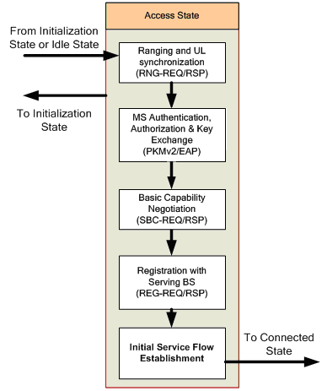
Figure 6 Access State Transition Diagram

-----------------------------------------------------End of the Text Proposal---------------------------------------------------

