Project | IEEE 802.16 Broadband Wireless Access Working Group <http://ieee802.org/16>
Title | Proposed Text of Channel Coding and HARQ for the IEEE 802.16m Amendment
Date Submitted | 2009-01-15
Source(s) | Yu-Chuan Fang, 1Zheng Yan-Xiu, Ren-Jr Chen, Chang-Lan Tsai, Chung-Lien Ho, Richard Li, Chien-Yu Kao, Cheng-Ming Chen, 3Yu-Tao Hsieh, Jen-Yuan Hsu, Pang-An Ting,  ITRI  Wern-Ho sheen, NCTU/ITRI | Voice:  ¹+886-3-5914715  ²+886-3-5917596  ³+886-3-5914854  E-mail:  ¹zhengyanxiu@itri.org.tw  ²richard929@itri.org.tw  ³ythsieh@itri.org.tw
Re | IEEE 802.16m-08/053r1, “Call for Comments and Contributions on Project 802.16m Amendment Working Document”.  Target topic: “11.13 Channel Coding and HARQ”.
Abstract | The contribution proposes the text for HARQ bit-rearrangement
Purpose | To be discussed and adopted by TGm for the 802.16m amendment.
Notice | This document does not represent the agreed views of the IEEE 802.16 Working Group or any of its subgroups. It represents only the views of the participants listed in the “Source(s)” field above. It is offered as a basis for discussion. It is not binding on the contributor(s), who reserve(s) the right to add, amend or withdraw material contained herein.
Release | The contributor grants a free, irrevocable license to the IEEE to incorporate material contained in this contribution, and any modifications thereof, in the creation of an IEEE Standards publication; to copyright in the IEEE’s name any IEEE Standards publication even though it may include portions of this contribution; and at the IEEE’s sole discretion to permit others to reproduce in whole or in part the resulting IEEE Standards publication. The contributor also acknowledges and accepts that this contribution may be made public by IEEE 802.16.
Patent Policy | The contributor is familiar with the IEEE-SA Patent Policy and Procedures:  <http://standards.ieee.org/guides/bylaws/sect6-7.html#6> and <http://standards.ieee.org/guides/opman/sect6.html#6.3>.  Further information is located at <http://standards.ieee.org/board/pat/pat-material.html> and <http://standards.ieee.org/board/pat>.
Proposed Text of Channel Coding and HARQ
for the IEEE 802.16m Amendment

Yu-Chuan Fang, Zheng Yan-Xiu, Ren-Jr Chen, Chang-Lan Tsai, Chung-Lien Ho, Richard Li,
Chien-Yu Kao, Cheng-Ming Chen Yu-Tao Hsieh, Jen-Yuan Hsu, Pang-An Ting,
ITRI

Wern-Ho sheen, NCTU/ITRI
ITRI

- Introduction
The contribution proposes the text of bit re-arrangement to be included in the 802.16m amendment. The proposed text is developed so that it can be readily combined with IEEE P802.16 Rev2/D7 [1], it is compliant to the 802.16m SRD [2] and it follows the style and format guidelines in [3]. In section 11.13.2.2 of [4], bit re-arrangement includes a bit-level interleaver and an inverter. Referring to [5,6,7,8], a scheme of a simple bit circular shifter with bit-priority mapping and a bit inverter is proposed for the bit re-arrangement. For chase combining (CC) mode, the bit circular shifter and inverter change the bit positions and bit reliabilities of a subpacket transmitted previously for retransmissions. Besides, the bit-priority mapping can improve the error rate of initial transmission and overall throughput. For incremental redundancy (IR) mode, the bit-priority mapping can protect relative significant bits in different redundancy versions more robustly and bit circular shifter can interleave the selected coded bits to achieve more diversity gain.

- Motivation

In the legacy transmitter the CTC encoder encodes N_{EP} bits to generate a codeword of 3×N_{EP} coded bits. After the interleaver and the bit selection including puncturing or repetition, a subpacket is formed and then fed into the modulator. The bit selection may product several subpackets as redundancy versions for retransmission. While receiving a NACK, the transmitter retransmits the subpacket or another subpacket of the codeword to enhance the decoding ability. However, it does not satisfy the requirement of better system performance and higher throughput. The bit rearrangement can help arrange coded bits by several BitRe versions to obtain diversity gain. Fig. 1 illustrates the transmitter with the bit rearrangement block. Through the bit selection and bit rearrangement the transmitter may make several versions of subpackets.

Fig. 1 An illustration of the transmitter with bit rearrangement

In order to improve the system performance, the diversity gain deserves attention for the bit re-arrangement. We introduce several familiar diversities.
- Constellation diversity:
The bits have different reliabilities on some constellations. Taking 16-QAM for example, four bits, , are mapping into a position on the constellation to form a 16-QAM symbol. and modulate the in-phase carrier and and modulate the quadrature carrier. Bits and respectively modulate the phases of the in-phase and quadrature carriers. In particular, the phase is 0° when or is 0 and 180° when or is 1. Bits and respectively modulate the amplitudes of the in-phase and quadrature carriers, where the amplitude is greater when or is 1 than otherwise. Thus, and have higher reliabilities than and . The diversity occurs due to different reliabilities.
- Frequency diversity:
After the modulation, the modulation symbols may be allocated into the resource units with different subcarrier indices. Over the fading channel, the bits at different subcarrier indices should suffer from different fading, as generates diversity.
- Antenna diversity:
While multiple antennas are used, the coded bits are separated into several streams. Different channels may cause different effects on the bits.

The bit rearrangement should have two properties to take advantage of diversities, which are introduced as follows.
- Bit-priority mapping:
The coded bits may be given different priority according to their relative significance, such as systematic or parity bits. More significant bits should be protected more robustly to improve the decoding performance. Therefore, more significant bits may be mapped into more reliable positions on the constellation, or mapped into streams passing better channels. The distribution of priority may change for multiple transmissions of a codeword. Especially, the bit-priority mapping can provide benefit at the initial transmission.
- Averaging reliability:
If some specific bits are always given the highest priority at multiple retransmissions, the performance improvement would degrade. Thus, we let the bits exchange the priorities or reliabilities, i.e. the bit with higher/lower reliability at previous transmission is given lower/higher reliability at current transmission. After several transmissions, the bit reliability seems to be averaged.
In the next section we propose a bit re-arrangement method which utilizes the bit-level interleaver and bit inverter to achieve the properties and advantage mentioned above.

- Proposed bit re-arrangement method
The proposed bit rearrangement method comprises the bit-level interleaver and bit inverter. For convenience of introduction the bit-level interleaver is separated into two blocks, bit-priority mapper and circular shifter. Thus, the block diagram shown in Fig. 2 has three function blocks, bit-priority mapper, circular shifter and bit inverter. The bit rearrangement for CC-HARQ and IR-HARQ modes are respectively introduced in two sections and its operations are also described in the sub-clauses.
Fig. 2 An illustration of the bit rearrangement method

The parameters are defined as follows.

3.1 CC-HARQ mode

3.1.1 Bit-priority mapper
After the bit selection, the coded bits are divided into two groups for 16-QAM and three groups for 64-QAM, and then the more/less significant bits are mapped to more/less reliable positions on the constellation as shown in Fig. 3. The coded bits of the subpacket at the initial transmission comprises systematic and parity parts, which are respectively regarded as the more and less significant parts. Assume the input is and the output is .
Let the new address is denoted as BPM.
.
Then, . Note that is used at the initial transmission.
Fig. 3 Bit-priority mapping (a) for 16-QAM (b) for 64-QAM

3.1.2 Bit circular shifter
For retransmission, the bit sequence based on priority is shifted rightward by a shift value to obtain , and then is fed into the next block. Or, we can circularly access the bit sequence from the new initial index given by the shift value to obtain . The circular shift may change the bit reliability on the constellation, the corresponding subcarrier indices or the stream allocation to achieve diversity gain.
Taking 16-QAM case for example, the shift value can be controlled by two parameters, q₁ and q₂, and can be represented as the function of them, such as . q₁ determines the subcarrier (or frequency) index and q₂ determines the bit reliability on the constellation and antenna. Fig. 4 illustrates this example on condition of 16QAM. If a bit is located at different subcarriers at different transmissions, it may suffer from different fading. That could decrease the probability of invariant bad fading on the bit. In Fig. 4, q₁ and q₂ are equal to zero so that no shift occurs at the initial transmission. At the second transmission q₁=2 lets the bit sequence be shift rightward about half length of the occupied subcarrier indices and q₂=2 lets the bit sequence be shifted two units more across the original modulation symbols to obtain antenna diversity while multiple antennas are used. At the third transmission q₁=3 lets the bit sequence be shifted rightward about three-fourths length of the occupied subcarrier indices and q₂=1 lets the bit sequence be shifted one unit more to change the bit reliability on the constellation. At the fourth transmission q₁=1 lets the bit sequence be shifted rightward about one-fourth length of the occupied subcarrier indices and q₂=1 lets the bit sequence be shifted one unit more to change the bit reliability. represents the logically inverting of x. At the second and third transmissions, some bits are logically inverted to change the positions on the constellation, as will be introduced in the next section.
Fig. 4 An illustration of the circular shift for 16-QAM and CC-HARQ case

The shift value is calculated by the following equations.
,
where q₁ and q₂ can be referred to Table 1.

Table 1 The bit re-arrangement parameters for CC-HARQ
Modulation | mod 4 |  |  | Invert pattern
QPSK | 0 | 0 | 0 | None
QPSK | 1 | 2 | 2 | None
QPSK | 2 | 3 | 0 | None
QPSK | 3 | 1 | 2 | None
Modulation | mod 4 |  |  | Invert pattern
16-QAM | 0 | 0 | 0 | None
16-QAM | 1 | 2 | 2 | [0 1]
16-QAM | 2 | 3 | 1 | [0 1]
16-QAM | 3 | 1 | 1 | None
Modulation | mod 6 |  |  | Invert pattern
64-QAM | 0 | 0 | 0 | None
64-QAM | 1 | 2 | 3 | [0 1 1]
64-QAM | 2 | 3 | 2 | None
64-QAM | 3 | 1 | 1 | None
64-QAM | 4 | 0 | 2 | [0 1 1]
64-QAM | 5 | 2 | 1 | [0 1 1]

3.1.3 Bit inverter
The bit inverter is used to scramble the bit position with lower reliability on the constellation for some BitRe versions. It logically inverts bits by an invert patterns. For 16-QAM, the invert pattern is [0 1], when mod 4 = 1 or 2, otherwise the invert pattern is none. For 64-QAM, the invert pattern is [0 1 1], when mod 6 = 1, 4 or 5, otherwise the invert pattern is none. [0 1] means the last one per two bits is needed to be inverted and [0 1 1] means the last two per three bits are needed to be inverted. In other words, [0 1] represents every two bits are exclusive-ORed by the vector [0 1] and [0 1 1] represents every three bits are exclusive-ORed with the vector [0 1 1]. Besides, none means no inverting operation. The invert pattern can be referred to Table 1.

Note that Table 1 shows four BitRe versions for QPSK and 16-QAM, and six BitRe versions for 64-QAM. However, in the later amendment draft we will suggest only first four BitRe versions for 64-QAM to keep the same signaling overhead for each modulation type.

3.2 IR-HARQ mode
3.2.1 Bit-priority mapper
Due to the different redundancy versions from bit-selection, the first N_{EP} bits of coded bits of different redundancy versions are regarded as significant bits and other coded bits are regarded as insignificant bits.
Then, the coded bits are divided into two groups for 16-QAM and three groups for 64-QAM, and the more/less significant bits are mapped to more/less reliable positions on the constellation as shown in Fig. 5.
Let the new address is denoted as BPM.
, .

Fig. 5 Bit-priority mapping (a) for 16-QAM (b) for 64-QAM

3.2.2 Bit circular shifter
For retransmission, the bit sequence is divided into two groups based on priority and shifted rightward by a shift values of different groups to obtain , and then is fed into the next block. We can obtain the shift value in accordance with which group the index belongs to and access the bit from the position with the new index . The circular shift may change the bit reliability on the constellation, the corresponding subcarrier indices or the stream allocation to achieve diversity gain. The shift value and the new index are calculated by the following equations.
Then, . Note that is coded bit sequence selected by the bit selection.

Fig. 6 An illustration of the circular shift for 16-QAM and IR-HARQ case

For IR-HARQ mode, the bit inverter is not needed.

- Simulation Results
Simulation parameters:
Carrier Frequency | 2.5GHz
FFT Size (N) | 1024
Guard Interval | 1/8
MS Velocity | Ped-B 3 km/hr
Permutation Type | RB (18X6), symbol based random permutation
Channel Coding | CTCs with 8 iterations, Max-Log-MAP
HARQ Type | Chase Combining (CC),  Incremental Redundancy (IR)
N_{EP} | Chase case: 16QAM 1/2 : 480 bits * 2 FEC (5 RBs)  64QAM 1/2 : 432 bits * 2 FEC (3 RBs)  IR case: 16QAM 1/2 : 480 bits * 2 FEC (5 RBs)  64QAM 1/2 : 288 bits * 2 FEC (2 RBs)
Transmission Times | For BLER Simulation: 1TX, 2TX, 3TX  For Throughput Simulation: Maximal Trans. = 3 (including initial trans.)
Retransmission Delay | 2 frames (10 msec)
MIMO Configuration | SM 2x2

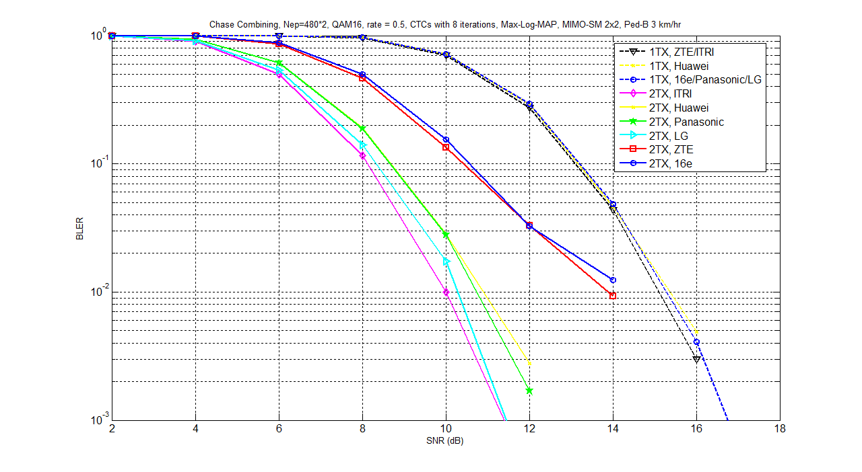
Fig.7 BLER performance for 16QAM 1/2 CC-HARQ under 1TX and 2TX
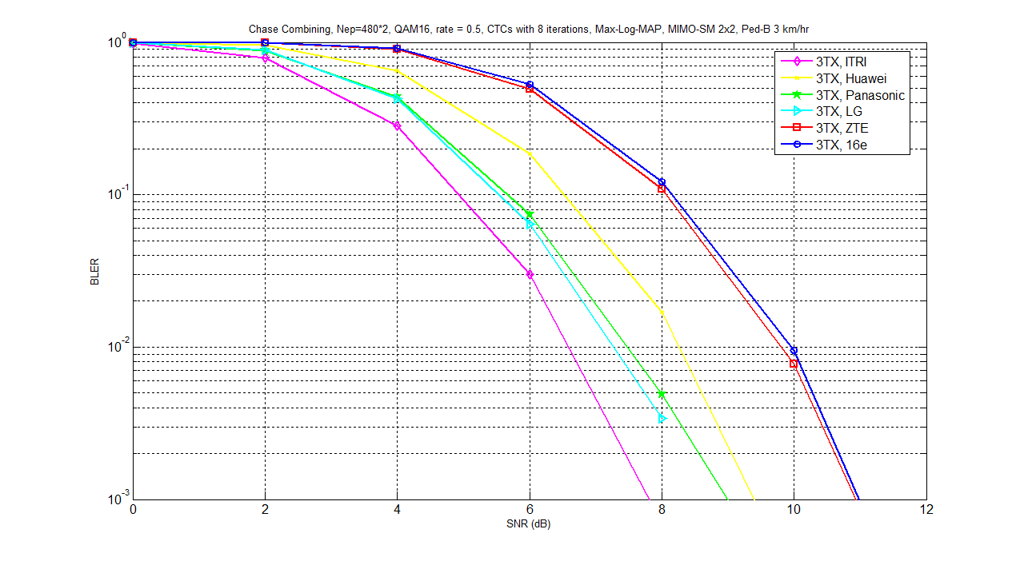
Fig.8 BLER performance for 16QAM 1/2 CC-HARQ under 3TX
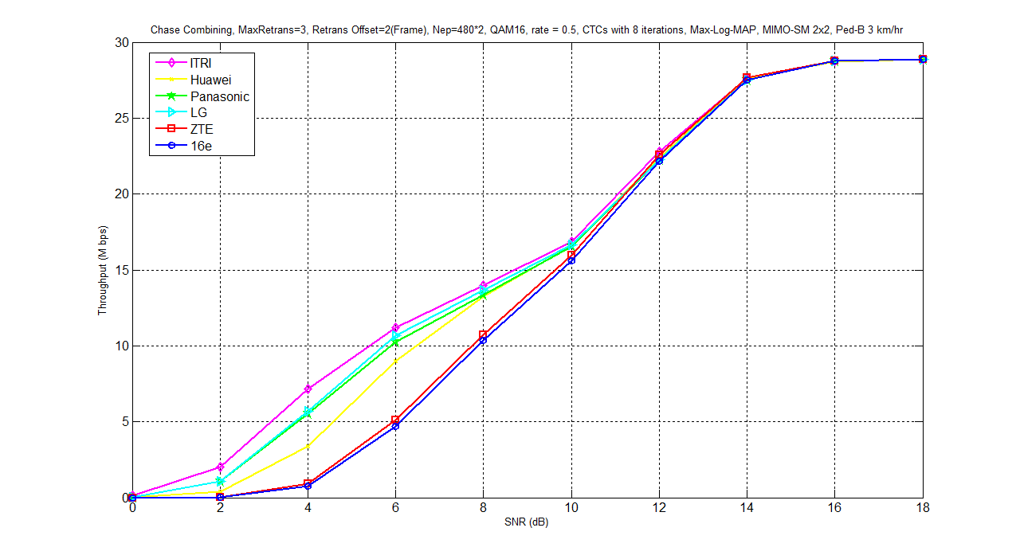
Fig.9 Throughput performance for 16QAM 1/2 CC-HARQ
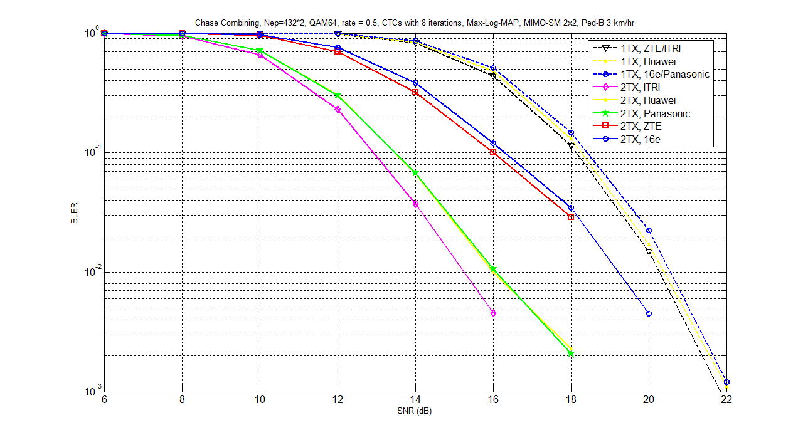
Fig.10 BLER performance for 64QAM 1/2 CC-HARQ under 1TX and 2TX
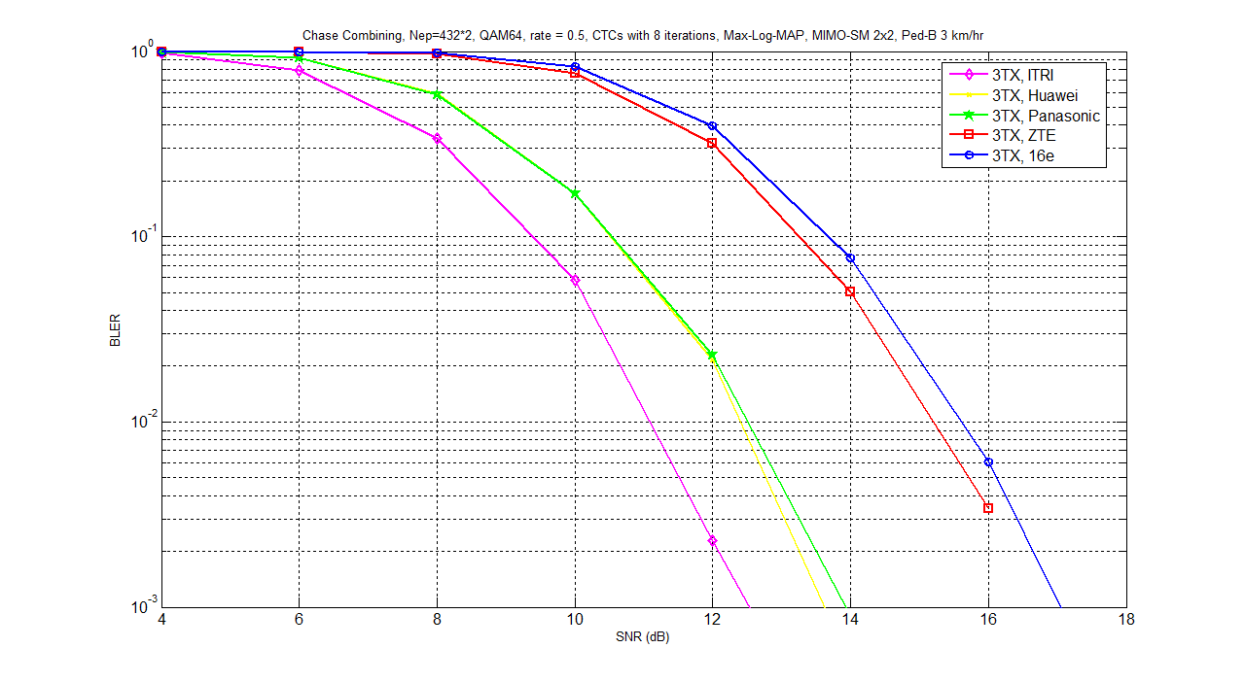
Fig.11 BLER performance for 64QAM 1/2 CC-HARQ under 3TX

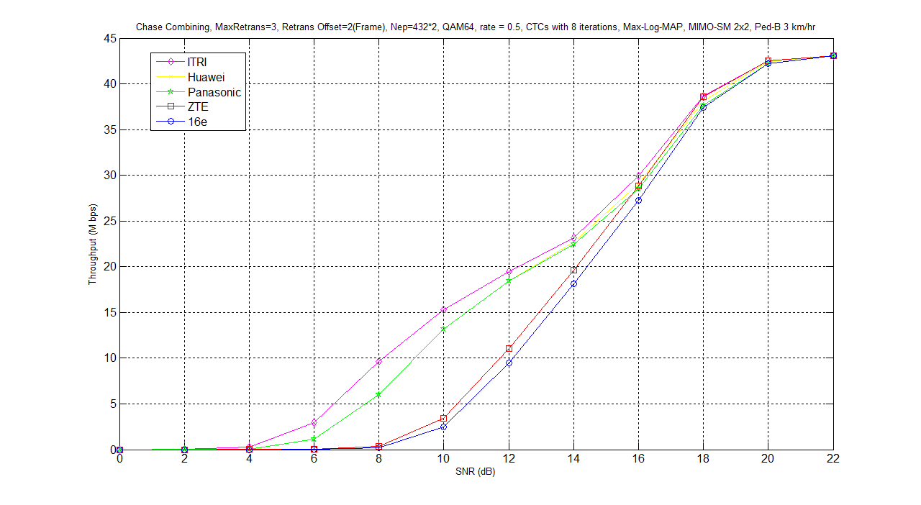
Fig.12 Throughput performance for 64QAM 1/2 CC-HARQ
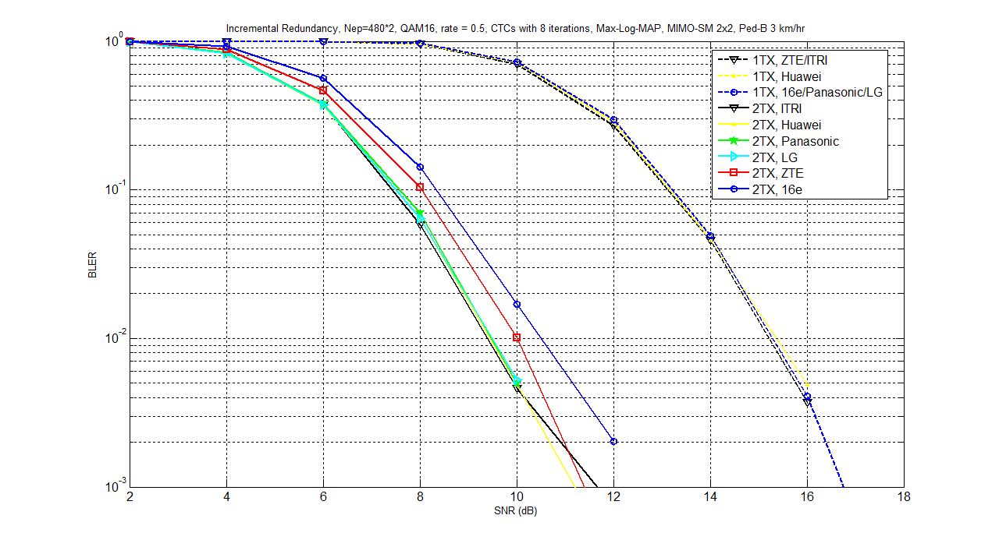
Fig.13 BLER performance for 16QAM 1/2 IR-HARQ under 1TX and 2TX

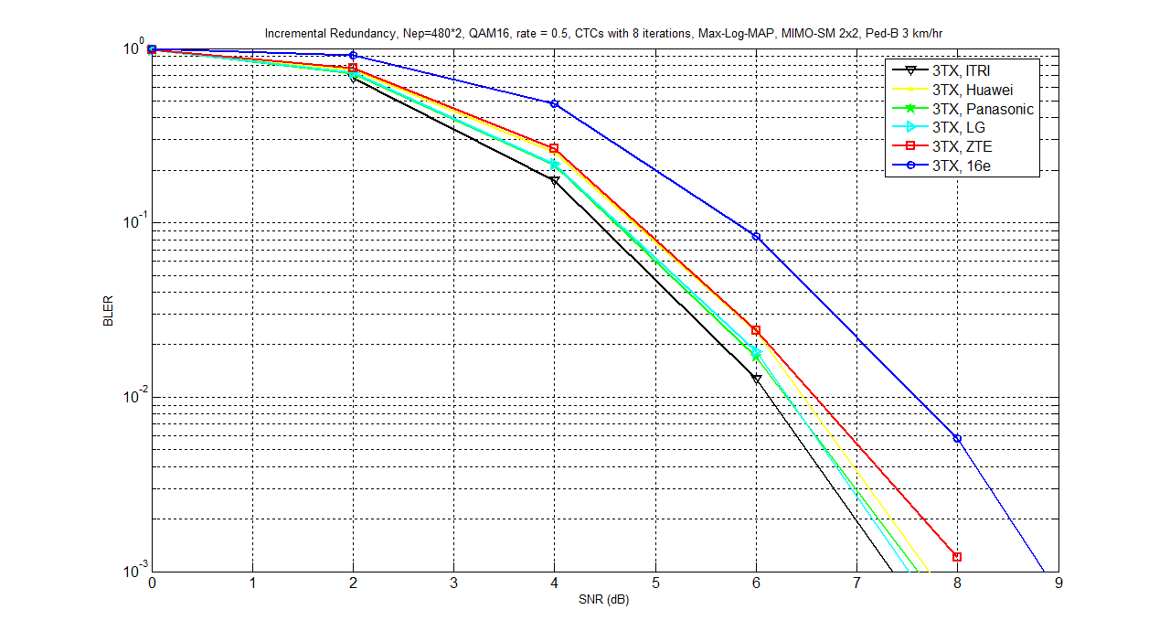
Fig.14 BLER performance for 16QAM 1/2 IR-HARQ under 3TX
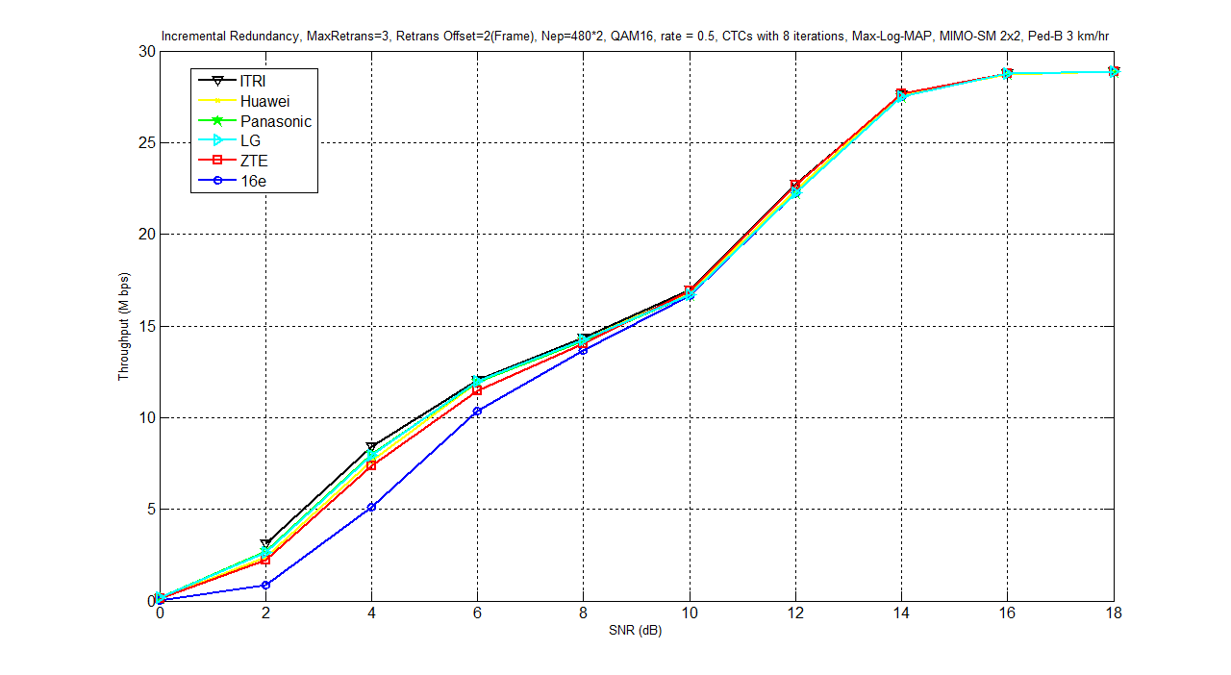
Fig.15 Throughput performance for 16QAM 1/2 IR-HARQ
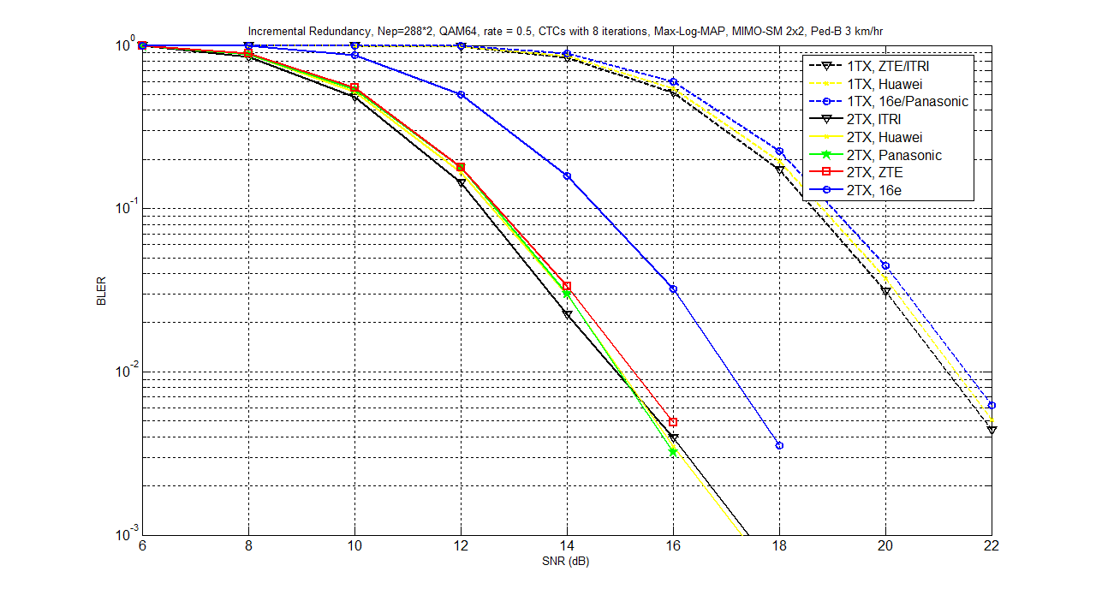
Fig.16 BLER performance for 64QAM 1/2 IR-HARQ under 1TX and 2TX
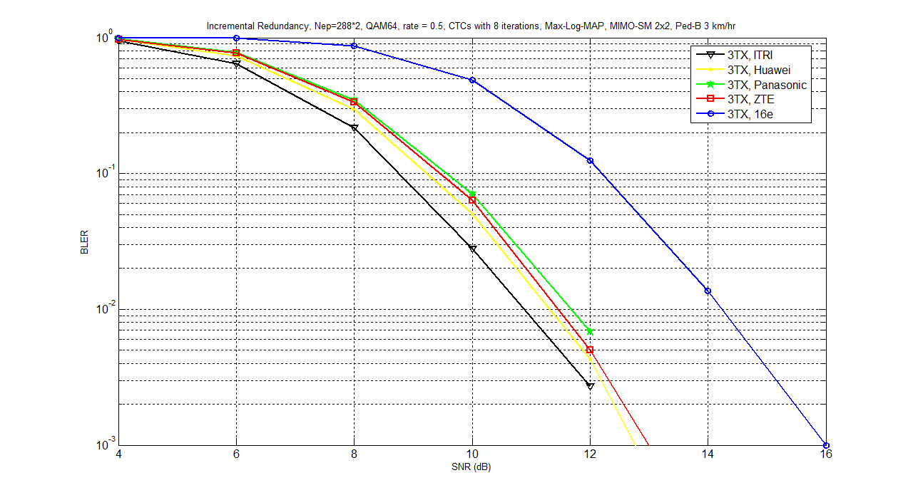
Fig.17 BLER performance for 64QAM 1/2 IR-HARQ under 3TX
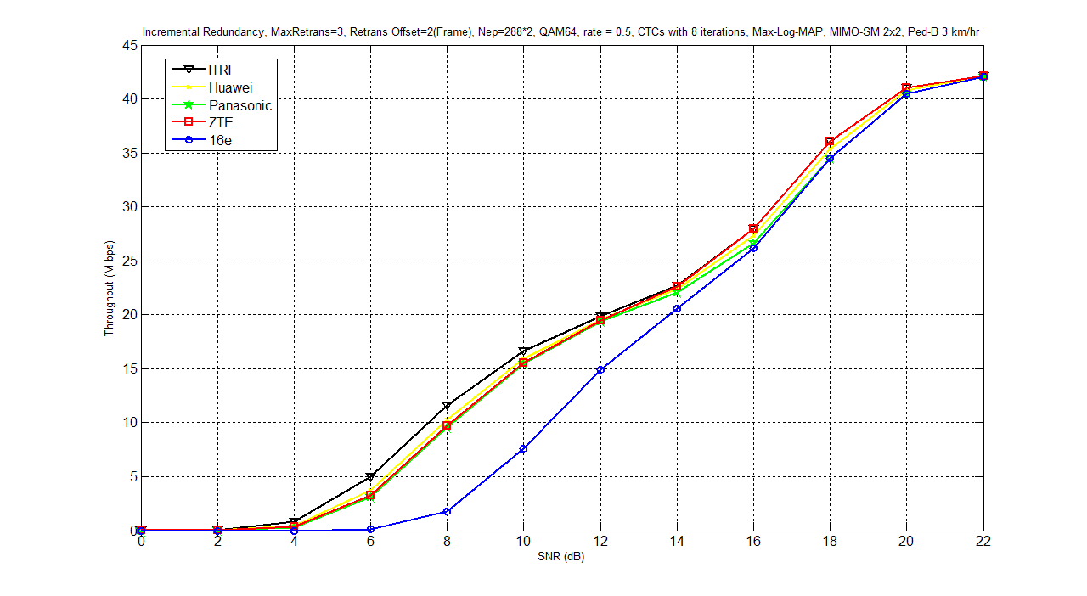
Fig.18 Throughput performance for 64QAM 1/2 IR-HARQ

- References
[1] IEEE P802.16 Rev2 / D7, “Draft IEEE Standard for Local and Metropolitan Area Networks: Air Interface
for Broadband Wireless Access,” Oct. 2008.
[2] IEEE 802.16m-07/002r6, “802.16m System Requirements”
[3] IEEE C802.16m-08/043, “Style guide for writing the IEEE 802.16m amendment”
[4] IEEE 802.16m-08/003r6, “The Draft IEEE 802.16m System Description Document”
[5] IEEE C802.16m-08/581, “The Hybrid ARQ Physical Layer Architecture.”
[6] IEEE C802.16m-08/1144r1, “New bit-rearrangement method to enhance HARQ performance.”
[7] IEEE C802.16m-08/685r2, “Bit Priority Mapping to enhance CTC IR HARQ performance.”
[8] IEEE C80216m-08_301r2, “Enhancing CTC HARQ performance by bit rearrangement.”
[9] IEEE 802.16m-08/771r1, “Enhanced HARQ scheme with Signal Constellation Rearrangement.”
[10] IEEE C80216m-07_292r1, “Enhanced HARQ technique using Constellation Rearrangement.”
- Text proposal for inclusion in the 802.16m amendment
------------------------------- Text Start ---------------------------------------------------
Insert a new section 15:
15. Advanced Air Interface
15.3 Physical layer
15.3.A Channel coding and HARQ
Figure aaa—Block diagram of channel coding supporting HARQ

15.3.A.1 Channel coding
15.3.A.1.1 Double binary turbo code
The CTC in Section 8.4.9.2.3 is adopted.
15.3.A.1.2. Bit selection
The bit selection is performed to generate the subpacket. The puncturing block is referred as bits selection in the viewpoint of subpacket generation. Mother code is transmitted with one of the subpackets. The bits of a subpacket are formed by selecting specific sequences of bits from the interleaved CTC encoder output sequence. The resulting subpacket sequence is a binary sequence of bits for the bit re-arrangement (if supporting HARQ) and the modulator. Note that Section 8.4.9.2.3.4.4 shall be not applied.
Let
k be the subpacket index when IR HARQ is enabled. k = 0 for the first transmission and increases by one for the next subpacket. k = 0 when IR-HARQ is not used. When there are more than one FEC blocks in a burst, the subpacket index for each FEC block shall be the same.
N_{EP} be the number of bits in the encoder packet (before encoding).
L_{k} be the number of bits in the subpacket.
m_{k} be the modulation order for the k-th subpacket (m_{k} = 2 for QPSK, 4 for 16-QAM, and 6 for 64-QAM).
Also, let the scrambled and selected bits be numbered from zero with the 0-th bit being the first bit in the
sequence. Then, the index of the i-th bit for the k-th subpacket shall be:
, where and .
The N_{EP}, m_{k}, and L_{k} are determined by the BS and can be inferred by the SS through the allocation size in the DL-MAP and UL-MAP. The first transmission includes the systematic part of the mother code. Thus, it can be used as the codeword for a burst where the HARQ is not applied or when Chase HARQ is applied.
Besides, for different MIMO-HARQ formats, rank should be feed back for adjusting the total number of transmitted coded bits for retransmissions. Table zzz shows the all MIMO-HARQ formats. The total transmitted coded bits may be verified according to Ri, Rr and p. The “Ri“ is the rate of the previous transmission for the subpacket. The “Rr“ is the reduced rate of retransmissions for the same subpacket. Besides, due to the rate of each retransmission may be reduced, only partial bits may be retransmitted and equivalent pilot tones may be also reduced in accordance with the reduced rate. Therefore, additional non-used pilot tones can be used to send more coded bits in current retransmission. The “p” is defined as a ratio that the number of used tones between initial transmission and each retransmission in Table zzz. Where,
Table zzz—Parameter R_{i} ,R_{r} and p for adaptive bit selection
R_{i} | R_{r} | p
1 | 1 | 1
2 | 1 | 1
2 | 2 | 1
3 | 2 | 24/23
3 | 3 | 1
4 | 2 | 24/23
4 | 3 | 1
4 | 4 | 1
If the rate of retransmissions is different from the rate of initial transmission, the index of the i-th bit for the k-th subpacket shall be:
Figure ttt-1, Figure ttt-2, and Figure ttt-3 show the different MIMO-HARQ formats with different rates between initial transmission and retransmissions.
Figure ttt-1—MIMO-HARQ with rate=2 for initial transmission and rate=1,2 for retransmission
Figure ttt-2—MIMO-HARQ with rate=3 for initial transmission and rate=2,3 for retransmission

Figure ttt-3—MIMO-HARQ with rate=4 for initial transmission and rate=2,3,4 for retransmission

15.3.A.1.3 Modulation
Gray-mapped QPSK, 16-QAM and 64-QAM shall be supported for data modulation (referring to Section 8.3.9.4.2) as shown in Fig. bbb. The constellations shall be normalized by multiplying the constellation point with the indicated factor c to achieve equal average power.
For QPSK, and respectively modulate the in-phase and quadrature carriers. For 16-QAM, four bits, , are mapping into a position on the constellation to form a 16-QAM symbol. and modulate the in-phase carrier and and modulate the quadrature carrier. Bits and respectively modulate the phases of the in-phase and quadrature carriers. In particular, the phase is 0° when or is 0 and 180° when or is 1. Bits and respectively modulate the amplitudes of the in-phase and quadrature carriers, where the amplitude is greater when or is 1 than otherwise. Thus, and have higher reliabilities than and . For 64-QAM, each modulation symbol consists of 6 bits, , where , , and modulate the in-phase carrier, and , , and modulate the quadrature carrier. With three bits modulating each carrier, the amplitude thereof is defined with a finer resolution. Particularly, and still respectively modulate the phases of the carriers, but and together modulate the amplitude of the in-phase carrier at four discrete levels, and and together modulate the amplitude of the quadrature carrier at four discrete levels. The amplitude of the in-phase carrier is the greatest when =11, is the least when =01, and has intermediate values when =10 or 00. The modulation of the quadrature carrier is similar and not explained in detail herein.
Each M interleaved bits (M = 2 for QPSK, 4 for 16-QAM, 6 for 64-QAM) shall be mapped to the constellation bits b(M – 1) – b0 in MSB-first order (i.e., the first bit shall be mapped to the higher index bit in the constellation). The interleaved bit sequence denoted as is input into the modulator and each M bits from the first bit are mapped into the constellation point with the corresponding label . For example, the corresponding modulation symbols are [-1-i, -3-i] for 16-QAM, if the input sequence is .
Figure bbb—Block diagram of channel coding supporting HARQ

15.3.A.2 HARQ
15.3.A.2.1 HARQ type
Incremental redundancy Hybrid-ARQ (IR-HARQ) and Chase Combining HARQ (CC-HARQ) are adopted. In IR-HARQ mode, the k-th subpacket generated by the bit selection in Section 15.3.A.1.2 is transmitted at the k-th transmission. k=0 is for the initial transmission. CC-HARQ retransmits the subpacket at the initial transmission.
15.3.A.2.2 Bit selection
The function of bit selection is described as that in Section 15.3.A.1.2. The subpacket is generated according to the number of transmission, HARQ mode and different MIMO-HARQ formats and then fed into the bit re-arrangement.
15.3.A.2.3 Bit re-arrangement
For HARQ (re)transmissions, the subpacket after the bit selection may be arranged according to different bit re-arrangement (BitRe) versions based on the changes of the significance and reliability of each coded bit. The bit re-arrangement comprises the bit-level interleaver and bit inverter shown as in Fig. ccc. In the bit-level interleaver the coded bits from bit-selection will be mapped to different bit reliabilities according to their significance, as is called the bit-priority mapping (BPM) method. In other words, the significant bits will be mapped to relatively more reliable positions and non-significant bits will be mapped to relatively less reliable positions. Then, the bit-level interleaver arranges bits in a simple manner—circular shift. A shift value is calculated in accordance with the selected BitRe version. Instead of really shifting bits, we utilize a circular buffer to register the coded bits after BPM and access them from the initial position which is given by the shift value. Finally, the bit inverter may logically invert some of the coded bits according to the selected BitRe version.
Figure ccc—bit re-arrangement block diagram
The procedure of the bit-level interleaver can be integrated in the following equations to obtain the new address ADD(i). The parameters are defined as
Assume the input sequence is denoted as and the output sequence is denoted as , where . ADD(i) can be calculated by the following equations.
Herein, q₁ and q₂ can be referred to Table xxx.
Table xxx The bit re-arrangement parameters for CC-HARQ
Modulation | mod 4 |  |  | Invert pattern
QPSK | 0 | 0 | 0 | None
QPSK | 1 | 2 | 2 | None
QPSK | 2 | 3 | 0 | None
QPSK | 3 | 1 | 2 | None
16-QAM | 0 | 0 | 0 | None
16-QAM | 1 | 2 | 2 | [0 1]
16-QAM | 2 | 3 | 1 | [0 1]
16-QAM | 3 | 1 | 1 | None
64-QAM | 0 | 0 | 0 | None
64-QAM | 1 | 2 | 3 | [0 1 1]
64-QAM | 2 | 3 | 2 | None
64-QAM | 3 | 1 | 1 | None

Finally the bit inverter is used to scramble the bit position with lower reliability on the constellation for some BitRe versions in the CC-HARQ mode. It logically inverts bits by an invert patterns. For 16-QAM, the invert pattern is [0 1], when mod 4 = 1 or 2, otherwise the invert pattern is none. For 64-QAM, the invert pattern is [0 1 1], when mod 4 = 1, otherwise the invert pattern is none. [0 1] means the last one per two bits is needed to be inverted and [0 1 1] means the last two per three bits are needed to be inverted. In other words, [0 1] represents every two bits are exclusive-ORed by the vector [0 1] and [0 1 1] represents every three bits are exclusive-ORed with the vector [0 1 1]. Besides, none means no inverting operation. The invert pattern can be referred to Table xxx. It is noted that the bit inverter is not applied in the IR-HARQ mode.
After all, the rearranged coded bits will be fed into the modulator.
15.3.A.2.4 SU-MIMO Mode Switch
The dynamic or semi-dynamic rank is fed back for enhancing the reliability of retransmission. The retransmitted MIMO Mode is switched based on the relation of R_{i} and R_{r}. Table kkk lists the relation of SU-MIMO Mode Switching Rule.
Table kkk—MIMO Mode HARQ Switching Table A
R_{i} | R_{r}
Rank 1 SISO + precoding  or  Rank 1 SFBC + precoding | Rank 1 SISO + precoding  or  Rank 1 SFBC + precoding
Rank 2 SM +precoding | Rank 1 SFBC + precoding
Rank 2 SM + precoding | Rank 2 SM + precoding
Rank 3 SM + precoding | Rank 2 SM + precoding
Rank 3 SM + precoding | Rank 3 SM + precoding
Rank 4 SM + precoding | Rank 2 SM + precoding
Rank 4 SM + precoding | Rank 3 SM + precoding
Rank 4 SM + precoding | Rank 4 SM + precoding
15.3.A.2.5 MU-MIMO Mode Switch
In the Multi-User MIMO mode, only the k users who reported a NACK will ask for retransmission. Hence, the data transmitted to M users in the previous transmission may retransmit to only k users. Each user who transmits a NACK may retransmit with k user with 1 stream. However, if only one user reported with a NACK message, the MU-MIMO Mode should be switched to SU-MIMO mode, and the retransmitted stream number may grow according to SU-MIMO rank. If ABS transmits with N_{t}=8 and each AMS equips with N_{r}=4 or N_{r}=2, the retransmitted combination is listed in Table uuu.
Table sss—MU-MIMO switch to SU-MIMO HARQ Switching A
N_{t} | N_{r} | Rank for NACK user | SU-MIMO Mode
8 | 4 | 4 | Rank 4 SM + precoding
8 | 4 | 3 | Rank 3 SM + precoding
8 | 2/4 | 2 | Rank 2 SM + precoding
8 | 2/4 | 1 | Rank 1 SFBC + precoding
If ABS transmits with N_{t}=4 and each AMS equips with N_{r}=4 or N_{r}=2, the retransmitted combination is listed in Table uuu.
Table uuu—MU-MIMO HARQ Switching B
N_{t} | N_{r} | Rank for NACK user | SU-MIMO Mode
4 | 4 | 4 | Rank 4 SM + precoding
4 | 4 | 3 | Rank 3 SM + precoding
4 | 2/4 | 2 | Rank 2 SM + precoding
4 | 2/4 | 1 | Rank 1 SFBC + precoding
If ABS transmits with N_{t}=2 and each AMS equips with N_{r}=4 or N_{r}=2, the retransmitted combination is listed in Table vvv.
Table vvv—MU-MIMO HARQ Switching C
N_{t} | N_{r} | NACK Users k | Each user received rate
2 | 2/4 | 2 | Rank 2 SM + precoding
2 | 2/4 | 1 | Rank 1 SFBC + precoding

------------------------------- Text End --------------------------------------------------------------------------

