04
Project | IEEE 802.16 Broadband Wireless Access Working Group <http://ieee802.org/16>
Title | Proposed Text Related to Synchronization Channel Section for the IEEE 802.16m Amendment
Date Submitted | 2009-01-12
Source(s) | Zheng Yan-Xiu, Tsung-Pao Chen, Yu-Tao Hsieh, Pang-An Ting, Richard Li  ITRI | Voice :  E-mail: zhengyanxiu@itri.org.tw
Re: | IEEE 802.16m-08/053r1, “Call for Comments and Contributions on Project 802.16m Amendment Working Document”
Abstract | This contribution proposes the text of synchronization channel section for the 802.16m amendment.
Purpose | Propose to be discussed and adopted by TGm for the 802.16m amendment
Notice | This document does not represent the agreed views of the IEEE 802.16 Working Group or any of its subgroups. It represents only the views of the participants listed in the “Source(s)” field above. It is offered as a basis for discussion. It is not binding on the contributor(s), who reserve(s) the right to add, amend or withdraw material contained herein.
Release | The contributor grants a free, irrevocable license to the IEEE to incorporate material contained in this contribution, and any modifications thereof, in the creation of an IEEE Standards publication; to copyright in the IEEE’s name any IEEE Standards publication even though it may include portions of this contribution; and at the IEEE’s sole discretion to permit others to reproduce in whole or in part the resulting IEEE Standards publication. The contributor also acknowledges and accepts that this contribution may be made public by IEEE 802.16.
Patent Policy | The contributor is familiar with the IEEE-SA Patent Policy and Procedures:  <http://standards.ieee.org/guides/bylaws/sect6-7.html#6> and <http://standards.ieee.org/guides/opman/sect6.html#6.3>.  Further information is located at <http://standards.ieee.org/board/pat/pat-material.html> and <http://standards.ieee.org/board/pat>.

Proposed Text Related to Synchronization Channel Section for the IEEE 802.16m Amendment

Zheng Yan-Xiu, Tsung-Pao Chen, Yu-Tao Hsieh, Pang-An Ting, Richard Li
ITRI

Introduction
The proposed text for the synchronization channel (SCH) sections in the IEEE 802.16m Amendment is included in this contribution.

Proposed Descriptions

2.1. Index mapping of P-SCH
The index used for the P-SCH sequence is defined in Table X-1. According to the SDD, Primary synchronization channel (P-SCH) should contain partial cell ID information and limited signaling, and a complete cell ID should be transmitted in Secondary synchronization channel (S-SCH).
The BS type and sector information are discussed as a part of cell ID information, and system bandwidth and carrier information are considered as limited signaling.

Table 1 P-SCH sequence index.
$${\text{ID}}_{P−\text{SCH}}$$ | Segment | BS type | Bandwidth | Carrier type
0 | 0 | Macro | 512-FFT | Fully-configured
1 | 1 | Macro | 512-FFT | Fully-configured
2 | 2 | Macro | 512-FFT | Fully-configured
3 | 0 | Macro | 1024-FFT | Fully-configured
4 | 1 | Macro | 1024-FFT | Fully-configured
5 | 2 | Macro | 1024-FFT | Fully-configured
6 | 0 | Macro | 2048-FFT | Fully-configured
7 | 1 | Macro | 2048-FFT | Fully-configured
8 | 2 | Macro | 2048-FFT | Fully-configured
9 | N/A | CSG Femto | N/A | Fully-configured
10 | N/A | OSG Femto | N/A | Fully-configured
11 | N/A | Macro/Femto | N/A | Partially-configured

2.2. Proposed Synchronization Channel Architecture
The proposed SCH architecture includes P-SCH and S-SCH. The superframe timing synchronization, radio frame timing synchronization, and some system information are obtained in P-SCH. S-SCH is responsible for radio frame timing synchronization and a complete cell ID information. Figure 1 shows the proposed SCH architecture.

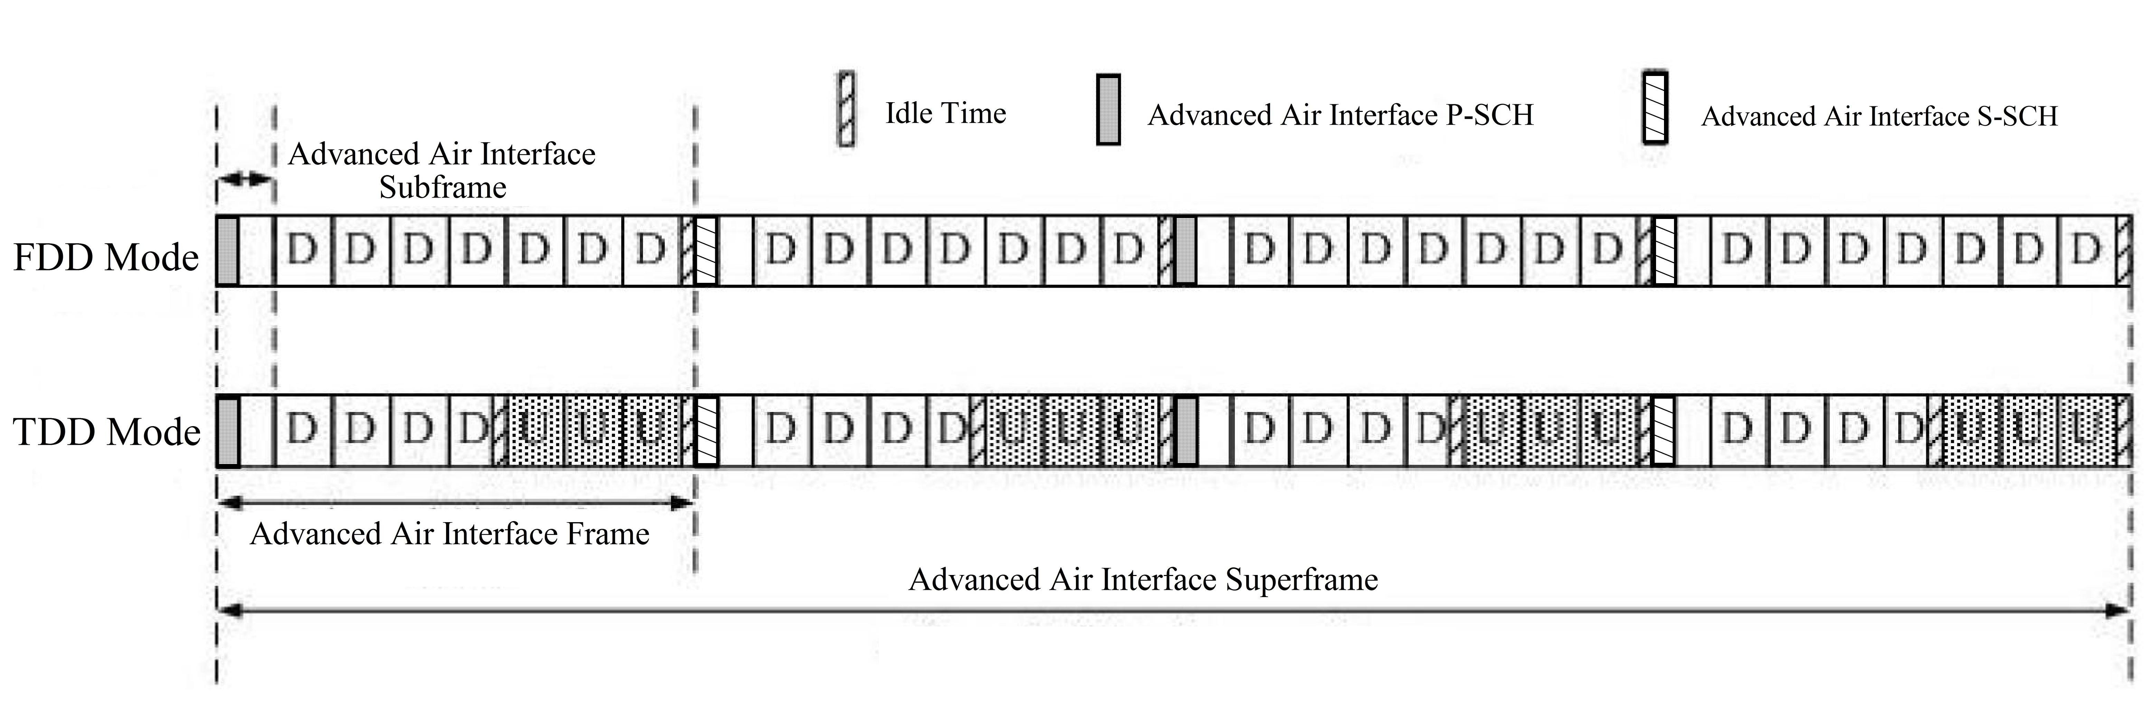
Figure 1 SCH architecture for 16m-only mode

Text proposal for the 802.16m amendment

============================== Start of Proposed Text =================================
[Adopt the following modifications:]

15.3.7 DL Control Structure

15.3.7.1 DL Control Information Classification

15.3.7.2 Transmission of DL Control Information

15.3.7.2.1 Synchronization Channel (SCH)

The synchronization channel (SCH) is a DL physical channel which provides a reference signal for time, frequency, and frame synchronization, RSSI estimation, channel estimation, and BS identification.

The synchronization channel is hierarchical structure composed of primary synchronization channel (P-SCH) and secondary synchronization channel (S-SCH).

The P-SCH transmits one of [12] unique identifications to support the acquisition of physical cell/sector identifications transmitted in S-SCH. The S-SCH transmits one of [512] complete physical cell/sector identifications.

There are 4 OFDM symbols located for P-/S-SCH in a single superframe as shown in Figure X-1. The P-SCH shall be transmitted in the first and third radio frame, and the S-SCH shall be located in the second the fourth radio frame of the superframe. Each P-SCH and S-SCH symbol is located in the first DL subframe of the frame and occupies the [TBD]-th symbol position within a subframe.
Figure X-1 Transmission of SCH symbols

15.3.7.2.1.1 Primary Synchronization Channel (P-SCH)

The P-SCH is used for symbol synchronization, frame synchronization, bandwidth identification, sector identification, partially configurable carrier identification, cell type identification.

15.3.7.2.1.1.1 P-SCH Modulation Series

The P-SCH identifies sector, BS type, system bandwidth, and carrier information. [Note: The section 15.3.X.Y should include modulation and power boosting of P-SCH.]

The index used for the P-SCH sequences is defined in Table X-1.

Table X-1 P-SCH sequence index.
$${\text{ID}}_{P−\text{SCH}}$$ | Segment | BS type | Bandwidth | Carrier type
0 | 0 | Macro | 512-FFT | Fully-configured
1 | 1 | Macro | 512-FFT | Fully-configured
2 | 2 | Macro | 512-FFT | Fully-configured
3 | 0 | Macro | 1024-FFT | Fully-configured
4 | 1 | Macro | 1024-FFT | Fully-configured
5 | 2 | Macro | 1024-FFT | Fully-configured
6 | 0 | Macro | 2048-FFT | Fully-configured
7 | 1 | Macro | 2048-FFT | Fully-configured
8 | 2 | Macro | 2048-FFT | Fully-configured
9 | N/A | CSG Femto | N/A | Fully-configured
10 | N/A | OSG Femto | N/A | Fully-configured
11 | N/A | Macro/Femto | N/A | Partially-configured

15.3.7.2.1.1.2 Transmission (Mapping) of P-SCH series

The PCH sequence is located at the center frequency of a carrier and the bandwidth is 5 MHz. In time domain, the P-SCH symbol has two repeated waveforms. In frequency domain, the P-SCH sequence is placed on [odd|even] subcarriers. The subcarriers on the guardband carry null symbols.

============================== End of Proposed Text =================================

