Project | IEEE 802.16 Broadband Wireless Access Working Group <http://ieee802.org/16>
Title | Frame Structure for a System Bandwidth of 8.75 MHz
Date Submitted | 2009-01-07
Source(s) | Sungho Moon, Jin Sam Kwak  LG Electronics | Voice : +82-31-450-1852  E-mail: msungho@lge.com
Re: | Re: IEEE 802.16m-08/053r1, “Call for Comments and Contributions on Project 802.16m Amendment Working Document”
Abstract | The contribution proposes the text of frame structure section to be included in the 802.16m amendment.
Purpose | To be discussed and adopted by TGm for the 802.16m amendment.
Notice | This document does not represent the agreed views of the IEEE 802.16 Working Group or any of its subgroups. It represents only the views of the participants listed in the “Source(s)” field above. It is offered as a basis for discussion. It is not binding on the contributor(s), who reserve(s) the right to add, amend or withdraw material contained herein.
Release | The contributor grants a free, irrevocable license to the IEEE to incorporate material contained in this contribution, and any modifications thereof, in the creation of an IEEE Standards publication; to copyright in the IEEE’s name any IEEE Standards publication even though it may include portions of this contribution; and at the IEEE’s sole discretion to permit others to reproduce in whole or in part the resulting IEEE Standards publication. The contributor also acknowledges and accepts that this contribution may be made public by IEEE 802.16.
Patent Policy | The contributor is familiar with the IEEE-SA Patent Policy and Procedures:  <http://standards.ieee.org/guides/bylaws/sect6-7.html#6> and <http://standards.ieee.org/guides/opman/sect6.html#6.3>.  Further information is located at <http://standards.ieee.org/board/pat/pat-material.html> and <http://standards.ieee.org/board/pat>.

Frame Structure for a System Bandwidth of 8.75 MHz
Sungho Moon, Jin Sam Kwak
LG Electronics

Introduction

This contribution includes the proposed text for the frame structure section in the IEEE 802.16m Amendment. The technical text is inherited from the 802.16m SRD [1], the IEEE 802.16m SDD [2], and the IEEE P802.16 Rev2/D7 [3]. Moreover, this contribution follows the tentative outline and style guide in the IEEE 802.16m Amendment [4]. In this contribution, amendment text including several illustrations is proposed for the section in which 16m members have enough consensus.

Proposed Frame Structure for the 8.75MHz bandwidth

4.1 OFDMA parameters
Table I shows the current OFDMA parameters included in the amendment text [5]. The [TBD] fields in the bandwidth of 8.75 MHz and G=1/16 are modified into detailed values for defining a frame structure of 8.75 MHz.
Table I – OFDMA parameters
The nominal channel bandwidth, BW (MHz) |  | 5 | 7 | 8.75 | 10 | 20
Sampling factor, $n$ |  | 28/25 | 8/7 | 8/7 | 28/25 | 28/25
Sampling frequency, $F_{s}$ (MHz) |  | 5.6 | 8 | 10 | 11.2 | 22.4
FFT size, $N_{\text{FFT}}$ |  | 512 | 1024 | 1024 | 1024 | 2048
Subcarrier spacing, $Δf$(kHz) |  | 10.94 | 7.81 | 9.77 | 10.94 | 10.94
Useful symbol time, $T_{b}$ (us) |  | 91.4 | 128 | 102.4 | 91.4 | 91.4
CP ratio, G = 1/8 | OFDMA symbol time, $T_{s}$ (us) | 102.82 | 144 | 115.2 | 102.82 | 102.82
CP ratio, G = 1/8 | Number of OFDMA symbols  per 5ms frame | 48 | 34 | 43 | 48 | 48
CP ratio, G = 1/8 | Idle time (us) | 62.86 | 104 | 46.40 | 62.86 | 62.86
CP ratio, G = 1/16 | OFDMA symbol time, $T_{s}$ (us) | 97.143 | [TBD] | 108.8 | 97.143 | 97.143
CP ratio, G = 1/16 | FDD  Number of OFDMA symbols per 5ms frame | 51 | [TBD] | 45 | 51 | 51
CP ratio, G = 1/16 | Idle time (us) | 45.71 | [TBD] | 104 | 45.71 | 45.71

4.2 Design Criteria

In the current SDD and amendmet text, two types of subframes have been defined, i.e., type-1 with 6 symbols and type-2 with 7 symbols. In addition, there is a short type of subframe to accommodate a gap between DL and UL. Therefore, the main rule of our design is to use these subframe types to define a new frame structure of 8.75 MHz. A new subframe type like 3 symbol subframe or 9 symbol subframe should be avoided to reduce a burden to design a new PHY structure. Here are our design criteria:

- A new frame structure should be designed by type-1 and type-2 subframes, and if necessary, one short type of subframe can be used in TDD.
- New subframe type definitions should be avoided to reduce a burden PHY design.
- Type-1 subframes should be utilized in a frame as many as possible since it is a default subframe type optimized in a PHY design.
- There should be commonalities between TDD and FDD.
- The switching point of TDD frame structure having a CP length of 1/16 T_{b} should be aligned with that of the 16m system with a CP length of 1/8 T_{b}.

4.3 Frame structure for CP = 1/8 T_{b}

Since there are 43 OFMDA symbols for CP = 1/8 T_{b}, seven type-1 subframes can be defined within a TDD frame. One remaining OFDMA symbol could be used for TTG and RTG durations.

Figure 1 shows examples of the proposed TDD and FDD frame structures. In TDD, all subframes are type-1 subframe with a TTG of 87.2 us and a RTG of 74.4 us, which are exactly the same as those in the WiMAX profile. The FDD frame structure has a commonality with the TDD frame structure in the number of subframes, and six subframes can be configured as the type-1 subframe, and one subframe should be configured as the type-2 subframe with 7 OFDMA symbols. The location of the type-2 subframe is FFS.

Figure 1 Examples of TDD and FDD Frame Structures with a CP of 1/8 Tb

4.4 Frame structure for CP = 1/16 T_{b}

For a CP length of 1/16 T_{b}, the switching point alignment with the legacy or the 16m system with a CP length of 1/8 T_{b} should be one of the important design criteria due to the DL and UL interference problem in a TDD mode. Moreover, the proposed frame structure should have a commonality with those of 5, 10, and 20 MHz.

For nominal channel bandwidths of 5, 10, and 20 MHz, a frame has five type-1 subframes and three type-2 subframes from 51 OFDMA symbols according to 15.3.5. In each TDD frame, the last one OFDMA symbol in a type-2 subframe is an idle symbol, which is used to accommodate the gap required to switch from DL to UL. Each FDD frame has have five type-1 subframes and three type-2 subframes, and each TDD frame should have six type-1 subframes and two type-1 subframes.

Here, we propose TDD and FDD frame structures not only allowing the coexistence with the legacy and the 16m systems operating with a CP length of 1/8 Tb, but also having a commonality of subframe configurations.
In TDD, two type-2 subframes should be located in DL and UL region separately, and the last one OFDMA symbols in another type-2 subframe is an idle symbol, which is the same as those of 5, 10, 20 MHz bandwidth cases. All other DL/UL ratio cases, i.e., (2:5), (3:4), (5:2), and (6:1) can satisfy the coexistence with the 16m systems operating with a CP length of 1/8 Tb. In the FDD frame, there exists an additional type-2 subframe, and the location of this subframe is FFS.
Figure 1 Examples of TDD and FDD Frame Structures with a CP of 1/16 Tb

References
[1] IEEE 802.16m-07/002r4, “802.16m System Requirements.”
[2] IEEE 802.16m-08/003r6, “The Draft IEEE 802.16m System Description Document.”
[3] IEEE P802.16 Rev2/D7, “Draft IEEE Standard for Local and Metropolitan Area Networks: Air Interface
for Broadband Wireless Access,” Oct. 2008.
[4] IEEE 802.16m-08/043, “Style guide for writing the IEEE 802.16m amendment.”
[5] IEEE 802.16m-08/050, “IEEE 802.16m Amendment Working Document.”

Text proposal for the 802.16m amendment

============================== Start of Proposed Text =================================
[Adopt the following modifications:]
15.3.3.2 Frame structure for CP = 1/8 Tb
15.3.3.2.1 FDD frame structure

A BS supporting FDD mode shall be able to simultaneously support half duplex and full duplex MSs operating on the same RF carrier. The MS supporting FDD mode shall use either H-FDD or FDD.

The FDD frame shall be constructed on the basis of the basic frame structure defined in 15.3.3.1. In each frame, all subframes are available for both DL and UL transmissions. The DL and UL transmissions are separated in the frequency domain.

FDD MS is able to receive data burst in any DL subframe while accessing UL subframe at the same time. For H-FDD MS, only one of transmission and reception is allowed in each subframe.

The idle time specified in Table 1 shall be placed at the end of each FDD frame as shown in Figure 4.

Figure 390 illustrates an example FDD frame structure, which is applicable to the nominal channel bandwidth of 5, 10, and 20 MHz with G = 1/8.
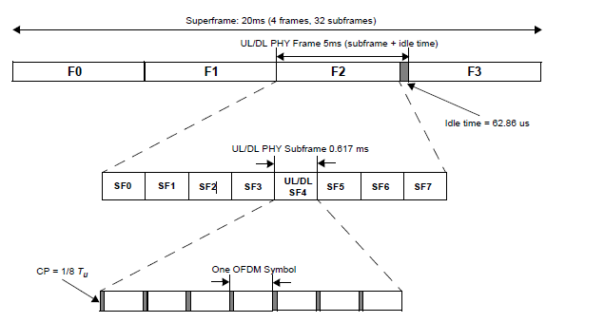
Figure 390—Frame structure with type-1 subframe in FDD duplex mode for 5, 10 and 20 MHz channel bandwidths (CP = 1/8 Tb)

Figure 390-1 illustrates an example FDD frame structure, which is applicable to the nominal channel bandwidth
of 8.75 MHz with G = 1/8. The [fourth] subframe among seven subframes is the type-2 subframe including 7 OFDM symbols.

Figure 390-1 — Frame structure with type-1 subframe in FDD duplex mode for the 8.75 MHz channel bandwidth (CP = 1/8 Tb)
15.3.3.2.1.1 H-FDD frame structure
15.3.3.2.2 TDD frame structure

The TDD frame shall be constructed on the basis of the basic frame structure defined in 15.3.3.1.

In a TDD frame with DL to UL ratio of D:U, the 1st contiguous D subframes and the remaining U subframes are assigned for DL and UL, respectively, where D + U = 8 for 5, 10 and 20 MHz channel bandwidths and D + U = 7 for the 8.75 MHz channel bandwidth. The ratio of D:U for 5, 10 and 20 MHz channel bandwidths shall be selected from one of the following values: [TBD] for 5, 10 and 20 MHz channel bandwidths and [TBD] for 8.75 MHz channel bandwidths.

In each frame, the TTG and RTG shall be inserted between the DL and UL and at the end of each frame, respectively.

Figure 391 illustrates an example TDD frame structure with D:U = 5:3, which is applicable to the nominal channel bandwidths of 5, 10, and 20 MHz with G = 1/8.
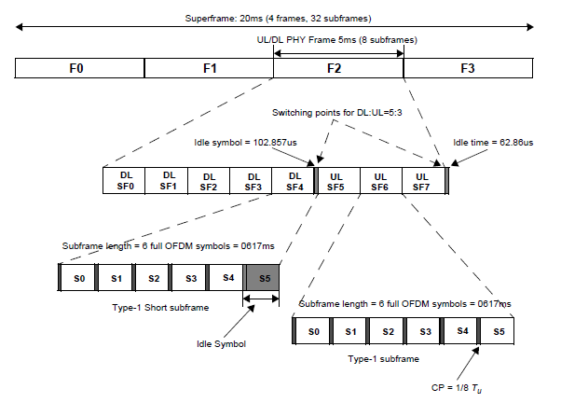
Figure 391—Frame structure with Type-1 subframe in TDD duplex mode for 5, 10
and 20 MHz channel bandwidths (CP=1/8 Tb)

Figure 391-1 illustrates an example TDD frame structure with D:U = 4:3, which is applicable to the nominal channel bandwidths of 8.75 MHz with G = 1/8.

Figure 391-1—Frame structure in TDD duplex mode for 8.75 MHz channel bandwidth (CP=1/8 Tb)

15.3.3.3 Frame structure for CP = 1/16 Tb

The frame structure for a CP length of 1/16 Tb shall consist of type-1 and type-2 subframes.

For channel bandwidths of 5, 10, and 20 MHz, a frame shall have five type-1 subframes and three type-2 subframes.

For a channel bandwidth of 8.75 MHz, a frame shall have four type-1 subframes and three type-2 subframes.

In the TDD frame, the first and last subframes within each frame shall be type-2 subframes. The last OFDMA symbol in a type-2 subframe preceding a DL to UL switching point shall be an idle symbol, which is used to accommodate the gap required to switch from DL to UL.

In the FDD frame, the first, fifth, and last subframes within each frame shall be type-2 subframes.

Figure 392 illustrates an example of TDD and FDD frame structure for 5, 10, and 20 MHz channel bandwidths with a CP of 1/16 Tb. Assuming OFDMA symbol duration of 97.143 μs and a CP length of 1/16 Tb, the length of type-1 and type-2 subframes are 0.583 ms and 0.680 ms, respectively.

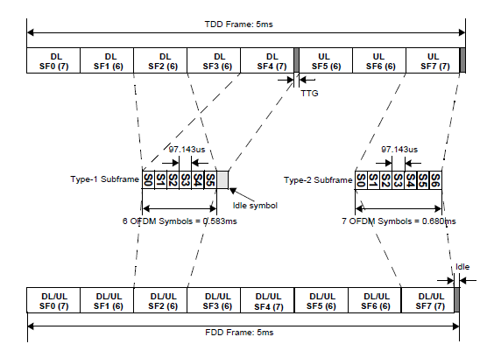
Figure 392—TDD and FDD frame structure for 5, 10, and 20 MHz channel bandwidths with a CP of 1/16 Tb (DL to UL ratio of 5:3)

Figure 392-1 illustrates an example of TDD and FDD frame structure for the 8.75 MHz channel bandwidth with a CP of 1/16 Tb. Assuming OFDMA symbol duration of 108.8 μs and a CP length of 1/16 Tb, the length of type-1 and type-2 subframes are 0.6528 ms
and 0.7616 ms, respectively.

Figure 392-1— TDD and FDD frame structure for 8.75 MHz channel bandwidth with a CP of 1/16 Tb (DL to UL ratio of 4:3)
============================== End of Proposed Text =================================

