Project | IEEE 802.16 Broadband Wireless Access Working Group <http://ieee802.org/16>
Title | Amendment Text Proposal on Downlink HARQ Parameter Signaling
Date Submitted | 2009-01-07
Source(s) | Lei Huang  Panasonic Singapore Laboratories  Isamu Yoshii  Panasonic Corporation | Voice: +65-65505304  E-mail: lei.huang@sg.panasonic.com
Re: | 802.16m amendment working document  Target topic: MAC Support for HARQ
Abstract | 802.16m amendment text proposal on HARQ parameter signaling
Purpose | For discussion and approval by IEEE 802.16 TGm
Notice | This document does not represent the agreed views of the IEEE 802.16 Working Group or any of its subgroups. It represents only the views of the participants listed in the “Source(s)” field above. It is offered as a basis for discussion. It is not binding on the contributor(s), who reserve(s) the right to add, amend or withdraw material contained herein.
Release | The contributor grants a free, irrevocable license to the IEEE to incorporate material contained in this contribution, and any modifications thereof, in the creation of an IEEE Standards publication; to copyright in the IEEE’s name any IEEE Standards publication even though it may include portions of this contribution; and at the IEEE’s sole discretion to permit others to reproduce in whole or in part the resulting IEEE Standards publication. The contributor also acknowledges and accepts that this contribution may be made public by IEEE 802.16.
Patent Policy | The contributor is familiar with the IEEE-SA Patent Policy and Procedures:  <http://standards.ieee.org/guides/bylaws/sect6-7.html#6> and <http://standards.ieee.org/guides/opman/sect6.html#6.3>.  Further information is located at <http://standards.ieee.org/board/pat/pat-material.html> and <http://standards.ieee.org/board/pat>.
Amendment Text Proposal on Downlink HARQ Parameter Signaling
Lei Huang
Panasonic Singapore Laboratories
Isamu Yoshii
Panasonic Corporation
- Introduction

For IEEE 802.16m, hybrid ARQ (HARQ) has been adopted to be mandatory for both downlink (DL) and uplink (UL) unicast data traffic at both base station (BS) and mobile station (MS). This contribution addresses the parameter signaling for DL HARQ.

- DL HARQ Parameter Signaling

For DL HARQ, the parameters for each subpacket should be signaled independent of the subpacket itself.

A basic HARQ parameter for each subpacket is HARQ channel identifier (ACID) [2], which is used to identify HARQ channels. Each connection can have multiple HARQ channels, each of which may have an encoder packet transaction pending.

According to IEEE 802.16m SDD [1], incremental redundancy (IR) HARQ is used by determining the starting position of the bit selection for HARQ (re)transmissions. Therefore, a necessary HARQ parameter is HARQ subpacket identifier (SPID), which is used to identify the starting position of the bit selection in circular buffer for each subpacket.

A new feature of IEEE 802.16m is the introduction of Bit Re-arrangement (BitRe) into HARQ retransmissions. According to IEEE 802.16m SDD [1], bit re-arrangement includes a bit-level interleaver and an inverter. It has been shown in [4] that the BitRe scheme of a bit-level interleaver and an inverter within a QAM symbol, i.e., constellation re-arrangement (CoRe), outperforms the scheme of a bit-level interleaver and an inverter across multiple QAM symbols. Therefore, control signaling is also required to indicate the CoRe-version (CRV) for each subpacket.

There are two ways for signaling of SPID and CRV. One is to separately signal SPID and CRV, and the other is to jointly signal SPID and CRV. Compared with separate signaling, joint signaling can reduce signaling overhead by excluding some specific combinations of SPID and CRV which may never be used or may be used less frequently. In other words, with the same signaling overhead, joint signaling can improve the chance of allowing more CoRe-versions compared with separate signaling.

In addition, control signaling is also required to provide the indication of the new data. In case of separately signaling of SPID and CRV, there are two alternatives for new data indication, i.e., explicit indication with HARQ identifier sequence number (AI_SN) field and indication with SPID = 0. In the former, the AI_SN is toggled between “0” and “1” on successfully transmitting each encoder packet with the same HARQ channel. In the latter, SPID = 0 is used to indicate transmission of new data, and SPID = 0 cannot be used for retransmissions. However, in case of jointly signaling of SPID and CRV, only explicit indication with AI_SN field is feasible.

We propose three options for DL HARQ parameter signaling as shown in Table 1.

Table 1: DL HARQ parameter signaling

Options | ACID | AI_SN | SPID | CRV | Note
1 | 4 bits | 1 bit | 3 bits |  | a) Joint signaling of SPID and CRV  b) 4 BitRe-versions and 4 starting positions  c) Total 8 bit signaling overhead  d) SPID = 0 can be used for (re)transmissions  e) Reduced flexibility of combining SPID and CRV
2 | 4 bits | NA | 2 bits | 2 bit | a) Separate signaling of SPID and CRV  b) SPID = 0 implies indication of new data, and SPID = 0 cannot be used for retransmissions  c) 4 BitRe-versions and 4 starting positions  d) Total 8 bit signaling overhead  e) Good flexibility of combining SPID and CRV
3 | 4 bits | 1 bit | 2 bits | 2 bit | a) Separate signaling of SPID and CRV  b) 4 BitRe-versions and 4 starting positions  c) Total 9 bit signaling overhead  d) SPID = 0 can be used for (re)transmissions  e) Good flexibility of combining SPID and CRV

- Joint Signaling of SPID and CRV

In the following, a joint signaling mechanism of SPID and CRV is described according to an example of CoRe operation shown in [3]. From Figure 1, we can observe that it has great possibility that the subpacket with SPID = 1 has overlapping bits with the subpackets with SPID = 0 and SPID = 2, and the subpacket with SPID = 3 has overlapping bits with the subpackets with SPID = 0 and SPID = 2. Therefore, an efficient joint signaling mechanism is shown in Table 1.
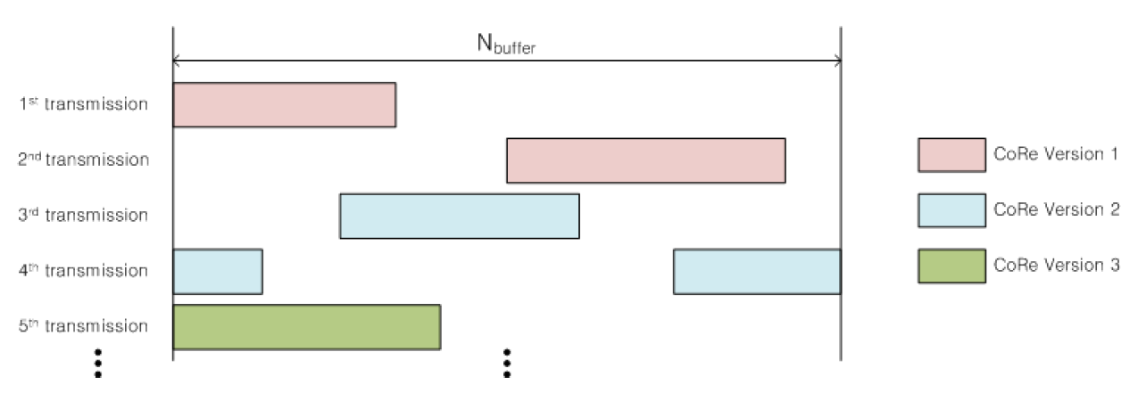

Figure 1 CoRe operation in IR HARQ [3]

Table 2: Exemplary joint signalling mechanism of SPID and CRV
SPID/CRV | SPID | CRV
0 | 0 | 1
1 | 1 | 2
2 | 2 | 1
3 | 3 | 2
4 | 0 | 2
5 | 0 | 3
6 | 0 | 4
7 | 1 | 4
Note that the subpackets with SPID = 0 may have 4 different CoRe-versions. This is particularly useful for supporting chase combining (CC) HARQ as a special case of IR HARQ.

Reference
[1] IEEE 802.16m-08/003r6, IEEE 802.16m System Description Document [draft]
[2] IEEE 802.16REV2-D8
[3] IEEE 802.16m-08/1333r1, Proposal for Constellation Re-arrangement in IR HARQ
[4] IEEE 802.16m-09/0159, Comments on Bit Rearrangement/Constellation Rearrangement

Suggested Amendment Text
----------------------------------------------------------------------------------

Advanced Air Interface

Medium Access Control

MAC Support for HARQ

15.2.X.Y DL HARQ parameter signaling
For DL HARQ, the parameters for each subpacket should be signaled independent of the subpacket itself. Three options for DL HARQ parameter signaling are shown in Table yyy.

Table xxx: DL HARQ parameter signaling
Options | ACID | AI_SN | SPID | CRV | Note
1 | 4 bits | 1 bit | 3 bits |  | a) Joint signaling of SPID and CRV  b) 4 BitRe-versions and 4 starting positions  c) Total 8 bit signaling overhead  d) SPID = 0 can be used for (re)transmissions  e) Reduced flexibility of combining SPID and CRV
2 | 4 bits | NA | 2 bits | 2 bit | a) Separate signaling of SPID and CRV  b) SPID = 0 implies indication of new data, and SPID = 0 cannot be used for retransmissions  c) 4 BitRe-versions and 4 starting positions  d) Total 8 bit signaling overhead  e) Good flexibility of combining SPID and CRV
3 | 4 bits | 1 bit | 2 bits | 2 bit | a) Separate signaling of SPID and CRV  b) 4 BitRe-versions and 4 starting positions  c) Total 9 bit signaling overhead  d) SPID = 0 can be used for (re)transmissions  e) Good flexibility of combining SPID and CRV
ACID
The HARQ channel identifier, which is used to identify HARQ channels. Each connection can have multiple HARQ channels, each of which may have an encoder packet transaction pending.
SPID
The HARQ subpacket identifier, which is used to identify the starting position of the bit selection in circular buffer for each subpacket.
CRV
The constellation re-arrangement version, which is used to identify the constellation re-arrangement version for each subpacket.
AI_SN
The HARQ identifier sequence number. This is toggled between 0 and 1 on successfully transmitting each encoder packet with the same HARQ channel.

Note that in case of joint signaling of SPID and CRV, detailed joint signal mechanism is FFS.
-----------------------------------------------------------------------------------------------------------------

