Project | IEEE 802.16 Broadband Wireless Access Working Group <http://ieee802.org/16>
Title | Proposed Text of DL PHY Control Structure Section (BCH) for the IEEE 802.16m Amendment
Date Submitted | 2009-01-07
Source(s) | Mihyun Lee, Rakesh Taori, Hyunkyu Yu, Gwanhee Rho, Kichun Cho, Taeyoung Kim, Hokyu Choi, Heewon Kang  Samsung Electronics Co., Ltd. | Voice: +82-31-279-0390  E-mail: mihyun.mac.lee@samsung.com
Re: | IEEE 802.16m-08/053r1, “Call for Contributions for Project 802.16m Amendment Working document Text”  Target topic: “DL PHY control structure”
Abstract | The contribution proposes the text of DL PHY control structure section to be included in the 802.16m amendment.
Purpose | To be discussed and adopted by TGm for the 802.16m amendment.
Notice | This document does not represent the agreed views of the IEEE 802.16 Working Group or any of its subgroups. It represents only the views of the participants listed in the “Source(s)” field above. It is offered as a basis for discussion. It is not binding on the contributor(s), who reserve(s) the right to add, amend or withdraw material contained herein.
Release | The contributor grants a free, irrevocable license to the IEEE to incorporate material contained in this contribution, and any modifications thereof, in the creation of an IEEE Standards publication; to copyright in the IEEE’s name any IEEE Standards publication even though it may include portions of this contribution; and at the IEEE’s sole discretion to permit others to reproduce in whole or in part the resulting IEEE Standards publication. The contributor also acknowledges and accepts that this contribution may be made public by IEEE 802.16.
Patent Policy | The contributor is familiar with the IEEE-SA Patent Policy and Procedures:  <http://standards.ieee.org/guides/bylaws/sect6-7.html#6> and <http://standards.ieee.org/guides/opman/sect6.html#6.3>.  Further information is located at <http://standards.ieee.org/board/pat/pat-material.html> and <http://standards.ieee.org/board/pat>.

Proposed Text of DL PHY Control Structure Section for the IEEE 802.16m Amendment

Mihyun Lee, Rakesh Taori, Hyunkyu Yu, Gwanhee Rho, Kichun Cho, Taeyoung Kim, Hokyu Choi, Heewon Kang

Samsung Electronics Co., Ltd.

Contents
1 Introduction 3
2 Design Requirements 3
2.1 Operating bandwidths 3
2.2 Multiple antenna configurations 3
2.3 Handover interruption time 3
2.4 Mobility 4
2.5 Cell coverage 4
2.6 Synchronization 4
3 Preparation for Ranging: General Flow 5
4 PHY Structure 6
4.1 Superframe header structure 6
4.2 Transmission format 7
4.2.1 Target SINR Coverage 7
4.2.2 MIMO transmission 8
4.2.3 Coding rate 8
4.2.4 Available information size 9
4.2.5 Channel coding 11
5 References 11
6 Text proposal for inclusion in the 802.16m amendment 13

- Introduction
The contribution proposes text for the DL control structure section to be included in the 802.16m amendment. The proposed text is developed so that it can be readily combined with IEEE P802.16 Rev2/D7 [1], it is compliant to the 802.16m SRD [2] and the 802.16m SDD [3], and it follows the style and format guidelines in [4].

The proposed text is limited to the PHY aspect of BCH. This contribution, however describes the details of DL control structure including the operation procedure and information elements required to support the proposed text.

- Design Requirements
This section addresses design requirements for BCH design which are subsets of 802.16m SRD. The design requirements are based on the general requirements, the functional requirements, the baseline performance requirements, and the operational requirements.
Table 1 summarizes the design requirement for system optimization.
Table 1 – Design requirement
Topic | Requirement
BW | Minimum 5 MHz
DL MIMO | Minimum 2 x 2
Intra-frequency HO latency | 27.5 ms
Mobility | Pedestrian
Cell coverage | 5 Km (i.e. 8.6 Km ISD)
Synchronization | Synchronized timing and frame counters across entire systems

  - Operating bandwidths
Scalable bandwidth is ability to operate with different bandwidth allocations. IEEE 802.16m shall support scalable bandwidths from 5 to 40 MHz.

  - Multiple antenna configurations
The minimum is consistent with a 2x2 downlink configuration.

  - Handover interruption time
The handover interruption times specified in Table 2 apply to handover of IEEE 802.16m MS between IEEE 802.16m BSs operating in the absence of legacy MSs under normal operating conditions.
Table 2 – Handover interruption times
Handover type |  | Max. interruption time (ms)
Intra-frequency |  | 27.5
Inter-frequency | Within a spectrum band | 40
Inter-frequency | Between spectrum bands | 60

  - Mobility
Mobility shall be supported across the IEEE 802.16m network.
Table 3 summarizes the mobility performance.
Table 3 – Mobility support
Mobility | Performance
Stationary, pedestrian 0 – 10 km/h | Optimized
Vehicular 10 – 120 km/h | Graceful degradation as a function of vehicular speed
High speed vehicular 120 – 350 km/h | System should be able to maintain connection

  - Cell coverage
IEEE 802.16m shall support the deployment scenarios captured in Table 4 in terms of maximum cell range.
Table 4 – Deployment scenarios
Cell range | Performance target
Up to 5 km | Optimized
5 – 30 km | Graceful degradation in system/edge spectral efficiency
30 – 100 km | System should be functional (thermal noise limited scenario)

  - Synchronization
IEEE 802.16m shall support the ability to synchronize frame timing and frame counters across the entire system deployed in given geographic area, including synchronization among all BSs and MSs operating on the same or on different carrier frequencies and among neighboring IEEE 802.16m system, whether operated by the same operator or not.

- Preparation for Ranging: General Flow
MS needs ranging when MS performs the initial access, handover and while exiting idle mode. Figure 1 shows the general operation flows to prepare for ranging.
Figure 1 – General operation flow: preparation for ranging

Table 5 shows the information required for the preparation for ranging.
Table 5 – Information contents
 | Information
DL Parameters | DL carrier frequency
DL Parameters | OFDM symbol length
DL Parameters | DL BW
DL Parameters | Cell ID
DL Parameters | DL/UL ratio*
DL Parameters | # of Tx antennas**
DL Parameters | DL Subband allocation count (SAC)
DL Parameters | DL Frequency partition configuration (FPC)
DL Parameters | DL Resource configuration (e.g. ratio of CRU and DRU)
DL Parameters | USCCH configuration (e.g. size, MCS level, location)
DL Parameters | Superframe number
DL Parameters | System descriptor change count
UL Parameters | UL carrier frequency/BW (needed for FDD)
UL Parameters | UL Subband allocation count (SAC)+
UL Parameters | UL Frequency partition configuration (FPC)+
UL Parameters | UL Resource configuration (e.g. ratio of CRU and DRU)+
UL Parameters | UL start timing
UL Parameters | Information related initial ranging (e.g. codes/backoff range/interval/region)
UL Parameters | Information related HO ranging (e.g. codes/backoff range/region)
UL Parameters | Information related exiting idle mode (e.g. codes/backoff range/ region)

The required information to prepare the Ranging may be divided into three groups. The first information group can be obtained blindly. The second information group is a set of time critical information. This group is mapped to PBCH/SBCH. The third group is a set of remained information.

Table 6 shows the information obtained blindly.
Table 6 –Information obtained by blind detection
Information | Size
DL carrier frequency | -
OFDM symbol length | -
DL BW | -

Table 7 shows the information contents of PBCH. PBCH carries information regarding current superframe configuration.
Table 7 –Information contents of PBCH
Information | Size
Cell ID | 6
DL Resource configuration (e.g. ratio of CRU and DRU) | TBD
USCCH configuration (e.g. size) | 6
System descriptor change count | 5

Table 8 shows the information contents of SBCH. SBCH carries information regarding the DL carrier.
Table 8 –Information contents of SBCH
Information | Size
DL/UL ratio | 3
# of Tx antennas | 2
DL Subband allocation count (SAC) | 5
DL Frequency partition configuration (FPC) | 12
USCCH configuration (e.g. MCS level, location) | 3
Superframe number | 12

Table 9 shows the set of remained information. Other information such as information related ranging may be transmitted using MAC management message over DL traffic channels.
Table 9 –Other information
Information | Size
UL carrier frequency/BW (needed for FDD) | -
UL Subband allocation count (SAC)+ | 5
UL Frequency partition configuration (FPC)+ | 12
UL Resource configuration (e.g. ratio of CRU and DRU)+ | TBD
UL start timing | TBD
Information related ranging (e.g. codes/backoff range/interval/region) | -

- PHY Structure
The superframe header (SFH) includes PBCH and SBCH, and is located in the first subframe of a superframe.

Table 10 summarizes the PHY structure which this contribution suggests.
Table 10 – Suggested PHY structure
Topic | Value
PRU configuration | Type-1 subframe with 5 symbols
Resource Units | DRU
BW Occupancy | Up to 24 LRUs (are spread across full BW)
Tx diversity | Rate -1 using 2 streams
Channel coding | Convolutional code
Pilot pattern | 2 stream pilot
Target coverage | 8.67 km ISD with 98 % coverage
Repetition # within a superframe | {PBCH, SBCH} = {up to 24, 8}

  - Superframe header structure
The superframe header (SFH) is the first DL subframe of the superframe and uses 6 OFDMA symbols. The SFH consists of BCH and SCH (P-SCH or S-SCH). Additionally, other bursts such as USCCH and data may be included in the SFH. Within the same subframe, PBCH/SBCH is TDM with SCH and is FDM with other channels. Figure 2 shows the superframe header structure.
Figure 2 – Superframe header structure

  - Transmission format
    - Target SINR Coverage
The 16m SRD specifies that the system should be optimized for cell ranges up to 5km (i.e. 8.67 km ISD). The 16m EVM also mentions the mandatory cell size being 0.87 km (i.e.1.5 km ISD) for the baseline configuration.
Figure 3 shows the CDF of the SINR for two cell ranges with frequency reuse of 1 and frequency reuse of 3. The test environments and associated configurations for this system level simulation are based on 16m EVM.

Figure 3 – SINR distribution

In order to evaluate the SINR coverage, we can consider the points on the plot corresponding to the 98% and 95 % coverage. Based on simulation results, we can make the following observations regarding the Target SINR:
Table 11 – Target SINR [dB]
Cell size  Coverage | 1.5 Km ISD |  | 8.7 Km ISD
Cell size  Coverage | FR-1 | FR-3 | FR-1 | FR-3
98 % | -5 | -1 | -7 | -6
95 % | -3.5 | 1 | -6 | -5
The target SINR is a minimum threshold which represents the average SINR that must be experienced by a stationary user in order to obtain the required percentage of coverage in the cell.

It should be noted that frequency reuse of 3 isn’t helpful for 8.67 km ISD cell. So, the design of 16m BCH shall be optimized for 8.67 km ISD cell (as specified in 16m SRD), but with a frequency reuse of 1.

    - MIMO transmission
Simulation results show that with 2 Tx pilot pattern, SFBC is better than 1 stream transmission. So, the transmit diversity scheme for BCH is SFBC (i.e. M = 2 streams) using the 2 Tx rate-1 mode.
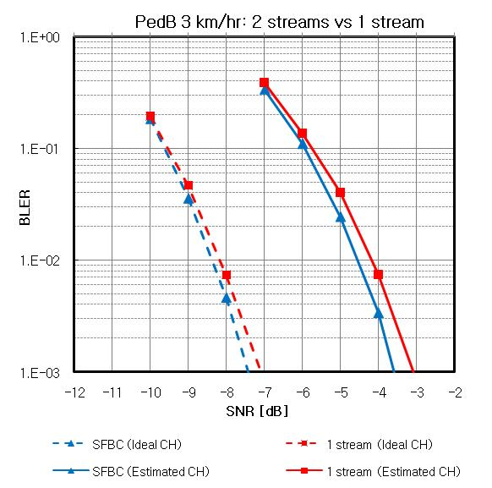
Figure 4 – Link performance: 2 streams vs 1 stream

    - Coding rate
Link performance to achieve the above target SINRs were evaluated using LLS. The following parameters are used.
- BW/FFT : 5 MHz / 512
- Tx diversity: SFBC
- Information bits: 48 bits /96 bits
- Channel coding: CC or CTC
- PedB 3 km/hr
- Channel estimation: PRU based MMSE
- Resource unit: DRU
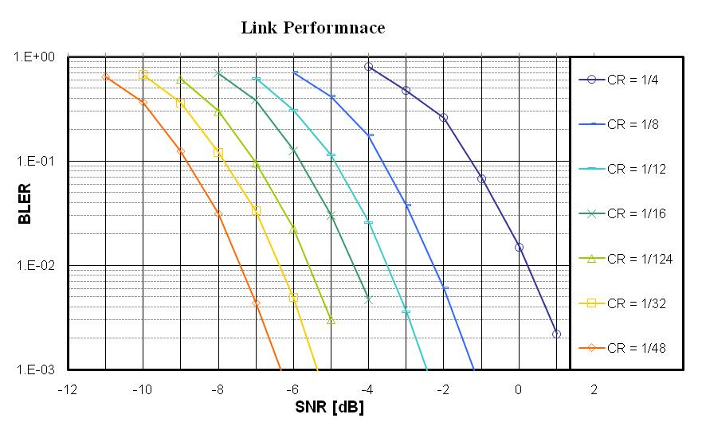
Figure 5 – Link Performance with various coding rate

Based on these simulation results, we can make the following observations.
- The coding rate with 1/16 can achieve the target SINR for 98 % coverage of 1.5km ISD cell with a target BLER of 1%.
- The coding rate with 1/48 can achieve the target SINR for 98 % coverage of 8.67km ISD cell with a target BLER of 1%.

For robustness, the coding rate for 8.67 km ISD cell should be equal to or less than 1/48, and the coding rate for 1.5 km ISD cell should be equal to or less than 1/16.

    - Available information size
To compute the available information size, we consider the following:
- The pilot structure uses 2 stream pilot patterns.
- 5 Symbols are available symbols for BCH as described in section 4.1.
- PBCH and SBCH occupy no more BW than 5 MHz.
Based on the foregoing, the size of available resource is 1920 tones.

To achieve the target SINR with 98 % coverage for 8.67 km ISD cell with the frequency reuse of 1, we consider the following three approaches:
According to the first approach, the whole information block is transmitted every superframe. This requires a code rate of 1/48 to achieve the aforementioned requirement
According to the second approach, the whole information block is repeated over multiple superframes to get a lower code.
The third approach combines the first and the second approach.

Next we look at the number of repetitions required in case of the second and third approaches. A code rate of 1/16 is required to achieve the target SINR with 98 % coverage for 1.5 km ISD cell with the frequency reuse of 1. We propose that the information block with the code rate of 1/16 is transmitted during 4 consecutive superframes. This facilitate MSs within 1.5 km ISD coverage to get faster access and conserve power, while the coverage requirement is met for the MSs further away.

Considering QPSK modulation and 16-bit CRC, the aforementioned three approaches imply the following:
- Approach # 1: For a code rate of 1/48, 24 repetitions are needed. So, we need to find X satisfying 24X = 1920.
  - X = 80, i.e. the size of the available information bits is 64 bits
- Approach # 2: For a code rate of 1/16, 8 repetitions are needed. So, we need to find Y satisfying 8Y = 1920.
  - Y = 240, i.e. the size of the available information bits is 224 bits
- Approach # 3: The information is divided into 2 blocks. One block (X bits) is transmitted using approach #1 and another block (Y bits) is transmitted using approach #2. So, we need to find both X and Y satisfying 24X + 8Y = 1920. Illustrative values can be:
  - X=48 (i.e. information = 32 bits), Y = 96 (i.e. information = 80 bits). The size of the available information bits is 112 bits
  - X=56 (i.e. information = 40 bits), Y = 72 (i.e. information = 56 bits), i.e. the size of the available information bits is 96 bits.
  - X=64 (i.e. information = 48 bits), Y = 48 (i.e. information = 32 bits), i.e.the size of the available information bits is 80 bits.

Similarly, we also consider the target SINR with 95 % coverage. This requires code rate of 1/32 and 1/12.
- Approach # 1: For a code rate of 1/32, 16 repetitions are needed. So, we need to find X satisfying 16X = 1920.
  - X = 120, i.e. the size of the available information bits is 104 bits.
- Approach # 2: For a code rate of 1/12, 6 repetitions are needed. So, we need to find Y satisfying 6Y = 1920.
  - Y = 320, i.e. the size of the available information bits is 304 bits
- Approach # 3: The information is divided into 2 blocks. One block (X bits) is transmitted using approach #1 and another block (Y bits) is transmitted using approach #2. So, we need to find both X and Y satisfying 16X + 6Y = 1920. Illustrative values can be:
  - X=48 (i.e. information = 32 bits), Y = 192 (i.e. information = 176 bits), i.e. the size of the available information bits is 208 bits
  - X=72 (i.e. information = 56 bits), Y = 128 (i.e. information = 112 bits), i.e. the size of the available information bits is 168 bits
  - X=96 (i.e. information = 80 bits), Y = 64 (i.e. information = 48 bits), i.e. the size of the available information bits is 128 bits

In deciding the final approach, the information bit should be agreed first.

    - Channel coding
The channel coding depends on the size of the information block.
Based on simulation results, convolutional code should be considered for information block size less than 96 bits while CTC should be considered for information block size is equal to or larger than 96.
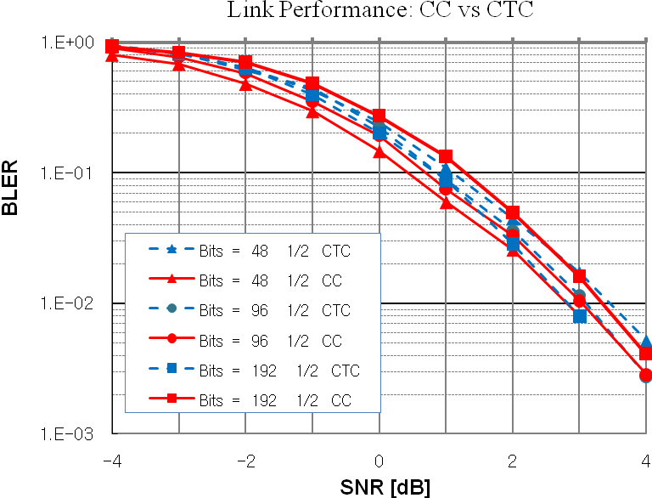
Figure 6 – Link Performance: CC vs CTC

Since the information size considered is equal to or less than 96 bits, convolutional code seems to be the appropriate choice for BCH transmission.

- References
[1] IEEE P802.16 Rev2 / D7, “Draft IEEE Standard for Local and Metropolitan Area Networks: Air Interface
for Broadband Wireless Access,” Oct. 2008.
[2] IEEE 802.16m-07/002r4, “802.16m System Requirements”
[3] IEEE 802.16m-08/003r5, “The Draft IEEE 802.16m System Description Document”
[4] IEEE 802.16m-08/043, “Style guide for writing the IEEE 802.16m amendment”
[4] IEEE 802.16m-08/050, “IEEE 802.16m Amendment Working Document”

- Text proposal for inclusion in the 802.16m amendment

------------------------------- Text Start ---------------------------------------------------

3. Definitions
Insert the following at the end of section 3:
3.xx superframe header: The first DL subframe of the superframe.
3.xx superframe prefix message: A data structure that contain information regarding superframe.
3.xx downlink channel prefix message: A data structure that contain information regarding downlink channel.

4. Abbreviations and acronym
Insert the following at the end of section 4:

BCH broadcast channel
PBCH primary broadcast channel
SBCH secondary broadcast channel
SFP superframe prefix
DLCP downlink channel prefix

Insert a new section 15:

15.3.x Broadcast Channel (BCH) in Superframe Header(SFH)
The superframe header (SFH) is the first DL subframe of the superframe and uses 6 OFDMA symbols. The SFH consists of BCH and SCH (P-SCH or S-SCH). Additionally, other bursts such as USCCH and data may be included in the SFH.
Except SCH, the SFH uses the distributed resource unit which is described in section 15.3.5 in IEEE 802.16m-08/050[5]. The frequency reuse for the resource allocation is predetermined. N_{FR, SFH} indicates the value of frequency reuse and is set to 1 (or FFS).
Figure1 shows the superframe header structure.
Figure 1 – Superframe header structure

- BCH
The BCH is divided into two parts: PBCH and SBCH. The PBCH carries the superframe prefix (SFP) message and the SBCH carries the downlink channel prefix (DLCP) messages.
Figure 2 shows the structure of the BCH.
Figure 2 – Structure for BCH
The BCH is sent on the first N_{BCH} subchannels (i.e. logical subchannel number with 0 to N_{BCH} -1). The value of N_{BCH} is TBD.
The SFP message shall be mapped to the first N_{SFP} subchannels (i.e. logical subchannel number with 0 to N_{SFP} -1) in the BCH. The value of N_{SFP} is TBD.
The DLCP message immediately follows the SFP message after repetition code is applied. The DLCP message shall be mapped to N_{DLCP} subchannels (i.e. logical subchannel number with N_{SFP} to N_{SFP} + N_{DLCP} -1) in the BCH. The value of N_{DLCP} is TBD.
Note that N_{BCH} = N_{DLCP} + N_{SFP}, where N_{BCH}, N_{DLCP}, and N_{SFP} represent the number of subchannels for BCH, DLCP message and SFP message, respectively.

- Superframe Prefix (SFP) Message
The SFP message is a data structure transmitted in each superframe.
The SFP message contains information regarding the current superframe and is mapped to PBCH. The SFP message format is TBD.
The SFP message is generated as shown in figure 4.
Figure 4 – Generation of the SFP Message

  - Channel Coding
The SFP block shall be appended with CRC. A CRC length of N_{CRC, SFP} shall be used, where N_{CRC, SFP} is TBD. (e.g. 16 bit)
The resulting sequence of bits shall be encoded by the convolutional encoder and then interleaved by the bit-interleaver. The convolutional encoder and the bit-interleaver defined in section 8.4.9 in IEEE P802.16 Rev2 / D7 [1]. A coding rate of 1/2 is used.
The block of channel encoded sequences shall be repeated N_{repetition, SFP} times. The value of N_{repetition, SFP} is up to 24.
  - Data Scrambler
The block of repeated bit sequences shall be scrambled with a cell-specific sequence. The scrambling sequence is TBD.
  - Modulation
The block of scrambled bit sequences shall be modulated using QPSK.
  - MIMO Encoder
The block of modulated symbols shall be mapped to 2 streams using transmit diversity scheme of rate 1

- Downlink Channel Prefix(DLCP) Message
The DLCP message is a data structure transmitted during N_{period, DLCP} consecutive superframes. The DLCP message starts in superframes which satisfy n_{superframe number} mod N_{period, DLCP} = 0, where n_{superframe number} is the superframe number and N_{period, DLCP} represents the number which the DLCP message is transmitted over multiple superframes repeatedly. The value of N_{period, DLCP} is TBD (e.g. 4).
The DLCP message contains information regarding the DL carrier and is mapped to the SBCH. The DLCP message format is TBD.
The DLCP message is generated as shown in figure 3.
Figure 3 – Generation of the DLCP Message

  - Channel Coding
The DLCP information shall be appended with a CRC of length N_{CRC, DLCP}. N_{CRC, DLCP} is TBD (e.g. 16 bit).
The resulting sequence of bits shall be encoded by the convolutional encoder and then interleaved by the bit-interleaver. The convolutional encoder and the bit-interleaver are defined in section 8.4.9 in IEEE P802.16 Rev2 / D7 [1]. A coding rate of 1/2 is used.
The block of channel encoded bit sequences shall be repeated N_{repetition, DLCP} times. The value of N_{repetition, DLCP} is TBD (e.g. 8).
  - Data Scrambler
The block of repeated bit sequences shall be scrambled with a cell-specific sequence. The scrambling sequence is TBD.
  - Modulation
The block of scrambled bit sequences shall be modulated using QPSK.
  - MIMO Encoder
The block of modulated symbols shall be mapped to 2 streams using transmit diversity scheme of rate 1.

- Superframe Prefix (SFP) Message
The SFP message is a data structure transmitted in each superframe.
The SFP message contains information regarding the current superframe and is mapped to PBCH. The SFP message format is TBD.
The SFP message is generated as shown in figure 4.
Figure 4 – Generation of the SFP Message

  - Channel Coding
The SFP block shall be appended with CRC. A CRC length of N_{CRC, SFP} shall be used, where N_{CRC, SFP} is TBD. (e.g. 16 bit)
The resulting sequence of bits shall be encoded by the convolutional encoder and then interleaved by the bit-interleaver. The convolutional encoder and the bit-interleaver defined in section 8.4.9 in IEEE P802.16 Rev2 / D7 [1]. A coding rate of 1/2 is used.
The block of channel encoded sequences shall be repeated N_{repetition, SFP} times. The value of N_{repetition, SFP} is up to 24.
  - Data Scrambler
The block of repeated bit sequences shall be scrambled with a cell-specific sequence. The scrambling sequence is TBD.
  - Modulation
The block of scrambled bit sequences shall be modulated using QPSK.
  - MIMO Encoder
The block of modulated symbols shall be mapped to 2 streams using transmit diversity scheme of rate 1
------------------------------- Text End ---------------------------------------------------

