Project | IEEE 802.16 Broadband Wireless Access Working Group <http://ieee802.org/16>
Title | Proposed Text on Frame Structure Supporting the WirelessMAN-OFDMA Frames for the IEEE 802.16m Amendment
Date Submitted | 2009-01-07
Source(s) | Juejun Liu, Ke Zeng, Sean Mcbeath  Huawei Technologies | E-mail: smcbeath@huawei.com
Re: | IEEE 802.16m-08/053r1: Call for Comments and Contributions on Project 802.16m Amendment Working Document
Abstract | This contribution proposes the frame structure supporting the WirelessMAN-OFDMA.
Purpose | For discussion and adoption by IEEE 802.16m group
Notice | This document does not represent the agreed views of the IEEE 802.16 Working Group or any of its subgroups. It represents only the views of the participants listed in the “Source(s)” field above. It is offered as a basis for discussion. It is not binding on the contributor(s), who reserve(s) the right to add, amend or withdraw material contained herein.
Release | The contributor grants a free, irrevocable license to the IEEE to incorporate material contained in this contribution, and any modifications thereof, in the creation of an IEEE Standards publication; to copyright in the IEEE’s name any IEEE Standards publication even though it may include portions of this contribution; and at the IEEE’s sole discretion to permit others to reproduce in whole or in part the resulting IEEE Standards publication. The contributor also acknowledges and accepts that this contribution may be made public by IEEE 802.16.
Patent Policy | The contributor is familiar with the IEEE-SA Patent Policy and Procedures:  <http://standards.ieee.org/guides/bylaws/sect6-7.html#6> and <http://standards.ieee.org/guides/opman/sect6.html#6.3>.  Further information is located at <http://standards.ieee.org/board/pat/pat-material.html> and <http://standards.ieee.org/board/pat>.
Proposed Text on Frame Structure Supporting the WirelessMAN-OFDMA Frames
for the IEEE 802.16m Amendment
Juejun Liu, Ke Zeng, Sean Mcbeath
Huawei Technologies

Introduction
To support WirelessMAN-OFDMA, the current Amendment Working Document defines the multiplexing scheme of WirelessMAN-OFDMA and Advanced Air Interface. In downlink, TDM approach is supported, and in uplink, both FDM and TDM should be supported. When PUSC mode and FDM approach is adopted for the WirelessMAN-OFDMA, a permutation scheme different with normal permutation is applied.
In this contribution, we propose a method to notify the configuration of multiplexing mode and permutation scheme.

2. Subframe Type Bitmap
As defined in SDD draft, when WirelessMAN-OFDMA operates in the PUSC mode, in order to provide FDM-based legacy support, the subchannelization for Advanced Air Interface PUSC is identical to legacy uplink PUSC. A WirelessMAN-OFDMA PUSC tile is 4 contiguous subcarriers by N_{sym} symbols (N_{sym} is dependent on subframe type). Six tiles constitute an Advanced Air Interface PUSC LRU (or a Advanced Air Interface PUSC subchannel).
In [2], a more detailed description is provided for subchannelization of Advanced Air Interface PUSC.
- First, all usable subcarriers are divided into PUSC tiles.
- Permutation are performed according to WirelessMAN-OFDMA
- PUSC subchannels for Advanced Air Interface are extended in time domain to N_{sym} symbols, and broadcast those subchannels through control message.
In our opinion, it is doubtful to notify PUSC subchannels for Advanced Air Interface.
- It will result large overhead: if one bit is used to stand for a subchannel, there will need 70 bits long bitmap for 20MHz, and 35 bits long bitmap for 10MHz.
- Useless: Uplink transmission is controlled by BS. MS only use resource BS allocates to it, it need not to know whether other resources is used by Advanced Air Interface or WirelessMAN-OFDMA.
In the legacy support system, Advanced Air Interface MS shall know UL subframe configuration, which indicates UL subframe type. From the perspective of an Advanced Air Interface MS, UL Subframe type can be:
- WirelessMAN-OFDMA only subframe.
- Advanced Air Interface only subframe.
- WirelessMAN-OFDMA/Advanced Air Interface FDM PUSC subframe.
- WirelessMAN-OFDMA/ Advanced Air Interface FDM AMC subframe .Within this type subframe, for Advanced Air Interface MS, it is no different with Advanced Air Interface only subframe type, because the same UL physical structure is applied.
So in this contribution, we proposed that BS broadcast UL subframe configuration to notify the UL subframe type to Advanced Air Interface MS. A bitmap is used to do that, the most significant bit is corresponding to the first UL subframe. This bitmap can be located in SBCH.
Below is the example of subframe type bitmap.
When DL/UL ratio is 5:3, 3 bit map in table 1 is recommended.
Bitmap | Subframe type
000 | UL subframe #0,#1,#2 are pure Advanced Air Interface or FDM WirelessMAN-OFDMA for AMC
001 | #0,#1: pure WirelessMAN-OFDMA  #2: pure Advanced Air Interface or FDM WirelessMAN-OFDMA for AMC
011 | #0: pure WirelessMAN-OFDMA  #1,#2: pure Advanced Air Interface or FDM WirelessMAN-OFDMA for AMC
100 | #0: FDM PUSC subframe  #1,#2: pure Advanced Air Interface or FDM WirelessMAN-OFDMA for AMC
110 | #0,#1: FDM PUSC subframe  #2: pure Advanced Air Interface or FDM WirelessMAN-OFDMA for AMC
111 | #0,#1,#2: FDM PUSC subframe
010 | Reserved
101 | Reserved
Table 1 subframe Type Bitmap for DL/UL ratio 5:3
When DL/UL ratio is 4:4, 4 bits bitmap in table 2 is recommended.
Bitmap | Subframe type
0000 | UL subframe #0,#1,#2,#3 are pure Advanced Air Interface or FDM WirelessMAN-OFDMA for AMC
0001 | #0,#1,#2: pure WirelessMAN-OFDMA  #3: pure Advanced Air Interface or FDM WirelessMAN-OFDMA for AMC
0011 | #0,#1: pure WirelessMAN-OFDMA  #2,#3: pure Advanced Air Interface or FDM WirelessMAN-OFDMA for AMC
0111 | #0: pure WirelessMAN-OFDMA  #1,#2,#3: pure Advanced Air Interface or FDM WirelessMAN-OFDMA for AMC
1000 | #0: FDM PUSC subframe  #1,#2,#3: pure Advanced Air Interface or FDM WirelessMAN-OFDMA for AMC
1100 | #0,#1: FDM PUSC subframe  #2,#3: pure Advanced Air Interface or FDM WirelessMAN-OFDMA for AMC
1110 | #0,#1,#2: FDM PUSC subframe  #3: pure Advanced Air Interface or FDM WirelessMAN-OFDMA for AMC
1111 | #0,#1,#2,#3: FDM PUSC subframe
Others | Reserved
Table 2 Figure 1 subframe Type Bitmap for DL/UL ratio 4:4

Proposed Text for Amendment
------------------------------------------------------Start of the Text----------------------------------------------------
[change the following text]

In the UL, the two three configurations, FDM only mode, TDM only mode and FDM/TDM mixed mode, are applicable:

[Insert the following text into the end of 15.3.3.4.1]

3) FDM/TDM mixed mode: In a subset of UL subframe which is used as FDM based UL PUSC zone, a group of subcarriers ( subchannels ) , spanning all those subframe, is dedicate to WirelessMAN-OFDMA operation. The remaining subcarriers in this subset, denoted the Advanced Air Interface UL subchannels group are forming the Advanced Air Interface UL subframes, are dedicated to the Advanced Air Interface operation. The remaining subframe can be used for Advanced Air Interface only operation or FDM based UL AMC zone.

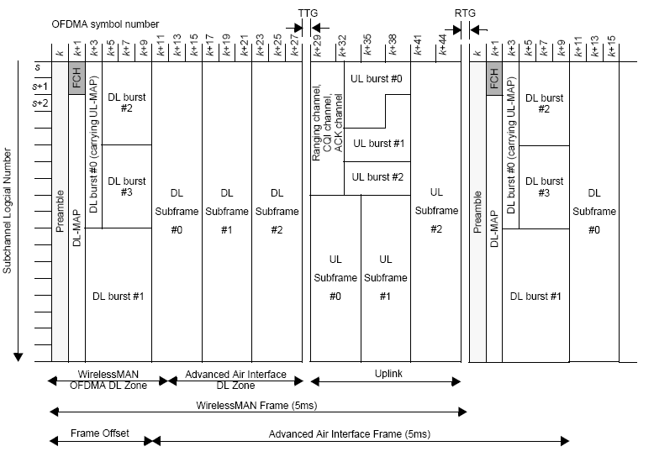

Advanced Air Interface BS should notify the UL subframe configuration in the BCH:
- indicate each UL subframe, a WirelessMAN-OFDMA only subframe, Advanced Air Interface only subframe or, AMC FDM legacy support mode subframe or PUSC FDM legacy support mode subframe

Table xx1 ~ Table xx4 define UL subframe configuration of different DL/UL ratio (3:5, 4:4, 5:3 and 6:2).

Table xx1 UL SubFrame Configuration Setting for supporting DL:UL=3:5
UL Subframe  Configuration bitmap | Explain | Illustration
00000 | #0,#1,#2,#3,#4: pure Advanced Air Interface or FDM legacy support for AMC
00001 | #0,#1,#2,#3: pure WirelessMAN-OFDMA  #4: pure Advanced Air Interface or FDM legacy support for AMC
00011 | #0,#1,#2: pure WirelessMAN-OFDMA  #3,#4: pure Advanced Air Interface or FDM legacy support for AMC
00111 | #0,#1: pure WirelessMAN-OFDMA  #2,#3,#4: pure Advanced Air Interface or FDM legacy support for AMC
01111 | #0: pure WirelessMAN-OFDMA  #1,#2,#3#4: pure Advanced Air Interface or FDM legacy support for AMC
10000 | #0,: FDM PUSC subframe  #1,#2,#3,#4: pure Advanced Air Interface or FDM legacy support for AMC
11000 | #0, #1: FDM PUSC subframe  #2,#3,#4: pure Advanced Air Interface or FDM legacy support for AMC
11100 | #0,#1,#2: FDM PUSC subframe  #3,#4: pure Advanced Air Interface or FDM legacy support for AMC
11110 | #0,#1,#2,#3: FDM PUSC subframe  #4: pure Advanced Air Interface or FDM legacy support for AMC
11111 | #0,#1,#2,#3,#4: FDM PUSC subframe
Others | Reserved

Table xx2 UL SubFrame Configuration Setting for supporting DL:UL=4:4
UL Subframe  Configuration bitmap | Explain | Illustration
0000 | #0,#1,#2,#3: pure Advanced Air Interface or FDM legacy support for AMC
0001 | #0,#1,#2: pure WirelessMAN-OFDMA  #3: pure Advanced Air Interface or FDM legacy support for AMC
0011 | #0,#1: pure WirelessMAN-OFDMA  #2,#3: pure Advanced Air Interface or FDM legacy support for AMC
0111 | #0: pure WirelessMAN-OFDMA  #1,#2,#3: pure Advanced Air Interface or FDM legacy support for AMC
1000 | #0: FDM PUSC subframe  #1,#2,#3: pure Advanced Air Interface or FDM legacy support for AMC
1100 | #0, #1: FDM PUSC subframe  #2,#3: pure Advanced Air Interface or FDM legacy support for AMC
1110 | #0,#1,#2,: FDM PUSC subframe  #3: pure Advanced Air Interface or FDM legacy support for AMC
1111 | #0,#1,#2,#3: FDM PUSC subframe
Others | Reserved

Table xx3 UL SubFrame Configuration Setting for supporting DL:UL=5:3
UL Subframe  Configuration bitmap | Explain | Illustration
000 | #0,#1,#2: pure Advanced Air Interface or FDM legacy support for AMC
001 | #0,#1: pure WirelessMAN-OFDMA  #2: pure Advanced Air Interface or FDM legacy support for AMC
011 | #0: pure WirelessMAN-OFDMA  #1,#2: pure Advanced Air Interface or FDM legacy support for AMC
100 | #0: FDM PUSC subframe  #1,#2: pure Advanced Air Interface or FDM legacy support for AMC
110 | #0, #1: FDM PUSC subframe  #2: pure Advanced Air Interface or FDM legacy support for AMC
111 | #0,#1,#2: FDM PUSC subframe
Others | Reserved

Table xx4 UL SubFrame Configuration Setting for supporting DL:UL=6:2
UL Subframe  Configuration bitmap | Explain | Illustration
00 | #0,#1: pure Advanced Air Interface or FDM legacy support for AMC
01 | #0: pure WirelessMAN-OFDMA  #1: pure Advanced Air Interface or FDM legacy support for AMC
10 | #0: FDM PUSC subframe  #1: pure Advanced Air Interface or FDM legacy support for AMC
11 | #0,#1: FDM PUSC subframe

-------------------------------------------------------End of the Text----------------------------------------------------

