Project | IEEE 802.16 Broadband Wireless Access Working Group <http://ieee802.org/16>
Title | Proposed Text on Frame Structure Supporting the WirelessMAN-OFDMA Frames for the IEEE 802.16m Amendment
Date Submitted | 2009-01-09
Source(s) | Juejun Liu, Ke Zeng, Sean McBeath  Huawei Technologies | E-mail: smcbeath@huawei.com
Re: | IEEE 802.16m-08/053r1: Call for Comments and Contributions on Project 802.16m Amendment Working Document
Abstract | This contribution proposes the frame structure supporting the WirelessMAN-OFDMA.
Purpose | For discussion and adoption by IEEE 802.16m group
Notice | This document does not represent the agreed views of the IEEE 802.16 Working Group or any of its subgroups. It represents only the views of the participants listed in the “Source(s)” field above. It is offered as a basis for discussion. It is not binding on the contributor(s), who reserve(s) the right to add, amend or withdraw material contained herein.
Release | The contributor grants a free, irrevocable license to the IEEE to incorporate material contained in this contribution, and any modifications thereof, in the creation of an IEEE Standards publication; to copyright in the IEEE’s name any IEEE Standards publication even though it may include portions of this contribution; and at the IEEE’s sole discretion to permit others to reproduce in whole or in part the resulting IEEE Standards publication. The contributor also acknowledges and accepts that this contribution may be made public by IEEE 802.16.
Patent Policy | The contributor is familiar with the IEEE-SA Patent Policy and Procedures:  <http://standards.ieee.org/guides/bylaws/sect6-7.html#6> and <http://standards.ieee.org/guides/opman/sect6.html#6.3>.  Further information is located at <http://standards.ieee.org/board/pat/pat-material.html> and <http://standards.ieee.org/board/pat>.
Proposed Text on Frame Structure Supporting the WirelessMAN-OFDMA Frames
for the IEEE 802.16m Amendment
Juejun Liu, Ke Zeng, Sean McBeath
Huawei Technologies

Introduction
To support WirelessMAN-OFDMA, the current Amendment Working Document supports an FDM mode for WirelessMAN-OFDMA MS and Advanced Air Interface MS. When the FDM mode utilizes PUSC for the WirelessMAN-OFDMA MS, PUSC is also applied to support Advanced Air Interface MS. In this contribution, we propose a signaling scheme for the configuration of the multiplexing mode and permutation.

2. Subframe Configuration Bitmap
As defined in the SDD, when WirelessMAN-OFDMA operates in the PUSC mode, in order to provide FDM-based legacy support, the subchannelization for the Advanced Air Interface PUSC is identical to legacy uplink PUSC. A WirelessMAN-OFDMA PUSC tile is 4 contiguous subcarriers by N_{sym} symbols (N_{sym} is dependent on subframe type). Six tiles constitute an Advanced Air Interface PUSC LRU (or an Advanced Air Interface PUSC subchannel).
In the SDD, the Advanced Air Interface PUSC is characterized as follows:
- All usable subcarriers are divided into PUSC tiles
- Permutations are performed according to WirelessMAN-OFDMA
- PUSC subchannels for the Advanced Air Interface are extended in the time domain to N_{sym} symbols, and an indication of these subchannels broadcast using a control message.

When legacy support is enabled, the Advanced Air Interface mobile stations need to know the UL subframe configuration. From the perspective of an Advanced Air Interface MS, the UL Subframe type can be:
- WirelessMAN-OFDMA only subframe
- Advanced Air Interface only subframe
- WirelessMAN-OFDMA/Advanced Air Interface FDM PUSC subframe
- WirelessMAN-OFDMA/ Advanced Air Interface FDM AMC subframe

In this contribution, we propose that the BS broadcast a UL Subframe Configuration in the SBCH to notify the UL subframe type to the Advanced Air Interface MS. The indication uses a simple bitmap, where the most significant bit corresponds to the first UL subframe. Table 1 provides an example of the UL Subframe Configuration bitmap for the 5:3 DL:UL ratio.

Table 1 - Subframe Configuration Bitmap for DL/UL ratio 5:3
Bitmap | Subframe Configuration
000 | UL subframe #0,#1,#2 are pure Advanced Air Interface or FDM WirelessMAN-OFDMA for AMC
001 | #0,#1: pure WirelessMAN-OFDMA  #2: pure Advanced Air Interface or FDM WirelessMAN-OFDMA for AMC
011 | #0: pure WirelessMAN-OFDMA  #1,#2: pure Advanced Air Interface or FDM WirelessMAN-OFDMA for AMC
100 | #0: FDM PUSC subframe  #1,#2: pure Advanced Air Interface or FDM WirelessMAN-OFDMA for AMC
110 | #0,#1: FDM PUSC subframe  #2: pure Advanced Air Interface or FDM WirelessMAN-OFDMA for AMC
111 | #0,#1,#2: FDM PUSC subframe
010, 101 | Reserved

Proposed Text for Amendment
------------------------------------------------------Start of the Text----------------------------------------------------
[change the following text]

In the UL, the two three configurations, FDM only mode, TDM only mode and FDM/TDM mixed mode, are applicable:

[Insert the following text into the end of 15.3.3.4.1]

3) FDM/TDM mixed mode: In the subset of UL subframes which are used as an FDM based UL PUSC zone, a group of subcarriers (subchannels), spanning the subset of UL subframes, is dedicate to WirelessMAN-OFDMA operation. The remaining subcarriers in this subset, denoted the Advanced Air Interface UL subchannels group and forming the Advanced Air Interface UL Subframes, are dedicated to the Advanced Air Interface operation. The remaining subframes can be used for Advanced Air Interface only operation or FDM based UL AMC zone. Figure 1 illustrates an example frame configuration for supporting the WirelessMAN-OFDMA operation when FDM/TDM mixed mode is used.

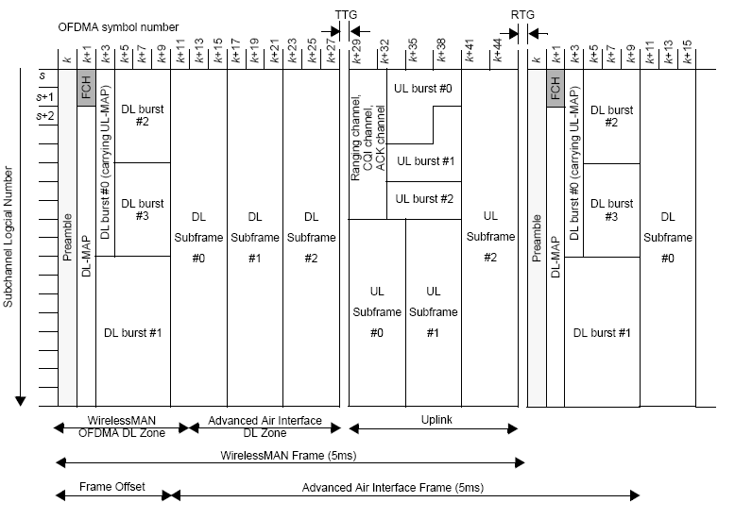
Figure 1 —TDD frame configuration for supporting the WirelessMAN-OFDMA operation with UL FDM/TDM mixed mode

The Advanced Air Interface BS shall notify the UL Subframe Configuration in the SBCH:
- The UL Subframe Configuration field shall be set to designate the subframe as either WirelessMAN-OFDMA system only subframe, Advanced Air Interface system only subframe, AMC FDM legacy support mode subframe, or PUSC FDM legacy support mode subframe from the perspective of an Advanced Air Interface MS.

Table 1 - Table 4 define the UL Subframe Configuration field for DL/UL ratios 3:5, 4:4, 5:3 and 6:2.

Table 1 - UL Subframe Configuration Mapping for 3:5 DL:UL Ratio

UL Subframe Configuration bitmap | Description | Illustration
00000 | #0,#1,#2,#3,#4: pure Advanced Air Interface or FDM legacy support for AMC
00001 | #0,#1,#2,#3: pure WirelessMAN-OFDMA  #4: pure Advanced Air Interface or FDM legacy support for AMC
00011 | #0,#1,#2: pure WirelessMAN-OFDMA  #3,#4: pure Advanced Air Interface or FDM legacy support for AMC
00111 | #0,#1: pure WirelessMAN-OFDMA  #2,#3,#4: pure Advanced Air Interface or FDM legacy support for AMC
01111 | #0: pure WirelessMAN-OFDMA  #1,#2,#3#4: pure Advanced Air Interface or FDM legacy support for AMC
10000 | #0,: FDM PUSC subframe  #1,#2,#3,#4: pure Advanced Air Interface or FDM legacy support for AMC
11000 | #0, #1: FDM PUSC subframe  #2,#3,#4: pure Advanced Air Interface or FDM legacy support for AMC
11100 | #0,#1,#2: FDM PUSC subframe  #3,#4: pure Advanced Air Interface or FDM legacy support for AMC
11110 | #0,#1,#2,#3: FDM PUSC subframe  #4: pure Advanced Air Interface or FDM legacy support for AMC
11111 | #0,#1,#2,#3,#4: FDM PUSC subframe
All Other Values | Reserved

Table 2 - UL Subframe Configuration Mapping for 4:4 DL:UL Ratio

UL Subframe Configuration Bitmap | Description | Illustration
0000 | #0,#1,#2,#3: pure Advanced Air Interface or FDM legacy support for AMC
0001 | #0,#1,#2: pure WirelessMAN-OFDMA  #3: pure Advanced Air Interface or FDM legacy support for AMC
0011 | #0,#1: pure WirelessMAN-OFDMA  #2,#3: pure Advanced Air Interface or FDM legacy support for AMC
0111 | #0: pure WirelessMAN-OFDMA  #1,#2,#3: pure Advanced Air Interface or FDM legacy support for AMC
1000 | #0: FDM PUSC subframe  #1,#2,#3: pure Advanced Air Interface or FDM legacy support for AMC
1100 | #0, #1: FDM PUSC subframe  #2,#3: pure Advanced Air Interface or FDM legacy support for AMC
1110 | #0,#1,#2,: FDM PUSC subframe  #3: pure Advanced Air Interface or FDM legacy support for AMC
1111 | #0,#1,#2,#3: FDM PUSC subframe
All Other Values | Reserved

Table 3 - UL Subframe Configuration Mapping for 5:3 DL:UL Ratio

UL Subframe Configuration bitmap | Description | Illustration
000 | #0,#1,#2: pure Advanced Air Interface or FDM legacy support for AMC
001 | #0,#1: pure WirelessMAN-OFDMA  #2: pure Advanced Air Interface or FDM legacy support for AMC
011 | #0: pure WirelessMAN-OFDMA  #1,#2: pure Advanced Air Interface or FDM legacy support for AMC
100 | #0: FDM PUSC subframe  #1,#2: pure Advanced Air Interface or FDM legacy support for AMC
110 | #0, #1: FDM PUSC subframe  #2: pure Advanced Air Interface or FDM legacy support for AMC
111 | #0,#1,#2: FDM PUSC subframe
All Other Values | Reserved

Table 4 UL - Subframe Configuration Mapping for 6:2 DL:UL Ratio

UL Subframe Configuration bitmap | Description | Illustration
00 | #0,#1: pure Advanced Air Interface or FDM legacy support for AMC
01 | #0: pure WirelessMAN-OFDMA  #1: pure Advanced Air Interface or FDM legacy support for AMC
10 | #0: FDM PUSC subframe  #1: pure Advanced Air Interface or FDM legacy support for AMC
11 | #0,#1: FDM PUSC subframe

-------------------------------------------------------End of the Text----------------------------------------------------

