Project | IEEE 802.16 Broadband Wireless Access Working Group <http://ieee802.org/16>
Title | MBS Service Areas
Date Submitted | 2009-01-12
Source(s) | Tricci So, Jerry Chow  ZTE Corporation | tso@zteusa.com
Re: | IEEE 802.16m-08/052: Call for Comments on Project 802.16m System Description Document (SDD)
Abstract | Addresses service continuity of MBS content in a wide geographic area comprising one or more MBS zones by introducing the concept of MBS service area.
Purpose | For review and adoption in SDD Text.
Notice | This document does not represent the agreed views of the IEEE 802.16 Working Group or any of its subgroups. It represents only the views of the participants listed in the “Source(s)” field above. It is offered as a basis for discussion. It is not binding on the contributor(s), who reserve(s) the right to add, amend or withdraw material contained herein.
Release | The contributor grants a free, irrevocable license to the IEEE to incorporate material contained in this contribution, and any modifications thereof, in the creation of an IEEE Standards publication; to copyright in the IEEE’s name any IEEE Standards publication even though it may include portions of this contribution; and at the IEEE’s sole discretion to permit others to reproduce in whole or in part the resulting IEEE Standards publication. The contributor also acknowledges and accepts that this contribution may be made public by IEEE 802.16.
Patent Policy | The contributor is familiar with the IEEE-SA Patent Policy and Procedures:  <http://standards.ieee.org/guides/bylaws/sect6-7.html#6> and <http://standards.ieee.org/guides/opman/sect6.html#6.3>.  Further information is located at <http://standards.ieee.org/board/pat/pat-material.html> and <http://standards.ieee.org/board/pat>.
MBS Service Areas
Tricci So, Jerry Chow
ZTE Corporation

- Introduction
This contribution introduces a hierarchical E-MBS service area architecture that supports inter-MBS-zone transitions with seamless service continuity for a given MBS service.

In today’s 802.16-Rev2, the support of inter-MBS-zone transitions with seamless service continuity for a given MBS service is achieved via the advertisement of MBS-zone neighbor information. The following diagram describes this concept of MBS-zone neighbors.

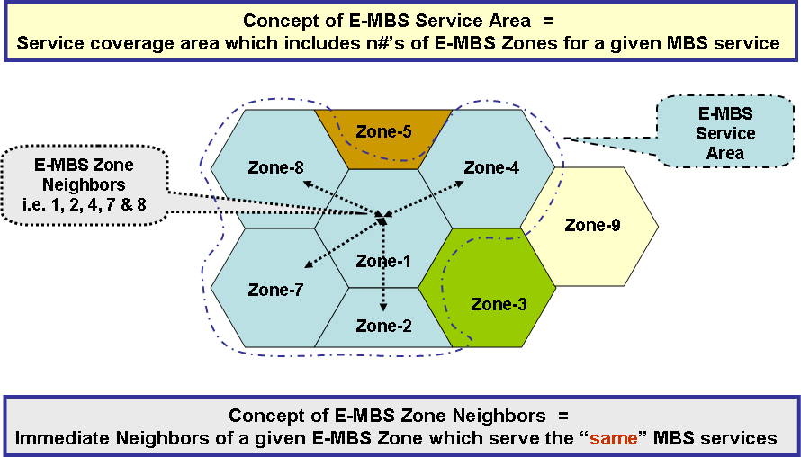
Figure 1: Concepts of the E-MBS Zone Neighbors and E-MBS Service Area

The issue with the approach using MBS-zone neighbors is the amount of zone neighbor information that is required to be advertised grows linearly with the number of the zone neighbors and with the number of the MBS services supported by the BS. Since service continuity during inter-MBS-zone transitions is generally required for a certain set of MBS contents, it is reasonable to expect that the MBS service flow parameters can remain the same between the MBS zones which serve the same MBS service. Therefore, it is unnecessary to advertise the MBS service flow parameters across the BSs which serve the same MBS service.

By utilizing this simplification of MBS service flow management between MBS zones, service continuity between MBS zones supporting the same MBS service content can easily be achieved by introducing another level in the MBS content transmission architecture. This higher level is called the MBS service area, which simply collects the set of MBS zones through which the same set of MBS service content is transmitted over the air via one or more MBS zones. An MBS service area is identified by an MBS service area identifier which the MS can use to determine if a certain set of MBS content can be received via a BS.

The intent of introducing the MBS service area is to simplify the design and to minimize the service advertisement overheads to support the service continuity; in addition, MS cell selection can utilize the identification of MBS service areas for BS selection decisions. The above figure-1 also describes the concept of the MBS service area.

To provide a better understanding of the trade-off between the E-MBS Zone neighbors and E-MBS service area, the following figure presents an example to describe both mechanisms.

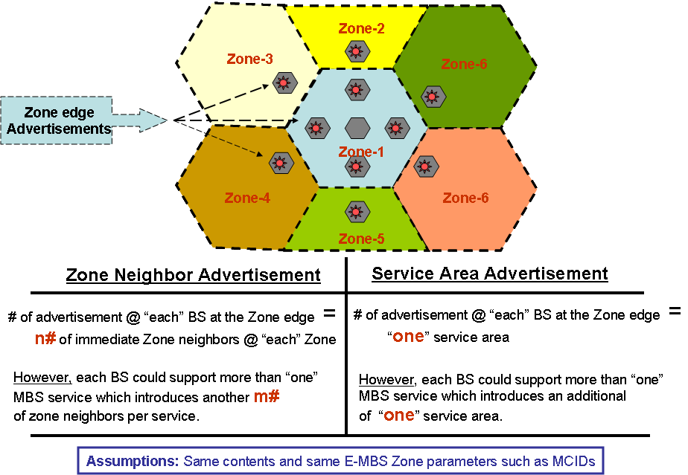

Figure 2: E-MBS Zone Neighbor vs. E-MBS Service Area Advertisements

- Proposed SDD Text Changes
---------------------------------------------------------Start of the Text-------------------------------------------------------

<Note to SDD editor: Modify Section 14.1 and 14.1.1 starting at line 19 on page 129>

14 Support for Enhanced Multicast Broadcast Service
14.1 General Concepts
Enhanced multicast and broadcast services (E-MBS) are point-to-multipoint communication systems where
data packets are transmitted simultaneously from a single source to multiple destinations. The term broadcast
refers to the ability to deliver contents to all users. Multicast, on the other hand, refers to contents that are
directed to a specific group of users that have the associated subscription for receiving such services.

Both Static and Dynamic Multicast are supported.

The E-MBS content is transmitted over an area identified as a zone. An E-MBS zone is a collection of ABSs
transmitting the same content. The contents are identified by the same identifiers (IDs). Each ABS capable of
E-MBS service can belong to one or more E-MBS zones. Each E-MBS Zone is identified by a unique E-
MBS_Zone ID.
E-MBS uses a hierarchical service area architecture to deliver MBS content for a particular MBS service to participating mobile stations with service continuity over a possibly wide geographic service area. The E-MBS hierarchical service area architecture is illustrated in Figure xx.

At the base level, particular MBS content is transmitted within the coverage area of a base station via an MBS MAC connection.

At the next higher level, MBS content being provided over one or more MBS MAC connections are transmitted in an E-MBS zone comprising a set of one or more ABSs over which the transmissions of this content are synchronized in a common fashion between these ABSs. Within an E-MBS zone, the transmissions of the same content can be sent simultaneously over the same frequency resources in order to provide RF macro-diversity. Alternatively, the E-MBS zone may only provide a lesser degree of transmission synchronization that does not provide RF macro-diversity. Within the E-MBS zone, the same values of the service flow parameters of an MBS connection, such as flow identifier and security association, apply at all ABSs so that an AMS can continue to receive MBS content from any ABS without updating service flow parameters. An E-MBS zone is identified by an E-MBS Zone Identifier.

At the highest level, an E-MBS service area for particular MBS content defines the geographic reach within which service continuity is available for that content as the AMS moves between ABSs within the E-MBS service area. An E-MBS service area is comprised of one or more E-MBS zones but an E-MBS zone belongs to one and only one E-MBS service area. The MBS content transmissions are synchronized sufficiently and the procedure for the updating of service flow parameters of MBS connections is sufficiently timely between neighboring E-MBS zones to allow service continuity to be maintained as the AMS moves between E-MBS zones within the E-MBS service area. An E-MBS service area is identified by an E-MBS Service Area Identifier.

An ABS can provide E-MBS content transmissions belonging to multiple E-MBS service areas. At an ABS, the transmissions for a particular E-MBS service area are delivered via one E-MBS zone.

BS
E-MBS zone
E-MBS service area
Zone 1
Zone 2
Zone 3
Zone 4
Service Area 1
Service Area 2
Figure xx – Illustration of E-MBS Service Area Architecture

An AMS can continue to receive the E-MBS content transmissions within the E-MBS service area zone in Connected State or Idle State. The definitions of E-MBS service area and E-MBS region are FFS.

A ABS may provide E-MBS services belonging to different MBS zones (i.e. the ABS locates in the overlapping MBS zone area).

MBS data bursts may be transmitted in terms of several sub-packets, and these sub-packets may be transmitted
in differeent subframe and to allow AMSs combining but without any acknowledgement from AMSs.

14.1.1 Relationship to Basic MBS in Reference System

Except for the introduction of E-MBS service area, Tthe basic concepts and procedures in EMBS are consistent with MBS definitions in 802.16REV2, but the concepts have been adapted to the new MAC and PHY structure.
EMBS refers to a data service offered on multicast connection using specific (E-)MBS features in MAC and
PHY to improve performance and operation in power saving modes. A ABS may allocate simple multicast
connections without using E-MBS features.

<Note to SDD editor: Modify Section 14.4.2.1 starting at line 23 on page 133>

14.4.2.1 E-MBS Zone and Service Area Configuration
Each E-MBS service area has a unique E-MBS service area identifier (ID). All the ABSs belonging to a particular E-MBS service area advertises the same E-MBS service area ID.

Each E-MBS zone has a unique zone ID within the scope of an E-MBS service area. All the ABSs in an E-MBS zone within an E-MBS service area shall broadcast advertises the same E-MBS zone ID mapping to E-MBS service area ID. If a ABS belongs to several E-MBS zones, it shall broadcast all the zone IDs with which it is
associated. If an ABS belongs to several E-MBS service areas, it advertises the E-MBS service area ID and associated ID of the E-MBS zone to which the ABS belongs within the service area.

<Note to SDD editor: Modify Section 14.4.2.4 starting at line 16 on page 134>

14.4.2.4 E-MBS Mobility Management
When an AMS moves across the E-MBS zone boundaries within an E-MBS service area, it can continue to receive MBS data from the ABS in Connected State or Idle State. Within an E-MBS zone, the MS continues to receive MBS data from any BS without requiring any updates to the service flow parameters of the associated MBS MAC connections. Within an E-MBS service area, the MS may continue to receive MBS data from any BS without requiring any updates to the service flow parameters of the associated MBS MAC connections.In Connected State, the AMS performs handover procedure for MBS.

During MBS zone transition in Idle State, the AMS may transit to Connected State to perform handover or it
may initiate MBS location update process for the purpose of MBS zone transition.

------------------------------------------------------- End of the Text --------------------------------------------------------

