Project | IEEE 802.16 Broadband Wireless Access Working Group <http://ieee802.org/16>
Title | CR for SDD Text on Interference Avoidance and Interference Mitigation of Femtocell
Date Submitted | 2009-02-27
Source(s) | Chie Ming Chou, Yung-Han Chen, Fang-Ching (Frank) Ren, Chun-Yen Wang  ITRI | chieming@itri.org.tw  chenyunghan@itri.org.tw  *<http://standards.ieee.org/faqs/affiliationFAQ.html>
Re: | IEEE 802.16m-09/0008, “IEEE 802.16m Internal Documents Configurations Control Procedure (CCP)”
Abstract | This contribution proposes modifications on interference avoidance and interference mitigation of femtocell.
Purpose | Change request for discussion and adoption in 802.16m SDD
Notice | This document does not represent the agreed views of the IEEE 802.16 Working Group or any of its subgroups. It represents only the views of the participants listed in the “Source(s)” field above. It is offered as a basis for discussion. It is not binding on the contributor(s), who reserve(s) the right to add, amend or withdraw material contained herein.
Release | The contributor grants a free, irrevocable license to the IEEE to incorporate material contained in this contribution, and any modifications thereof, in the creation of an IEEE Standards publication; to copyright in the IEEE’s name any IEEE Standards publication even though it may include portions of this contribution; and at the IEEE’s sole discretion to permit others to reproduce in whole or in part the resulting IEEE Standards publication. The contributor also acknowledges and accepts that this contribution may be made public by IEEE 802.16.
Patent Policy | The contributor is familiar with the IEEE-SA Patent Policy and Procedures:  <http://standards.ieee.org/guides/bylaws/sect6-7.html#6> and <http://standards.ieee.org/guides/opman/sect6.html#6.3>.  Further information is located at <http://standards.ieee.org/board/pat/pat-material.html> and <http://standards.ieee.org/board/pat>.
CR for SDD Text on Interference Avoidance and Interference Mitigation of Femtocell

Chie Ming Chou, Yung-Han Chen, Fang-Ching (Frank) Ren, Chun-Yen Wang

ITRI

Introductions
In femtocell network, the number of femtocell BS is huge and licensed bandwidth of operator is limited. A femtocell BS uses the same carrier frequency with macro cell BS is an inevitable solution. Unfortunately, when same carrier frequency is used, huge interference may be introduced. As shown in figure 1, there are two worst cases:
(1) When the location of femtocell BS is close to a macro cell BS, then macro cell’s DL power may interfere with femtocell BS’s DL power, e.g. MS1 which was served by femtocell BS1 may have strong interference from macro cell BS This case can be detected during femtocell BS’s initialization. (2) When an inaccessible MS goes into the coverage of a femtocell BS and be far away from the macro cell, then macro BS may recommend MS to increase its UL power. Hence, the UL power of inaccessible MS may interfere with the UL power of accessible MS and make poor transmission, e.g. MS3 is served by macro cell BS and be not allowable to enter the femtocell BS2. Because of longer distance, macro cell BS will request MS3 transmits with large power and this may interfere with UL power from MS4 which is served by femtocell BS2. This case happened dynamically and be dependent on the location of MS served by the overlapped macro cell BS.
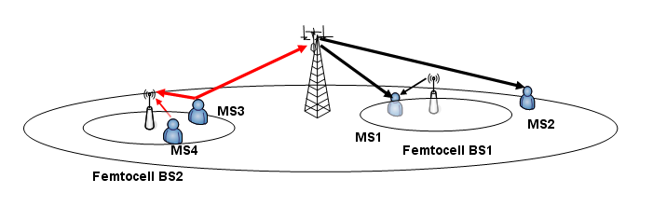
Figure 1; Interference when femtocell BS uses the same carrier frequency with macro cell BS

Current SDD text has already specified the interference avoidance and mitigation scheme in Section 17.8. To well support interference avoidance and mitigation, the radio resource reservation and sharing needs to more be flexible. We propose additional functionalities and capabilities for those mechanisms to optimize the resources utilization.

Proposals
The concept of dynamic reserving radio resources from macro cell for femtocell BS’s usage is proposed. A femtocell zone is a region which was originally used by a macro cell BS. When a new developed or operating femtocell BS finding there is no clear channel to provide a good transmission for its serving MSs or serving MSs give the complaint about interference, then femtocell BS will request neighboring macro cell to reserve one of its resources for femtocell BS’s transmission. While macro cell BS agrees to grant this region to femtocell BS, the macro cell BS could not allocate its MSs in this region. Alternatively, a femtocell BS could start schedule the transmission on this region after receiving the agreement. The femtocell zone might be shared with multiple femtocell BSs to acquire the spatial multiplexing benefit. The configuration of femtocell zone could be dynamic. If there is no MSs under femtocell BS’s coverage or interference problem has been resolved, then the femtocell zone could be released to macro cell BS.
Once the femtocell zone is used, a femtocell BS could place an indicator in its BCH to tell its serving MSs that a potential region for their transmissions. The indicator may indicate the allocation of the femtocell zone. This can avoid MS reading signaling from other BSs. Inside the femtocell zone, associated USCCH will be given to point out to the corresponding data location for individual MSs. From MS’s view, it will first read the broadcast message and know the allocation of total femtocell zone, and then MS could decode and acquire its individual data based on the indictor in the femtocell zone. Figure 2 is an example of control structure for this usage.

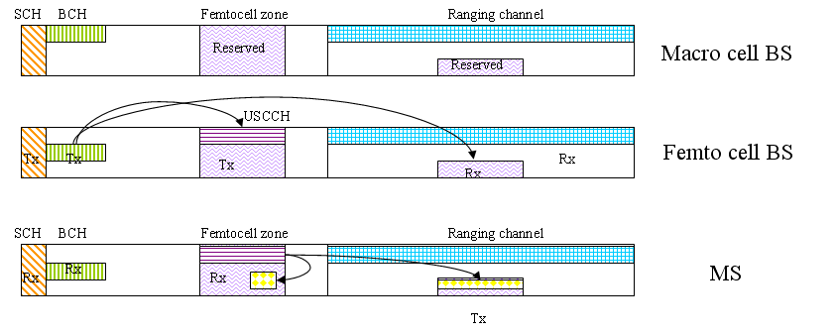
Figure 2; The control structure of femtocell zone

Furthermore, during femtocell BS’s SON, a femtocell BS may coordinate with macro cell BS to reserve a radio resource region for putting its broadcast control signaling such as BCH. The Advanced Preamble can be used to derive the resource block arrangements. Figure 3 is an example which shows both the control signaling and data signaling of a femtocell BS can be allocated in individual reserved radio resources.
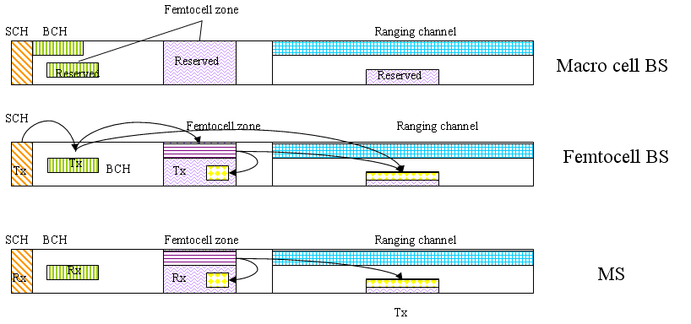
Figure 3; Femtocell zone applied for control signaling and data

Proposed SDD Text Modification
[Modify section 17.8 as follows in red color underline]
-------------------------------------------------------- Text Start ------------------------------------------------------------

17.8 Interference Avoidance and Interference Mitigation

An MS may be requested by its serving BS to report the signal strength measurement of neighbor BSs, including macro and/or Femtocell BSs. The reported information can be used by the serving BS to coordinate with its neighbor BSs to mitigate interference caused to MSs at the coverage boundary of macro BSs and Femtocell BSs. Large interference from an inaccessible Femtocell may trigger a nearby MS to report the interference to the serving BS. The serving BS and/or the network may request the interfering Femtocell BS to mitigate the interference by reducing transmission power, and/or blocking some resource region. In order to enable the interference avoidance or mitigation schemes, the Femtocell BS shall be capable to scan the signals transmitted from neighbor BSs.

Alternatively, the interference between Femtocells and/or macro cells can be mitigated by static or semi-static radio resource reservation and resource sharing using FDM and/or TDM manner. A reserved radio resource may be further shared among multiple femtocell BSs. The operation of resource reservation shall not contradict with the FFR operation defined in 20.1. A Femtocell BS may detect and reserve the resources autonomously, or in cooperation with the overlay macro BS. The reservation could be static, or semi-static or dynamic based on event-trigger. When radio resource reservation is used and be gathered in a zone with sub-frame unit, a femtocell BS may give corresponding allocation indications in broadcast control signaling for its MSs. An MS connected to a macro BS may detect the least interfered resource from surrounding Femtocells and report to the serving BS, so that the serving BS may select appropriate resources for its traffic.

In order to reduce interference on the control signaling such as SFH and essential control signaling of Femtocells and/or macro BSs, different resources block arrangements may be used among Femtocells and/or macro cells for transmitting control signaling. Radio resource reservation and resource sharing may be also applied for the control signaling arrangements. The MS can derive the resource block arrangements for control signaling based on Advanced Preamble (A-PREAMBLE).

In all cases a Femto BS may select the carrier frequency to avoid the mutual interference between macro/micro cells and Femtocells or among Femtocells based on the measurement result of surrounding reception power. The Femto BS may select the carrier frequency to avoid the interference to the overlay macro/micro BS.

-------------------------------------------------------- Text End ------------------------------------------------------------

