Project | IEEE 802.16 Broadband Wireless Access Working Group <http://ieee802.org/16>
Title | Change Request for the multiplexing scheme for E-MBS Zone Specific Pilot in 802.16m SDD
Date Submitted | 2009-02-27
Source(s) | Takaaki KISHIGAMI,  Isamu YOSHII  Panasonic Corporation  Tsuguhide Aoki,  Shigeo Terabe,  Yong Sun  Toshiba Corporation | Voice: + 81-46-840-5123  E-mail: kishigami.takaaki@jp.panasonic.com  yoshii.isamu@jp.panasonic.com  tsuguhide.aoki@toshiba.co.jp  shigeo.terabe@toshiba.co.jp  Sun@toshiba-trel.com
Re: | Change Request to 802.16m SDD (802.16m-08/003r7)  - Target topic: “11.5.3.2 E-MBS zone specific pilot for MBSFN ”.
Abstract | We propose the E-MBS zone specific scrambled and/or interlaced pilots in order to reduce inter-zone interference..
Purpose | For 802.16m discussion and adoption
Notice | This document does not represent the agreed views of the IEEE 802.16 Working Group or any of its subgroups. It represents only the views of the participants listed in the “Source(s)” field above. It is offered as a basis for discussion. It is not binding on the contributor(s), who reserve(s) the right to add, amend or withdraw material contained herein.
Release | The contributor grants a free, irrevocable license to the IEEE to incorporate material contained in this contribution, and any modifications thereof, in the creation of an IEEE Standards publication; to copyright in the IEEE’s name any IEEE Standards publication even though it may include portions of this contribution; and at the IEEE’s sole discretion to permit others to reproduce in whole or in part the resulting IEEE Standards publication. The contributor also acknowledges and accepts that this contribution may be made public by IEEE 802.16.
Patent Policy | The contributor is familiar with the IEEE-SA Patent Policy and Procedures:  <http://standards.ieee.org/guides/bylaws/sect6-7.html#6> and <http://standards.ieee.org/guides/opman/sect6.html#6.3>.  Further information is located at <http://standards.ieee.org/board/pat/pat-material.html> and <http://standards.ieee.org/board/pat>.

Change Request for the multiplexing scheme
for E-MBS Zone Specific Pilot in 802.16m SDD

Takaaki KISHIGAMI, Isamu YOSHII
Panasonic Corporation

Introduction
During #59, we agreed a MBSFN channel model for E-MBS pilot design[3] and withdrew the related comments for further evaluations[7]. Although main discussion for these proposals was to decide a common E-MBS pilot design, our discussion point in previous contribution[6] was how to avoid the inter-E-MBS zones interference among neighboring E-MBS zones which provide different MBSFN services.
Followings are potential multiplexing schemes [2].
  - Scrambled pilot scheme : E-MBS zone-specific scrambling code is multiplied to the basic pilot pattern.
  - Interlaced pilot scheme : E-MBS zone-specific frequency/time offset is applied to the basic pilot pattern.
In following discussions, we show the performance gain comparing between those schemes by the link level simulation based on the MBSFN channel model[3].

E-MBS Zone Specific Pilot structure
2.1 Scrambled pilot scheme
Figure 1 shows a scrambled pilot scheme. The example is a scrambling code using phase rotation in a E-MBS zone with three E-MBS zones and a basic pilot pattern based on the 802.16e Downlink PUSC[4]. In the figure, the phase rotation for P_{k} illustrates the pilot symbol transmitted for stream #k. The maximum number of streams within the E-MBS zone is two[1]. The phase rotation(φ) of 0, 2π/3, and 4π/3 is added every adjacent pilot subcarrier to the E-MBS zone #1, #2, and #3, respectively.
When the proposed scrambled pilot scheme is used, the inter-E-MBS zone interference on the pilot channel from the neighboring E-MBS zones can be avoided by dispreading among neighbor pilot subcarrier, leading to accurate channel estimation.
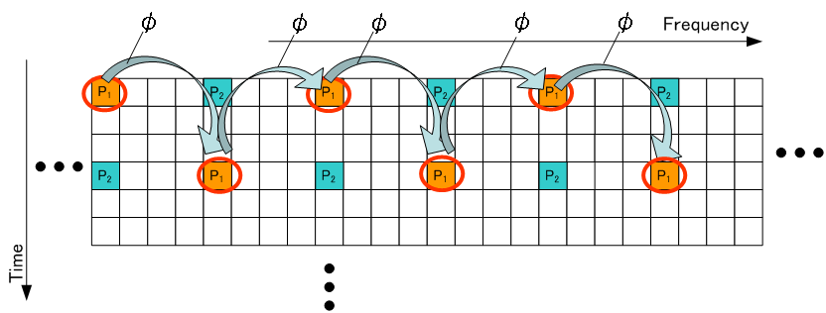$φ=\left\{\begin{matrix} 0 (\text{for} \text{Zone} & 1)\begin{matrix} \\ \\ \end{matrix}2) \\ \frac{4π}{3} (\text{for} \text{Zone} & 3)\end{matrix}\right.$

Figure 1 – Example of scrambled pilot scheme for E-MBS specific pilot

2.2 Interlaced pilot scheme
Figure 2 shows an interlaced pilot scheme. The E-MBS zone specific offset is applied to the basic pilot pattern which is defined as the pilot pattern in E-MBS zone #1. The offset in the E-MBS zone #k is (k-1)ΔSC. (Figure 2 shows the case of ΔSC =1.) The offset of pilot positions is given in frequency/time direction for the basic pilot pattern as shown in Figure 1 . The E-MBS zone specific offset is applied to all pilot symbols for up to two streams(P₁, P₂).
In the non-orthogonal pilot channel structure using the E-MBS zone specific offset, the inter-E-MBS zone interference on the pilot signals, especially power boosted pilot case, can be reduced compared to the no offset case, although the interference from the pilot channel to the data channel is increased at the same time.
E-MBS Zone
#1
E-MBS Zone
#2
E-MBS Zone
#3
Figure 2 – Example of interlaced pilot scheme for E-MBS specific pilot

Simulation Evaluations
We compare three pilot scheme(scrambled, interlaced and non zone-specific pilots) as shown in Figure 3. The scrambled pilots, interlaced pilots are as same as descried in Section 2.1 and 2.2. We evaluate the case with cyclic time offset within PRU(ΔSC =1 [OFDM symbol]) for interlaced pilots and evaluate three kinds of basic pilot patterns shown in Figure 5. In figure 6, the scrambled pilots for each basic pilot pattern are shown. The transmission power of the pilot symbol is set to 5dB higher than that of the data symbol.
E-MBS Zone
#k
E-MBS Zone
#(k+1)
(a)Scrambled pilots (b)Non zone-specific pilots (c)Interlaced pilots
Figure 3– Evaluated pilot scheme
We investigate the effect of the E-MBS zone specific pilots from the viewpoint of the BLER performance in a E-MBS zone with three E-MBS zone. Table 1 lists the radio parameters assumed in the link-level simulations. Figure 4 shows the interference model among E-MBS zones. The parameter of inter-E-MBS zone interference [ΔI=P_{zone#1}/ (P_{zone#2} + P_{zone#3})] represents the difference in the average received signal power at a MS in E-MBS zone #1, corresponding to the difference in the distances from the neighboring BSs in two E-MBS zones(#2, #3). Figure 7 plots the BLER performance in case of ΔI =6, 9, 12 and 15 dB.
We find that both of the scrambled pilots and interlaced pilots are better throughput performance compared to that of the non-zone specific pilot scheme. The scrambled pilots are more effective than the interlaced pilots when the pilot density is relatively large like LGE' pilot pattern, and when inter-MBS zone interference is relatively large such as ΔI =6 or 9[dB].

Figure 4 – Simulation model considering inter-E-MBS zones interference

Table 1 – Simulation Parameters

Parameter | Value
OFDM parameters | 10 MHz (1024 subcarriers)
Number of OFDM symbols per subframe | 6
Data burst size | 4 PRUs distributed over 48 PRUs
Permutation | Tone based LDRU
Number of total RU in one subframe | 48
Number of Antennas | 2 transmitter antennas, 2 receiver antennas [2Tx,2Rx]
Transmission mode | Rate 1 transmission scheme : SFBC
Modulation/Coding | QPSK, R=1/2,3/4; 16QAM, R=1/2,3/4  with CTC FEC (8 Turbo decoding iterations)
Channel model | MBSFN channel models for 1.5km ISD  with MS speed of 120km/h
Channel estimation | MMSE channel estimator with 3 PRU level CE
Pilot boosting | 5dB
MIMO detector | LMMSE for rate 2 scheme
Scenarios | Interference Limited (Inter-zone interference is two interfering zone signals with equal power ratio.)  The inter-E-MBS zone interference: ΔI=6, 9 , 12, 15 dB

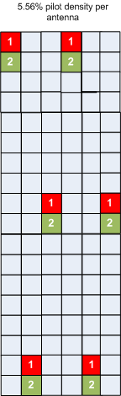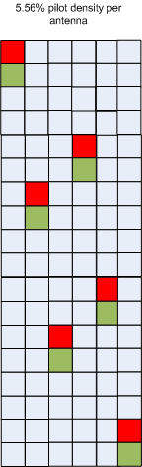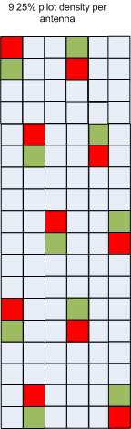
(a) Pattern A in SDD[1] (b)Intel’s proposal[8] (c) LGE’s proposal[5]
Figure 5 – Basic pilot pattern used for evaluation

$φ=\left\{\begin{matrix} 0 (\text{for} \text{Zone} & 1)\begin{matrix} \\ \\ \end{matrix}2) \\ \frac{4π}{3} (\text{for} \text{Zone} & 3)\end{matrix}\right.$
(a) Pattern A in SDD[1] (b)Intel’s proposal[8] (c) LGE’s proposal[5]
Figure 6 – Scrambled pilots used for evaluation

Scrambled zone pilots
Non zone specific pilots
Interlaced zone pilots
CDM pilots
ΔΙ=6dB
ΔΙ=9dB
ΔΙ=12dBB
ΔΙ=15dBdB
(a-1)Pattern A in SDD, 2x2 SFBC, QPSK R=1/2 ,120km/h

Scrambled zone pilots
Non zone specific pilots
Interlaced zone pilots
CDM pilots
ΔΙ=6dB
ΔΙ=9dB
ΔΙ=12dBB
ΔΙ=15dBdB
(a-2)Pattern A in SDD, 2x2 SFBC, 16QAM R=1/2 ,120km/h

ΔΙ=6dB
ΔΙ=9dB
ΔΙ=12dBB
ΔΙ=15dBdB
Scrambled zone pilots
Non zone specific pilots
Interlaced zone pilots
CDM pilots
(b-1)Intel’s Pattern: 2x2 SFBC, QPSK R=1/2 ,120km/h

ΔΙ=6dB
ΔΙ=9dB
ΔΙ=12dBB
ΔΙ=15dBdB
Scrambled zone pilots
Non zone specific pilots
Interlaced zone pilots
CDM pilots
(b-2)Intel’s Pattern: 2x2 SFBC, 16QAM R=1/2 ,120km/h

ΔΙ=6dB
ΔΙ=9dB
ΔΙ=12dBB
ΔΙ=15dBdB
Scrambled zone pilots
Non zone specific pilots
Interlaced zone pilots
CDM pilots
(c-1)LGE’s Pattern, 2x2 SFBC, QPSK R=1/2 ,120km/h

ΔΙ=6dB
ΔΙ=9dB
ΔΙ=12dBB
ΔΙ=15dBdB
Scrambled zone pilots
Non zone specific pilots
Interlaced zone pilots
CDM pilots
(c-2)LGE’s Pattern, 2x2 SFBC, 16QAM R=1/2 ,120km/h

Figure 7 – BLER performance

Conclusions
We presented the improved performance of the E-MBS zone-specific scrambled and interlaced pilot scheme compared to the non zone-specific pilots scheme by link-level simulation evaluation considering inter-E-MBS zone interference. The scrambled pilots would be more effective than the interlaced pilots if the pilot density increases. This causes the higher correlation between pilot tones in higher pilot density pattern .
We thought the MBSFN pilot would be the higher density pattern than unicast pilot because of adjusting to the larger delay spread caused by the MBSFN channel, and the scrambled pilot scheme would be preferable than interlaced pilot scheme.
However, the basic pilot pattern for MBSFN is not decided at the current stage. Hence, it would be wise to remain the possibility to further examine both scrambled and interlaced pilot.

Proposed Change Text in 16m SDD[1]
Section 11.5.3.2 E-MBS zone specific pilot for MBSFN, page 77, line 17
- Replace the following text
“The definitions of the E-MBS zone specific pilots are FFS.”
with
“The E-MBS zone specific pilots use the E-MBS zone specific scrambled and/or interlaced structure to reduce the inter-E-MBS zone interference.”

References
[1]IEEE 802.16m-08/003r7, “The Draft IEEE 802.16m System Description Document”
[2]IEEE C802.16mDL_PHY-08/716, Panasonic, “Sector-Specific Common Pilot Structure in IEEE802.16m Downlink.”
[3]IEEE C80216m-09/0089r2, “Modeling MBSFN Channels”
[4]IEEE Std 802.16e-2005.
[5]IEEE C802.16m-09/0127, LGE, ” Considerations on the E-MBS in 802.16m : Pilot patterns for 1 and 2 MBS data streams”
[6] IEEE C802.16m-09/0163, Panasonic,” Proposed text for E-MBS Zone Specific Pilot Structure for MBSFN”
[7] IEEE 802.16m-09/0011, “IEEE 802.16m Minutes of Session #59, San Diego, CA, USA”
[8]IEEE C802.16m-09/0090, Samsung, ” E-MBS Zone Specific Pilot Patterns for MBSFN”

