Project | IEEE 802.16 Broadband Wireless Access Working Group <http://ieee802.org/16>
Title | MAC Header Structures and Formats
Date Submitted | 2009-02-27
Source(s) | Xiao Xu, Hua Xu | hua.xu@motorola.com
Re: | Change Request on Project 802.16m System Description Document (SDD IEEE 80216m-08_003r7), MAC, MAC header design
Abstract | This contribution proposes MAC header formats for 802.16m SDD
Purpose | To be discussed and adopted for 802.16m SDD
Notice | This document does not represent the agreed views of the IEEE 802.16 Working Group or any of its subgroups. It represents only the views of the participants listed in the “Source(s)” field above. It is offered as a basis for discussion. It is not binding on the contributor(s), who reserve(s) the right to add, amend or withdraw material contained herein.
Release | The contributor grants a free, irrevocable license to the IEEE to incorporate material contained in this contribution, and any modifications thereof, in the creation of an IEEE Standards publication; to copyright in the IEEE’s name any IEEE Standards publication even though it may include portions of this contribution; and at the IEEE’s sole discretion to permit others to reproduce in whole or in part the resulting IEEE Standards publication. The contributor also acknowledges and accepts that this contribution may be made public by IEEE 802.16.
Patent Policy | The contributor is familiar with the IEEE-SA Patent Policy and Procedures:  <http://standards.ieee.org/guides/bylaws/sect6-7.html#6> and <http://standards.ieee.org/guides/opman/sect6.html#6.3>.  Further information is located at <http://standards.ieee.org/board/pat/pat-material.html> and <http://standards.ieee.org/board/pat>.

MAC Header Structures and Formats
Xiao Xu, Hua Xu
Motorola, Inc.

Introduction
The generic MAC header (GMH) in IEEE 802.16e-2005 reference system is 6 bytes, which needs to be present in every MAC PDU. Lots of other overheads also need to be added, including subheaders, extended subheaders and CRCs. For some applications with small payload sizes such as VoIP, this significantly reduces efficiency and degrades system capacity.

The 16e Generic MAC Header (GMH) is illustrated by Figure 19 below. Careful analysis will show that many of the fields can be reduced or eliminated without functional impairment to the system.
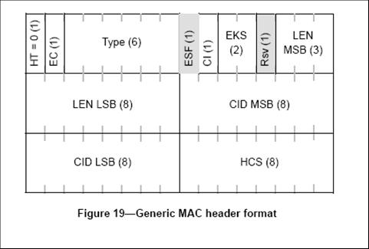

Detailed discussions of MAC headers

Generic MAC Header Fields

The following changes will happen to generic MAC header fields:
- Header type (HT) – denotes whether the header is generic or compact..
- FlowID – if the flow ID (transport CID) is used in the resource allocation, we do not need to repeat this every packet unless the allocation is for multiple flows for a single MS. In that case, a shorter 4-bit flow identifier can be used to identify flows within one MS.
- EC – can be removed from the header and exchanged during connection establishment process only. No need to be transmitted in every MAC PDU.
- CI – No need to retain 4-byte MAC PDU CRC. CI is also unnecessary.
- Type – after changing all the subheaders and extended subheaders to the extended header format, we no longer need these Type bits for the five 16e subheaders. For example we no longer need a bit to indicate fragmentation subheader as it is replaced by the FFI field and the PDU SN field. Also since ARQ is not used for every connection the ‘Extended’ and ‘ARQ feedback’ bits can be moved to an extended header.
- EH – New 1-bit field which Indicates if extended headers are present.
- FFI – New 1-bit field to indicate whether it’s the first fragment. This field together with the PDU SN field eliminates the need for FSH (fragmentation subheader).
- MSN – MAC sequence number. This replaces the ARQ BSN, fragmentation SN, and PDU SN, which are defined in previous version of the standards. The MSN is designed for MAC data block re-sequencing and ARQ retransmission window management.
- EKS – If encryption is enabled, these 2 bits are needed for every PDU. Can be put into the 2 LSB of PN (4 bytes), leaving 30 bits for PN.
- HCS – extra protection for header, if HARQ is enabled this is redundant since HARQ CRC is enough.

Extended Headers

In 16e there are 5 subheaders (packing, fragmentation, and grant management, etc) and some extended headers. The extended subheaders are organized into a group format while the subheaders are not. There is really no point in differentiating the subheaders from the extended subheaders. They can all be called extended headers’ and organized into a group format that is very similar to the 16e extended subheader group format. This is a more logical and uniform way of organizing these extended headers. The order of the extended headers is FFS.

Proposed SDD text Changes

================= Start of Proposed Text ========================

[Delete all text in 10.12.1.1 in SDD and insert the following text:]
10.12.1.1 Generic MAC Header
In 802.16m, MAC headers consist of the generic MAC header (GMH) or the compact MAC header (CMH) and extended headers. The first bit of the header is Header Type (HT). When HT = 0, it indicates a generic MAC header which follows the format in Figure 22. Description of the fields of the GMH is in Table 1.

Figure 22. Generic MAC Header (GMH) Format (HT = 0)

Table 1. Generic MAC Header Fields

[Delete all text in 10.12.1.2 in SDD and insert the following text:]
10.12.1.2 Compact MAC Header
When HT = 1, it indicates a compact MAC header (CMH). The compact MAC header is used for persistent allocations such as VoIP and fixed-size SDUs such as TCP ACKs. Since the CMH is for small packets, there shall be no fragmentation, which eliminates the FFI field. There are two types of CMHs depending on the value of the CT field, which follow the formats in Figure 23 and Figure 24 respectively. Description of the fields of the CMH is in Table 2.

Figure 23. Compact MAC Header (CMH) Format Type 1
Figure 24. Compact MAC Header (CMH) Format Type 2

Table 2. Compact MAC Header Fields

10.12.2 Extended header
The inclusion of extended header is indicated by EH indicator bit in MAC Header. The EH format is shown in Figure 23 Figure 25 and will be used unless specified otherwise.
Length of extended header group
Figure 25. Extended Header Group Format

[Delete all text in 10.12.2.1 in SDD and insert the following text:]
10.12.2.1 Packing extended header
The format of the packing extended header is illustrated in figure 26. The packing extended header is only included when there are more than one SDU fragments in the MAC PDU. There is one packing extended header for each MAC PDU, covering all SDU fragments.
- ‘Num SDUs’ field denotes the number of SDU fragments in this MAC PDU.
- ‘Length field’ is variable length, which contains (n-1) x 11 bits, where n is the number of SDU fragments in this MAC PDU, corresponding to the ‘Num SDUs’ field. Since the GMH includes a Length field, which covers the total length of the MAC PDU, the length of the n^{th} SDU fragment can be derived.

Figure 26. Packing Extended Header Format
10.12.2.2 Security extended header
The format of the packing extended header is illustrated in figure 27. The presence of the security extended header in a MAC PDU indicates that all MAC PDUs in the HARQ block after this MAC PDU (inclusive) are encrypted. All encrypted MAC PDUs shall be associated with the same SA and the encryption shall be done using the key material associated with this SA. The content of the security extended header includes the PN (4 bytes), which includes the 2-bit EKS in its LSB.

With the presence of the security extended header, construction of the HARQ block which contains multiple MAC PDUs, each containing SDUs from a single flow, is shown in Figure 28.
Figure 27. Security Extended Header Format
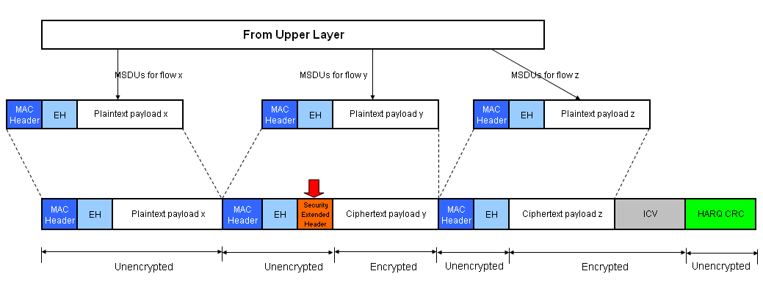
Figure 28. Construction of a HARQ block with security information

============================== End of Proposed Text ===============

References
[1] IEEE Std. 802.16e-2005, IEEE Standard for Local and metropolitan area networks, Part 16: Air Interface for Fixed and Mobile Broadband Wireless Access Systems, Amendment 2: Physical and Medium Access Control Layers for Combined Fixed and Mobile Operation in Licensed Bands, and P802.16Rev2/D5 (June 2008).
[2] IEEE 802.16m-08/003r2, “The Draft IEEE 802.16m System Description Document”

