Project | IEEE 802.16 Broadband Wireless Access Working Group <http://ieee802.org/16>
Title | HARQ Bit Selection Algorithm
Date Submitted | 2009-03-10
Source(s) | Yu-Chuan Fang, ¹Zheng Yan-Xiu,  Ren-Jr Chen, Chang-Lan Tsai,  Chung-Lien Ho, Chien-Yu Kao,  Cheng-Ming Chen, ²Yu-Tao Hsieh,  Jen-Yuan Hsu, Pang-An Ting,  ITRI  Wern-Ho sheen, NCTU/ITRI | Voice:  ¹+886-3-5914715  ²+886-3-5914854  E-mail:  ¹zhengyanxiu@itri.org.tw  ²ythsieh@itri.org.tw
Re | IEEE 802.16m-09/0012, “Call for Contributions on Project 802.16m Amendment Working Document (AWD) Content”.  Target topic: “Channel Coding and HARQ”.
Abstract | The contribution proposes the HARQ bit selection algorithm for IEEE 802.16m. The algorithm enhances the performance of 16e channel interleaver and further improves 16e IR-HARQ and CC-HARQ performance.
Purpose | To be discussed and adopted by TGm for the 802.16m amendment.
Notice | This document does not represent the agreed views of the IEEE 802.16 Working Group or any of its subgroups. It represents only the views of the participants listed in the “Source(s)” field above. It is offered as a basis for discussion. It is not binding on the contributor(s), who reserve(s) the right to add, amend or withdraw material contained herein.
Release | The contributor grants a free, irrevocable license to the IEEE to incorporate material contained in this contribution, and any modifications thereof, in the creation of an IEEE Standards publication; to copyright in the IEEE’s name any IEEE Standards publication even though it may include portions of this contribution; and at the IEEE’s sole discretion to permit others to reproduce in whole or in part the resulting IEEE Standards publication. The contributor also acknowledges and accepts that this contribution may be made public by IEEE 802.16.
Patent Policy | The contributor is familiar with the IEEE-SA Patent Policy and Procedures:  <http://standards.ieee.org/guides/bylaws/sect6-7.html#6> and <http://standards.ieee.org/guides/opman/sect6.html#6.3>.  Further information is located at <http://standards.ieee.org/board/pat/pat-material.html> and <http://standards.ieee.org/board/pat>.
HARQ Bit Selection Algorithm

Yu-Chuan Fang, Zheng Yan-Xiu, Ren-Jr Chen, Chang-Lan Tsai, Chung-Lien Ho,
Chien-Yu Kao, Cheng-Ming Chen Yu-Tao Hsieh, Jen-Yuan Hsu, Pang-An Ting,
ITRI

Wern-Ho sheen
ITRI/NCTU

- Introduction
The CTC (Convolutional Turbo Code) of code rate 1/3 defined in the IEEE 802.16e standard [1] is adopted in IEEE 802.16m SDD [2]. In IEEE 802.16e, CTC subpacket generation is used to generate different subpackets for HARQ packet transmission. It plays the role of channel interleaver and its procedure comprises bit separation, subblock interleaving, bit grouping and bit selection. In the higher modulation, the constellation provides different level of protection. However, the channel interleaver has a problem that some contiguous bits would be mapped onto the location with low protection and the reliability distribution of systematic and parity bits corresponding to the same information bit is not uniform. This will degrade the decoding performance of turbo decoder. Therefore, a more robust modified channel interleaver is required for the IEEE 802.16m to pursue better error performance and higher throughput. On the other hand, HARQ is an attractive technique to promote system throughput. Herein, HARQ bit selection algorithm is proposed to cater to the requirement. It not only considers the average reliability distribution but also provides more diversity gains for HARQ. Furthermore, the selection of coded bits is performed circularly over the buffer and the subpacket size may change as mentioned in SDD [2].

- Proposed HARQ bit selection
The modified channel interleaver for CTC comprises several parts.
- Bit separation
- Subbock interleaving
- Bit grouping
- Bit selection
The bit separation and subblock interleaving continue using that specified in [1]. The bit grouping may refer to the new bit grouping proposal (C-symbol permutation) [6], or the proposal “BPM” of ITRI [7]. In this contribution a bit selection method supporting HARQ is investigated and proposed. The process may be divided into five procedures for convenience of discussion.
- Bit prioritization (BP)
BP prioritizes all coded bits according to the desired reliability distribution among systematic and parity bits.
- Prioritized circular reading (PCR)
PCR accesses the bits in the buffer circularly and contiguously by an initial index. It controls the prioritized coded bits on the desired MSB or LSB of a symbol and minimizes complexity of buffer reading.
- Priority Swapping (PS)
PS swaps the priority and reassigns the coded bits to MSB or LSB to average modulation effect.
- Shifted IR redundancy version selection (SIRRVS)
SIRRVS improves performance by selecting code bits at first when complete code bits are selected to obtain coding gain as shown in Fig. 1.
- Bit inverting (BI)
BI logically inverts coded bits by exclusive-OR with 1 to acquire more constellation diversity gain.
Through these functions, the subpacket would be read out. In the following clauses the bit selection methods for CC-HARQ and IR-HARQ are illustrated.

Fig. 1 An illustration of the shifted IR redundancy version selection (SIRRVS).

2.1 CC-HARQ mode
Fig. 1 and Fig. 2 illustrate the CC-HARQ bit selection method for 16-QAM, R=1/2 and 64-QAM, R=1/2 respectively, where R represents the puncturing code rate. Assume N_{EP} bits are encoded by the CTC encoder and 3N_{EP} bit are generated. The subpacket at the first transmission consists of L_{k} bits denoted as . The bit selection forms four kinds of subpackets according to the initial position F_{k}, where k is the subpacket index and k = 0, 1, 2, 3. The bit first selected of the k-th subpacket is denoted as . When the initial position is determined, the bits are accessed contiguously and circularly to generate the k-th subpacket for retransmissions. (k = 0 for the first transmission)
In addition, the bit inverting is used to scramble the bit with lower constellation protection. For 16-QAM, the latter bit per two bits is exclusive-ORed by 1 when k = 1 and 2. On the other hand, for 64-QAM, the last two per three bits are exclusive-ORed by 1 when k = 1.
Fig. 2 An illustration of the bit selection method for CC-HARQ with 16-QAM and code rate 1/2.

Fig. 3 An illustration of the bit selection method for CC-HARQ with 64-QAM and code rate 1/2.

The parameters are defined as follows.

If is the mother codeword, the k-th subpacket according to F_{k} is denoted as , where and . For example, when k=0, the subpacket is . The proposed algorithm for CC-HARQ bit selection is shown below.

2.2 IR-HARQ mode
The systematic or parity bits are selected contiguously and circularly from the mother codeword to form a subpacket according to the starting position, N_{start}, and the length of subpacket, L_{k}. The selected bits are separated into two groups. If N_{start} + L_{k} < 3N_{EP}, the first group length is N_{EP} and the second group length is L_{k}–N_{EP}. Otherwise, the first group length is 3N_{EP}–N_{start} and the second group length is L_{k}–(3N_{EP}–N_{start}). The bits of the two groups can accessed in parallel and the initial position of each group, or , may change according to the index k. It seems the two groups are circularly shifted by a number of bits, and , respectively. Besides, Shifted IR redundancy version selection (SIRRVS) is utilized herein to improve performance by selecting parity bits at first when complete coded bits are selected. Finally, some bits are exclusive-ORed by 1 in the same cases as CC-HARQ.
Fig. 4 - Fig.6 are the examples for the IR-HARQ mode. The k-th subpacket is assumed for the k-th transmission, i.e. k=0 for the initial transmission, the length for each transmission is the same as L_{k}, and the subpackets are continuously selected. Thus, k =0 for 1st TX (transmission), k =1 for 2nd TX, k =2 for 3rd TX and k=3 for 4th TX.

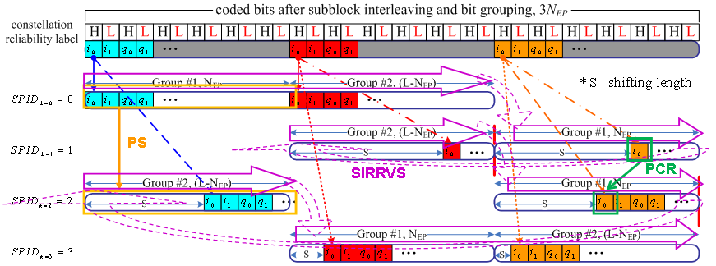
Fig. 4 An illustration of the bit selection method for IR-HARQ with 16-QAM and code rate 1/2.

Fig. 5 An illustration of the bit selection method for IR-HARQ with 64-QAM and code rate 1/2.

Fig. 6 An illustration of the bit selection method for IR-HARQ with 16-QAM and code rate 3/4.

The IR-HARQ bit selection algorithm is integrated into the following expressions.

- Simulation Results

Simulation parameters:
Carrier Frequency | 2.5GHz
FFT Size (N) | 1024
Guard Interval | 1/8
MS Velocity | Ped-B 3 km/hr or Veh-A 60km/hr
Resource Allocation | Distributed resource allocation
Channel Coding | CTCs with 8 iterations, Max-Log-MAP
HARQ Type | Chase Combining (CC),  Incremental Redundancy (IR)
N_{EP} | Chase case: | 16QAM 1/2 : 480 bits * 2 FEC (5 RBs)  64QAM 1/2 : 432 bits * 2 FEC (3 RBs)
N_{EP} | IR case: | 16QAM 1/2 : 480 bits * 2 FEC (5 RBs)  64QAM 1/2 : 288 bits * 2 FEC (2 RBs)
Transmission Times | 1TX, 2TX, 3TX
Retransmission Delay | 2 frames (10 msec)
MIMO Configuration | Spatial Multiplexing 2x2

Table 1 List of simulation cases
HARQ type | MCS | Nep | MS velocity | Transmission number | Figure
CC-HARQ | 16-QAM  R=1/2 | 480 | Ped-B 3 km/hr | 1 TX | Fig. 7(a)
 |  |  |  | 2 TX | Fig. 7(b)
 |  |  |  | 3 TX | Fig. 7(c)
CC-HARQ | 16-QAM  R=1/2 | 480 | Veh-A 60 km/hr | 1 TX | Fig. 8(a)
 |  |  |  | 2 TX | Fig. 8(b)
 |  |  |  | 3 TX | Fig. 8(c)
CC-HARQ | 64-QAM  R=1/2 | 432 | Ped-B 3 km/hr | 1 TX | Fig. 9(a)
 |  |  |  | 2 TX | Fig. 9(b)
 |  |  |  | 3 TX | Fig. 9(c)
CC-HARQ | 64-QAM  R=1/2 | 432 | Veh-A 60 km/hr | 1 TX | Fig. 10(a)
 |  |  |  | 2 TX | Fig. 10(b)
 |  |  |  | 3 TX | Fig. 10(c)
IR-HARQ | 16-QAM  R=1/2 | 480 | Ped-B 3 km/hr | 1 TX | Fig. 11(a)
 |  |  |  | 2 TX | Fig. 11(b)
 |  |  |  | 3 TX | Fig. 11(c)
IR-HARQ | 16-QAM  R=1/2 | 480 | Veh-A 60 km/hr | 1 TX | Fig. 12(a)
 |  |  |  | 2 TX | Fig. 12(b)
 |  |  |  | 3 TX | Fig. 12(c)
IR-HARQ | 64-QAM  R=1/2 | 288 | Ped-B 3 km/hr | 1 TX | Fig. 13(a)
 |  |  |  | 2 TX | Fig. 13(b)
 |  |  |  | 3 TX | Fig. 13(c)
IR-HARQ | 64-QAM  R=1/2 | 288 | Veh-A 60 km/hr | 1 TX | Fig. 14(a)
 |  |  |  | 2 TX | Fig. 14(b)
 |  |  |  | 3 TX | Fig. 14(c)

The simulation cases are listed in Table 1 and the simulation results are shown in Fig. 7~Fig. 14. In short, the simulation results show the combination of modified bit grouping (MBG) [6], prioritized circular reading (PCR) and priority swapping (PS) has the best performance, so only its results are shown in this contribution.

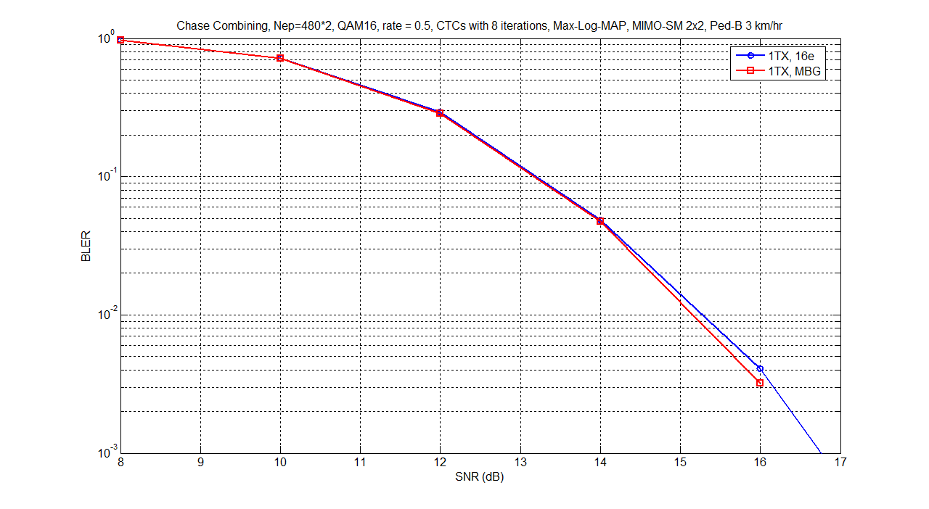
Fig. 7(a)

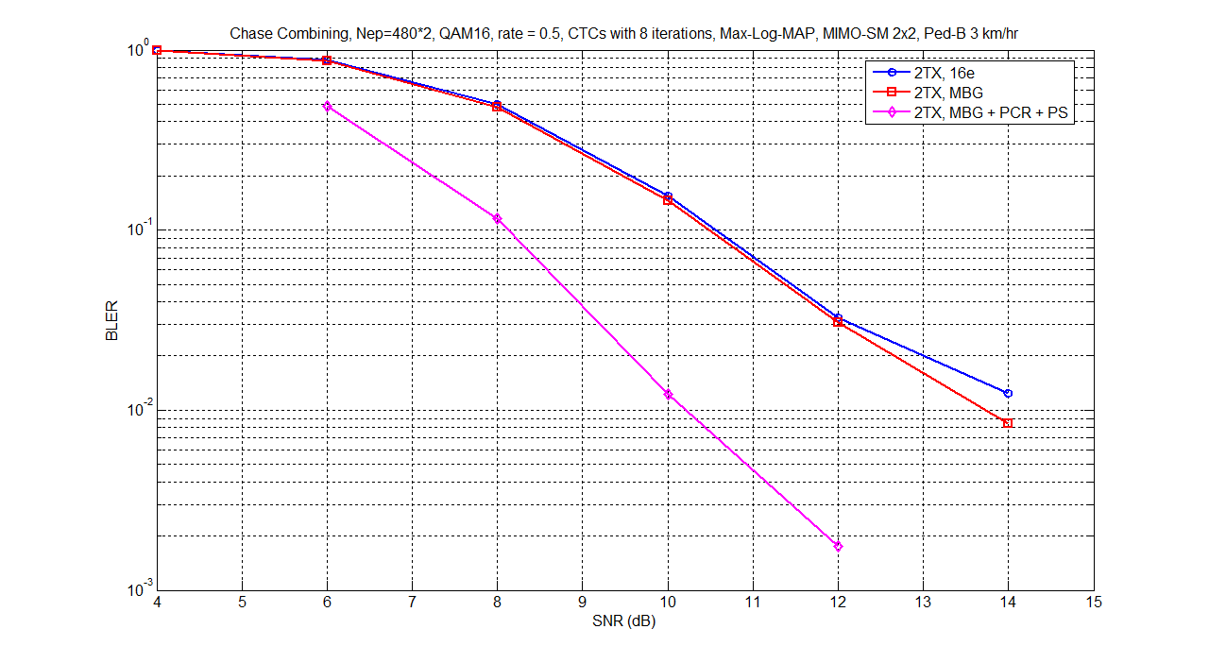
Fig. 7(b)

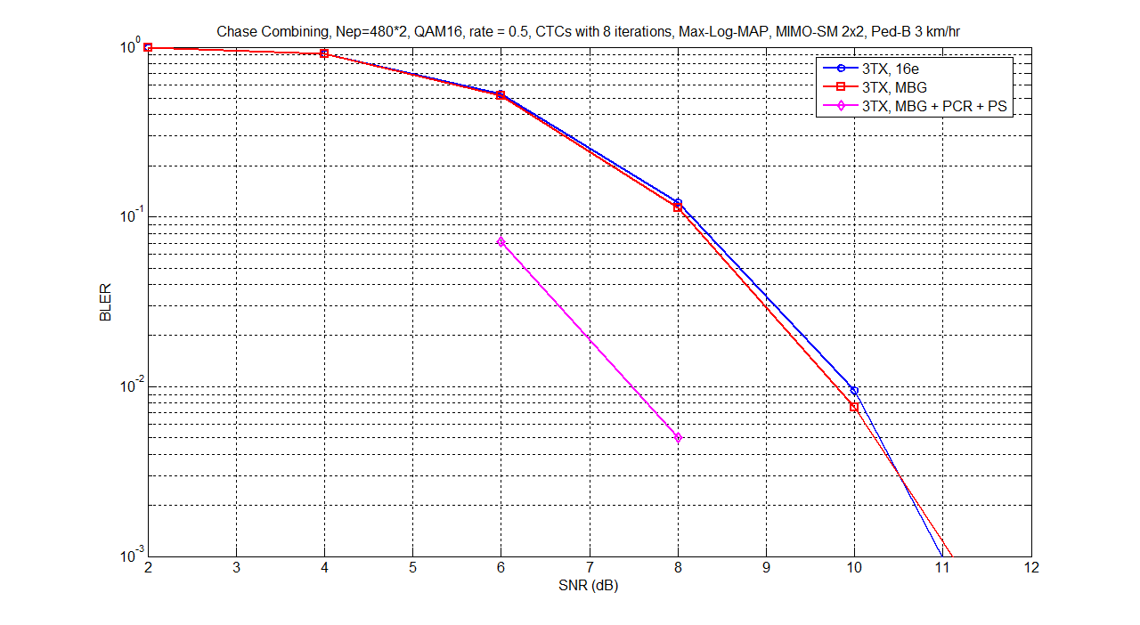
Fig. 7(c)

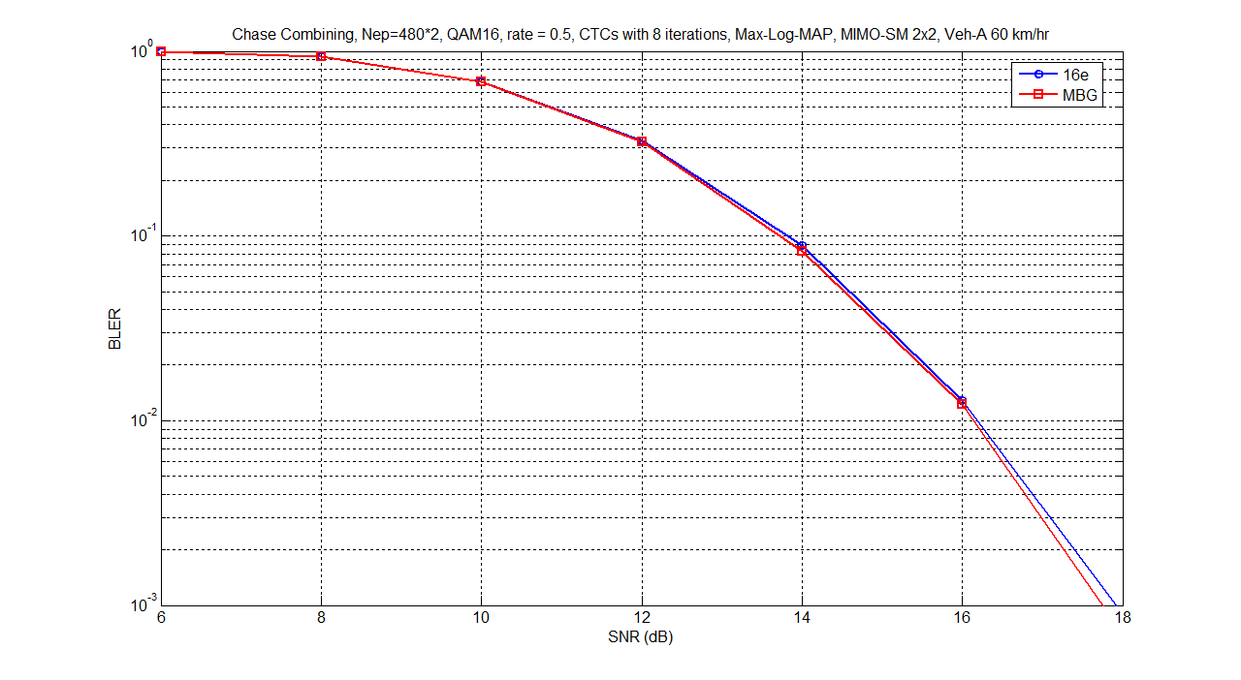
Fig. 8(a)

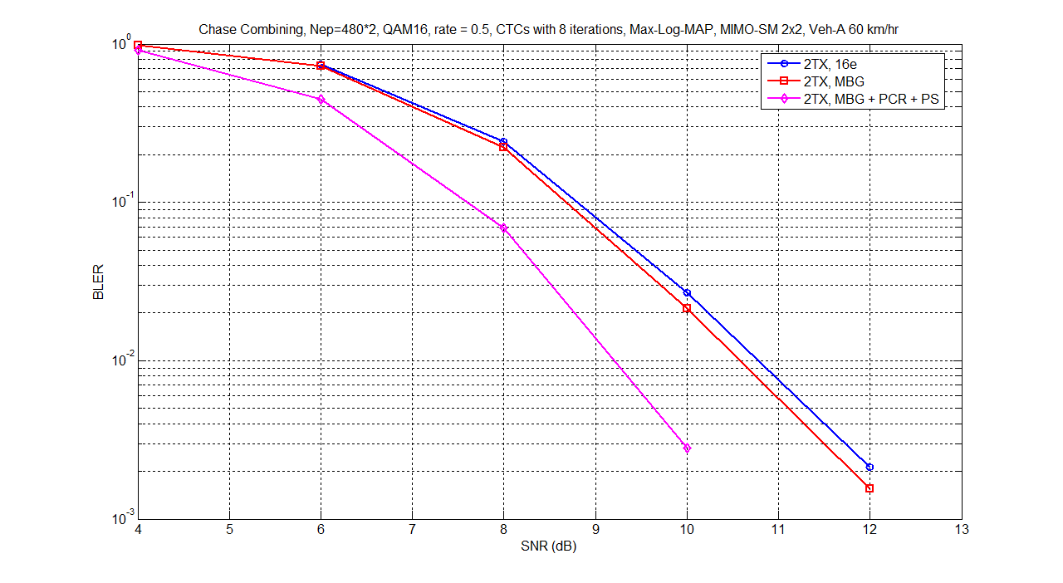
Fig. 8(b)

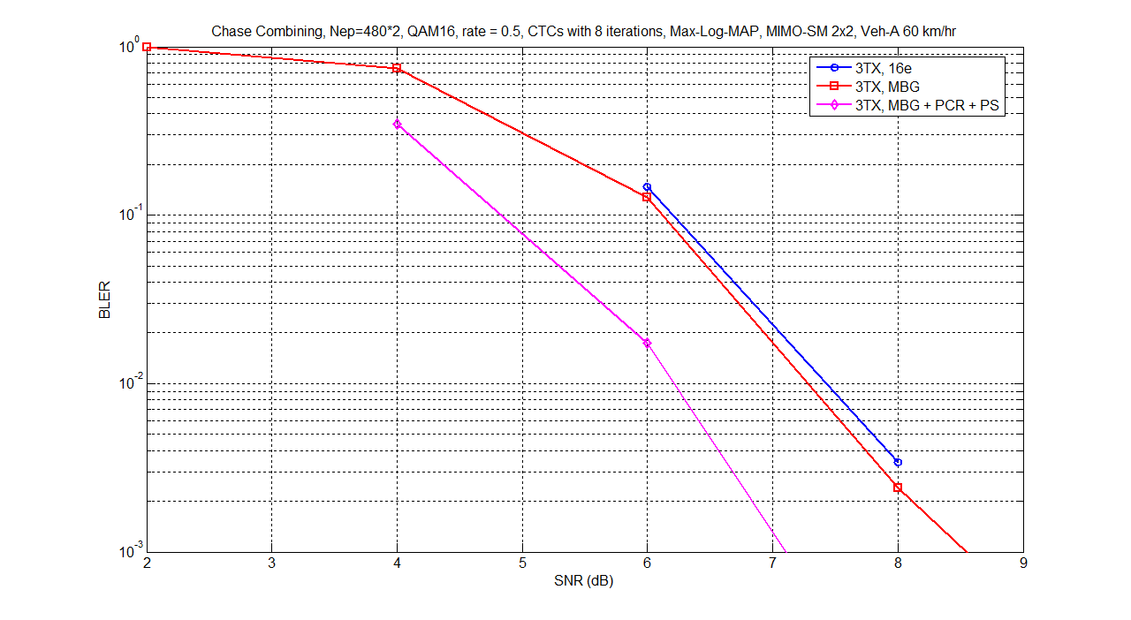
Fig. 8(c)

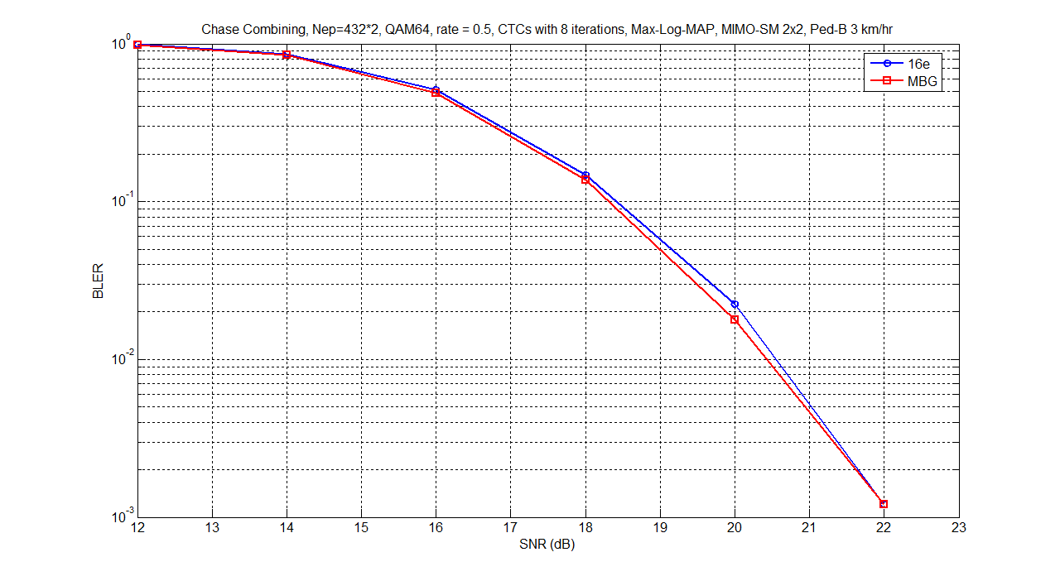
Fig. 9(a)

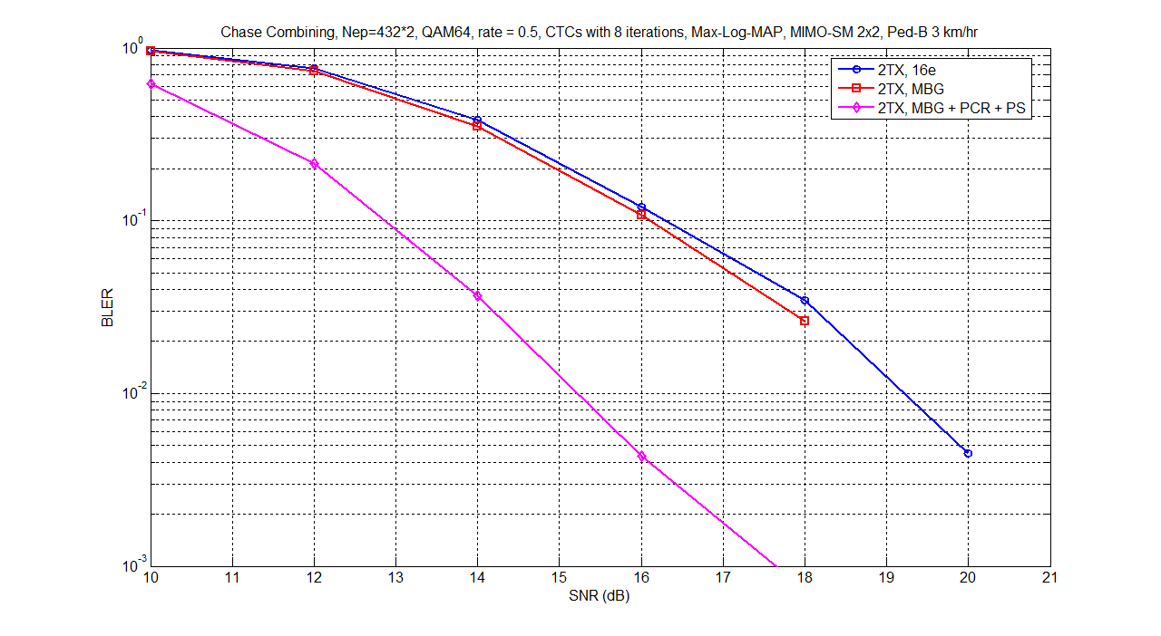
Fig. 9(b)

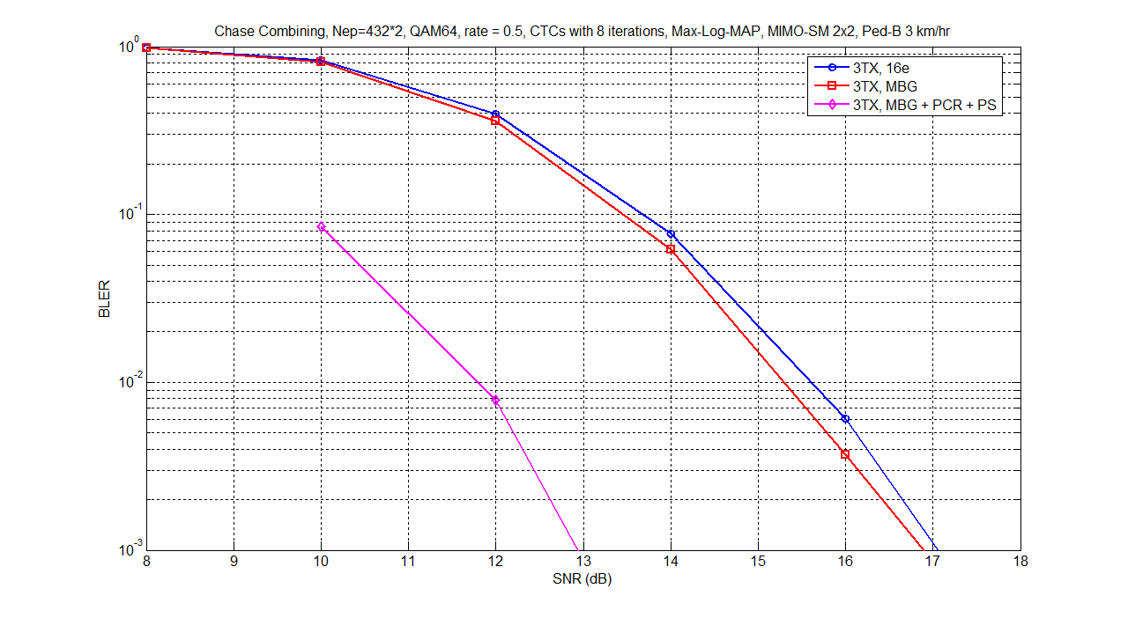
Fig. 9(c)

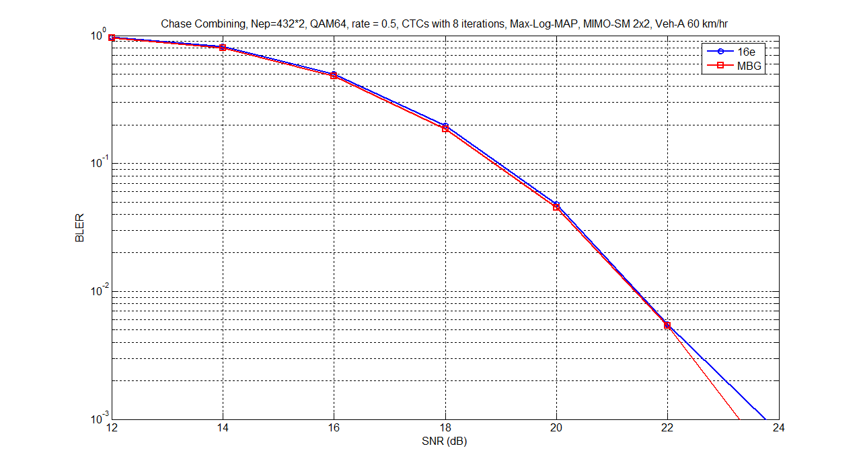
Fig. 10(a)

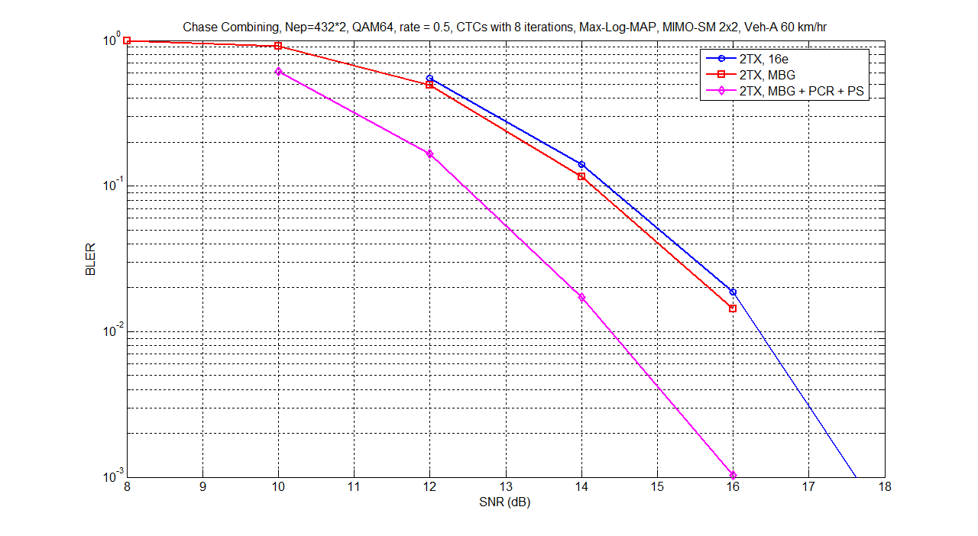
Fig. 10(b)

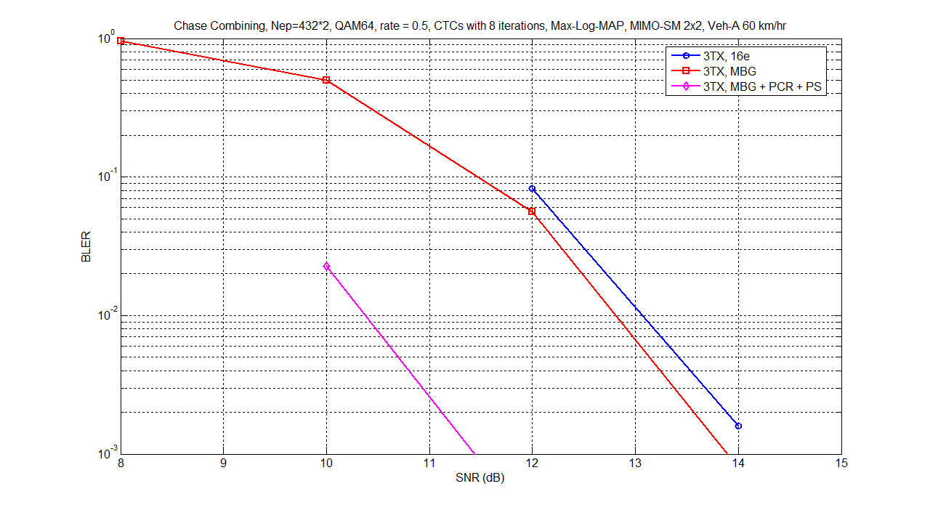
Fig. 10(c)

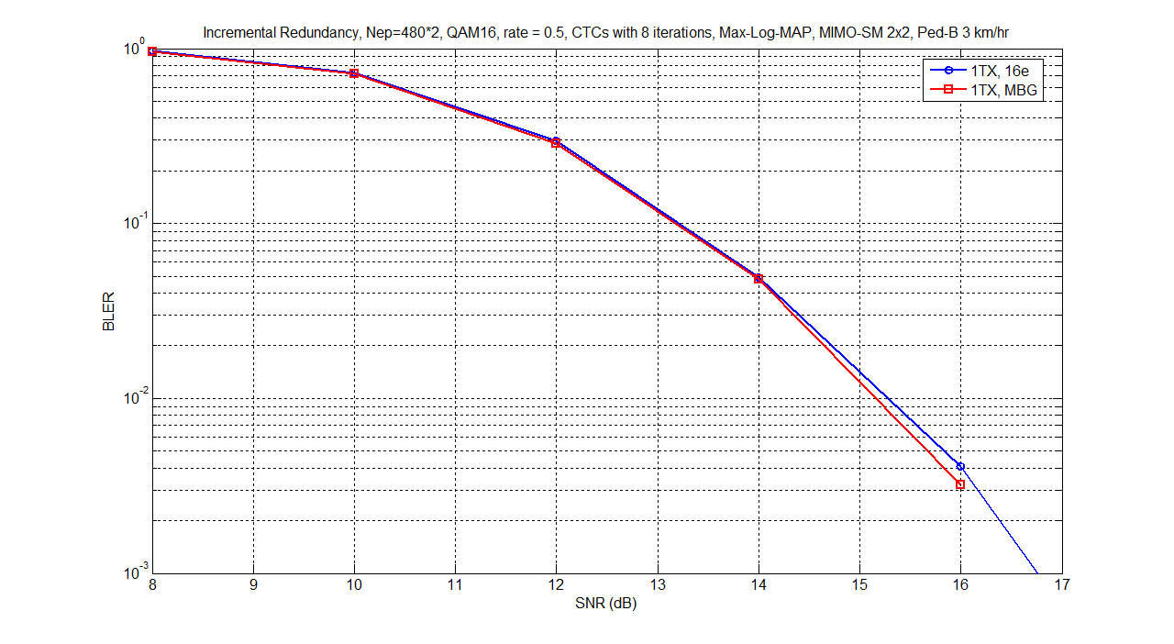
Fig. 11(a)

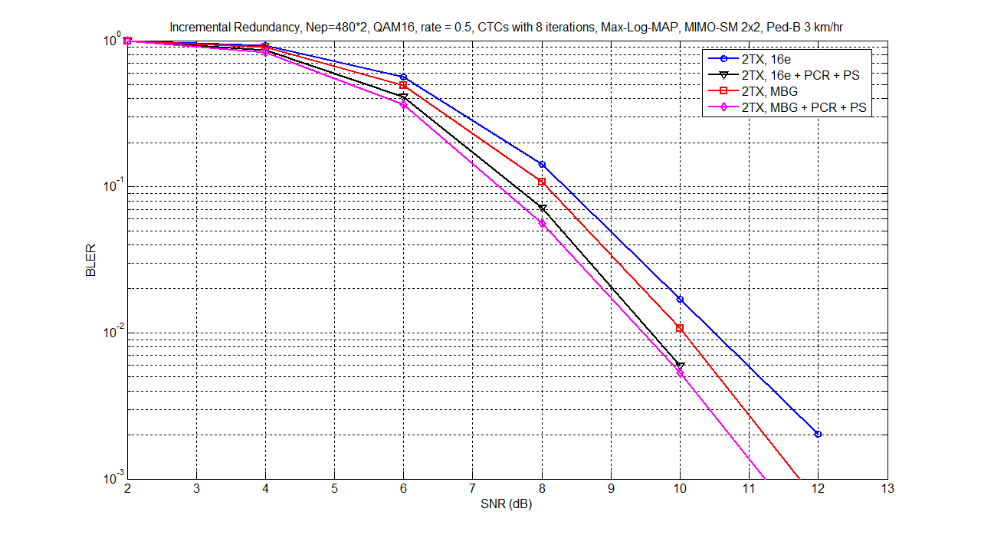
Fig. 11(b)

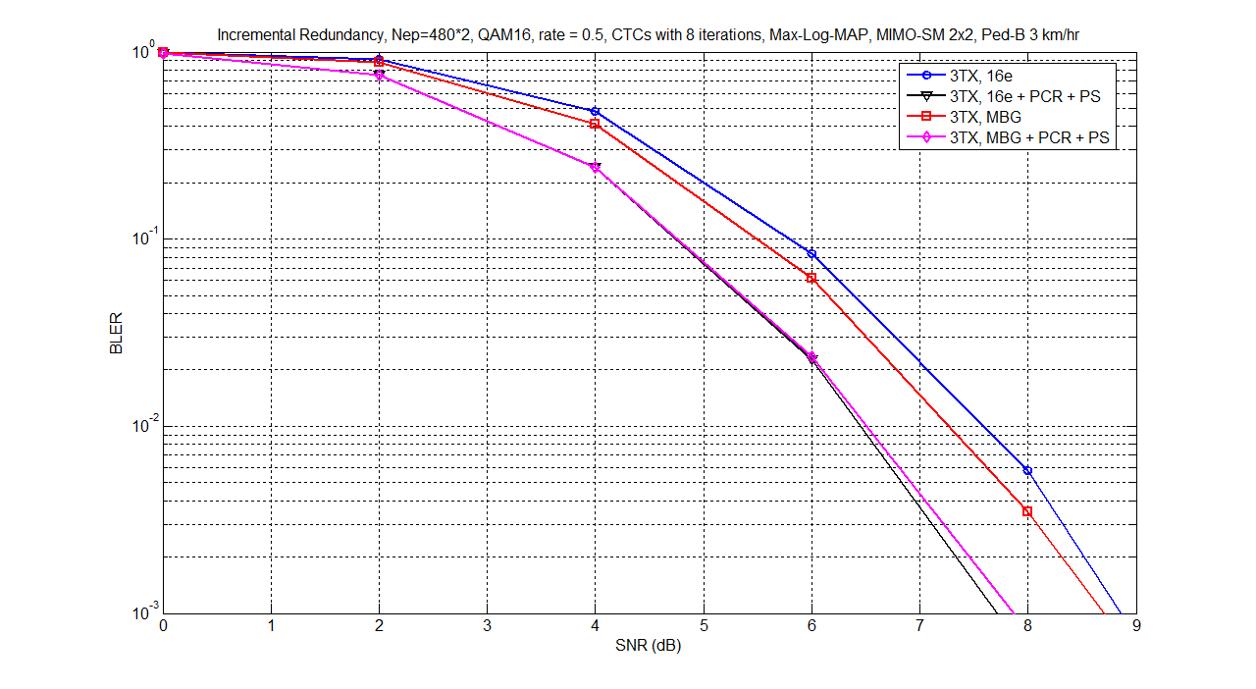
Fig. 11(c)

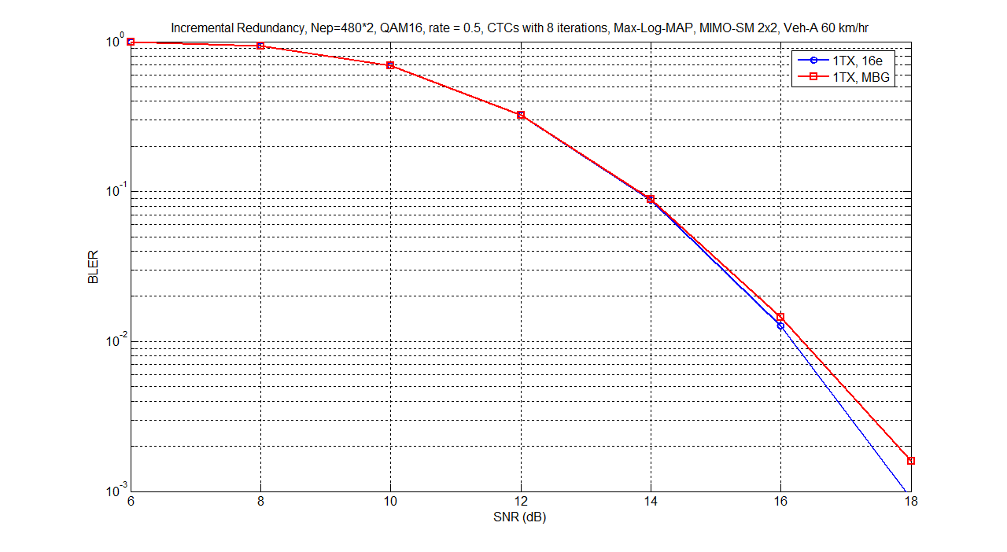
Fig. 12(a)

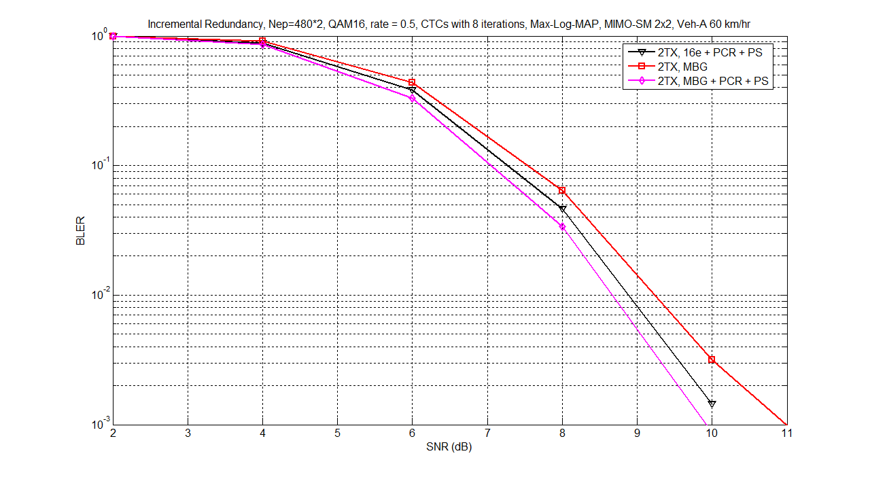
Fig. 12(b)

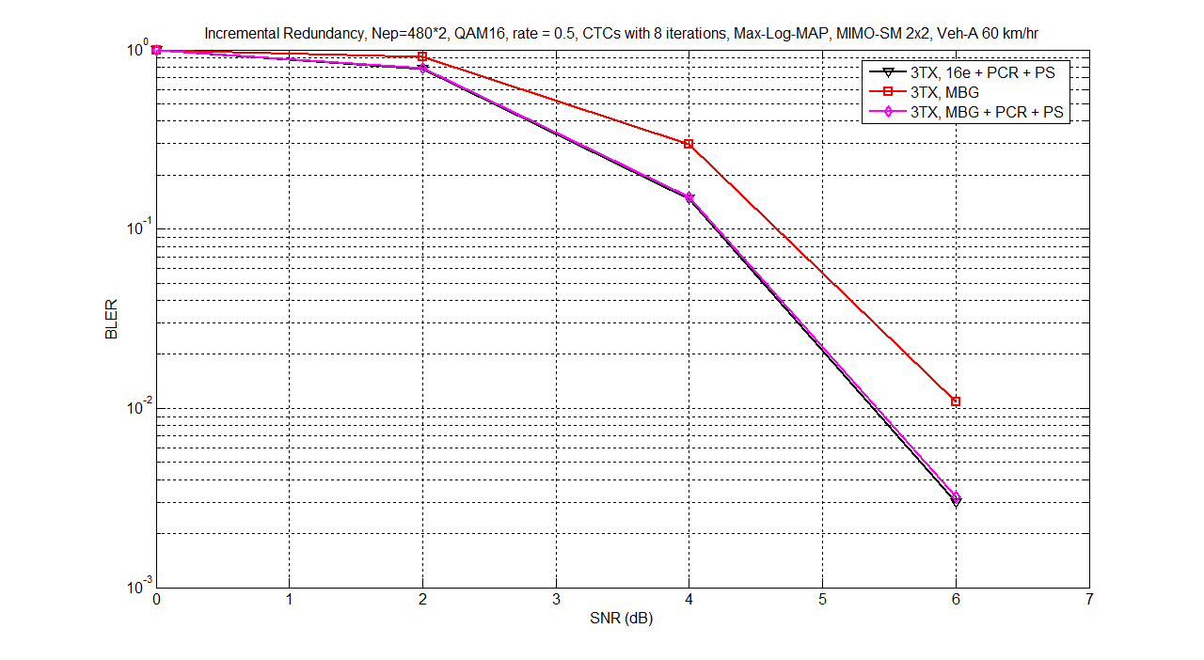
Fig. 12(c)

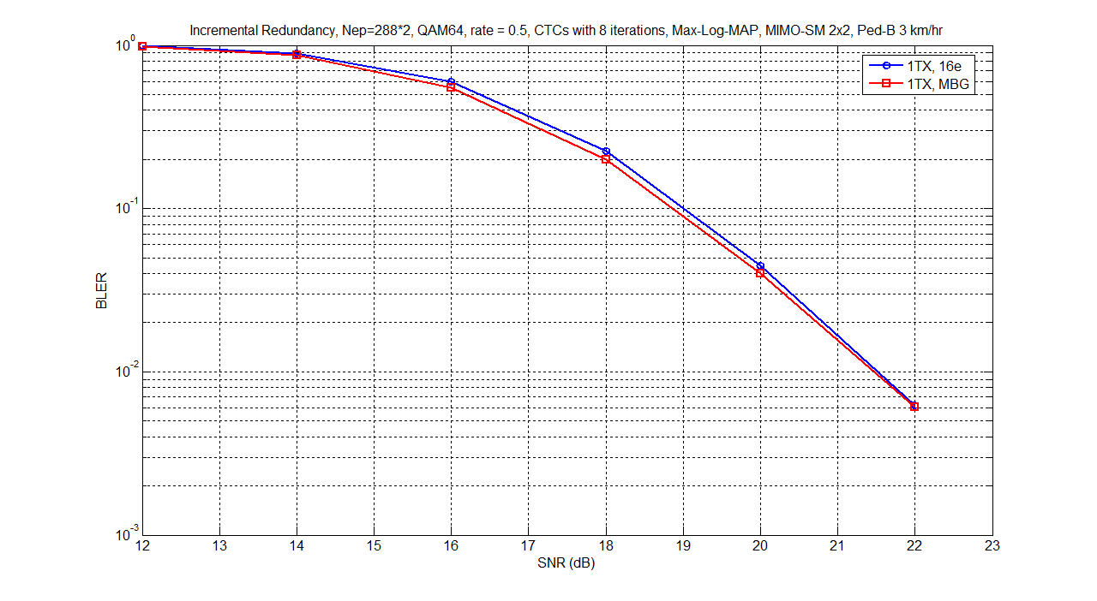
Fig. 13(a)

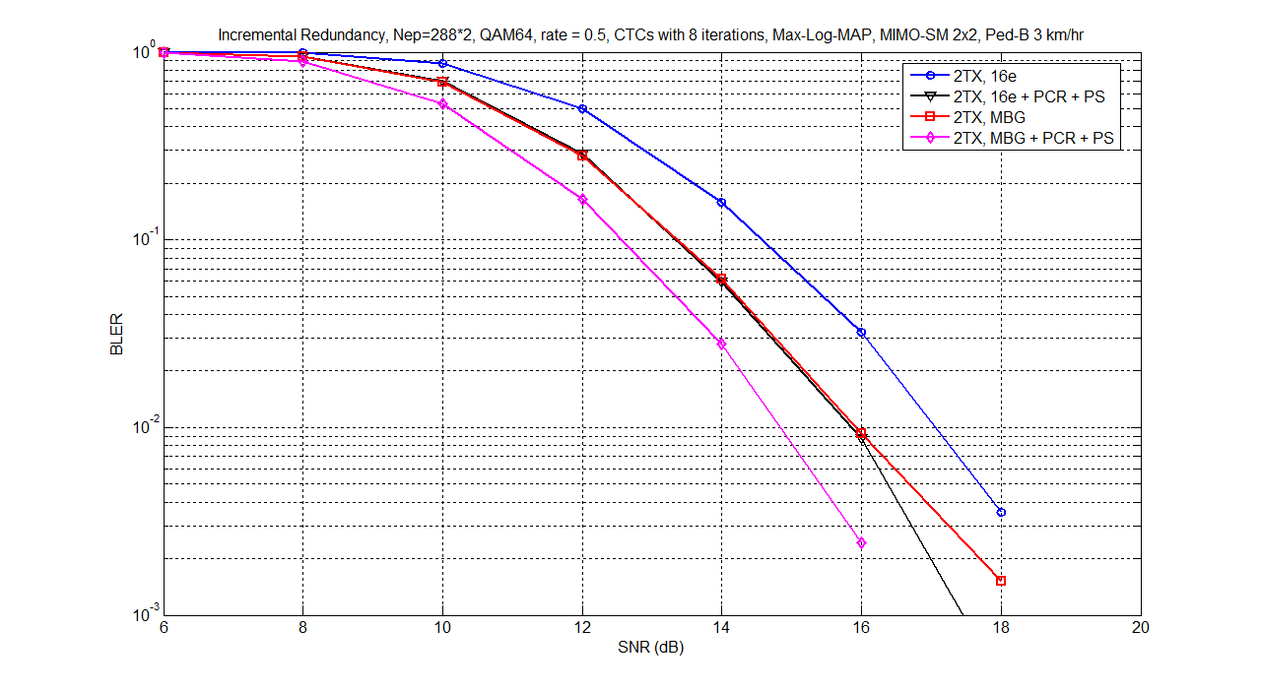
Fig. 13(b)

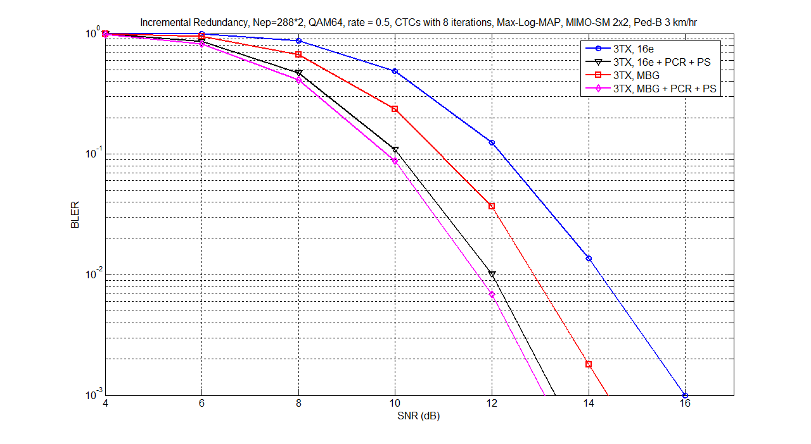
Fig. 13(c)

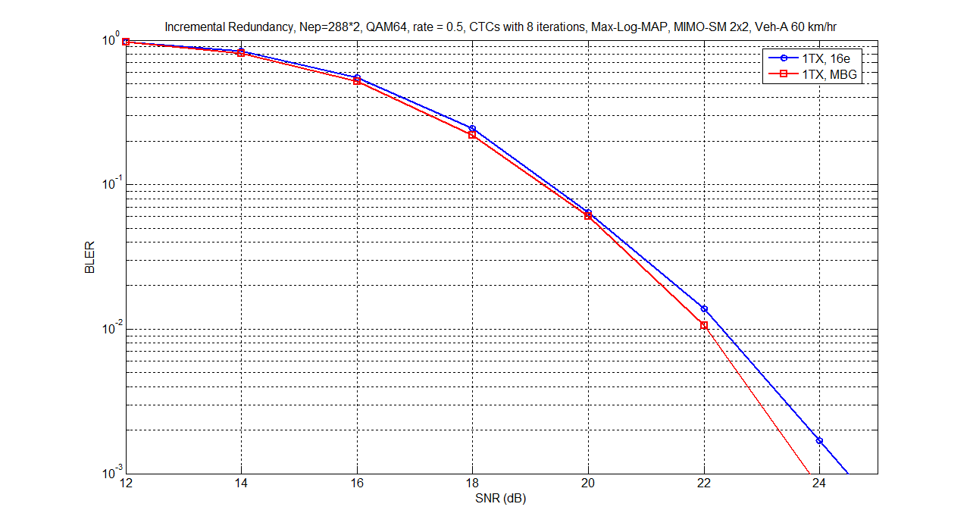
Fig. 14(a)

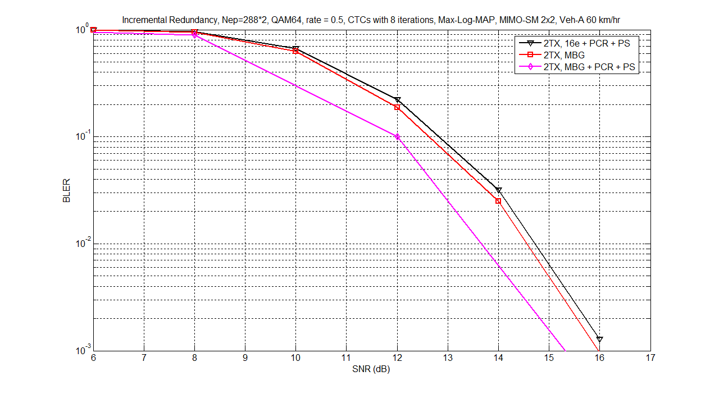
Fig. 14(b)

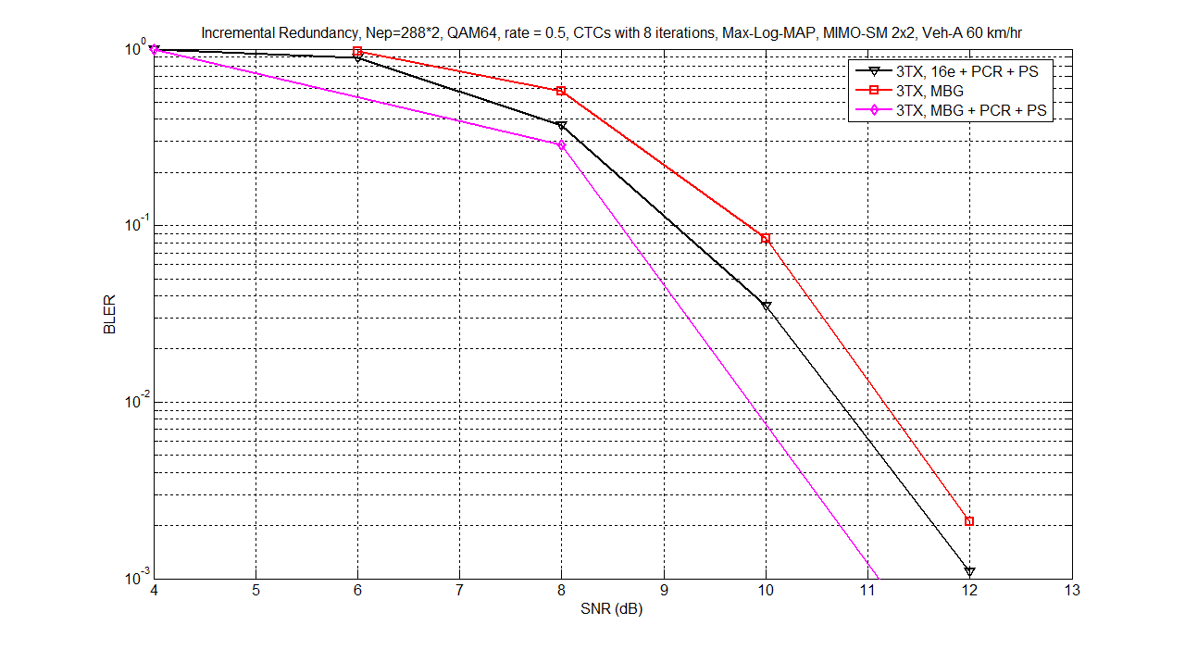
Fig. 14(c)

- References
[1] IEEE P802.16 Rev2 / D8, “Draft Standard for Local and Metropolitan Area Networks Part 16: Air Interface for Broadband Wireless Access,” Dec. 2008.
[2] IEEE 802.16m-08/003r7, “IEEE 802.16m System Description Document [Draft]”
[3] IEEE 802.16m-07/002r7, “802.16m System Requirements”
[4] IEEE C802.16m-08/043, “Style guide for writing the IEEE 802.16m amendment”
[5] IEEE 802.16m-08/050, “IEEE 802.16m Amendment Working Document”
[6] IEEE C802.16m-09/0665, “Proposed Text of CTC Bit grouping for IEEE 802.16m Amendment”
[7] IEEE C802.16m-09/0573, “Bit Grouping Performance Comparison for Bit Priority Mapping and 16e Mapping in the 1st Transmission”

- Text proposal for inclusion in the 802.16m amendment

------------------------------- Text Start ---------------------------------------------------
Insert a new section 15:
15.x.1.5.1.7 Bit selection
The bit selection is performed to generate the subpacket. The puncturing block is referred as bits selection in the viewpoint of subpacket generation. Mother code is transmitted with one of the subpackets. The bits of a subpacket are formed by selecting specific sequences of bits from the interleaved CTC encoder output sequence.

If is the mother codeword from the CTC encoder, the k-th subpacket according to F_{k}, denoted as where and , can be obtained by the following HARQ bit selection algorithm.

------------------------------- Text End --------------------------------------------------------------------------

