Project | IEEE 802.16 Broadband Wireless Access Working Group <http://ieee802.org/16>
Title | Frame_Offset related comment on the Amendment Working Document
Date Submitted | 2009-3-2
Source(s) | Huiying Fang, Yanfeng Guan  ZTE Corporation | Voice:  E-mail: fang.huiying@zte.com.cn  *<http://standards.ieee.org/faqs/affiliationFAQ.html>
Re: | Call for Comments on Amendment Working Document
Abstract | This contribution proposes some detail description on Frame Offset issue
Purpose | To be discussed and adopted by TGm for the Amendment Working Document.
Notice | This document does not represent the agreed views of the IEEE 802.16 Working Group or any of its subgroups. It represents only the views of the participants listed in the “Source(s)” field above. It is offered as a basis for discussion. It is not binding on the contributor(s), who reserve(s) the right to add, amend or withdraw material contained herein.
Release | The contributor grants a free, irrevocable license to the IEEE to incorporate material contained in this contribution, and any modifications thereof, in the creation of an IEEE Standards publication; to copyright in the IEEE’s name any IEEE Standards publication even though it may include portions of this contribution; and at the IEEE’s sole discretion to permit others to reproduce in whole or in part the resulting IEEE Standards publication. The contributor also acknowledges and accepts that this contribution may be made public by IEEE 802.16.
Patent Policy | The contributor is familiar with the IEEE-SA Patent Policy and Procedures:  <http://standards.ieee.org/guides/bylaws/sect6-7.html#6> and <http://standards.ieee.org/guides/opman/sect6.html#6.3>.  Further information is located at <http://standards.ieee.org/board/pat/pat-material.html> and <http://standards.ieee.org/board/pat>.
Frame_Offset related comment on the Amendment Working Document

Introduction
The maximum value of the Frame_Offset is described in Amendment Working Document as the number of DL subframes minus one. However, due to symbol puncturing problem when 16m adjacent channel coexistence with other system, the maximum value of Frame_Offset defined in Amendment working document is not correct.
.

Maximum value of Frame_Offset
In section 15.3.3.4.1 TDD frame structure of the Amendment Working Document 802.16m-09/0010, FRAME_OFFSET is described as “The WirelessMAN-OFDMA and the Advanced Air Interface frames shall be offset by a fixed number of subframes, FRAME_OFFSET = 1,2, … , K as shown in Figure 393 and Figure 394. The maximum value of parameter K is equal to the number of DL subframes minus one, since the Advanced Air Interface frame shall contain at least one DL subframe”. From the description above, the maximum value of Frame_Offset equals to the number of DL subframes minus one. But, if FRAME_OFFSET equals to the maximum value, i.e., the number of DL subframes minus one, the SFH(Super Frame Header) may be put in the last DL subframe as shown in Figure 1.

Fig. 1. SFH location when Frame_Offset equals to (DL subframe number -1)

Considering the text described as “IEEE 802.16m downlink radio frame is time aligned with reference timing signal and should support symbol puncturing to minimize the inter-system interference.” and Fig 32, Fig 33 in section 11.4.4 Coexistence Support in Frame Structure of SDD, partial symbols in the last DL subframe will be punctured when 16m is adjacent channel coexistence with other system. Fig32 and Fig 33 give examples of symbol puncturing when 16m Adjacent Channel Coexistence with LTE-TDD and TD-SCDMA respectively.

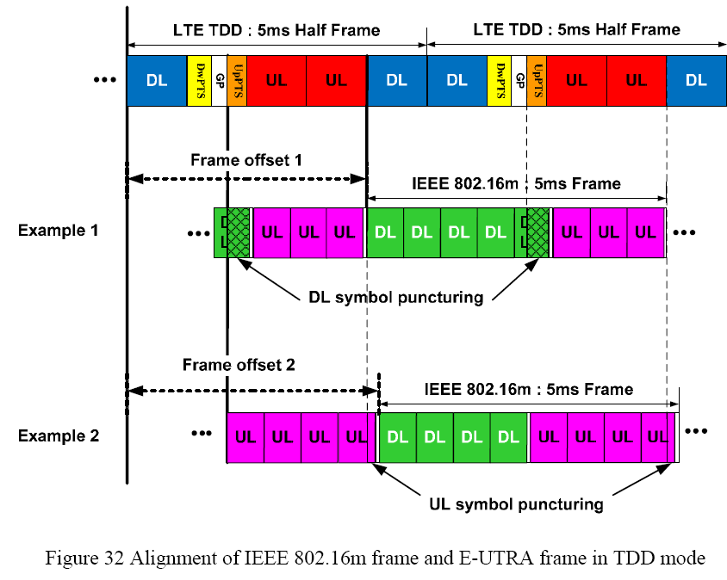

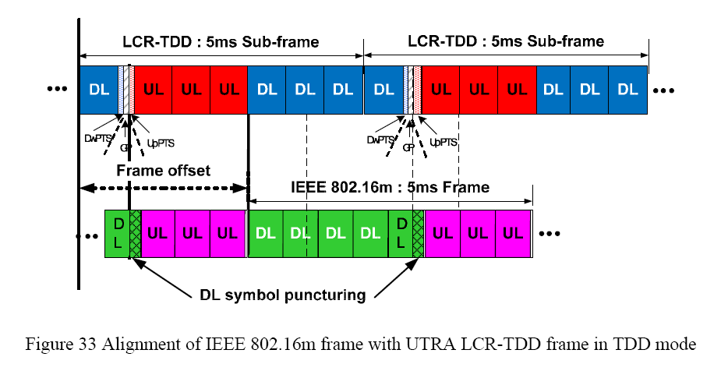

Considering the symbol puncturing problem of the last subframe when 16m adjacent channel coexistence with other system, if Frame_Offset equals to the number of DL subframes minus one, the SFH in the last subframe may be punctured as shown in Fig 2.

Fig. 2. SFH information punctured when Frame_Offset equals to (DL subframe number -1)

To avoid the SFH information being punctured, the Frame-Offset can not be set to the number of DL subframes minus one.

Conclusion

The maximum value of FRAME_OFFSET can not be set to the number of DL subframes minus one, because the SFH information may be punctured if being put in the last DL subframe. As described in the Amendment Working document “The ratio of D:U for 5, 10 and 20 MHz channel bandwidths shall be selected from one of the following values: 8:0, 6:2, 5:3, 4:4, or 3:5.”, the DL subframe number may be 6 , 5, 4, or 3 when 16m legacy supports the WirelessMAN-OFDMA. The FRAME-OFFSET may be set to 1, 2,…, (DL subframe number -2) as shown in Fig 3. Then, the maximum value of parameter K is equal to the number of DL subframes minus two.

Fig 3 The possible value of Frame_Offset

Text Proposal for the 802.16m Amendment text

---------------------------------------------- Start of Proposed Text --------------------------------------------------------

15.3.3.4.1 TDD frame structure

The WirelessMAN-OFDMA and the Advanced Air Interface frames shall be offset by a fixed number of
subframes, FRAME_OFFSET = 1,2, … , K as shown in Figure 393 and Figure 394. The maximum value of
parameter K is equal to the number of DL subframes minus one two, since the Advanced Air Interface frame
shall contain at least one DL subframe. In the case where Advanced Air Interface BSs coexist with Wireless-
MAN-OFDMA BSs, two switching points shall be selected in each TDD radio frame.
---------------------------------------------- End of Proposed Text --------------------------------------------------------

