Project | IEEE 802.16 Broadband Wireless Access Working Group <http://ieee802.org/16>
Title | Tail-Biting Convolutional Codes with Expurgation and Rate-Compatible Puncturing for the Secondary Fast Feedback Channel
Date Submitted | March 2, 2009
Source(s) | Tsao-Tsen (Jason) Chen, Kai Yu, Sten Sjöberg , Per-Erik Östling, Per Ernström  Ericsson AB | Email: {jason.t.chen, kai.a.yu, sten.ingemar.sjoberg, per-erik.ostling, per.ernstrom}@ericsson.com
Re: | 802.16m-09/012, Call for Contributions on Project 802.16m Amendment Working Document (AWD) Content  Ballot id: tgmawd
Abstract | Tail-biting convolutional codes (TBCC) are proposed to be used for the Secondary Fast Feedback Channel (SFBCH), allowing low complexity WAVA (Wrap Around Viterbi Algorithm) decoding, and reuse of tail biting decoder structures already implemented for 802.16e equipment. TBCC allows single encoding for all payload sizes from 7 bits to 24 bits, hence improving the code performances especially for the cases where payload sizes ≥ 13 bits. For the code performances in terms of the minimum distance (d_min), TBCC are equal to (for payload sizes <13 bits) or better than (for payload sizes ≥ 13 bits) other linear block code proposals, except for the payload 7-bits case. For payload sizes ≥ 13 bits, the performance gains of TBCC over other linear block codes range from 1dB to 2dB when packet error rate 10⁻⁴ is considered over the AWGN channel. We also provide analysis on the complexity of decoding TBCC. In general, WAVA used by TBCC has much lower total decoding complexities than those of the maximum-likelihood decoding (MLD) used by other proposals.
Purpose | Discussion and Eventual Adoption
Notice | This document does not represent the agreed views of the IEEE 802.16 Working Group or any of its subgroups. It represents only the views of the participants listed in the “Source(s)” field above. It is offered as a basis for discussion. It is not binding on the contributor(s), who reserve(s) the right to add, amend or withdraw material contained herein.
Release | The contributor grants a free, irrevocable license to the IEEE to incorporate material contained in this contribution, and any modifications thereof, in the creation of an IEEE Standards publication; to copyright in the IEEE’s name any IEEE Standards publication even though it may include portions of this contribution; and at the IEEE’s sole discretion to permit others to reproduce in whole or in part the resulting IEEE Standards publication. The contributor also acknowledges and accepts that this contribution may be made public by IEEE 802.16.
Patent Policy | The contributor is familiar with the IEEE-SA Patent Policy and Procedures:  <http://standards.ieee.org/guides/bylaws/sect6-7.html#6> and <http://standards.ieee.org/guides/opman/sect6.html#6.3>.  Further information is located at <http://standards.ieee.org/board/pat/pat-material.html> and <http://standards.ieee.org/board/pat>.

Tail-Biting Convolutional Codes with Expurgation and Rate-Compatible Puncturing for the Secondary Fast Feedback Channel
Tsao-Tsen (Jason) Chen, Kai Yu, Sten Sjöberg, Per-Erik Östling, Per Ernström
Ericsson AB

Introduction

Tail-biting convolutional codes (TBCC) [2][3][4] are considerably less complex to decode compared to general block codes, since decoding can be performed over a uniform trellis, using e.g. the wrap around Viterbi algorithm (WAVA) [3]. Note also that TBCC are used in 802.16e and thus reuse of already implemented TBCC receiver structures is possible. Therefore TBCC should be utilized unless alternative codes provide very significant performance gains over TBCC.

The Secondary Fast Feedback Channel (SFBCH) consists of 3 distributed feedback mini-tiles (FMT) [1], with payload sizes ranging from 7 bits to 24 bits. When each 2x6 FMT has 2 pilot tones, the SFBCH payload is encoded to 60 coded bits, or 30 QPSK symbols. For the linear block code proposals in [1] for the SFBCH, the (60,12) mother code is used to encode the payload (from 7 bits to 24 bits) into 60 coded bits by the following methods:

- Payload sizes from 7 bits to 11 bits: The (60,12) mother code with expurgation (using a subset of the rows of the generator matrix) is used to encode the payload into 60 coded bits.

- Payload size 12 bits: The (60,12) mother code is used to encode the payload into 60 coded bits.

- Payload sizes from 13 bits to 24 bits: The payload is divided into two smaller payloads: ⎣k/2⎦ bits and (k-⎣k/2⎦) bits, where k=13,…, 24. By using the first half of the (60,12) mother code, the (30,12) code with expurgation is used to encode each of the two smaller payloads into 30 bits.

Here we show that there exist TBCC’s that have better or similar performances than the linear block codes proposed in [1] when they are used to encode SFBCH with payload sizes ranging from 7 bits to 24 bits. The TBCC’s for different payload sizes are derived from a rate 1/5 mother TBCC by either expurgation or rate-compatible puncturing, which allows the use of a single encoder and decoder structure for all payload sizes. The differences between the codes are clearly manifested in the larger minimum hamming distance (d_{min}), especially when the payload sizes are between 13 bits and 24 bits. For payload sizes ≥ 13 bits, the performance gains of TBCC over other linear block codes range from 1dB to 2dB when packet error rate 10⁻⁴ is considered over the AWGN channel. The reason for better performance of TBCC for payload ≥ 13 bits is that the whole payload bits are encoded once to 60 bits, while for the other linear block code proposals each of the 2 smaller payloads is encoded to 30 bits only. Dividing the larger payload into 2 smaller payloads has some advantage only in the “compare” complexity (which is a relatively small part of the total decoding complexity); however, the d_min values (and hence the code performances) are greatly reduced as the number of output bits per encoding is reduced from 60 bits to 30 bits.

TBCC can be decoded by the efficient Viterbi-type algorithms, e.g. the wrap-around Viterbi algorithm (WAVA). Given the same (n,k) code, the complexities of WAVA are much lower than those of the maximum-likelihood decoding (MLD) for most of the cases, especially over the high SNR region where WAVA can be terminated early so fewer decoding iterations are used. It is assumed that MLD is used by the linear block code proposals in [1]. In this document we will show that the total decoding complexities of WAVA are much lower than those of MLD.

Based on the performance and complexity analysis of the TBCC scheme presented in this document, we propose that the SFBCH payload be encoded by TBCC into 60 coded bits. Also, the TBCC encoding is done only once for each payload; that is, there is no need to divide larger payload (when ≥ 13 bits) into 2 smaller payloads followed by 2 separate encodings.

Definition

New terminology used in this document is defined in this section:

Tail-biting convolutional code (TBCC) [2].

Wrap-Around Viterbi algorithm (WAVA) [3]: low-complexity trellis-type algorithm for decoding tail-biting convolutional codes.

Tail-Biting Convolutional Codes for SFBCH

In this section, we derive TBCC’s for encoding SFBCH with payload sizes ranging from 7 bits to 24 bits. The TBCC’s are derived from a rate 1/5 mother TBCC by either expurgation or rate-compatible puncturing, which allows the use of a single encoder and decoder structure for all payload sizes. The set of generator polynomials for the mother TBCC is given in octal format by (16, 112, 556, 636, 656).

The information bits, (a₀, a₁,…, a_{L-1}), in the SFBCH shall be encoded to 60 encoded bits, (c₀, c₁, …, c₅₉). For 7≤L≤11, 5 to 1 zeros, respectively, are inserted into the information bits to perform the expurgation operation. The resulting length-12 zero-padded information bits vectors are encoded by the rate 1/5 mother TBCC to generate 60 encoded bits (see Figure 1). For 7≤L≤11, the input bits vectors are given by

(b₀,...,b₁₁)=(a₀,a₁,a₂,0,a₃,0,a₄,0,a₅,0,a₆,0) for L=7,
(b₀,...,b₁₁)=(a₀,a₁,a₂,a₃,a₄,0,a₅,0,a₆,0,a₇,0) for L=8,
(b₀,...,b₁₁)=(a₀,a₁,a₂,a₃,a₄,a₅,0,a₆,a₇,0,a₈,0) for L=9,
(b₀,...,b₁₁)=(a₀,a₁,a₂,a₃,a₄,a₅,0,a₆,a₇,a₈,a₉,0) for L=10,
(b₀,...,b₁₁)=(a₀,a₁,a₂,a₃,a₄,a₅,a₆,a₇,a₈,a₉,a₁₀,0) for L=11.

For 12≤L≤24, the input bits vector, (b₀,b₁,…,b_{L-1})=(a₀, a₁,…, a_{L-1}), are encoded by the rate 1/5 mother TBCC, the rate 1/4 TBCC, or the rate 1/3 TBCC according to the first-level puncturing given in Table 1. The rate 1/4 TBCC and rate 1/3 TBCC are punctured from the rate 1/5 mother TBCC by using only 3 and 4, respectively, generator polynomials from the set (16, 112, 556, 636, 656). The encoded bits from the TBCC encoders are further punctured by the second-level puncturing given in Table 1. The TBCC encoder is shown in Figure 1. Take the (60,21) (L=21) TBCC as an example. The 21 information bits are first encoded by the TBCC with the set of generator polynomials (112, 556, 636), and 63 encoded bits are generated. The (3•m)^{th},(3•m+1)^{th}, and (3•m+2)^{th} encoded bits are the encoder outputs from generator polynomials 112, 556, and 636, respectively, for the m^{th} input information bit, where m=0,1,…,20. During the second-level puncturing, the 0th, 27th, and 54th encoded bits are further punctured and the remaining 60 encoded bits exit the encoder.

Figure 1: Tail-biting convolutional codes for encoding SFBCH with payload sizes 7 to 24 bits. For payload sizes 7 to 11 bits, zeros are inserted into the information bits input to the encoder, and the first-level puncturing and the second-level puncturing do not apply.
Table 1: The puncturing patterns for generating (60,L) TBCC from the rate 1/5 mother TBCC with the set of generator polynomials (16,112,556,636,656). In the first-level puncturing, TBCC with all or part of the generator polynomials (in the second column) from the mother code set (16,112,556,636,656) are used to encode payloads from 12 bits to 24 bits. In the second-level puncturing, some (or none) of the encoded bits from the TBCC encoders (after the first-level puncturing) are further punctured according to the bit positions listed in the third column.
L | First-level puncturing: the set of generator polynomials for the TBCC encoding | Second-level puncturing: positions of bits to be punctured after the TBCC encoding
12 | (16,112,556,636,656) | none
13 | (16,112,556,636,656) | (1,16,31,46,61)
14 | (16,112,556,636,656) | (3,8,13,18,23,28,33,38,43,48)
15 | (16,112,636,656) | none
16 | (16,112,636,656) | (0,16,32,48)
17 | (16,112,636,656) | (0,8,16,24,32,40,48,56)
18 | (16,112,636,656) | (0,4,8,12,16,20,24,28,32,36,40,44)
19 | (16,112,636,656) | (0,4,8,12,16,20,24,32,36,40,48,52,56, 64,68,72)
20 | (112,556,636) | none
21 | (112,556,636) | (0,27,54)
22 | (112,636,656) | (2,15,23,31,52,60)
23 | (112,636,656) | (0,3,12,21,30,33,42,51,60)
24 | (112,636,656) | (1,7,13,19,25,31,37,43,49,55,61,67)

Performance Comparisons

Comparisons of the minimum distances (d_min) among different channel codes are shown in Figure 2. The proposed TBCC needs only one encoding/decoding for all payload sizes from 7 bits to 24 bits, and the d_min values are computed for the (60,k) codes for k=7 to 24. In Figure 2, there is only one curve for the d_min values of Ericsson TBCC as only one encoding is performed for each payload size.

For the linear block code proposals in [1], 1 encoding is needed for payload sizes < 13 bits and 2 encodings are needed for payload sizes >=13 bits. So "1st code" applies to all payloads sizes from 7 bits to 24 bits, and "2nd code" only applies to payload sizes >=13 bits. For example, the payload of size 15 bits is divided into 2 parts: 7 bits and 8 bits, and 2 encodings are used to encode each of them to 30 bits. Since the d_min for (30,7) and (30,8) codes may be different, 2 points are plotted at payload 15 bits for each linear block proposal. Therefore, in Figure 2 the d_min values are computed for the (60,k) codes for k=7 to 12. For k=13 to 24, the d_min values are computed for both the (30,⎣k/2⎦) code and the (30,k-⎣k/2⎦) code. Also, optimum expurgations are used to compute the d_min values of the linear block codes, though the expurgations used by the linear block code proposals in [1] are not necessarily the optimum ones.

In terms of d_min, TBCC’s are equal to (for payload sizes <13 bits) or better than (for payload sizes >= 13 bits) other linear block code proposals, except for the payload 7-bits case where LGe’s proposal is better. The reason for better performance of TBCC for payload sizes >=13 bits is that the whole payload bits are encoded once to 60 bits. Compared with the lower and upper bounds on the optimum d_min values, Ericsson’s TBCC provides graceful degradation as the payload size k increases, while in other linear block code proposals there is a big degradation of the code performance for k >=13 bits.

The better performances of TBCC are also verified by the link level simulations over the AWGN channel. In Figure 3, the required SNR at PER=10⁻⁴ over the AWGN are shown for the different channel codes. The conclusions are pretty much the same as those made from the d_min comparison. For payload sizes <13 bits, performances of TBCC are close to those of Samsung’s and LGe’s codes, except at payload size 7 bits where LGe’s code has about 0.3dB gain over TBCC. For payload sizes >= 13 bits, the performance gains of TBCC over other linear block codes range from 1dB to 2dB as shown in Figure 4. The link level simulations over the AWGN channel for payload sizes from 7 bits to 24 bits are given in the Appendix. If PER=10⁻² is to be considered, the performance gains of TBCC over other linear block codes range from 0.6dB to 1.2dB.
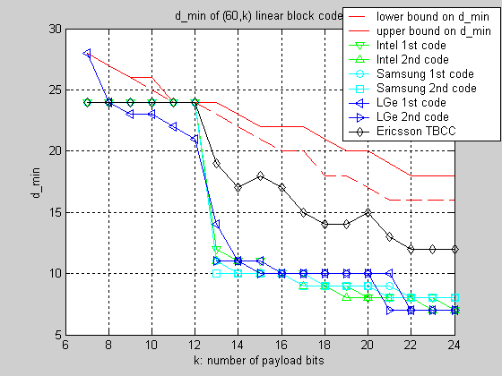
Figure 2: Comparison of the minimum distances (d_min) for the (60,k) codes for k=7 to 24 bits.
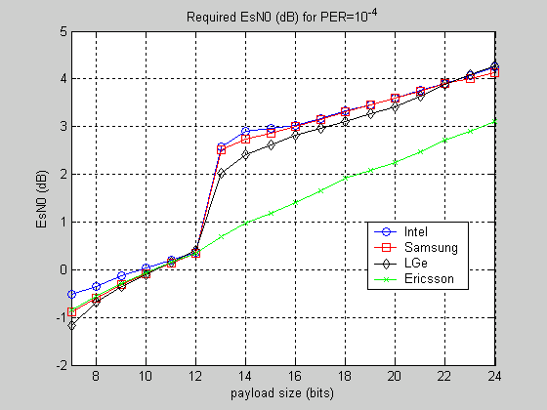
Figure 3: Comparison of the required SNR at PER=10⁻⁴ over the AWGN channel.

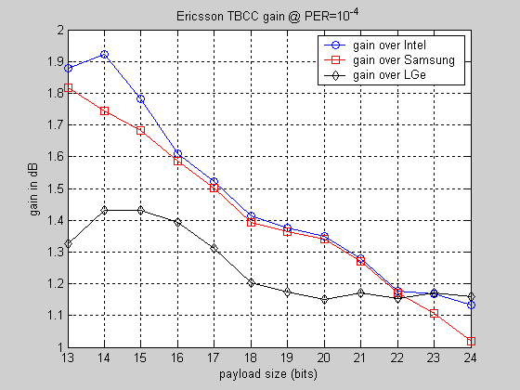
Figure 4: Performance gain of Ericsson’s TBCC over other linear block code proposals: PER=10⁻⁴ over AWGN.

Comparisons of Decoding Complexities

TBCC can be decoded by efficient Viterbi-type algorithms, e.g. the wrap-around Viterbi algorithm (WAVA) [3]. Given the same (n,k) code, the complexities of WAVA are much lower than those of maximum-likelihood decoding (MLD) for most of the cases, especially over the high SNR region where WAVA can be terminated early so that fewer decoding iterations are used. It is assumed that MLD is used by the linear block code proposals in [1].

For payload sizes >=13 bits, TBCC is a good candidate to encode the whole payload as the decoding complexity grows linearly with the payload size k, while MLD may become too complicated as the complexity grows exponentially with the payload size. In the linear block code proposals, the payload (when > 13 bits) are divided into 2 smaller parts first and then 2 encodings are used to encode each of them to 30 bits. As can be seen from the comparison, dividing the larger payload into 2 smaller parts has some advantage only in the “compare” complexity (which is a relatively small part of the total decoding complexity); however, the d_min values (and hence the code performances) are greatly reduced as the number of output bits per encoding is reduced from 60 bits to 30 bits.

In Figure 5, Figure 6 and Figure 7, decoding complexities in terms of the numbers of “add”, “multiply” and “compare” are illustrated for WAVA and MLD:

- “add” refers to adding 2 real numbers. From Figure 5 we see that the “add” complexities of WAVA are much lower than those of MLD for most of the payload sizes, even though in the MLD case the payload (when >=13 bits) is divided into 2 smaller parts.
- “multiply” means that the received soft bit value is multiplied by either +1 or -1. From Figure 6 we see that the “multiply” complexities of WAVA are much lower than those of MLD for all the payload sizes, even though in the MLD case the payload (when >=13 bits) is divided into 2 smaller parts.

- “compare” refers to comparing 2 numbers and picking the larger one. From Figure 7 we see that the comparisons are mixed. For payload sizes between 7 bits and 12 bits and for payload sizes between 21 bits and 24 bits, the “compare” complexities of WAVA are lower than those of MLD over the high SNR region and are higher than those of MLD over the lower SNR region. For payload sizes between 13 bits and 20 bits, the “compare” complexities of WAVA are higher than those of MLD, mainly due to the division of the payload into 2 smaller parts in the MLD case.

The figures show that complexity is dominated by the addition operation for all algorithms. Furthermore, the excess number of add operations for MLD is greater than the excess number of compare operations for the WAVA algorithm for most payload sizes. Assuming that the “add”, “multiply” and “compare” operations all have roughly the same complexity, comparisons of the total decoding complexities are shown in Figure 8. Hence, the total complexity of the WAVA algorithm for the proposed TBCC scheme is significantly lower than MLD for the block codes for most payload sizes.

In [5], decoding complexity comparisons between TBCC with WAVA and linear block code with trellis decoding are made. At this point we are not sure if the linear block code proposals can be described by an efficient trellis and decoded with the complexities reported in [5]; even that’s applicable, TBCC with WAVA still has lower complexities for most of the payload cases.

Conclusions

Based on the performance and complexity analysis in this document, we propose that the SFBCH payload (from 7 bits to 24 bits) be encoded by TBCC into 60 coded bits. Also, the TBCC encoding is done only once for each payload; that is, there is no need to divide larger payload (when ≥ 13 bits) into 2 smaller payloads followed by 2 separate encodings.

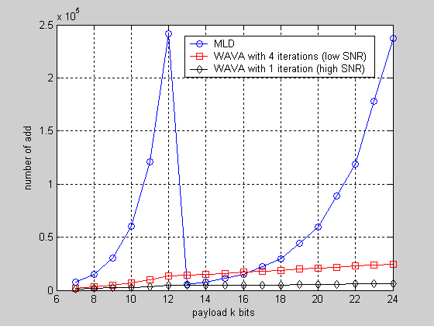
Figure 5: Comparison of the number of “add” for different decoding schemes.
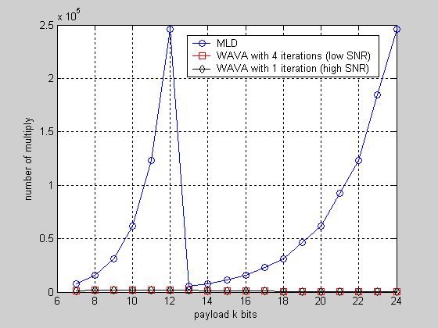
Figure 6: Comparison of the number of “multiply” for different decoding schemes.

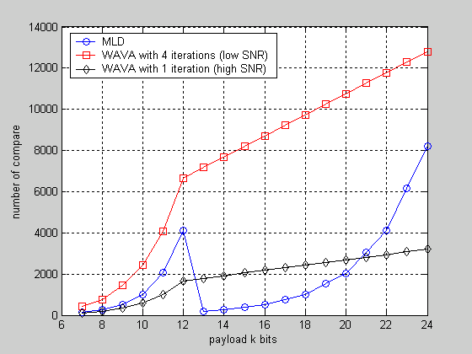
Figure 7: Comparison of the number of “compare” for different decoding schemes.

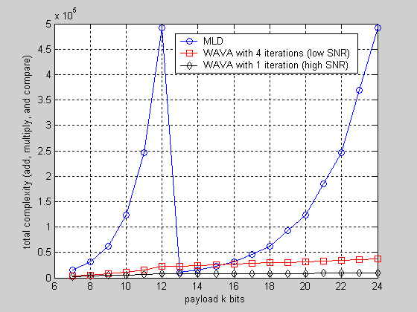
Figure 8: Comparison of the total complexities for different decoding schemes.

Appendix

In this Appendix, link level simulation results over the AWGN channel are given for the channel coding proposals considered in this contribution.

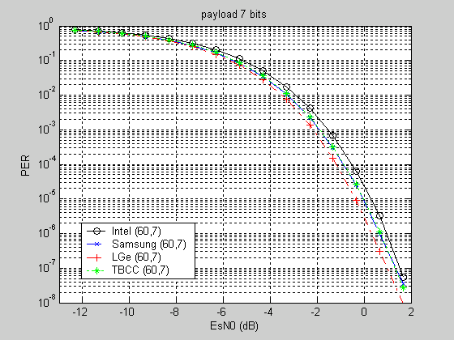
Figure 9
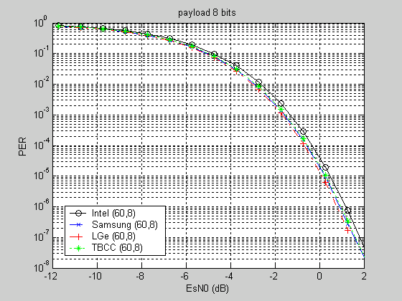
Figure 10
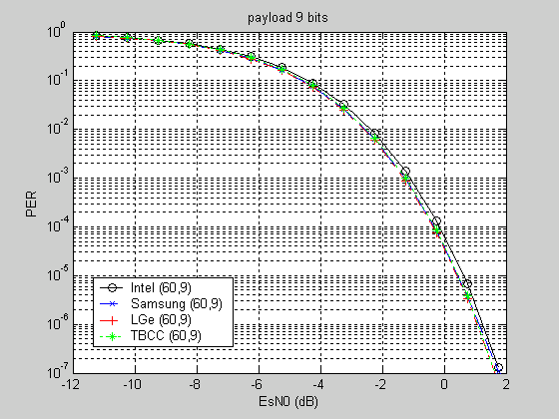
Figure 11

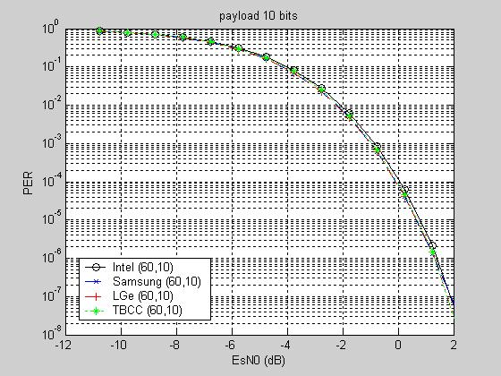
Figure 12
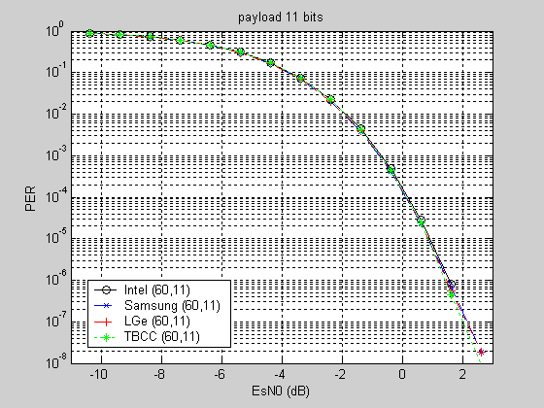
Figure 13
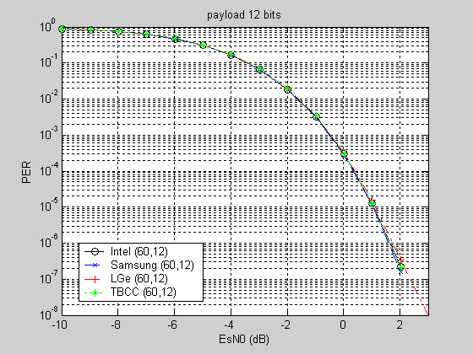
Figure 14
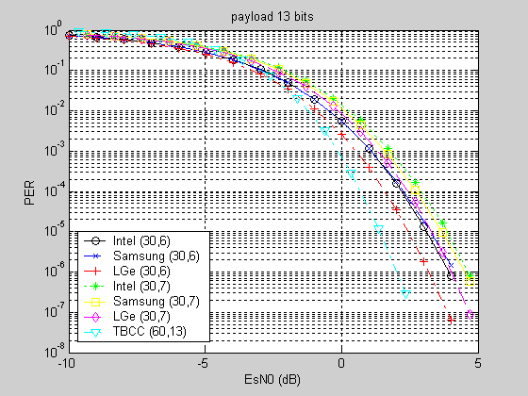
Figure 15
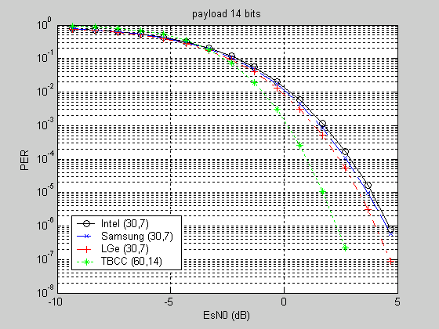
Figure 16
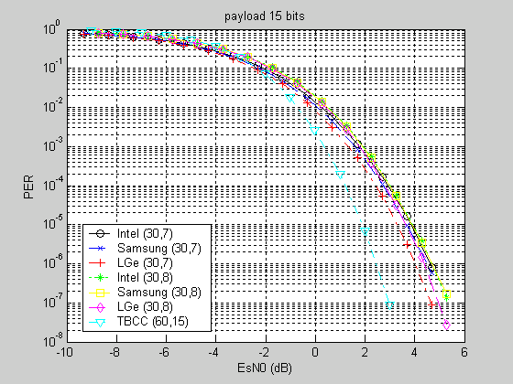
Figure 17

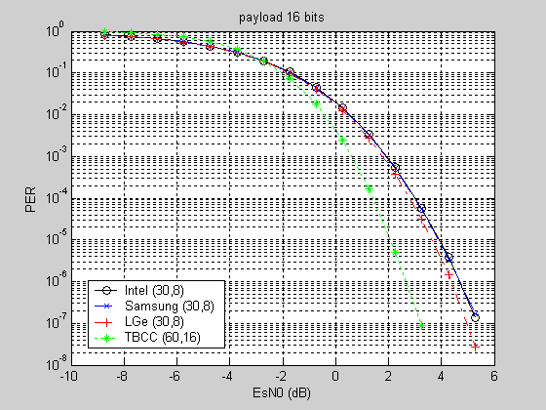
Figure 18
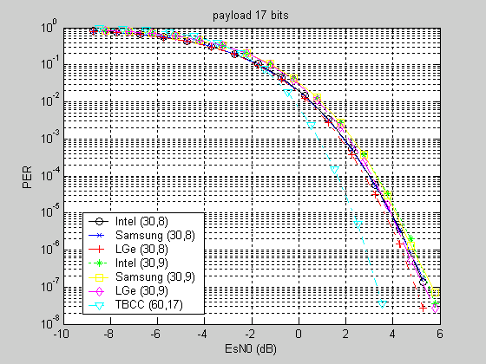
Figure 19
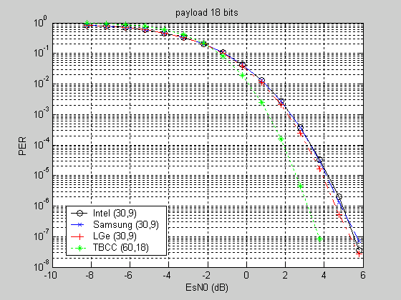
Figure 20
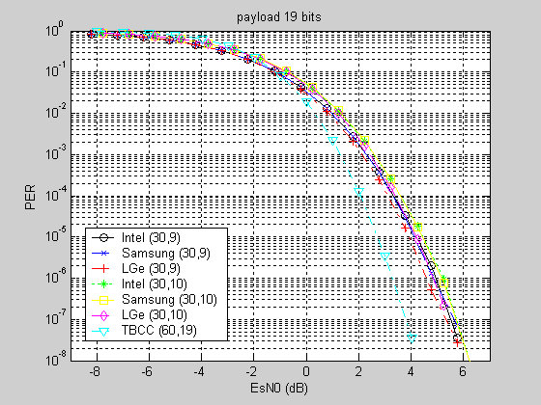
Figure 21
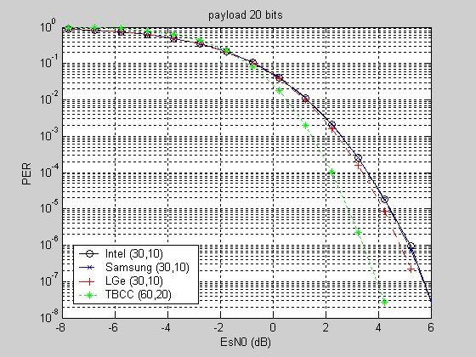
Figure 22
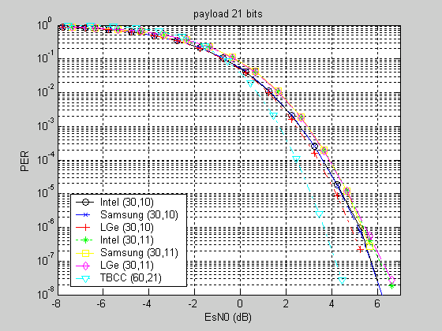
Figure 23
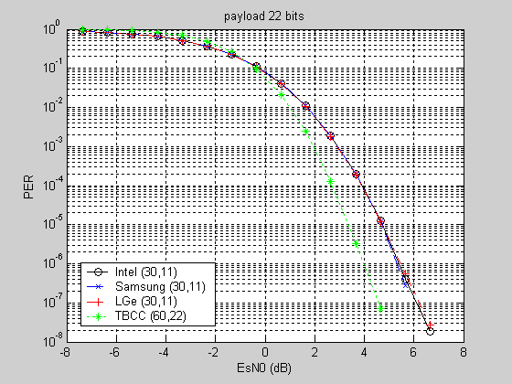
Figure 24
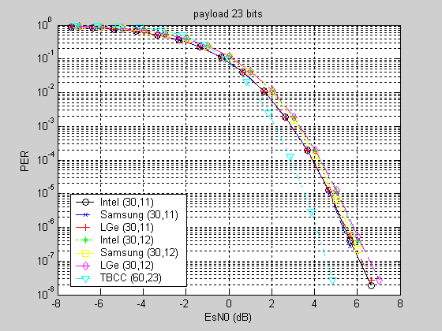
Figure 25
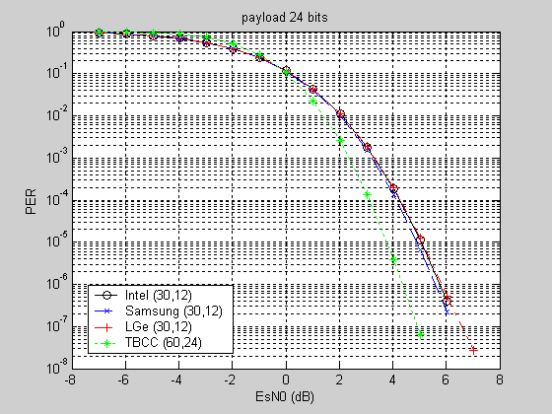
Figure 26

References

- IEEE C80216m-09_0387, “Proposed Text for the Draft P802.16m Amendment on the PHY Structure for UL Control -- Merged Version”.

- H. H. Ma and J. K. Wolf, “On tail biting convolutional codes,” IEEE Trans. Commun., vol. 34, pp. 104-111, Feb. 1986.

- R. Y. Shao, S. Lin and M. P. C. Fossorier, “Two decoding algorithms for tail-biting codes,” IEEE Trans. Commun., vol. 51, no. 10, pp. 1658-1665, Oct. 2003.

- S. Lin and D. J. Costello, Jr, Error control coding. Upper Saddle River, New Jersey: Pearson, 2004.

- IEEE C80216m-09_0732, “Complexity analysis for decoding SFBCH”.

The second option in [1] is to insert 4 pilot tones into each 2x6 FMT and the SFBCH payload is encoded to 48 coded bits, or 24 QPSK symbols. In this document we focus on the 2-pilot case. However, the same TBCC design approach can be applied to the 4-pilot case.

