Project | IEEE 802.16 Broadband Wireless Access Working Group <http://ieee802.org/16>
Title | Reduced-Overhead Covariance Matrix Feedback
Date Submitted | 2009-03-04
Source(s) | Phil Orlik, Simon Pun, Ramesh Annavajjala, Amine Maaref, Zhifeng (Jeff) Tao, Jinyun Zhang  Mitsubishi Electric Research Laboratories  Toshiyuki Kuze  Mitsubishi Electric Corp | E-mail: {porlik,mpun,annavajjala,maaref,tao,jzhang}@merl.com  Kuze.Toshiyuki@ah.MitsubishiElectric.co.jp
Re: | 802.16m AWD
Abstract | In this contribution, advanced quantization schemes are proposed to reduce the amount of overhead associated with the feedback of transmit correlation matrices.
Purpose | To discuss the proposed text in the IEEE 802.16m AWD
Notice | This document does not represent the agreed views of the IEEE 802.16 Working Group or any of its subgroups. It represents only the views of the participants listed in the “Source(s)” field above. It is offered as a basis for discussion. It is not binding on the contributor(s), who reserve(s) the right to add, amend or withdraw material contained herein.
Release | The contributor grants a free, irrevocable license to the IEEE to incorporate material contained in this contribution, and any modifications thereof, in the creation of an IEEE Standards publication; to copyright in the IEEE’s name any IEEE Standards publication even though it may include portions of this contribution; and at the IEEE’s sole discretion to permit others to reproduce in whole or in part the resulting IEEE Standards publication. The contributor also acknowledges and accepts that this contribution may be made public by IEEE 802.16.
Patent Policy | The contributor is familiar with the IEEE-SA Patent Policy and Procedures:  <http://standards.ieee.org/guides/bylaws/sect6-7.html#6> and <http://standards.ieee.org/guides/opman/sect6.html#6.3>.  Further information is located at <http://standards.ieee.org/board/pat/pat-material.html> and <http://standards.ieee.org/board/pat>.

Reduced-Overhead Covariance Matrix Feedback

Phil Orlik, Simon Pun, Ramesh Annavajjala, Amine Maaref, Zhifeng (Jeff) Tao, Jinyun Zhang
Mitsubishi Electric Research Labs

Toshiyuki Kuze
Mitsubishi Electric Corp

1. Introduction
Closed-loop (CL) transmit precoding is supported for multiple-input multiple output (MIMO) downlink (DL) transmission in the IEEE 802.16m [1]. Since the codebooks are designed for uncorrelated MIMO channels, such codebooks are not optimal for correlated MIMO channels. To circumvent this obstacle, the adaptive codebook feedback mode has been specified in the current IEEE 802.16m standard to feed back the quantized long-term channel covariance matrix to the base stations (BS) [1]. Exploiting the quantized long-term channel covariance matrix, both BS and mobile stations (MS) employ transformed codebook to optimize the subsequent DL precoding. However, two issues with the adaptive codebook feedback mode deserve further improvement. First, the long-term channel covariance matrix is simply defined as [1]
,
where is the correlated channel matrix in the i-th OFDM symbol and j-th subcarrier. As shown in Fig. 1, cell-edge users are subject to spatially colored interference from neighboring cells. As a result, DL transmission designed based on the long-term channel covariance matrix defined above is suboptimal since it ignores the presence of such colored interference.

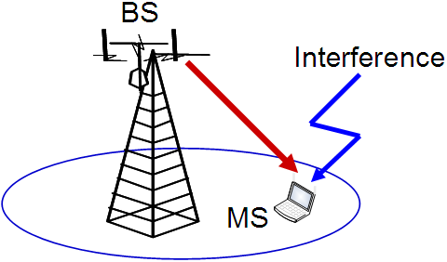
Fig. 1 Illustration of a system under asymmetric interference

In addition to the definition of the covariance matrix, large feedback overhead is required by the quantization method proposed in the current IEEE 802.16m standard. By exploiting the fact that the covariance matrix is Hermitian, the existing scheme performs direct quantization on the diagonal and upper-triangular elements with different levels of quantization precision. Unfortunately, this simple scheme incurs large feedback overhead. For instance, it requires 28 bits to quantize a matrix of by quantizing each real-valued diagonal element and complex-valued upper-triangular element with one and four bits, respectively. Clearly, the amount of overhead required by this scheme grows in the order of for a matrix of . In the sequel, this scheme is referred to as the direct quantization method.
In this contribution, advanced quantization schemes are proposed. Our proposal is threefold: first, we redefine the channel covariance matrix by explicitly taking into account the asymmetric interference in DL; second, two reduced-feedback quantization schemes are devised to feed back the quantized channel covariance matrix by exploiting the common codebook shared by MS and BS; third, a systematic approach is developed to extend smaller common codebooks in order to fully harvest the advantages provided by the proposed quantization schemes. It should be emphasized that the later two proposals are also applicable to any definitions of channel covariance matrices. The advantages of the proposed scheme are summarized as follows. First, the proposed scheme is the first of its kind to explicitly address the asymmetric interference problem in IEEE 802.16m DL transmission. Second, compared to existing quantization schemes, the two proposed quantization schemes can achieve comparable quantization performance with up to 50% overhead reduction at the cost of affordable increase in computational complexity. Finally, the systematic codebook extension enables both MS and BS to easily reconstruct any specific codeword based on its index number, even if the codeword is not defined in a given common codebook. For presentational simplicity, we concentrate our following discussion on while the discussion can be straightforwardly extended to or 8.

2. Proposed Schemes
In this section, we first refine the definition of the long-term channel covariance matrix before proposing two reduced-feedback quantization schemes.

2.1. Redefinition of long-term channel covariance matrix
We assume that the j-th subcarrier of MS is subject to both interference from neighboring cells and additive white Gaussian noise (AWGN) denoted by and , respectively. Thus, the covariance matrix of the interference-plus-noise is defined as
.
Note that is always full-rank when is non-negligible, which usually holds for cell-edge users. Furthermore, for cell-center MSs with negligible interference from neighboring cells, simply becomes the noise covariance matrix . By taking into account the DL interference , we propose to refine the channel covariance matrix as
.

2.2 Reduced-feedback quantization schemes
Next, we proceed to develop reduced-feedback quantization schemes to return quantized from MSs to BSs. We first observe that the covariance matrix can be decomposed into the following form.
,
where and are unitary and real-valued diagonal matrices, respectively.
Furthermore, recall that MSs and BSs share common unitary codebooks . Thus, intuitively speaking, if we can find a codeword in the common codebook, then only information about one codeword index and its corresponding quantized is sufficient for BSs to reconstruct . More specifically, if the common codebook is comprised of codewords and each diagonal element is quantized with b bits, the total number of feedback bits is given by B+4b. However, due to the fact that the codebooks being considered for in IEEE 802.16m are relatively small (B=4 or 6), it may be difficult to find any codeword in such small codebooks satisfying in practice. In the following section, we first propose a systematic approach to expand any given unitary codebook to a larger-size one.

2.2.1 Codebook Expansion
Exploiting the fact that products of unitary matrices are also unitary, we can expand any given unitary codebook by adding products of systematically selected codewords to the codebook. For instance, given a codebook of B=4, we can expand it to a larger codebook of B=5 as follows:
,
where with for and .
Note that the new codewords can be also alternatively generated by multiplying existing codewords with phase rotations. For instance, we can define the new codeword as
,
where with being some pre-defined phase-rotation vectors.
By exploiting the newly developed codebook expansion, BSs can easily reconstruct the desired codeword upon receiving its index from MSs, even if the codeword is not explicitly included in the existing common codebook.

2.2.2 Extended Codebook Decomposition (ECD)
We assume of B bits is the available common codebook or the expanded codebook obtained from the above discussion. In this section, we will devise a simple quantization scheme to feed back . More specifically, we will find the optimal codeword in and its corresponding real-valued diagonal matrix that approximate by
.
Denote by the i-th column vector of . Exploiting the orthogonality among the column vectors of , the i-th diagonal element of , for , can be approximated by
.
Then, each is first normalized with respect to before being uniformly quantized into with b bits. Finally, we can evaluate the resulting mean square error (MSE) as follows.
.
By evaluating the MSE according to the equation above, we can find the optimal and its corresponding quantized that minimize the resulting MSE. In the sequel, this quantization scheme is referred to as the extended codebook decomposition (ECD).
Fig. 2 shows the MSE performance as a function of the codebook size B with different values of b. Inspection of Fig. 2 reveals that ECD with B=5 or 6 can provide comparable performance compared to the direct quantization scheme. Furthermore, it is shown in Fig. 2 that b=3 is sufficient to provide good quantization performance with respect to . Finally, Fig. 2 indicates that the rank of channel covariance matrix has observable impact on the quantization performance, which will be further investigated in details in Fig. 3.
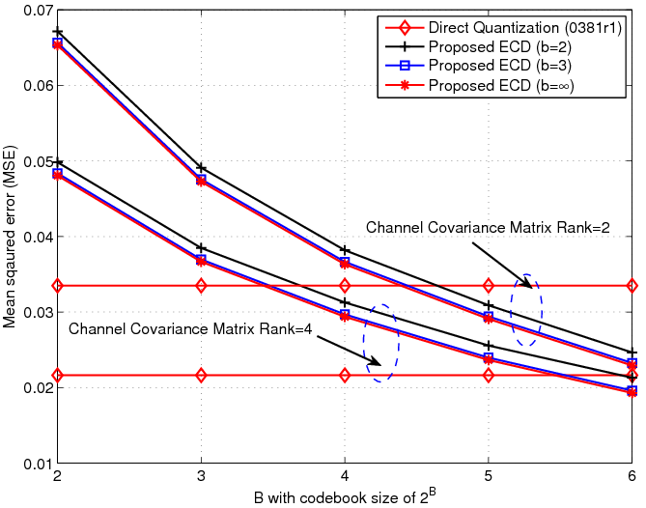
Fig. 2 MSE as a function of codebook size
Fig. 3 assesses the impact of the rank of channel covariance matrix on the MSE performance for B=5 or 6. It is shown in Fig. 3 that ECD provides more robust quantization performance compared to the direct quantization method for non full-rank channel covariance matrices (i.e. correlated MIMO channels). Recalling that the adaptive feedback mode is designed for correlated MIMO channels, ECD is more preferable over the direct quantization scheme for the adaptive feedback mode.
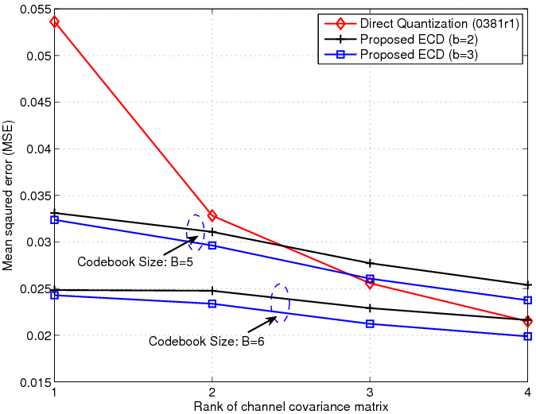
Fig. 3 MSE as a function of channel covariance matrix rank
2.2.3 Two-Level Decomposition (TLD)
Unlike ECD that improves the approximation accuracy by directly exploiting a larger codebook, this section proposes a two-level decomposition scheme by modeling the residual error with an extra level of decomposition using a relatively smaller codebook. More specifically, we approximate with
,
where with and being the unitary and diagonal matrices in the j-th level decomposition for j=1,2. Inspection of suggests that joint optimization of incurs formidable computational complexity. In the following, we propose a suboptimal iterative algorithm to optimize . Denote by the superscript the iteration number. The proposed iterative procedures operate as follows.
Step 1: Initialize and ;
Step 2: Update
,
and where is quantized with bits;
Step 3: Update
and where is quantized with bits;
Step 4: Increase and repeat Steps 2-3 until termination.
In the sequel, this scheme is referred to as the two-level decomposition (TLD).
Fig. 4 shows the MSE performance of TLD as a function of the codebook size B. Compared to Fig. 2, TLD requires a smaller codebook (B=5) to match the performance of the direct quantization method. In this experiment, we set the iteration numbers to two. It should be borne in mind that TLD requires more computation compared to ECD, which will be detailed in the next section.
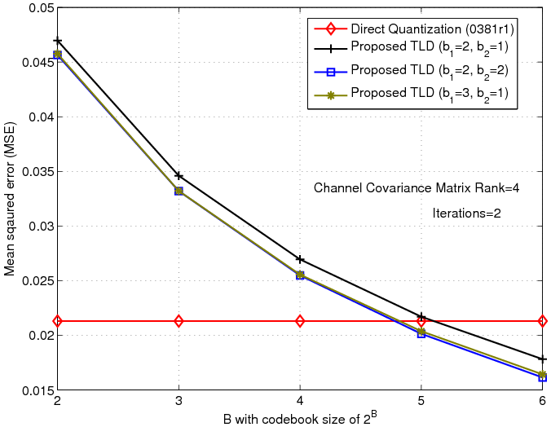
Fig. 4 MSE as a function of codebook size
Fig. 5 studies the convergence behavior of TLD. As shown in Fig. 5, two iterations are sufficient for TLD to achieve convergence. As a result, only two iterations are performed in the following TLD experiments.
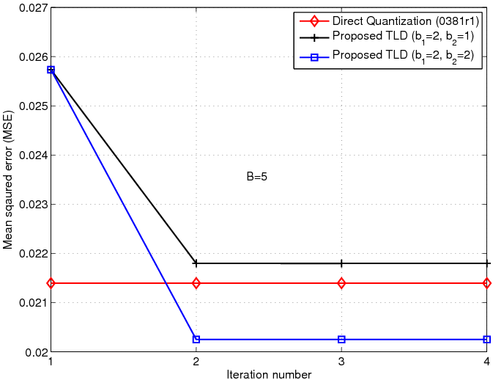
Fig. 5 Convergence behavior of TLD
Finally, we investigate the impact of channel rank on the performance of TLD. Fig. 6 confirms that TLD also has very robust performance over correlated MIMO channels.
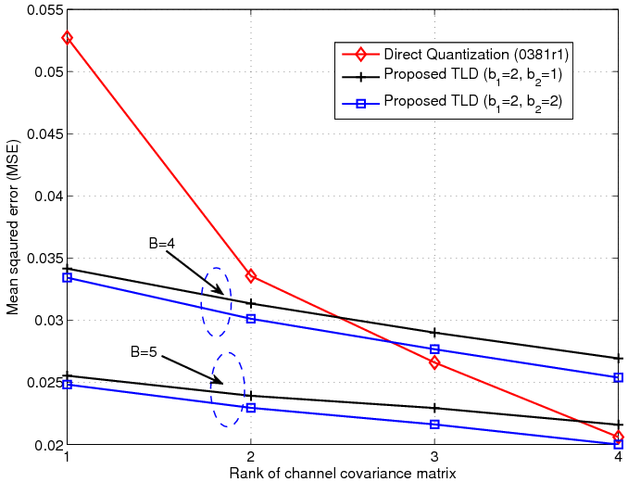
Fig. 6 MSE as a function of channel covariance matrix rank

2.2.4 Complexity Analysis
We first consider the complexity required by ECD. For each codeword in the codebook, two computations are performed: the computation of diagonal element of for takes operations whereas the evaluation of requires about operations by only assessing the diagonal and upper-triangular elements of the enclosed matrix (recall that both and are Hermitian). As a result, the total computational complexity required by ECD is about per each codeword or for a B-bit codebook. Note that some further computational reduction in the MSE evaluation step is possible by deriving with being pre-computed for each codeword in the extended codebook.
Next, we consider the computational complexity of TLD. Recall that TLD is comprised of two ECD operations in each iteration. Thus, the total computational complexity required by TLD is .

2.3 Summary
In this contribution, we have proposed to refine the definition of the channel covariance matrix by explicitly taking into account the asymmetric downlink interference. Furthermore, a systematic approach has been developed to expand any codebooks to larger sizes, which facilitates BSs and MSs to easily reconstruct any desired codeword based on its index. Finally, two reduced-feedback quantization schemes have been devised by exploiting the extended codebooks. Simulation results have confirmed that the proposed schemes can achieve comparable quantization performance with up to 50% less feedback overhead, compared to the direct quantization method. However, it is fair to say that this advantage is attained at the cost of some affordable computational complexity. Some potential configurations of the proposed schemes are summarized in the following table.
Scheme | Codebook Size B | Quantization Bits | Total feedback bits | Feedback reduction w.r.t. 28 bits | Complexity
ECD | 5 | b=3 | 17 | 39%
ECD | 6 | b=2 | 14 | 50%
TLD | 4 |  | 24 | 14%
TLD | 5 |  | 22 | 21%

Proposed Text
The following modification in [2] is proposed.
[-------------------------------------------------Start of Text Proposal---------------------------------------------------]
15.3.6.2.5. Feedback mechanisms and operation
15.3.6.2.5.3.3 Adaptive codebook-based feedback mode
During some time period and in the whole band, the correlation matrix is measured as
where is by transmit covariance matrix. The correlated channel matrix is in the i-th OFDM symbol and j-th subcarrier whereas is the covariance matrix of downlink interference-plus-noise.
15.3.6.2.8.5.1 Quantized feedback modes

Table 1 specifies the codebook feedback modes.

Codebook feedback mode | Syntax | Value | Section
Standard Mode | CM | 0b00
Adaptive Mode | CM | 0b01
Differential Mode | CM | 0b10
Reduced Overhead Adaptive Mode | CM | 0b11

            - Reduced Overhead Adaptive Feedback mode
We assume is the available common codebook or the expanded codebook. We can note that R can be approximated by the following form
.
where is a code word selected from and is a real-valued diagonal matrix. To find the optimal V and Λ the following computation is carried out:
Denote by the i-th column vector of . Exploiting the orthogonality among the column vectors of , the i-th diagonal element of , for , can be approximated by
.
Then, each is first normalized with respect to before being uniformly quantized into with b bits. Finally, we can evaluate the resulting mean square error (MSE) as follows.
.
By evaluating the MSE according to the equation above, we can find the optimal and its corresponding quantized that minimize the resulting MSE.

[-------------------------------------------------End of Text Proposal----------------------------------------------------]

Reference
[1] Shkumbin Hamiti, “The Draft IEEE 802.16m System Description Document”, IEEE 802.16m-08/003r6

[2] Yong Sun, “Draft 1: Table of Contents for Amendment Text on MIMO”, IEEE 802.16m-09/0381r1

