Project | IEEE 802.16 Broadband Wireless Access Working Group <http://ieee802.org/16>
Title | Comments on A-MAP IE to Support A-MAP Occurrence Indication and Secondary Carrier Activation
Date Submitted | 2009-03-05
Source(s) | Chieh-Yuan Ho, Ming-Hsien Wu, Ching-Yao Huang, I-Kang Fu, Yih-Shen Chen, Paul Cheng  NCTU/MediaTek | IK.Fu@mediatek.com  thorpe.ho@mediatek.com  cyhuang@faculty.nctu.edu.tw
Re: | IEEE 802.16m-09/0012, “Call for Contributions on Project 802.16m Amendment Working Document (AWD) Content” – Comments on P802.16m AWD
Abstract | According to P802.16m SDD, assigned secondary carriers will not always be activated for saving unnecessary AMS processing power and signaling overheads. In addition, the AMS also need to know which sub-frame the AMS doesn’t need to decode A-MAP for sleep or co-located coexistence operations. This contribution suggests adding the relative parameters into the proper A-MAP IE.
Purpose | For member’s review and adoption into P802.16m Amendment Working Document
Notice | This document does not represent the agreed views of the IEEE 802.16 Working Group or any of its subgroups. It represents only the views of the participants listed in the “Source(s)” field above. It is offered as a basis for discussion. It is not binding on the contributor(s), who reserve(s) the right to add, amend or withdraw material contained herein.
Release | The contributor grants a free, irrevocable license to the IEEE to incorporate material contained in this contribution, and any modifications thereof, in the creation of an IEEE Standards publication; to copyright in the IEEE’s name any IEEE Standards publication even though it may include portions of this contribution; and at the IEEE’s sole discretion to permit others to reproduce in whole or in part the resulting IEEE Standards publication. The contributor also acknowledges and accepts that this contribution may be made public by IEEE 802.16.
Patent Policy | The contributor is familiar with the IEEE-SA Patent Policy and Procedures:  <http://standards.ieee.org/guides/bylaws/sect6-7.html#6> and <http://standards.ieee.org/guides/opman/sect6.html#6.3>.  Further information is located at <http://standards.ieee.org/board/pat/pat-material.html> and <http://standards.ieee.org/board/pat>.
Comments on A-MAP IE to Support A-MAP Occurrence Indication and Secondary Carrier Activation

Chieh-Yuan Ho, Ming-Hsien Wu, Ching-Yao Huang, I-Kang Fu, Yih-Shen Chen, Paul Cheng
National Chiao Tung University (NCTU) / MediaTek

- Motivation
In the 802.16m System, Advanced Mobile Station (AMS) can support data transmission over multiple carriers. In order to best utilize the scarce radio resources, Advanced Base Station (ABS) may change carriers to serve data transmission for specific AMS from time to time, i.e. on a per frame basis. Therefore, an efficient method for carrier activation and de-activation will be necessary. Because AMS might consume more power while operating on more than one carrier, a detailed procedure of multi-carrier power management need to be carefully designed in order to further extend AMS battery life. The motivation of this contribution is to design an efficient carrier activation procedure and supporting message design to improve the performances of multi-carrier support in the 802.16m system.

- Introduction
In the latest P802.16m System Description Document (SDD), the carrier which may be potentially used by the AMS is defined as the assigned carriers. The assigned carriers are supposed to be determined based on ABS and AMS hardware capabilities. Among the assigned carriers, some of the carriers will be activated for data transmission based on system requirements and called the active carriers. Since the primary carrier will always be one of the active carriers, the secondary carriers of AMS may be activated or be de-activated from time to time.
In addition, the ABS should also let AMS know which sub-frames that AMS should decode the A-MAP. Otherwise AMS have to process the signals received during each sub-frame and decode all the A-MAP to see whether there exists its A-MAP IE. This will largely increase AMS complexity and power consumption. It will also disturb the multi-radio coexistence operation and possible sleep operation. Therefore, A-MAP should also transmit the proper IE to notify AMS in which sub-frames it should decode the A-MAP IEs.
In order to fulfill member’s classification on assigned carrier and active carrier, the stage 3 standard shall define proper procedure and messaging support for secondary carrier activation and de-activation. This contribution reviews the possible operations of secondary carriers and suggests the necessary input into SFH and A-MAP IE for enabling secondary carrier activation. The detail procedure will be further discussed and harmonized with TGm members.

- Recommended Procedure for Secondary Carrier Activation

The primary carrier shall be capable to carry a multi-carrier indication IE as part of the A-MAP IEs in the first sub-frame of each frame to indicate the information on active secondary carriers to AMSs. In addition, the current A-MAP IE design implies that AMS has to decode each sub-frame and check if there is any A-MAP IE is for him. This will result in huge AMS computation overhead and increase unnecessary complexity to AMS.
This contribution also recommends the first sub-frame of each carrier shall be capable to send IE to inform which sub-frames will contain the A-MAP IEs or A-A-MAP IE for specific AMS. By combining with the A-A-MAP IE content, AMS can know which sub-frame that AMS doesn’t have to process it at all and hence save some power for longer battery life. Moreover, this information can further combine with co-located multi-radio coexistence control mechanisms to inform AMS that which sub-frames will be silent (to specific AMS) in 16m air interface so that AMS may utilize this information to coordinate internal air-interfaces to for coexistence and prevent mutual interference.
The aforementioned multi-carrier indication IE in the primary carrier and the A-MAP occurrence indication IE in each carrier should be event-triggered IEs. In order to save MAC overhead, ABS may not send this information to each AMS in each frame. For example, the A-MAP IE to inform active secondary carrier will only send to the AMS who agree to activate its secondary carrier through its primary carrier. Meanwhile, the A-MAP IE to inform which sub-frames the A-MAP IE for specific AMS will exist may only send to the AMS request power saving in sub-frame level or request ABS to support its co-located multi-radio coexistence control. The usage cases and detail control flows for those functions can be further discussed by members. But having those IE in AWD to enable such function will be a fundamental step to make them work.
Up on receiving the active secondary carrier index through this indication IE, the AMS shall start processing the designated secondary carriers as the way it process the primary carrier. The A-A-MAP IE to support resource allocation in the secondary carriers for AMS is supposed to be transmitted through corresponding carriers respectively, so that AMS doesn’t need to decode the A-A-MAP IE in the primary carrier for the traffic in secondary carrier. In addition, the secondary carrier can also be de-activated by ABS through this indication IE in unsolicited manner. While ABS is not supposed to send further control information to AMS after sending unsolicited message in primary carrier to deactivate the secondary carrier, AMS doesn’t need to monitor the deactivated carrier since next frame.
For carrier aggregation mode, this multi-carrier indication A-MAP IE is supposed to be sent in on-off manner. Therefore, the indication to deactivate the secondary carrier should be sent after a period of time after activating it. For the carrier switching mode, this multi-carrier indication A-MAP IE may be sent in frame base. How to coordinate the transmission in carrier switching mode is FFS and up to members’ consensus.
The Figure 1 illustrates basic idea of the carrier activation IE for 802.16m system. As shown in figure, assuming three AMSs treat carrier 1 as their primary carrier, the indication IE on the primary carrier indicates AMSs with only the active secondary carrier indexes and the corresponding A-MAP IE occurrence information on the primary carrier. After the reception of the indication IEs, AMSs can decode the corresponding A-MAP IEs and A-A-MAP IE in the designated carriers and/or sub-frames. The current idea is that the IE content is pointing the situation in next frame, but this can be further discussed by members.

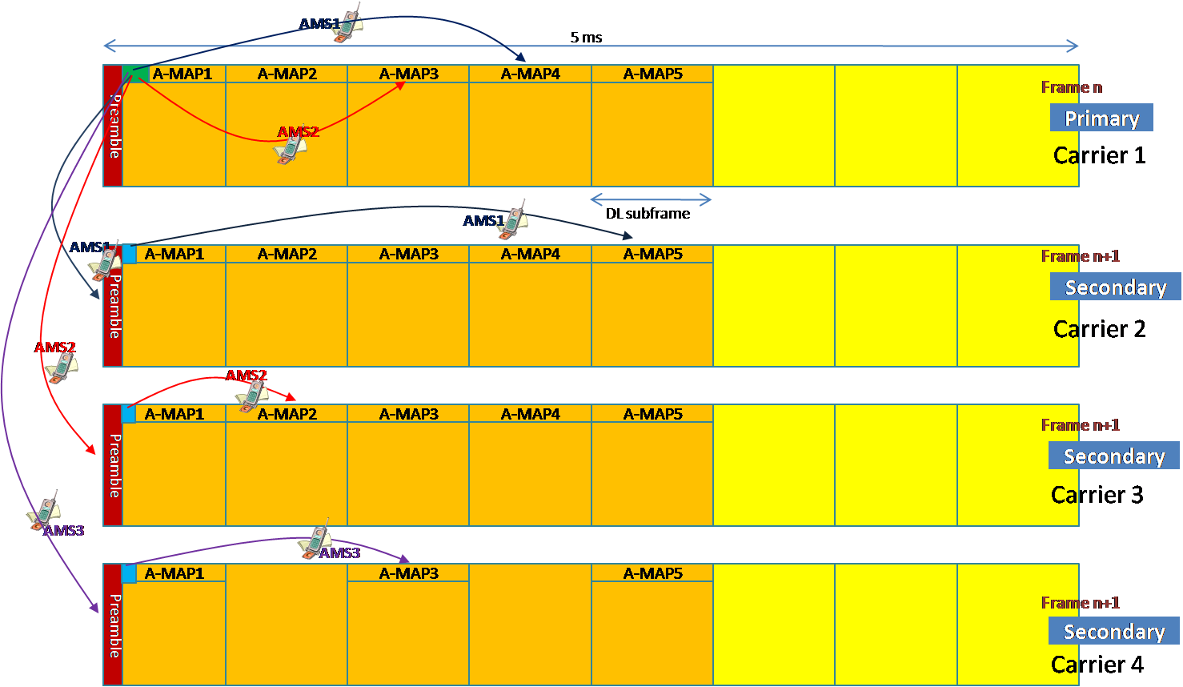

Fig. 1 Basic idea of the indication IE to activate secondary carrier and to identify which sub-frames contain the A-MAP IE or A-A-MAP IE for AMS

- Proposed Text Input to P802.16m Amendment Working Document

---------------------------------------------------------Start of the Text-----------------------------------------------------------
[Add the following text into P802.16m Amendment Working Document]

15.3.6.5.2.5 Multi-Carrier A-MAP IE
MC-A-MAP IE includes x bits bitmap for indicating the resource assignment across multiple carriers. When the bitmap indicates “1”, the multi-carrier AMS shall decode the Assignment A-MAP IE transmitted over the corresponding carriers in next frame to obtain detail resource allocation information. The order of the bitmap in MC-A-MAP IE is based on logical carrier index and the first bit refers to primary carrier.

Table xxx – MC-A-MAP IE format
Syntax | Size (bit) | Notes
MC-A-MAP IE format {
Carrier Activation Bitmap | 4 | The order is based on logical carrier index, and the 1st bit refers to primary carrier.
}

15.3.6.5.2.6 A-MAP Occurrence IE
A-MAP Occurrence IE locates in the first sub-frame if transmitted and indicates the occurrence of the A-MAP IE in next frame by bitmap for subsequent 7 sub-frames. When the bitmap indicates “1”, at least one of the A-MAP IE defined in 15.3.6.5.2 will be occurred in the corresponding sub-frame. The order of the bitmap in A-MAP Occurrence IE is based on the sub-frame index.

Table xxx –A-MAP Occurrence IE format
Syntax | Size (bit) | Notes
A-MAP Occurrence IE format {
A-MAP Occurrence Bitmap | 7 | 1: A-MAP IE is available  0: A-MAP IE is not available
}

----------------------------------------------------------End of the Text-----------------------------------------------------------

