Project | IEEE 802.16 Broadband Wireless Access Working Group <http://ieee802.org/16>
Title | Proposed Amendment Text Regarding to Uplink Pilot Patterns for Distributed LRUs
Date Submitted | 2009-03-02
Source(s) | Chih-Yuan Lin, Pei-Kai Liao, Yu-Hao Chang, I-Kang Fu, Yih-Shen Chen, Kelvin Chou, Paul Cheng  MediaTek Inc.  Zheng Yan-Xiu, Yu-Chuan Fang, Chang-Lan Tsai, Chung-Lien Ho, Hsi-Min Hsiao, Ren-Jr Chen  ITRI | chihyuan.lin@mediatek.com
Re: | 802.16m AWD: IEEE 802.16m-09/0012, “Call for Comments on Amendment Working Document”.
Abstract | Based on the consensus agreed by members during Session#59, the basic pilot patterns used in LZone was adopted in P802.16m SDD. This contribution proposes to forward the pilot structure into the Amendment Working Document to facilitate other stage 3 proposals preparation. Also, this contribution extends the pilot patterns of 6-symbol DLRU for 5- and 7-symbol DLRUs.
Purpose | For member’s review and adoption into P802.16m Amendment Working Document
Notice | This document does not represent the agreed views of the IEEE 802.16 Working Group or any of its subgroups. It represents only the views of the participants listed in the “Source(s)” field above. It is offered as a basis for discussion. It is not binding on the contributor(s), who reserve(s) the right to add, amend or withdraw material contained herein.
Release | The contributor grants a free, irrevocable license to the IEEE to incorporate material contained in this contribution, and any modifications thereof, in the creation of an IEEE Standards publication; to copyright in the IEEE’s name any IEEE Standards publication even though it may include portions of this contribution; and at the IEEE’s sole discretion to permit others to reproduce in whole or in part the resulting IEEE Standards publication. The contributor also acknowledges and accepts that this contribution may be made public by IEEE 802.16.
Patent Policy | The contributor is familiar with the IEEE-SA Patent Policy and Procedures:  <http://standards.ieee.org/guides/bylaws/sect6-7.html#6> and <http://standards.ieee.org/guides/opman/sect6.html#6.3>.  Further information is located at <http://standards.ieee.org/board/pat/pat-material.html> and <http://standards.ieee.org/board/pat>.
Proposed Amendment Text Regarding to Uplink Pilot Patterns for Distributed LRUs
Chih-Yuan Lin, Pei-Kai Liao, Yu-Hao Chang, I-Kang Fu, Yih-Shen Chen, Kelvin Chou, Yu-Hao Chang, Paul Cheng
MediaTek Inc.

- Background
This contribution aims to forward the pilot patterns for 16m distributed PUSC LRU, which was adopted in Seccion 59 and is shown in Figure 43 of SDD (please see below), to the amendment working document. Moreover, since current AWD does not determine the pilot patterns for type-1 short and type-2 subframes in the uplink case, this contribution also directly extends the pilot patterns of the type-1 (6-symbol) subrame for the two irregular subframes.
“11.6.4.1 Distributed Resource Unit for 16m PUSC
Unlike a DRU structure defined in 11.6.1.1, a DRU in 16m PUSC contains six tiles which size is 4xNsym where Nsym depends on the subframe type. Figure 43 shows a tile structure when a subframe has 6 symbols.
Figure 43 Tile structure in 16m PUSC.”
- Proposed Text Input to P802.16m Amendment Working Document
[Add the texts marked in red and figures in the IEEE 802.16m-08/0010]
15.3.8.4 Pilot Structure
Uplink pilot is dedicated to each user and can be precoded or beamformed in the same way as the data subcarriers of the resource allocation. The pilot structure is defined for up to 4 transmission streams.

The pilot pattern may support variable pilot boosting. When pilots are boosted, each data subcarrier should have the same Tx power across all OFDM symbols in a resource block. The boosting values are TBD.

Pilot structures in 18-by-6 allocations used for contiguous LRUs and in 6-by-6 tiles for distributed LRUs are shown in Figures 1 and 2 respectively. Figure 410 shows the pilot structure for contiguous LRUs where the number of streams is one, two, three or four. Note that the pilot patterns for UL contiguous LRUs are same as in the downlink case. Figures 411 and Figure 412 shows the pilot structure for distributed LRUs where the number of streams is one and two, respectively. Figures 413 and 414 are respectively the one- and two-stream pilot patterns for the distributed 16m PUSC LRUs.

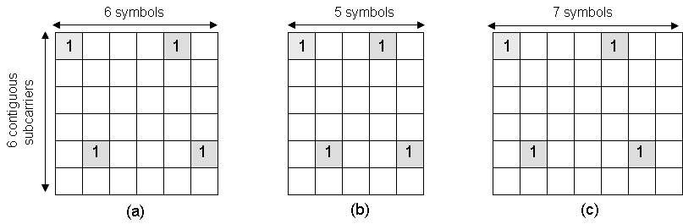
Figure 411. Pilot patterns of 1Tx stream for distributed LRUs: (a) type-1 subframe, (b) type-3 subframe, and (c) type-2 subframe cases.
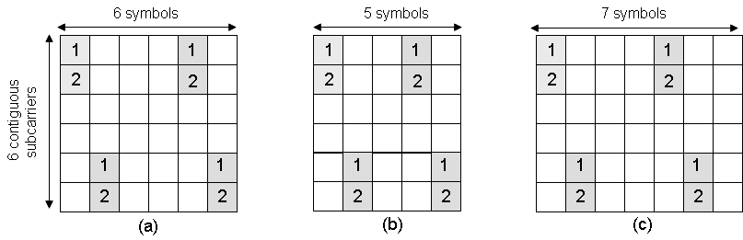
Figure 411. Pilot patterns of 2 Tx stream for distributed LRUs: (a) type-1 subframe, (b) type-3 subframe, and (c) type-2 subframe cases.
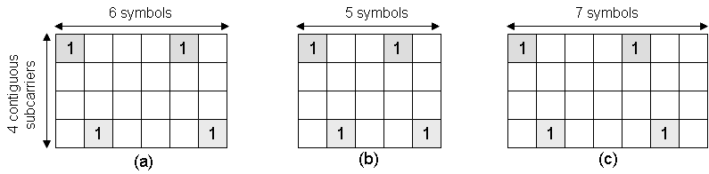
Figure 413. Pilot patterns of 1Tx stream for the distributed 16m PUSC LRUs: (a) type-1 subframe, (b) type-3 subframe, and (c) type-2 subframe cases.
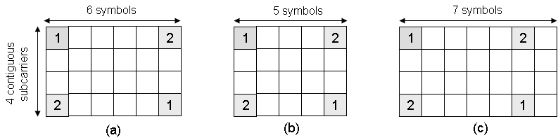
Figure 413. Pilot patterns of 2Tx stream for the distributed 16m PUSC LRUs: (a) type-1 subframe, (b) type-3 subframe, and (c) type-2 subframe cases.

