Project | IEEE 802.16 Broadband Wireless Access Working Group <http://ieee802.org/16>
Title | Proposed Amendment Text Regarding to Uplink Pilot Patterns for Distributed LRUs
Date Submitted | 2009-03-09
Source(s) | Chih-Yuan Lin, Pei-Kai Liao, Yu-Hao Chang, I-Kang Fu, Yih-Shen Chen, Kelvin Chou, Paul Cheng  MediaTek Inc.  Zheng Yan-Xiu, Yu-Chuan Fang, Chang-Lan Tsai, Chung-Lien Ho, Hsi-Min Hsiao, Ren-Jr Chen, Yutao Hsieh  ITRI  Jeongho Park, Jaeweon Cho, Heewon Kang, Hokyu Choi  Samsung Electronics | chihyuan.lin@mediatek.com
Re: | 802.16m AWD: IEEE 802.16m-09/0012, “Call for Comments on Amendment Working Document”.
Abstract | Based on the consensus agreed by members during Session#59, the basic pilot patterns used in LZone was adopted in P802.16m SDD. This contribution proposes to forward the pilot structures into the AWD to facilitate other stage 3 proposals preparation. This contribution also extends the pilot patterns of 6-symbol DLRU for 5- and 7-symbol DLRUs. Moreover, this contribution proposes to add some sections about legacy support in AWD.
Purpose | For member’s review and adoption into P802.16m Amendment Working Document
Notice | This document does not represent the agreed views of the IEEE 802.16 Working Group or any of its subgroups. It represents only the views of the participants listed in the “Source(s)” field above. It is offered as a basis for discussion. It is not binding on the contributor(s), who reserve(s) the right to add, amend or withdraw material contained herein.
Release | The contributor grants a free, irrevocable license to the IEEE to incorporate material contained in this contribution, and any modifications thereof, in the creation of an IEEE Standards publication; to copyright in the IEEE’s name any IEEE Standards publication even though it may include portions of this contribution; and at the IEEE’s sole discretion to permit others to reproduce in whole or in part the resulting IEEE Standards publication. The contributor also acknowledges and accepts that this contribution may be made public by IEEE 802.16.
Patent Policy | The contributor is familiar with the IEEE-SA Patent Policy and Procedures:  <http://standards.ieee.org/guides/bylaws/sect6-7.html#6> and <http://standards.ieee.org/guides/opman/sect6.html#6.3>.  Further information is located at <http://standards.ieee.org/board/pat/pat-material.html> and <http://standards.ieee.org/board/pat>.
Proposed Amendment Text Regarding to Uplink Pilot Patterns for Distributed LRUs
Chih-Yuan Lin, Pei-Kai Liao, Yu-Hao Chang, I-Kang Fu, Yih-Shen Chen, Kelvin Chou, Yu-Hao Chang, Paul Cheng
MediaTek Inc.
Zheng Yan-Xiu, Yu-Chuan Fang, Chang-Lan Tsai, Chung-Lien Ho, Hsi-Min Hsiao, Ren-Jr Chen, Yutao Hsieh
ITRI
Jeongho Park, Jaeweon Cho, Heewon Kang, Hokyu Choi
Samsung Electronics
- Background
This contribution has two separate parts. The first part focuses on the legacy support issue, which is not addressed in current AWD. The second part aims to forward the pilot patterns for 16m distributed PUSC LRU, which was adopted in Seccion 59 and is shown in Figure 43 of SDD (please see below), to the amendment working document. Moreover, since current AWD does not determine the pilot patterns for type-1 short and type-2 subframes in the uplink case, this contribution also directly extends the pilot patterns of the type-1 (6-symbol) subrame for the two irregular subframes.
“11.6.4.1 Distributed Resource Unit for 16m PUSC
Unlike a DRU structure defined in 11.6.1.1, a DRU in 16m PUSC contains six tiles which size is 4xNsym where Nsym depends on the subframe type. Figure 43 shows a tile structure when a subframe has 6 symbols.
Figure 43 Tile structure in 16m PUSC.”
- Part 1: Text Proposal for Section 15.3.8.3
[Add the following texts in the IEEE 802.16m-08/0010]
15.3.8.3.X WirelessMAN-OFDMA Systems Support
When frame structure is supporting the WirelessMAN-OFDMA MSs in PUSC zone by FDM manner as defined in 15.3.3.4, a new symbol structure and subchannelization defined in the subclause are used.
15.3.8.3.X.1 Basic Symbol Structure for FDM based UL PUSC Zone Support
The subcarriers of an OFDMA are partitioned into N_{g,left} left guard subcarriers, N_{g,right} right guard subcarriers, and N_{used} used subcarriers. The DC subcarrier is not loaded. The N_{used} subcarriers are divided into multiple PUSC tiles. Basic symbol structures for various bandwidths are shown in from Table x-1 to Table x-3.

Table x-1 – 512 FFT OFDMA UL subcarrier allocations for DRU
Parameters | Value | Comments
Number of DC subcarriers | 1 | Index 256 (counting from 0)
Number of left guard subcarriers (N_{g,left}) | 52
Number of right guard subcarriers (N_{g,right}) | 51
Number of total used subcarriers (N_{used}) | 409 | Number of all subcarriers used in WirelessMAN-OFDMA PUSC zone within a symbol, including DC carrier
Table x-2 – 1024 FFT OFDMA UL subcarrier allocations for DRU
Parameters | Value | Comments
Number of DC subcarriers | 1 | Index 512 (counting from 0)
Number of left guard subcarriers (N_{g,left}) | 92
Number of right guard subcarriers (N_{g,right}) | 91
Number of total used subcarriers (N_{used}) | 841 | Number of all subcarriers used in WirelessMAN-OFDMA PUSC zone within a symbol, including DC carrier
Table x-3 – 2048 FFT FFT OFDMA UL subcarrier allocations for DRU
Parameters | Value | Comments
Number of DC subcarriers | 1 | Index 1024 (counting from 0)
Number of left left guard subcarriers (N_{g,left}) | 184
Number of right guard subcarriers (N_{g,right}) | 183
Number of total used subcarriers (N_{used}) | 1681 | Number of all subcarriers used in WirelessMAN-OFDMA PUSC zone within a symbol, including DC carrier

15.3.8.3.X.2 Resource Block for FDM based UL PUSC Zone Support
When supporting FDM based UL PUSC zone, a tile consists of 4 consecutive subcarriers and 6 OFDMA symbols, as shown in Figure y-1.
Figure y-1. Resource block for FDM based UL PUSC zone Support.

15.3.8.3.X.3 Subchannelization for FDM based UL PUSC Zone Support
When supporting FDM based UL PUSC zone, UL subchannelization shall conform the following rules:
      - For the WirelessMAN-OFDMA system bandwidth, all usable subcarriers given from Table x-1 to Table x-3 are divided into PUSC tiles.
      - UL PUSC subchannelization is performed as described in section 8.4.6.2.2.
      - Available subchannels for Advanced Air Interface MS shall be specified through subchannel bitmap broadcasted by [system descriptor, TBD].
      - All PUSC tiles of specified subchannels from step 3 are extended in time domain from 3 OFDM symbols to N_{sym} OFDM symbols, where N_{sym} is dependent of subframe type.
      - Based on specified subchannels of step 3 with symbol extension tiles of step 4, DRUs for Advanced Air Interface are made up.
      - Repeat step 4 and step 5 for remained OFDMA symbols of every uplink subframe.
Overall process of subcarrier to subchannel mapping is shown in Figure y-2.
Figure y-2. Example of subchannelization for FDM based UL PUSC zone support
- Part 2: Text Proposal for Section 15.3.8.4
[Add the texts marked in red and figures in the IEEE 802.16m-08/0010]
15.3.8.4 Pilot Structure
Uplink pilot is dedicated to each user and can be precoded or beamformed in the same way as the data subcarriers of the resource allocation. The pilot structure is defined for up to 4 transmission streams.

The pilot pattern may support variable pilot boosting. When pilots are boosted, each data subcarrier should have the same Tx power across all OFDM symbols in a resource block. The boosting values are TBD.

Pilot structures in 18-by-6 allocations used for contiguous LRUs and in 6-by-6 tiles for distributed LRUs are shown in Figures 1 and 2 respectively. Figure 410 shows the pilot structure for contiguous LRUs where the number of streams is one, two, three or four. Note that the pilot patterns for UL contiguous LRUs are same as in the downlink case. Figures 411 and Figure 412 shows the pilot structure for distributed LRUs where the number of streams is one and two, respectively. Figures 413 and 414 are respectively the one- and two-stream pilot patterns for the distributed 16m PUSC LRU.

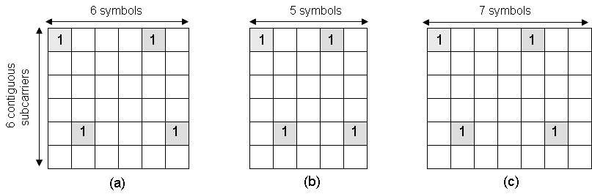
Figure 411. Pilot patterns of 1-Tx stream for distributed LRUs: (a) type-1 subframe, (b) type-3 subframe, and (c) type-2 subframe cases.
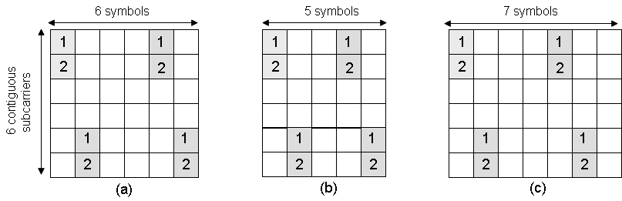
Figure 412. Pilot patterns of 2-Tx stream for distributed LRUs: (a) type-1 subframe, (b) type-3 subframe, and (c) type-2 subframe cases.
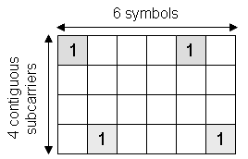
Figure 413. Pilot pattern of 1-Tx stream for the distributed 16m PUSC LRU.
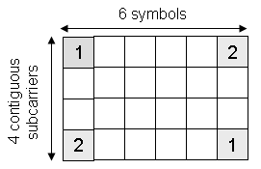
Figure 414. Pilot pattern of 2-Tx stream for the distributed 16m PUSC LRU.

