Project | IEEE 802.16 Broadband Wireless Access Working Group <http://ieee802.org/16>
Title | Proposed Amendment Text for Sounding Section
Date Submitted | 2009-03-02
Source(s) | Chih-Yuan Lin, Pei-Kai Liao, Yu-Hao Chang, I-Kang Fu, Yih-Shen Chen, Kelvin Chou, Paul Cheng  MediaTek Inc.  Zheng Yan-Xiu, Yu-Chuan Fang, Chang-Lan Tsai, Chung-Lien Ho, Hsi-Min Hsiao, Ren-Jr Chen  ITRI | chihyuan.lin@mediatek.com
Re: | 802.16m AWD: IEEE 802.16m-09/0012, “Call for Comments on Amendment Working Document”.
Abstract | This contribution proposes some modifications on the sounding section of the UL Ctrl DG text.
Purpose | For member’s review and adoption into P802.16m Amendment Working Document
Notice | This document does not represent the agreed views of the IEEE 802.16 Working Group or any of its subgroups. It represents only the views of the participants listed in the “Source(s)” field above. It is offered as a basis for discussion. It is not binding on the contributor(s), who reserve(s) the right to add, amend or withdraw material contained herein.
Release | The contributor grants a free, irrevocable license to the IEEE to incorporate material contained in this contribution, and any modifications thereof, in the creation of an IEEE Standards publication; to copyright in the IEEE’s name any IEEE Standards publication even though it may include portions of this contribution; and at the IEEE’s sole discretion to permit others to reproduce in whole or in part the resulting IEEE Standards publication. The contributor also acknowledges and accepts that this contribution may be made public by IEEE 802.16.
Patent Policy | The contributor is familiar with the IEEE-SA Patent Policy and Procedures:  <http://standards.ieee.org/guides/bylaws/sect6-7.html#6> and <http://standards.ieee.org/guides/opman/sect6.html#6.3>.  Further information is located at <http://standards.ieee.org/board/pat/pat-material.html> and <http://standards.ieee.org/board/pat>.
Proposed Amendment Text for Sounding Section
Chih-Yuan Lin, Pei-Kai Liao, Yu-Hao Chang, I-Kang Fu, Yih-Shen Chen, Kelvin Chou, Yu-Hao Chang, Paul Cheng
MediaTek Inc.

- Background
In current UL-PHY-Ctrl AWD text, the sounding symbol is determined to be the first or last symbol of UL subframe. However, the text does not determine how to use the remaining five symbols for the type-1 sufraeme or six symbols for the type-2 subframe, when sounding mode is enabled. This contribution intends to add several sentences and figures in current AWD to address this issue.
- Proposed Text Input to P802.16m Amendment Working Document
[Add the texts marked in red and figures in the IEEE 802.16m-09/0010]
[------------------- Part 1: For Text Proposal #3 of UL Ctrl DG --------------------]
15.3.9.1.3.1 Sounding PHY Structure
The sounding signal occupies a single OFDMA symbol in the UL sub-frame. The sounding symbol in the UL sub-frame is located in the [first][last] symbol. Each UL sub-frame can contain only one sounding symbol. For the type-1 subframe case, the remaining 5 consecutive symbols are formed to be a type-3 subframe, as shown in Figure x(a). For the type-2 subframe case, the remaining 6 consecutive symbols are formed to be a type-1 subframe, as shown in Figure x(b). Multiple UL subframes in a 5-ms frame can be used for sounding. The number of subcarriers for the sounding in a PRU is 18 adjacent subcarriers.

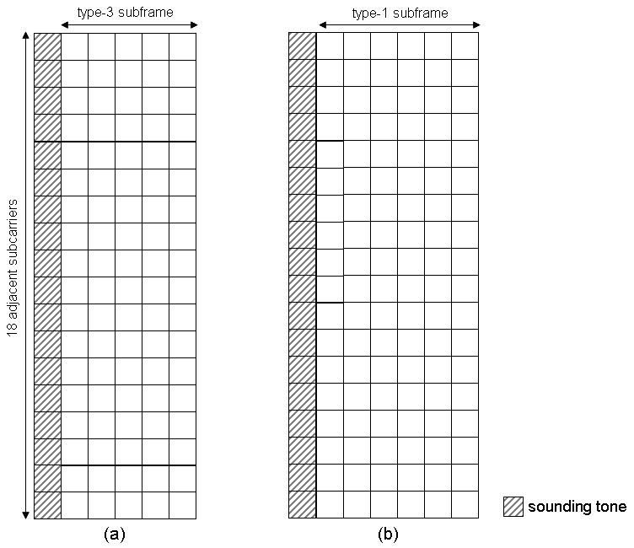
Figure x. Sounding PHY structures for (a) type-1 and (b) type-2 subframes.

[------------------- Part 2: For Text Proposal #7 of UL Ctrl DG --------------------]

15.3.9.2.1 Sounding Channel

15.3.9.2.1 Sounding sequence
The baseline sounding sequence is based on Golay sequence of length 2048 bits defined in Table 464 of Section 8.4.6.2.7 of WirelessMAN-OFDMA.

15.3.9.2.1 Multiplexing for multi-antenna and multi-AMS
The uplink sounding channels of multiple AMS and multiple antennas per AMS can be multiplexed through [Option 1: decimation separation or cyclic shift separation][Option2: decimation separation] in each sounding allocation. Also, in case of multiple UL subframes for sounding, time division separation can be applied by assigning different AMS to different UL subframe. For cyclic shift separation each AMS occupies all subcarriers within sounding allocation and uses the different sounding waveform [Editor's note: remove this sentence if Option 2 will be adopted]. For frequency decimation separation each AMS uses decimated subcarrier subset from the sounding allocation set with different frequency offset.

