Project | IEEE 802.16 Broadband Wireless Access Working Group <http://ieee802.org/16>
Title | Performance Comparison for Bit Priority Mapping and 16e Mapping in the 1st Transmission
Date Submitted | 2009-03-10
Source(s) | Yu-Chuan Fang, ¹Zheng Yan-Xiu,  Ren-Jr Chen, Chang-Lan Tsai,  Chung-Lien Ho, Chien-Yu Kao,  Cheng-Ming Chen, ²Yu-Tao Hsieh,  Jen-Yuan Hsu, Pang-An Ting,  ITRI  Wern-Ho sheen, NCTU/ITRI | Voice:  ¹+886-3-5914715  ²+886-3-5914854  E-mail:  ¹zhengyanxiu@itri.org.tw  ²ythsieh@itri.org.tw
Re | IEEE 802.16m-09/0012, “Call for Contributions on Project 802.16m Amendment Working Document (AWD) Content”.  Target topic: “Channel Coding and HARQ”.
Abstract | In IEEE 802.16e, CTC subpacket generation plays the role of channel interleaver and generates different subpackets. In the higher modulation, the constellation provides different level of protection. However, the channel interleaver had been found a significant deficiency that some contiguous bits would be mapped onto the constellation positions with low protection. This will degrade the decoding performance of turbo decoder. Therefore, bit priority mapping (BPM) is proposed to achieve better error performance and higher throughput since it protects the bits according to their priority, i.e., the higher prior, the more protection. Herein, BPM is compared with the 16e mapping and some simulation results are shown to demonstrate its potential for CTC.
Purpose | To be discussed and adopted by TGm for the 802.16m amendment.
Notice | This document does not represent the agreed views of the IEEE 802.16 Working Group or any of its subgroups. It represents only the views of the participants listed in the “Source(s)” field above. It is offered as a basis for discussion. It is not binding on the contributor(s), who reserve(s) the right to add, amend or withdraw material contained herein.
Release | The contributor grants a free, irrevocable license to the IEEE to incorporate material contained in this contribution, and any modifications thereof, in the creation of an IEEE Standards publication; to copyright in the IEEE’s name any IEEE Standards publication even though it may include portions of this contribution; and at the IEEE’s sole discretion to permit others to reproduce in whole or in part the resulting IEEE Standards publication. The contributor also acknowledges and accepts that this contribution may be made public by IEEE 802.16.
Patent Policy | The contributor is familiar with the IEEE-SA Patent Policy and Procedures:  <http://standards.ieee.org/guides/bylaws/sect6-7.html#6> and <http://standards.ieee.org/guides/opman/sect6.html#6.3>.  Further information is located at <http://standards.ieee.org/board/pat/pat-material.html> and <http://standards.ieee.org/board/pat>.
Performance Comparison for Bit Priority Mapping and 16e Mapping in the 1st Transmission

Yu-Chuan Fang, Zheng Yan-Xiu, Ren-Jr Chen, Chang-Lan Tsai, Chung-Lien Ho,
Chien-Yu Kao, Cheng-Ming Chen, Yu-Tao Hsieh, Jen-Yuan Hsu, Pang-An Ting,
ITRI

Wern-Ho sheen
ITRI/NCTU

- Introduction
The CTC (Convolutional Turbo Code) of code rate 1/3 defined in the IEEE 802.16e standard [1] is adopted in IEEE 802.16m SDD [2]. In IEEE 802.16e, CTC subpacket generation is used to generate different subpackets for HARQ packet transmission. It plays the role of channel interleaver and its procedure comprises bit separation, subblock interleaving, bit grouping and bit selection. In the higher modulation, the constellation provides different level of protection. However, the channel interleaver has a problem that some contiguous bits would be mapped onto the constellation positions with low protection. This will degrade the decoding performance of turbo decoder. Therefore, a more robust modified channel interleaver is required for the IEEE 802.16m to achieve better error performance and higher throughput. Bit priority mapping (BPM) is a considerable method since it advocates protecting the bits according to their priority, i.e., the higher prior, the more protection. Herein, BPM is compared with the 16e mapping and some simulation results are shown to demonstrate its potential for CTC.

Fig. 1 The structure of the channel interleaver of CTC in IEEE 802.16e.

- Proposed bit priority mapping for CTC
Fig. 1 shows the channel interleaver in IEEE 802.16e, which comprises several parts—bit separation, subbock interleaving, bit grouping and bit selection. Its deficiency is clearly disclosed in [6], [7] and [8]. Thus, BPM is proposed to improve the CTC performance. Before the bit mapping, all bits should be prioritized called bit prioritization, and then BPM maps higher/lower prior bits into more/less reliable positions. In this proposed method, bit prioritization performs according to the systematic or parity bits and the level of reliability originates from the modulation constellation. Therefore, bit prioritization divides the coded bits into two groups for 16-QAM and three groups for 64-QAM, and then the more/less significant bits are mapped to more/less reliable positions on the constellation as shown in Fig. 2. Since the order of the coded bits after the 16e channel interleaver of CTC is from systematic bits to parity bits, the coded bits are simply separated into equal parts with different level of significance. Assume the input is and the output is .
Let the new address is denoted as BPM.
,
where is the modulation order, 2 for QPSK, 4 for 16-QAM and 6 for 64-QAM, and is the subpacket length. Finally, BPM results in .

Fig. 2 Bit-priority mapping (a) for 16-QAM (b) for 64-QAM

- Simulation Results
Simulation parameters:
Carrier Frequency | 2.5GHz
FFT Size (N) | 1024
Guard Interval | 1/8
MS Velocity | Ped-B 3 km/hr or Veh-A 60 km/hr
Resource Allocation | Distributed resource allocation
Channel Coding | CTCs with 8 iterations, Max-Log-MAP
MIMO Configuration | Spatial Multiplexing 2x2 and SISO

The simulation cases are listed in Table 1 and the simulation results are shown in Fig. 3~Fig. 11. The column ‘Gain’ represents the gains in dB over the 16e mapping when the block error rate (BLER) is 10⁻². In Fig. 3~Fig. 9, the proposed BPM method is compared with the traditional 16e mapping. It outperforms the 16e mapping about at most 0.4 dB. In addition, BPM is more advantaged than 16e mapping at low SNR and especially for higher modulation. Note that the bit prioritization simply divides the coded bits into equal parts of contiguous bits and then at most 0.4 dB gain is achieved.
Furthermore, the proposed BPM method is compared with the C-symbol permutation [6]. It also outperforms the C-symbol permutation about at most 0.35 dB and 0.2 dB over the Ped-B 3km/hr and Veh-A 60km/hr channel respectively as shown in Fig. 10 and Fig. 11. These all demonstrate that BPM is a considerable method for 16m CTC.

Table 1 List of simulation cases
Modulation | Nep | Code rate | Scenario |  | Gain (dB) over the 16e mapping | Figure
16-QAM | 480 | 1/2 | AWGN | SISO | 0 | Fig. 3
16-QAM | 480 | 1/2 | Ped-B 3 km/hr | MIMO-SM 2x2 | 0.2 | Fig. 4, 10
16-QAM | 480 | 1/2 | Veh-A 60 km/hr | MIMO-SM 2x2 | 0.1 | Fig. 5, 11
64-QAM | 432 | 1/2 | AWGN | SISO | 0.3 | Fig. 6,
64-QAM | 432 | 1/2 | Ped-B 3 km/hr | MIMO-SM 2x2 | 0.25 | Fig. 7
64-QAM | 432 | 1/2 | Veh-A 60 km/hr | MIMO-SM 2x2 | 0.2 | Fig. 8
64-QAM | 384 | 2/3 | AWGN | SISO | 0.4 | Fig. 9
64-QAM | 288 | 1/2 | Ped-B 3 km/hr | MIMO-SM 2x2 | 0.4 | Fig. 10
64-QAM | 288 | 1/2 | Veh-A 60 km/hr | MIMO-SM 2x2 | 0.4 | Fig. 11

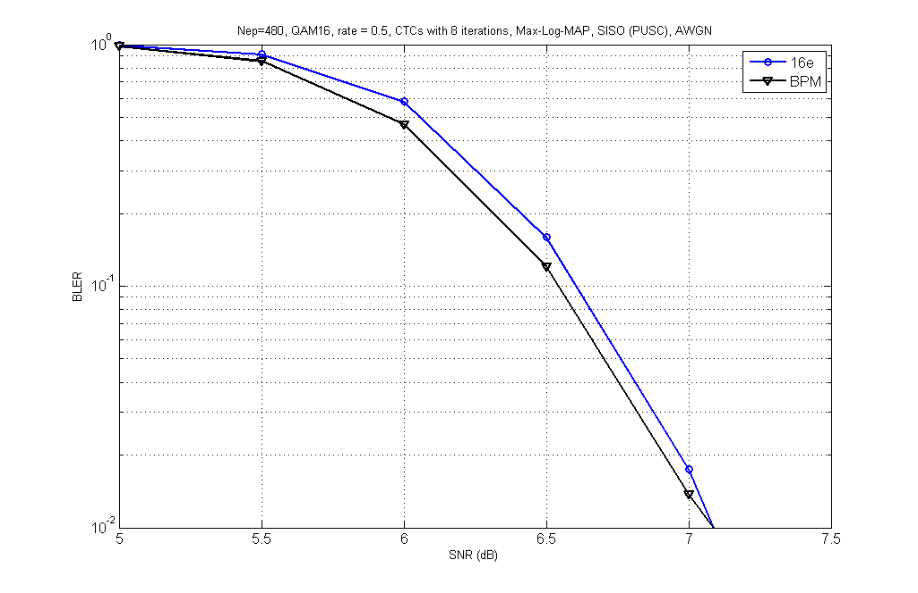
Fig. 3 Performance comparison between BPM and 16e mapping on condition of 16-QAM, R=1/2, SISO and AWGN

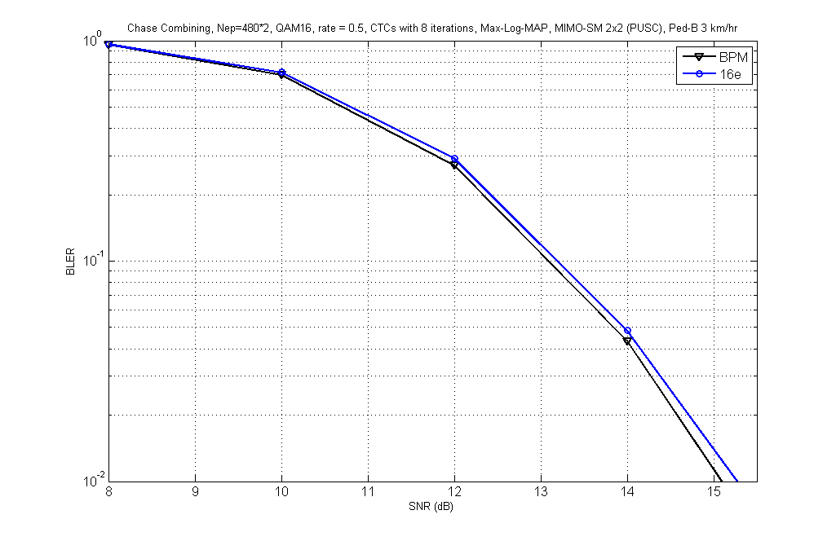
Fig. 4 Performance comparison between BPM and 16e mapping on condition of 16-QAM, R=1/2, MIMO-SM 2x2 and Ped-B 3 km/hr

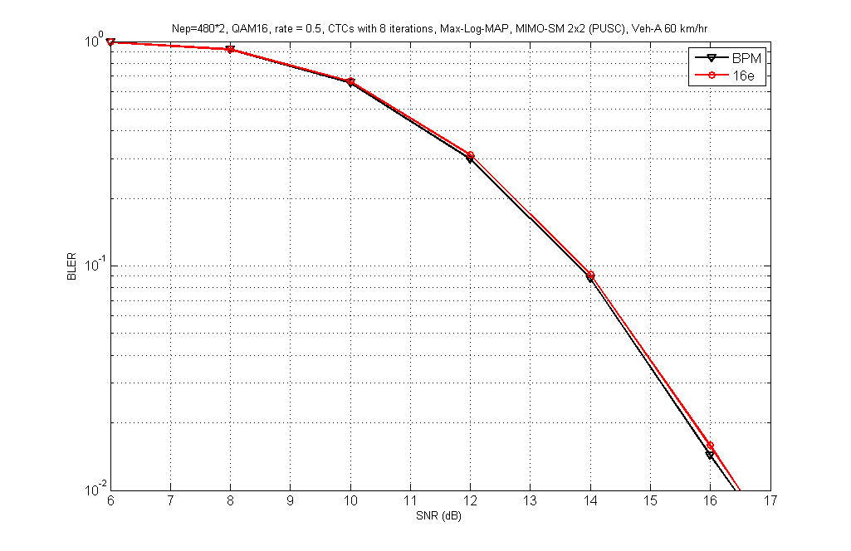
Fig. 5 Performance comparison between BPM and 16e mapping on condition of 16-QAM, R=1/2, MIMO-SM 2x2 and Veh-A 60 km/hr

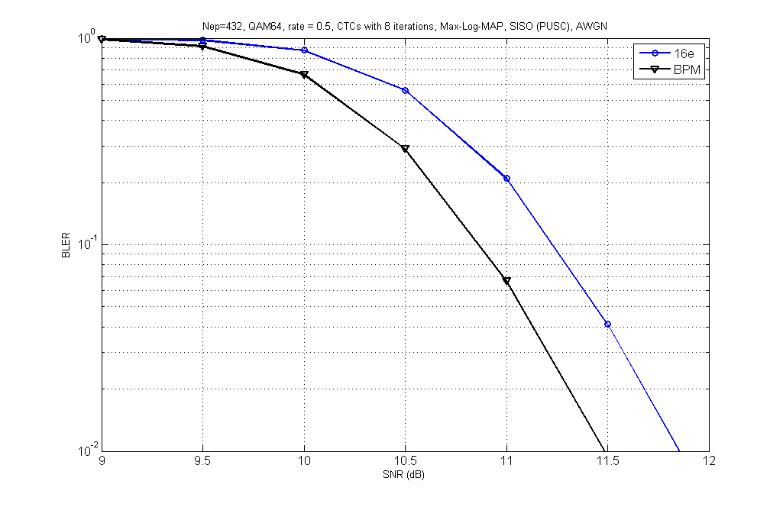
Fig. 6 Performance comparison between BPM and 16e mapping on condition of 64-QAM, R=1/2, SISO and AWGN

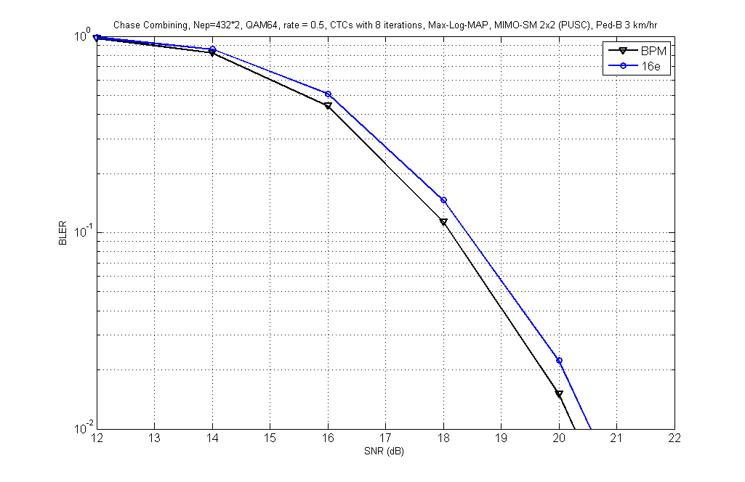
Fig. 7 Performance comparison between BPM and 16e mapping on condition of 64-QAM, R=1/2, MIMO-SM 2x2 and Peb-B 3 km/hr

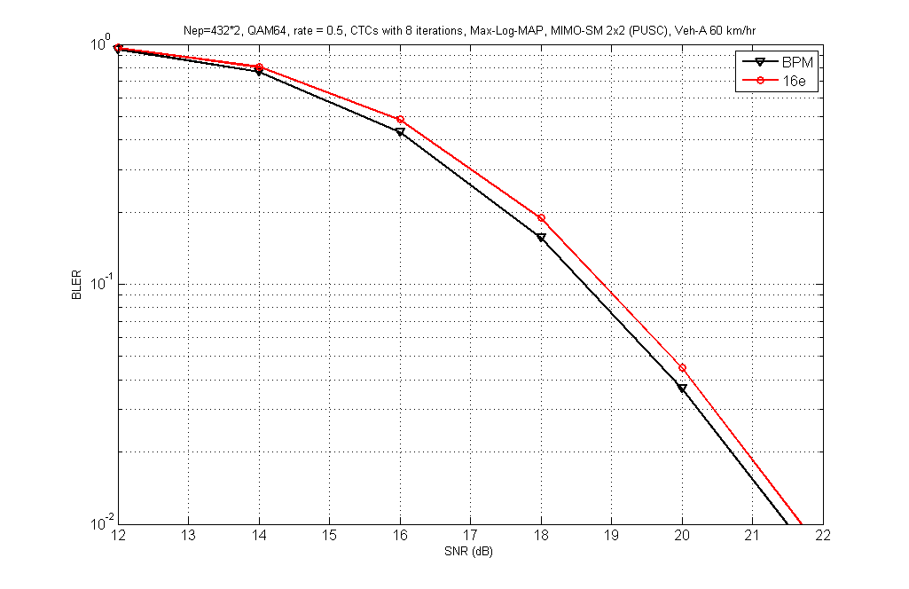
Fig. 8 Performance comparison between BPM and 16e mapping on condition of 64-QAM, R=1/2, MIMO-SM 2x2 and Veh-A 60 km/hr

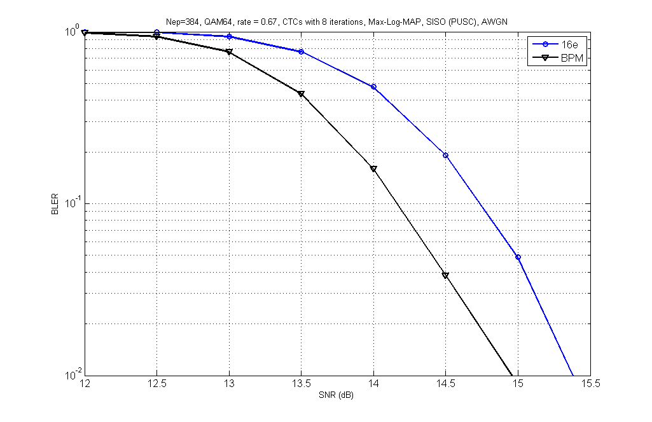
Fig. 9 Performance comparison between BPM and 16e mapping on condition of 64-QAM, R=2/3, SISO and AWGN

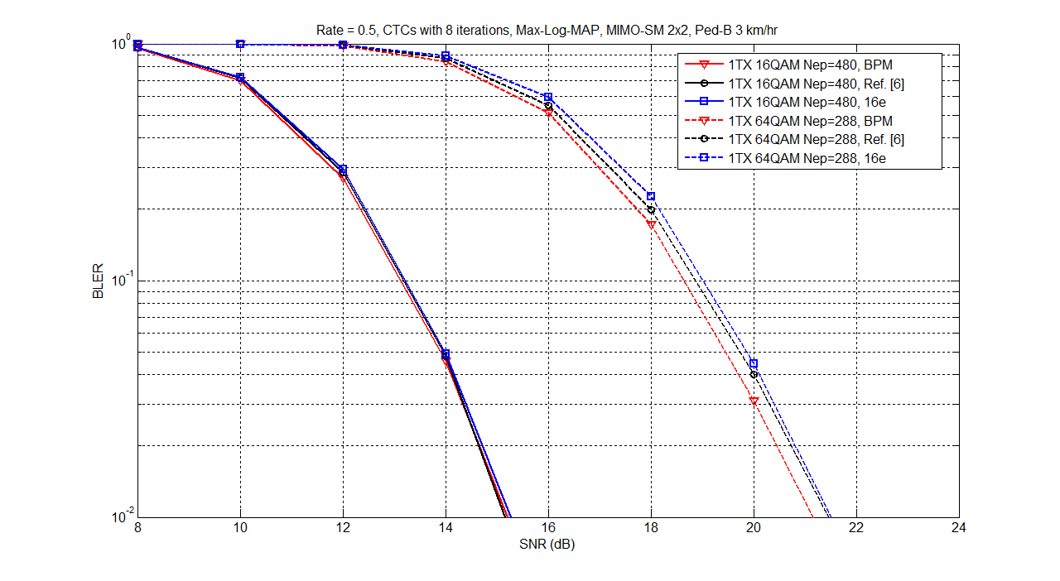
Fig. 10 Performance comparison among BPM, C-symbol permutation and 16e mapping on condition of 16-QAM, 64-QAM, R=1/2, MIMO-SM 2x2 and Peb-B 3 km/hr

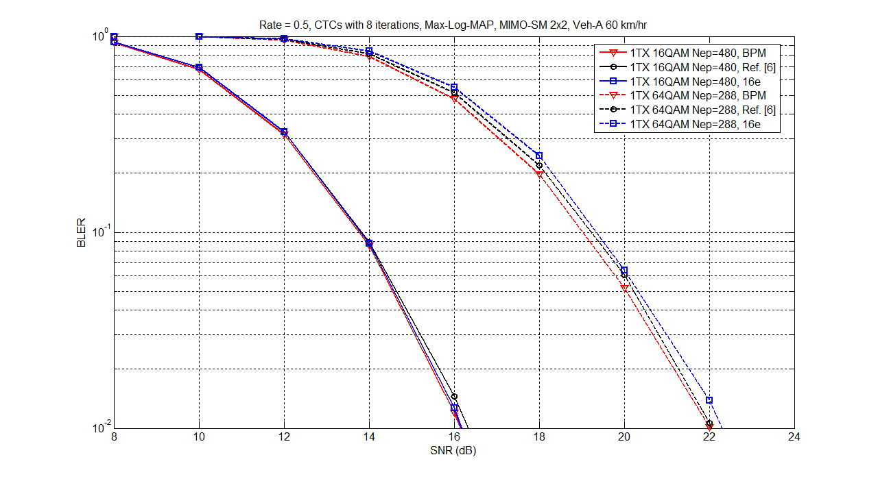
Fig. 11 Performance comparison among BPM, C-symbol permutation and 16e mapping on condition of 16-QAM, 64-QAM, R=1/2, MIMO-SM 2x2 and Veh-A 60 km/hr

- References
[1] IEEE P802.16 Rev2 / D8, “Draft Standard for Local and Metropolitan Area Networks Part 16: Air Interface for Broadband Wireless Access,” Dec. 2008.
[2] IEEE 802.16m-08/003r7, “IEEE 802.16m System Description Document [Draft]”
[3] IEEE 802.16m-07/002r7, “802.16m System Requirements”
[4] IEEE C802.16m-08/043, “Style guide for writing the IEEE 802.16m amendment”
[5] IEEE 802.16m-08/050, “IEEE 802.16m Amendment Working Document”
[6] IEEE C802.16m-09/0665, “Proposed Text of CTC Bit grouping for IEEE 802.16m Amendment”
[7] IEEE C802.16m-09/0141r1, “Channel Interleaver for Convolutional Turbo Code”
[8] IEEE C802.16m-09/0250, “Subblock interleaver for CTC and Symbol interleaver”

- Text proposal for inclusion in the 802.16m amendment

------------------------------- Text Start ---------------------------------------------------
Insert a new section 15:
15.x.1.5.1 Channel Interleaver
15.x.1.5.1.8 Bit Priority Mapping
The bit priority mapping (BPM) should be adopted with the channel interleaver to improve the performance of CTC. The procedure is shown as Fig. xxx. The coded bits after 16e channel interleaver are divided into two groups for 16-QAM and three groups for 64-QAM from high to low priority, and then the more/less significant bits are mapped to more/less reliable positions on the constellation as shown in Fig. yyy. Assume the input is and the output is .
Let the new address is denoted as BPM.
,
where is the modulation order, 2 for QPSK, 4 for 16-QAM and 6 for 64-QAM, and is the subpacket length. Therefore, .

Fig. xxx Flow chart of the channel interleaver
Fig. yyy Bit-priority mapping (a) for 16-QAM (b) for 64-QAM

------------------------------- Text End --------------------------------------------------------------------------

