Project | IEEE 802.16 Broadband Wireless Access Working Group <http://ieee802.org/16>
Title | Proposed Text of Idle Mode Operation Section for the IEEE 802.16m Amendment
Date Submitted | 2009-03-02
Source(s) | Ming-Hung Tao  Mamadou Kone  Ying-Chuan Hsiao  ITRI | MHTao@itri.org.tw
Re: | “802.16m AWD”:  IEEE 802.16m-09/0012, “Call for Contributions on Project 802.16m Amendment Working Document (AWD) Content”.  Target topic: “10.5 Power Management (Sleep, Idle)”.
Abstract | The contribution proposes the text of idle mode operation section to be included in the 802.16m amendment working document.
Purpose | To be discussed and adopted by TGm for 802.16m amendment working document.
Notice | This document does not represent the agreed views of the IEEE 802.16 Working Group or any of its subgroups. It represents only the views of the participants listed in the “Source(s)” field above. It is offered as a basis for discussion. It is not binding on the contributor(s), who reserve(s) the right to add, amend or withdraw material contained herein.
Release | The contributor grants a free, irrevocable license to the IEEE to incorporate material contained in this contribution, and any modifications thereof, in the creation of an IEEE Standards publication; to copyright in the IEEE’s name any IEEE Standards publication even though it may include portions of this contribution; and at the IEEE’s sole discretion to permit others to reproduce in whole or in part the resulting IEEE Standards publication. The contributor also acknowledges and accepts that this contribution may be made public by IEEE 802.16.
Patent Policy | The contributor is familiar with the IEEE-SA Patent Policy and Procedures:  <http://standards.ieee.org/guides/bylaws/sect6-7.html#6> and <http://standards.ieee.org/guides/opman/sect6.html#6.3>.  Further information is located at <http://standards.ieee.org/board/pat/pat-material.html> and <http://standards.ieee.org/board/pat>.

Proposed Text of Idle Mode Operation Section
for the IEEE 802.16m AWD

Ming-Hung Tao, Mamadou Kone, Ying-Chuan Hsiao
ITRI

- Introduction

This contribution proposes the amendment text on how to assign MS temporary identifiers during idle mode entry, and how to release MS temporary identifiers during idle mode exit.

- References
[1] IEEE P802.16 Rev2/D9, “Draft IEEE Standard for Local and Metropolitan Area Networks: Air Interface
for Broadband Wireless Access,” Jan. 2009.
[2] IEEE 802.16m-07/002r7, “802.16m System Requirements”
[3] IEEE 802.16m-08/003r7, “The Draft IEEE 802.16m System Description Document”
[4] IEEE 802.16m-08/043, “Style guide for writing the IEEE 802.16m amendment”

- Text proposal for inclusion in the 802.16m amendment working document

------------------------------- Text Start ---------------------------------------------------

15. Advanced Air Interface
15.2.x. Idle mode

Idle mode provides efficient power saving for the AMS by allowing the AMS to become periodically available for DL broadcast traffic messaging (e.g. Paging message) without registration at a specific ABS. The network assigns idle mode AMS to a paging group during idle mode entry or location update. The design allows the network to minimize the number of location updates performed by the AMS and the paging signaling overhead caused to the ABSs. The idle mode operation considers user mobility. The paging information for an AMS having higher mobility may be broadcast in a bigger range while the paging information for an AMS having lower mobility may be broadcast in a smaller range, even these two AMSs are belonging to the same paging group.

ABSs and Idle Mode AMSs may belong to one or multiple paging groups in order to minimize the number of location updates and paging load without increasing average paging delay and without increasing the overhead of transmitting of multiple paging IDs by the ABSs.

15.2.x.y. Idle Mode Entry/Exit Procedure
15.2.x.y.1 Idle mode initiation

An MS or serving BS initiates idle mode using procedures defined in the WirelessMAN-OFDMA Reference system. In order to reduce signaling overhead and provide location privacy, a Paging Identifier (PID) is assigned to uniquely identify the AMSs in the idle mode in a particular paging group. The AMS’s PID remains valid as long as AMS stays in the same paging group. The PID assignment may happen during idle mode entry or during location update due to paging group change. Paging Identifier may be used in paging messages or during AMS’s network re-entry procedure from idle mode as response to paging.

Paging controller shall embed the PIDs into the paging message to identify an MS in the paging message. As shown in Figure x1, PID is composed of paging cycle configuration bits and partial PID. When an AMS enters idle mode, it negotiates with the paging controller to decide its paging cycle configuration and paging offset configuration. The paging controller maintains partial paging identifiers (partial PIDs) for each combined paging cycle and paging offset configuration and assigns the AMS a partial PID from a list of available partial PIDs. The assignment of the partial PIDs from the list is based on the paging cycle and the paging offset information used by the AMS. Once assigned to the AMS, the partial PID is removed from the list so as to prevent repeated assignments of what are intended to be partial PIDs that are unique to the paging cycle and paging offset configuration. The paging controller then produces the final PID of the AMS by combining AMS’s paging cycle configuration and partial PID. PID can be reused by the AMSs which have the same paging cycle but different paging offset. An example illustrated in Figure x2 shows that the PID should be exchanged between the AMS and ABS when an AMS starts its idle mode or moves to another paging group. The PID should be piggybacked by the DREG-CMD or the RNG-RSP message. Henceforward, AMS will monitor the paging information containing its paging ID until it moves to another paging group. The size of the paging ID is 8 bits long.

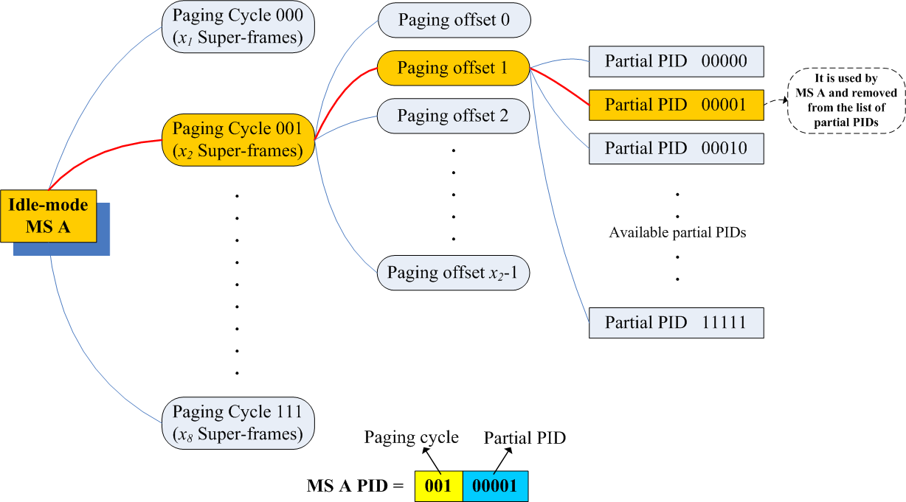

Figure x1. The PID of AMS A is composed of its paging cycle configuration bits and partial PID.

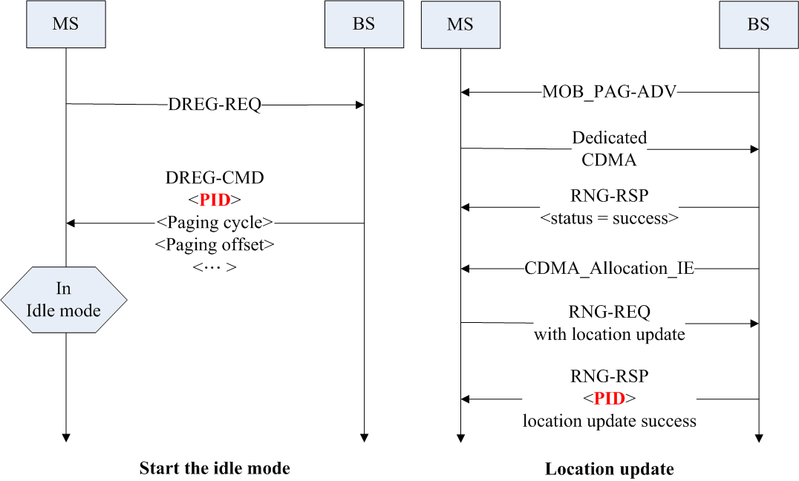
Figure x2. PID is exchanged when the AMS starts its idle mode or moves to another paging group.

15.2.x.y.2 Idle mode termination

Idle mode may only be terminated through
— AMS reentry to the network
— Detection of AMS unavailability through repeated, unanswered paging messages (paging controller detects)
— Expiration of the idle mode timer
An AMS may terminate idle mode at any time. For the termination of the idle mode, the AMS performs network re-entry with its preferred ABS. The network re-entry procedure can be shortened if the ABS possesses AMS’s information. When an AMS terminates idle mode, the AMS as well as the paging controller shall release the PID configuration from the AMS. The paging controller then can assign the released partial PID to another AMS.

------------------------------- Text End ---------------------------------------------------

