Project | IEEE 802.16 Broadband Wireless Access Working Group <http://ieee802.org/16>
Title | Proposed Text of ARQ Operation Section for the IEEE 802.16m Amendment
Date Submitted | 2009-03-02
Source(s) | Ming-Hung Tao  Mamadou Kone  Ying-Chuan Hsiao  ITRI | MHTao@itri.org.tw
Re: | “802.16m AWD”:  IEEE 802.16m-09/0012, “Call for Contributions on Project 802.16m Amendment Working Document (AWD) Content”.  Target topic: “10.4 ARQ”.
Abstract | The contribution proposes the text of ARQ operation section to be included in the 802.16m amendment working document.
Purpose | To be discussed and adopted by TGm for 802.16m amendment working document.
Notice | This document does not represent the agreed views of the IEEE 802.16 Working Group or any of its subgroups. It represents only the views of the participants listed in the “Source(s)” field above. It is offered as a basis for discussion. It is not binding on the contributor(s), who reserve(s) the right to add, amend or withdraw material contained herein.
Release | The contributor grants a free, irrevocable license to the IEEE to incorporate material contained in this contribution, and any modifications thereof, in the creation of an IEEE Standards publication; to copyright in the IEEE’s name any IEEE Standards publication even though it may include portions of this contribution; and at the IEEE’s sole discretion to permit others to reproduce in whole or in part the resulting IEEE Standards publication. The contributor also acknowledges and accepts that this contribution may be made public by IEEE 802.16.
Patent Policy | The contributor is familiar with the IEEE-SA Patent Policy and Procedures:  <http://standards.ieee.org/guides/bylaws/sect6-7.html#6> and <http://standards.ieee.org/guides/opman/sect6.html#6.3>.  Further information is located at <http://standards.ieee.org/board/pat/pat-material.html> and <http://standards.ieee.org/board/pat>.

Proposed Text of ARQ Operation Section
for the IEEE 802.16m AWD

Ming-Hung Tao, Mamadou Kone, Ying-Chuan Hsiao
ITRI

- Introduction

This contribution proposes the ARQ amendment text for IEEE 802.16m in which an ARQ protocol with variable ARQ block size is proposed to recover errors below MAC layer. The proposed protocol uses one-to-one mapping between ARQ block and MAC PDU, this mapping can reduce the control and feedback overheads and also break the ARQ throughput limitation caused by fixed-sized ARQ block. The protocol also includes a partition-enabling ARQ retransmission mechanism and the corresponding feedback structure.

- References
[1] IEEE P802.16 Rev2/D9, “Draft IEEE Standard for Local and Metropolitan Area Networks: Air Interface
for Broadband Wireless Access,” Jan. 2009.
[2] IEEE 802.16m-07/002r7, “802.16m System Requirements”
[3] IEEE 802.16m-08/003r7, “The Draft IEEE 802.16m System Description Document”
[4] IEEE 802.16m-08/043, “Style guide for writing the IEEE 802.16m amendment”

- Text proposal for inclusion in the 802.16m amendment working document

------------------------------- Text Start ---------------------------------------------------

15. Advanced Air Interface
15.2.x. ARQ mechanism

ARQ is a MAC-level mechanism which recovers errors seen below the MAC layer. The transmitter transfers the Protocol Data Unit (PDU) payload into ARQ block, and sends ARQ blocks to the receiver. The receiver then replies acknowledgement (ACK) or negative acknowledgement (NAK) to indicate the transmitter which ARQ blocks have been successfully received and which have been lost. If NAK is received, the transmitter will retransmit the corresponding error ARQ blocks. The ARQ block size for a connection is variable and shall be equal to the payload size of the corresponding PDU.

15.2.x.1. ARQ block usage

As shown in Figure 15.x, each MPDU has one ARQ subheader which contains control signaling for ARQ operations. One-to-one mapping between the ARQ block and MPDU embeds only one BSN in each MPDU regardless of how many different SDUs are included in that MPDU.

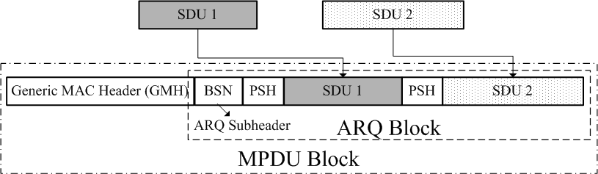

Figure 15.x. One-to-one mapping between ARQ block and MPDU.

The receiver can reply feedback information by either standalone or piggybacked messages, the same as subclause 6.3.4.2 of [1]. Most ACK types defined in [1] can also be applied in IEEE 802.16m except the “Cumulative ACK with Block Sequence ACK” which is more suitable for the small block-size ARQ architecture.

When errors occur, the transmitted MPDU can be partitioned into smaller pieces that will be retransmitted again. If an error MPDU can not be retransmitted due to insufficient bandwidth, this MPDU has to be partitioned into small pieces so that each piece can be transmitted separately.

To support retransmission with partition, each SDU inside the retransmitted MPDU is fragmented into small logic ARQ sub-blocks with fixed sub-block size. Each sub-block is assigned a continuous sequence number which is unique among the sub-blocks belonging to the original MPDU. The partition of the MPDU can only occurs at the boundaries of ARQ sub-blocks. As shown in Figure 15.y, each MPDU or partitioned MPDU has its own ARQ Subheader which may contain the following fields: Partition Flag (PF), BSN, Sub-block sequence number (SBSN), and Last partition indication (Last). SBSN and Last partition indication will be presented only when PF is equal to 1. The Partition Flag is 1 if the MPDU is retransmitted through partition; otherwise it is 0. The BSN of the partitioned MPDU is identical to the BSN of the original MPDU. SBSN indicates the sequence number of the first sub-block inside the MPDU. Last partition indication is 1 if the partitioned MPDU contains the last ARQ sub-block of the original MPDU; otherwise it is 0.

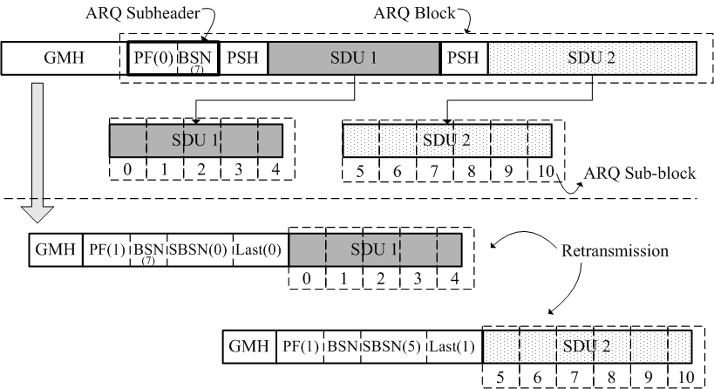
Figure 15.y. ARQ block retransmission with partition.

15.2.x.2. ARQ parameters

Table 15.x. ARQ parameters in IEEE 802.16m.
Parameters | value
ARQ_BSN_MODULUS | 2048
ARQ_WINDOW_SIZE | > 0 and ≤ 2²⁰ bytes
ARQ_RETRY_TIMEOUT | 0 ~ 6555.35 sec  (100 μs granularity)
ARQ_BLOCK_LIFETIME | 0 = infinite  0.1 ~ 6555.35 sec  (100 μs granularity)

15.2.x.3. ARQ feedback mechanism

To feedback the MPDU with PF=0, the receiver replies an ACK or NAK signaling in the bitmap within the ARQ feedback IE, which is similar to subclause 6.3.4.2 of [1]. To feedback the MPDU with PF=1, the receiver first checks whether all the partitions belonging to the same BSN are correctly received or not. If all partitions are correctly received, the receiver replies an ACK in the bitmap within the ARQ feedback IE. If there is any lost partition, the receiver replies a NAK in the bitmap within the ARQ feedback IE and appends an extended ARQ feedback IE in the ARQ feedback payload. This extended ARQ feedback IE is used by the receiver to reply the partitions that are correctly received. The extended ARQ feedback IE (ACK type = “ARQ sub-block ACK”) contains the following fields: Number of correctly received partitions (Num), BSN for each partition, SBSN for each partition. Take Figure 15.y for example, if the first partition of BSN (7) is correctly received but the second partition is not, the receiver will reply an NAK to BSN (7) in the first ARQ feedback IE, and reply the successful reception for the first partition in the following extended ARQ feedback IE. This example is shown in Figure 15.z.

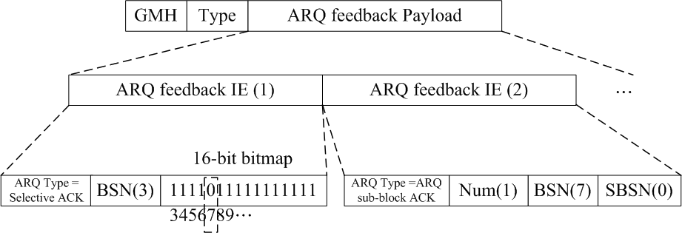
Figure 15.z. Feedback example for ARQ sub-block.

15.2.x.4. ARQ feedback IE format

Table 15.y. ARQ feedback format.
Syntax | Size (bit) | Notes
ARQ_Feedback_IE (LAST) { |  | -
FID | 12 | Flow identifier
Last | 1 | 0 = More ARQ Feedback IE in the list  1= Last ARQ Feedback IE in the list
ACK Type | 2 | 0x0 = Selective ACK entry  0x1 = Cumulative ACK entry  0x2 = Cumulative with Selective ACK entry  0x3 = ARQ sub-block ACK entry
BSN | 11 | -
Reserved | - | -
Number of ACK MAPs | 2 | If ACK type ==01, the field is reserved and set to 00.  Otherwise the field indicates the number of ACK maps:  0x0 = 1, 0x1 = 2, 0x2 = 3, 0x3 = 4
If (ACK Type != 01) { | - | -
For (i=0; i<Number of ACK MAPs+1; ++i) { | - | -
If (ACK Type !=3) { | - | -
Selective ACK MAP | 16 | -
} | - | -
Else { | - | -
BSN | 11 | -
SBSN | 5 | -
} | - | -
} | - | -
} | - | -
} | - | -

------------------------------- Text End ---------------------------------------------------

