Project | IEEE 802.16 Broadband Wireless Access Working Group <http://ieee802.org/16>
Title | Proposed Text on 15.x.1.3 Burst partition
Date Submitted | 2009-03-09
Source(s) | Seunghyun Kang, Sukwoo Lee  LG Electronics | Voice: +82-31-450-1918  E-mail: sh_kang@lge.com, sugoo@lge.com
Re: | IEEE 802.16m-09/0012, “Call for Contributions on Project 802.16m Amendment Working Document (AWD) Content”  Target topic: “Channel Coding”
Abstract | This contribution proposes the burst partition rule for IEEE 802.16m CTC.
Purpose | To be discussed and adopted in the Amendment Working Document.
Notice | This document does not represent the agreed views of the IEEE 802.16 Working Group or any of its subgroups. It represents only the views of the participants listed in the “Source(s)” field above. It is offered as a basis for discussion. It is not binding on the contributor(s), who reserve(s) the right to add, amend or withdraw material contained herein.
Release | The contributor grants a free, irrevocable license to the IEEE to incorporate material contained in this contribution, and any modifications thereof, in the creation of an IEEE Standards publication; to copyright in the IEEE’s name any IEEE Standards publication even though it may include portions of this contribution; and at the IEEE’s sole discretion to permit others to reproduce in whole or in part the resulting IEEE Standards publication. The contributor also acknowledges and accepts that this contribution may be made public by IEEE 802.16.
Patent Policy | The contributor is familiar with the IEEE-SA Patent Policy and Procedures:  <http://standards.ieee.org/guides/bylaws/sect6-7.html#6> and <http://standards.ieee.org/guides/opman/sect6.html#6.3>.  Further information is located at <http://standards.ieee.org/board/pat/pat-material.html> and <http://standards.ieee.org/board/pat>.

Proposed Text on 15.x.1.3 Burst partition
Seunghyun Kang, Sukwoo Lee
LG Electronics

Introduction
According to the current SDD[1], when the size of a data burst including a burst CRC exceeds the maximum FEC block size of 4800 bits, it is partitioned into a number of FEC blocks, each of which is encoded separately.
In this contribution, we propose new burst partition rule (or FEC block segmentation rule) for IEEE 802.16m CTC (Convolutional Turbo Codes) and provide the proposed text for the IEEE 802.16m AWD.

Baseline burst partition rule
In [2], the baseline burst partition has been provided by “Channel coding and HARQ drafting group” and it is as follows.

$$N_{\text{FB}}=\underset{X∈\left\{N_{\text{FB}}\right\}}{\text{argmax}}X≤(N_{\text{mod}}R_{\text{FEC}}N_{\text{RE}}N_{\text{SM}}K_{\text{FB}})$$
,where
N_{mod} is the modulation order of the burst transmission, which is specified by MCS index
R_{FEC} is the nominal code rate of the burst transmission, which is specified by MCS index
N_{RE} is the number of resource elements allocated for burst transmission. The calculation of NRE shall exclude the resource elements used by pilot channels
N_{SM} is the spatial multiplexing order of the resource elements allocated for burst transmission.
N_{FB_MAX} is the maximum FEC block size, which equals to 4800 bits.
K_{FB} is the number of FEC blocks and$K_{\text{FB}}=\text{ceil}\left({N_{\text{mod}}⋅R_{\text{FEC}}⋅N_{\text{RE}}⋅N_{\text{SM}}}/{N_{\text{FB_MAX}}}\right)$

However, by using the baseline burst partition rule, there can be undesirable burst partition results which require more FEC blocks than required as follows.

Table 1. Examples of the baseline burst partition rule.
k = N_{mod}·R_{FEC}·N_{RE}·N_{SM} | K_{FB} | N_{FB} | N_{Info}= K_{FB}·N_{FB} | 4800· (K_{FB}-1)
4800 < k < 4864 | 2 | 2368 | 4736 | 4800
9600< k <9792 | 3 | 3200 | 9600 | 9600
14400< k <14592 | 4 | 3600 | 14080 | 14400

In the above results, the required number of FEC block shall be (K_{FB} - 1) since the information block size N_{Info} ( or the transmittable burst size including burst CRC and FEC block CRC) is less than or equal to 4800*(K_{FB}-1). Furthermore, for the case that k is less than the minimum FEC block size of 48 bit, there is no way to force the information size to be 48 bits.

Proposed burst partition rules
In the previous meeting in La Jolla, USA (Session # 59), there had been one more burst partition rules in [3] which is also applicable to the terminology using the parameters of MCS and the number of resources. In the following, we introduce our proposed burst partition rule as a candidate scheme for IEEE 802.16m channel coding.

Details on the Burst partition rule.

In [3], if the information block size N_{Info} is larger than 4800 bits then it is partitioned into K_{FB} FEC blocks, each size of which is N_{FB,i} where i = 0, …, K_{FB} -1. Note that the FEC block size N_{FB,i} includes an FEC block CRC. The information block size N_{Info} and FEC block sizes shall be

$N_{\text{Info}}=\sum_{i=0}^{(K_{\text{FB}}−1)}{N_{\text{FB},i}}$.

Following to the terminology using the parameters of MCS and the number of resources, N_{Info} is defined as follows.

$$\begin{aligned}k=N_{\text{mod}}⋅R_{\text{FEC}}⋅N_{\text{RE}}⋅N_{\text{SM}} \\ \\ \text{IF} k≤N_{\text{FB_MAX,}} \\ N_{\text{Info}}=\underset{X∈\left\{N_{\text{FB}}\right\}}{\text{argmin}} X≥(k) \\ \text{ELSE}, \\ N_{\text{Info}}=\left\lceil \frac{k}{δ}\right\rceil ⋅δ\end{aligned}$$

, where δ is the resolution value of 64 bits for the FEC block sizes between 2400 and 4800 in [2].

Also, the number of FEC blocks K_{FB} is defined with N_{Info} as follows.

$$K_{\text{FB}}=\left\lceil \frac{N_{\text{Info}}}{N_{\text{FB_MAX}}}\right\rceil$$

When the information block size N_{Info} is larger than 4800 bits, the proposed burst partition rule is performed as follows.

Proposed burst partition rule:

- First, the base FEC block size N_{Base} is given by the followings.

$$\begin{aligned}N_{\text{Base}}=\left\lfloor \frac{N_{\text{Info}}}{K_{\text{FB}}⋅δ}\right\rfloor ⋅δ \\ \\ \text{If } N_{\text{Base}}\text{mod} 7 =0,N_{\text{Base}}=N_{\text{Base}}−δ\end{aligned}$$

- The parameters α,$Δ$, k and m are specified by the followings.

$$\begin{aligned}\text{If } \frac{N_{\text{Base}}}{δ}\text{mod} 7 =6,α=2⋅δ \\ \text{Otherwise,}α=δ\end{aligned}$$
$$Δ=N_{\text{Info}}−K_{\text{FB}}⋅N_{\text{Base}}$$
$k=\left\lfloor \frac{Δ}{α}\right\rfloor$
$$m=Δ\text{mod}α$$

- Initialization of N_{FB,i} , where i=0… K_{FB} -1

$$\begin{aligned}\text{If } i < k, \\ N_{\text{FB},i}=N_{\text{Base}}+α \\ \text{Otherwise,} \\ N_{\text{FB},i}=N_{\text{Base}}\end{aligned}$$

- If m = δ, modify N_{FB,i} as follows

$$\begin{aligned}\text{If }k =0 \\ N_{\text{FB},0}=N_{\text{FB},0}+2⋅δ \\ N_{\text{FB},(K_{\text{FB}}−1)}=N_{\text{FB},(K_{\text{FB}}−1)}−δ \\ \text{Otherwise,} \\ N_{\text{FB},0}=N_{\text{FB},0}+δ\end{aligned}$$

Comparison on the candidate burst partition rules

During the E-mail discussion in the “Channel coding and HARQ drafting group”, the modified baseline burst partition rule has been provided as one of the candidate schemes as follows.

$$N_{\text{FB}}=\underset{X∈\left\{N_{\text{FB}}\right\}}{\text{argmin}}X≥(N_{\text{mod}}R_{\text{FEC}}N_{\text{RE}}N_{\text{SM}}K_{\text{FB}})$$

For the comparison of the burst partition rules (both the proposed burst partition rule and the modified one), we have evaluated two sets of information block sizes with the following conditions.

Table 2. Evaluation conditions
# of RU’s | 1~192
# of RE’s per RU | 96
MCS | 16 MCS levels in [2]

Based on the two sets of information block sizes (for 16 MCS levels and 192 RU’s), the padding overhead has been evaluated in the following section.

Padding overhead
For the evaluation of padding overhead, we assume that scheduler will choose the number of RU’s which indicate an information block size larger than the SDU size under the given MCS levels. Also, the padding bits are required to fit the SDU size into the selected information block size.
In the following figures, the padding overhead of the usable information block sizes has been evaluated for each MCS level. Also, the figures depict the padding overhead for the case that the information block sizes are larger than 4800 bits in order to compare the burst partition rules. Also, for the information block sizes less than 4800 bits, the padding overhead of both partition rules are the same since the proposed one uses the same concept of the modified one.
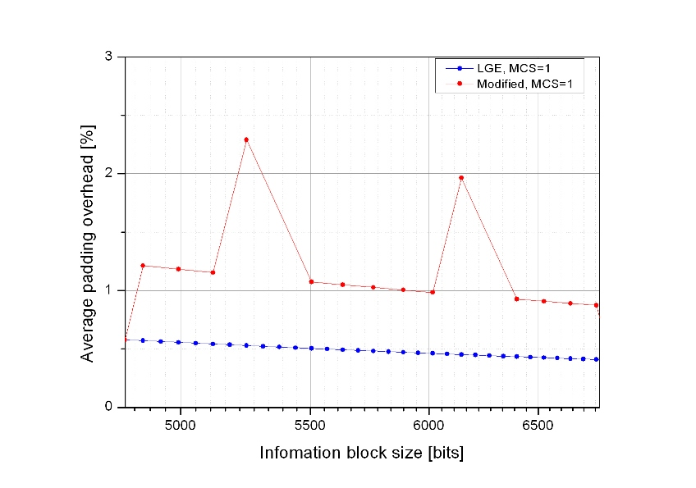
Figure 1. Padding overhead of the usable information block sizes with MCS level of 1
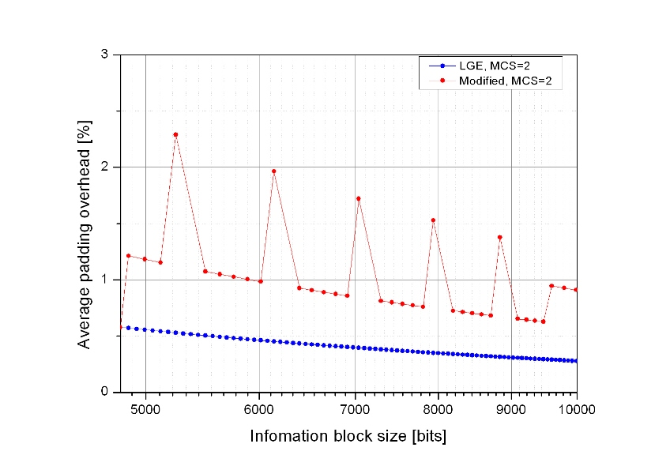
Figure 2. Padding overhead of the usable information block sizes with MCS level of 2
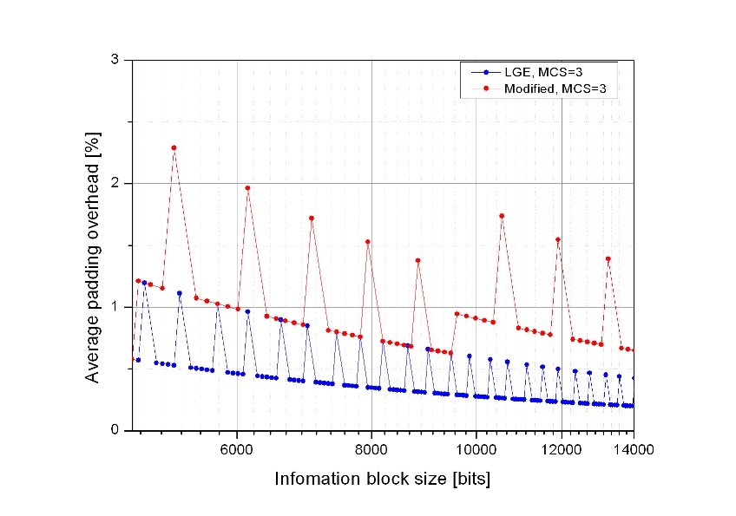
Figure 3. Padding overhead of the usable information block sizes with MCS level of 3
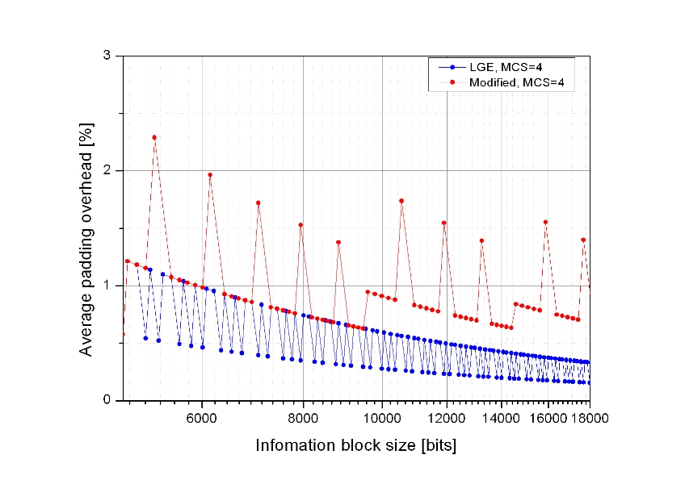
Figure 4. Padding overhead of the usable information block sizes with MCS level of 4
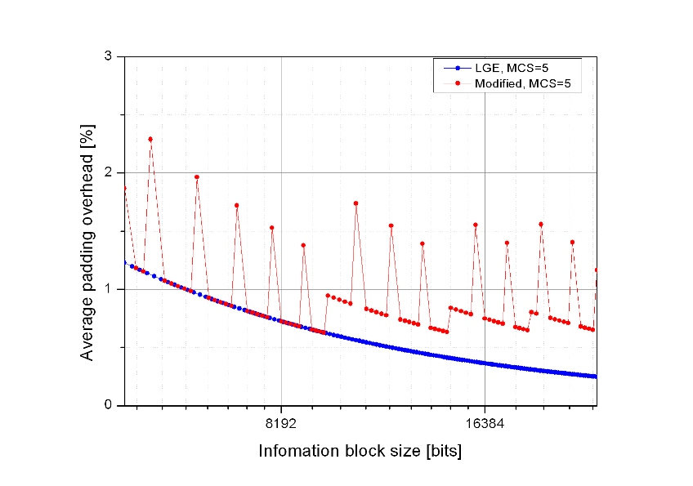
Figure 5. Padding overhead of the usable information block sizes with MCS level of 5
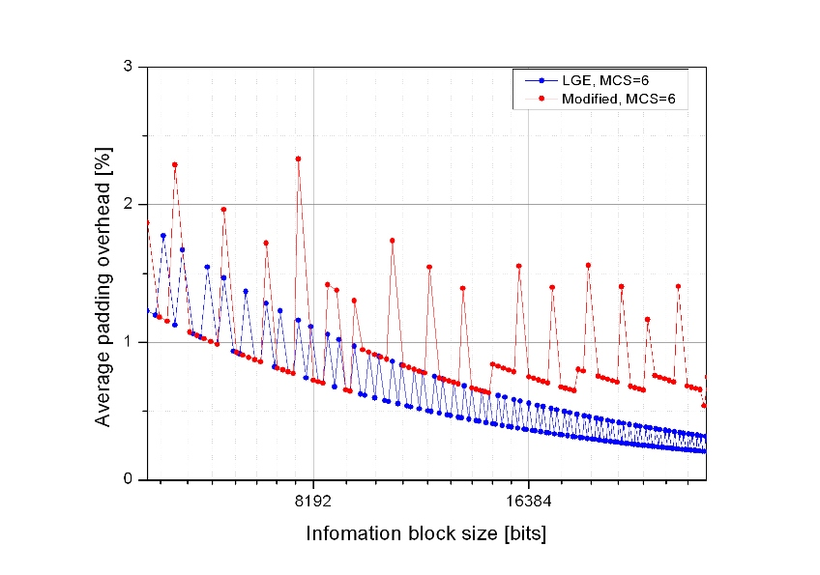
Figure 6. Padding overhead of the usable information block sizes with MCS level of 6
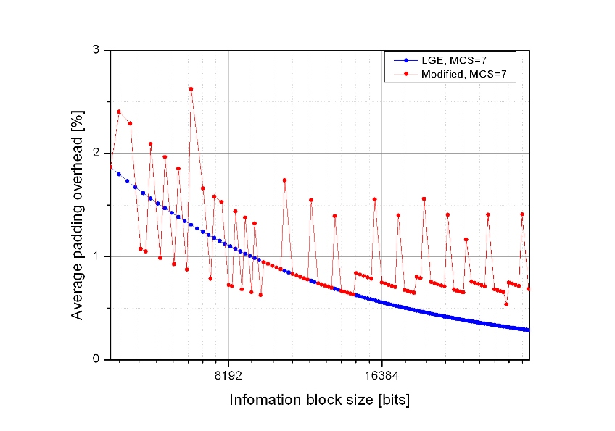
Figure 7. Padding overhead of the usable information block sizes with MCS level of 7
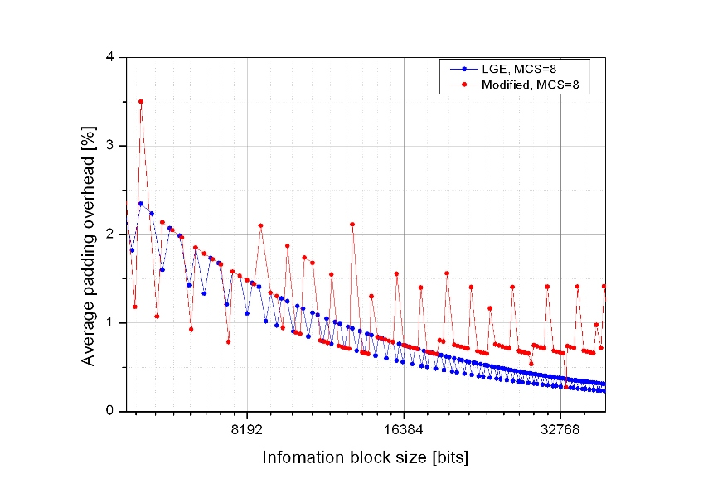
Figure 8. Padding overhead of the usable information block sizes with MCS level of 8
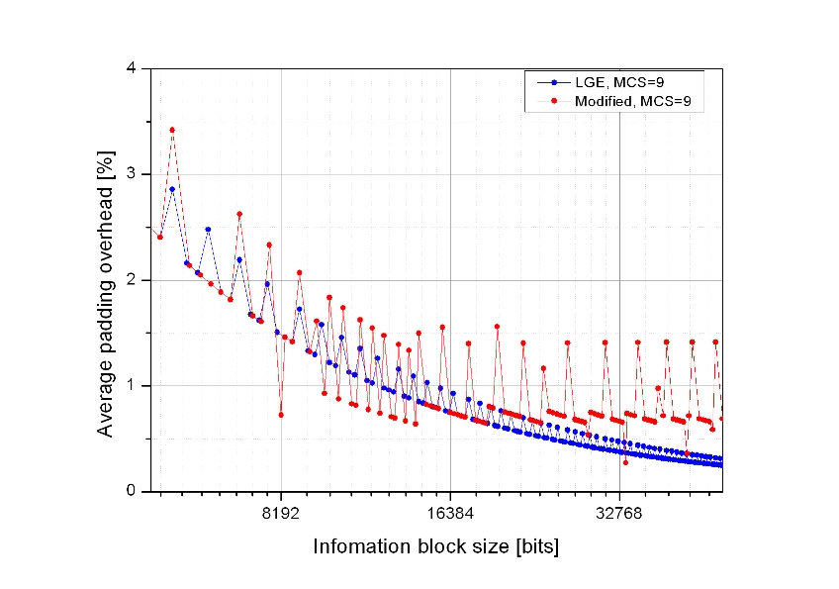
Figure 9. Padding overhead of the usable information block sizes with MCS level of 9
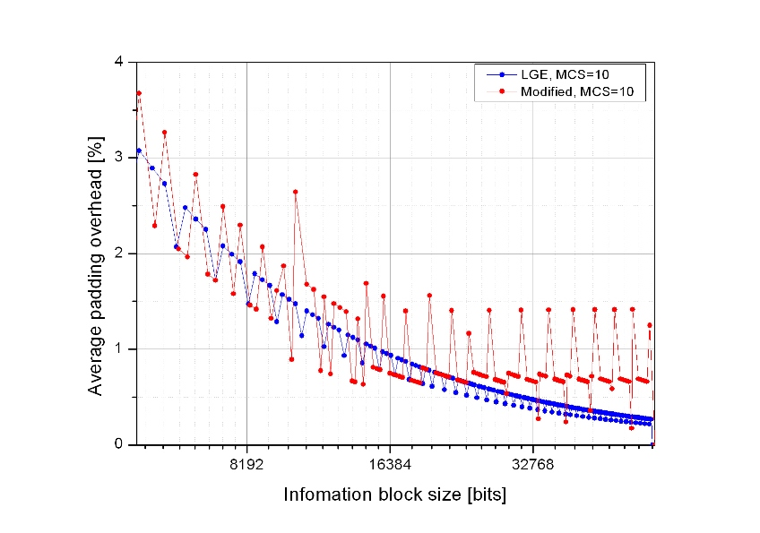
Figure 10. Padding overhead of the usable information block sizes with MCS level of 10
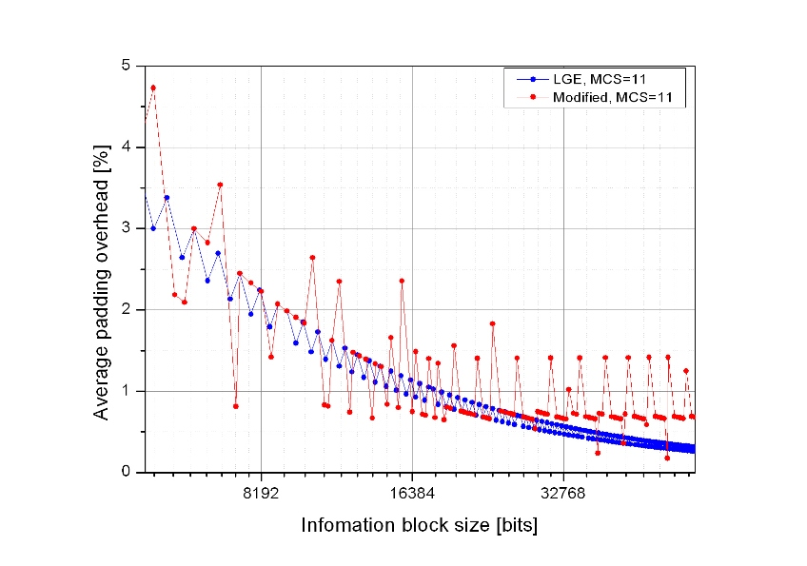
Figure 11. Padding overhead of the usable information block sizes with MCS level of 11
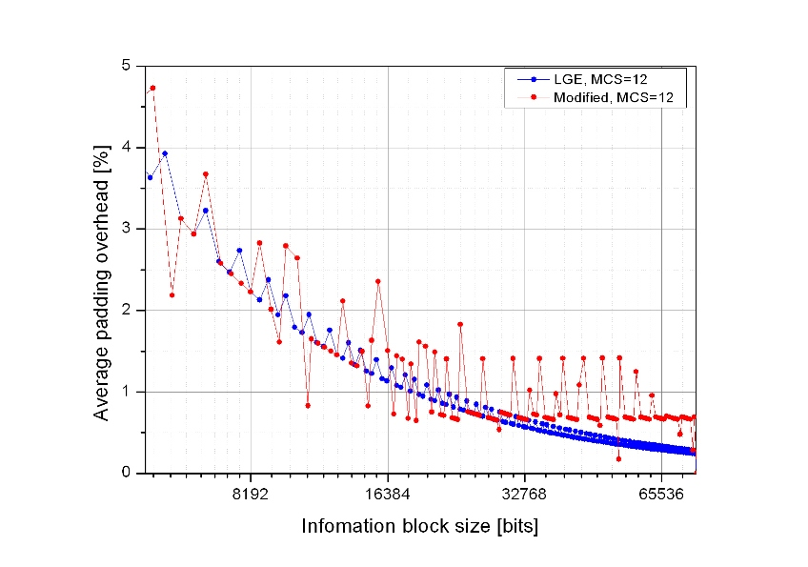
Figure 12. Padding overhead of the usable information block sizes with MCS level of 12
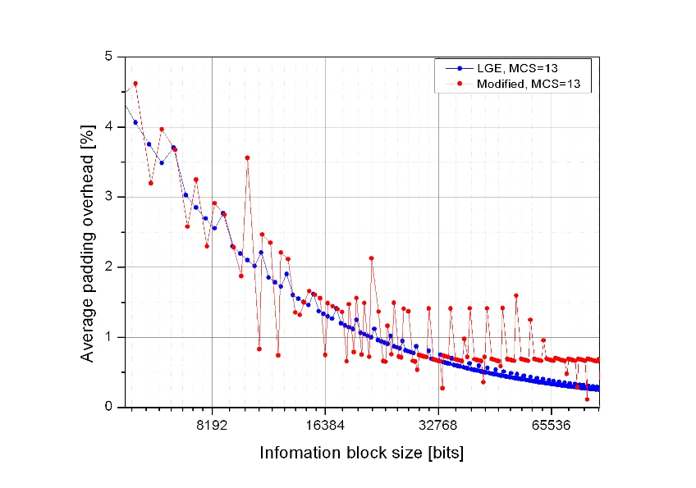
Figure 13. Padding overhead of the usable information block sizes with MCS level of 13
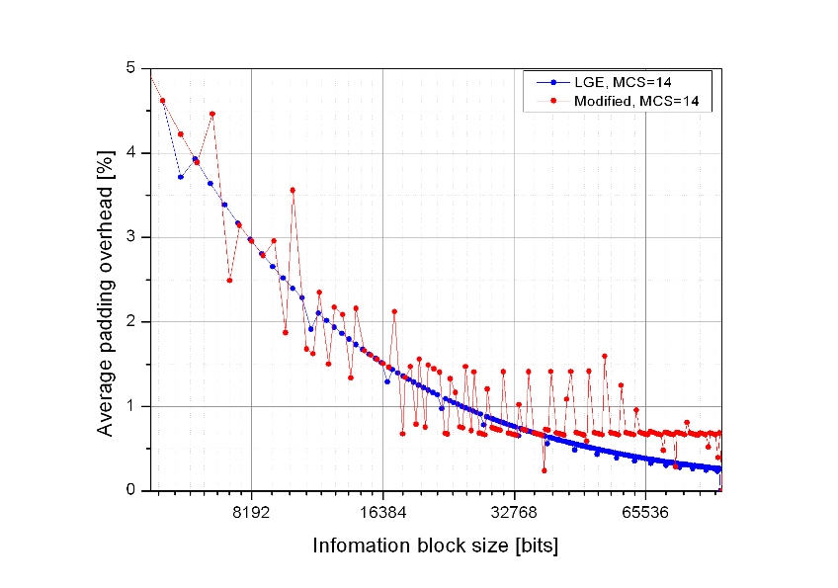
Figure 14. Padding overhead of the usable information block sizes with MCS level of 14
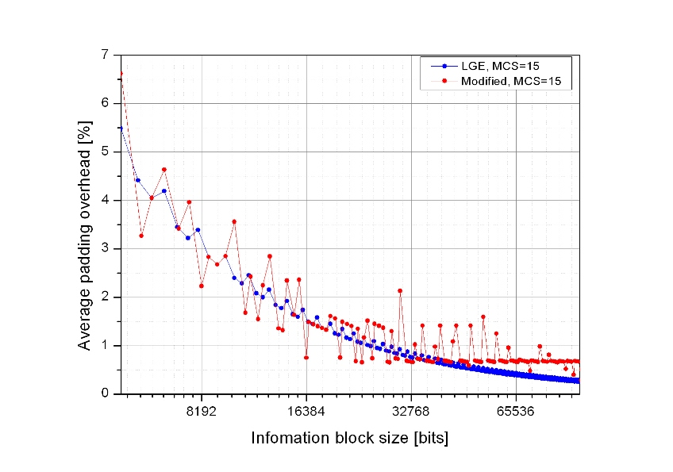
Figure 15. Padding overhead of the usable information block sizes with MCS level of 15

Conclusion
In this contribution, we have noticed the problem of the baseline text for burst partition rule. Also, we have introduced two burst partition rules and compared them. According to the padding overhead comparison in the section 4.1, the proposed burst partition rule would be better to be adopted in AWD.

Reference
[1] IEEE 802.16m-08/003r7, “The Draft IEEE 802.16m System Description Document”
[2] IEEE C802.16m-09/0510, “Proposed Text of Channel Coding and HARQ for the IEEE 802.16m Amendment”
[3] IEEE C802.16m-09/0314, “FEC block segmentation rule for IEEE 802.16m CTC”

Proposed text input
Replace the section “15.x.1.3 Burst partition” of DG text proposal [2] with the following text.
------------------------------------------------------ Text Start ------------------------------------------------------
      - Burst partition
        - Information block size and number of FEC blocks
When the burst size including 16 burst CRC bits exceeds maximum FEC block size, N_{FB_MAX}, the burst is partitioned into K_{FB} FEC blocks. The burst size N_{DB} including burst CRC (and FEC block CRC if N_{DB} > N_{FB_MAX}) is defined by the following equation.

$\begin{aligned}\text{If } (N_{\text{mod}}⋅R_{\text{FEC}}⋅N_{\text{RE}}⋅N_{\text{SM}})≤N_{\text{FB_MAX,}} \\ N_{\text{DB}}=\underset{X∈\left\{N_{\text{FB}}\right\}}{\text{argmin}} X≥(N_{\text{mod}}R_{\text{FEC}}N_{\text{RE}}N_{\text{SM}}) \\ \text{Else}, \\ N_{\text{DB}}=\left\lceil \frac{(N_{\text{mod}}R_{\text{FEC}}N_{\text{RE}}N_{\text{SM}})}{δ}\right\rceil ⋅δ\end{aligned}$

The value of K_{FB} is calculated by the following equation.

$$K_{\text{FB}}=\left\lceil \frac{N_{\text{DB}}}{N_{\text{FB_MAX}}}\right\rceil$$
, where
N_{mod} is the modulation order of the burst transmission, which is specified by MCS index.
R_{FEC} is the nominal code rate of the burst transmission, which is specified by MCS index.
N_{RE} is the number of resource elements allocated for burst transmission.
The calculation of N_{RE} shall exclude the resource elements used by pilot channels.
N_{SM} is the spatial multiplexing order of the resource elements allocated for burst transmission.
The value of N_{SM} depends on the MIMO transmission mode and is defined in section x.x.x.x.
N_{FB}__{MAX} is the maximum FEC block size, which equals to 4800 bits.
{N_{FB}} is a set of N_{FB} shown in Table 15.x.1-2.
δ is the resolution value of 64 for the FEC block sizes between 2400 and 4800 in Table 15.x.1-2.

The nominal MCS used in a data transmission shall be selected from Table 15.x.1-1.
Table 15.x.1-1. MCS table for downlink and uplink data channel
MCS index | Modulation | Code rate
‘0000’ | QPSK | 31/256
‘0001’ | QPSK | 47/256
‘0010’ | QPSK | 70/256
‘0011’ | QPSK | 98/256
‘0100’ | QPSK | 131/256
‘0101’ | QPSK | 166/256
‘0110’ | QPSK | 199/256
‘0111’ | 16QAM | 123/256
‘1000’ | 16QAM | 149/256
‘1001’ | 16QAM | 176/256
‘1010’ | 16QAM | 204/256
‘1011’ | 16QAM | 229/256
‘1100’ | 64QAM | 173/256
‘1101’ | 64QAM | 196/256
‘1110’ | 64QAM | 218/256
‘1111’ | 64QAM | 234/256

The FEC block size N_{FB,i} is calculated as follows, where i=0… (K_{FB} -1):

- The base FEC block size N_{Base} is calculated first

$\begin{aligned}N_{\text{Base}}=\left\lfloor \frac{N_{\text{DB}}}{K_{\text{FB}}⋅δ}\right\rfloor ⋅δ \\ \\ \text{If } N_{\text{Base}}\text{mod} 7 =0, N_{\text{Base}}=N_{\text{Base}}−δ\end{aligned}$

- The parameters α, k and m are specified.

$\begin{aligned}\text{If } ({N_{\text{Base}}}/δ)\text{mod} 7 =6, α=2⋅δ \\ \text{Else,}α=δ \\ k=\left\lfloor \frac{(N_{\text{DB}}−K_{\text{FB}}⋅N_{\text{Base}})}{α}\right\rfloor \\ m=(N_{\text{DB}}−K_{\text{FB}}⋅N_{\text{Base}})\text{mod}α\end{aligned}$

- Initialize N_{FB,i}

$\begin{aligned}\text{If } i < k, N_{\text{FB, i}}=N_{\text{Base}}+α \\ \text{Else,} N_{\text{FB, i}}=N_{\text{Base}}\end{aligned}$

- If m = δ, modify N_{FB,i}

$\begin{aligned}\text{If }k =0, N_{\text{FB,0}}=N_{\text{FB,0}}+2δ \text{and }N_{\text{FB, }(K_{\text{FB}}\text{-1})}=N_{\text{FB, }(K_{\text{FB}}\text{-1})}−δ \\ \text{Else,} N_{\text{FB,0}}=N_{\text{FB,0}}+δ\end{aligned}$

Table 15.x.1-2. FEC block size table for downlink and uplink data channels
Index | N_{FB} | Index | N_{FB} | Index | N_{FB} | Index | N_{FB} | Index | N_{FB}
0 | 48 | 30 | 328 | 60 | 720 | 90 | 1424 | 120 | 2752
1 | 64 | 31 | 344 | 61 | 736 | 91 | 1448 | 121 | 2816
2 | 72 | 32 | 352 | 62 | 752 | 92 | 1480 | 122 | 2880
3 | 80 | 33 | 360 | 63 | 768 | 93 | 1504 | 123 | 2944
4 | 88 | 34 | 368 | 64 | 776 | 94 | 1536 | 124 | 3008
5 | 96 | 35 | 376 | 65 | 800 | 95 | 1560 | 125 | 3072
6 | 104 | 36 | 384 | 66 | 824 | 96 | 1600 | 126 | 3200
7 | 120 | 37 | 400 | 67 | 848 | 97 | 1640 | 127 | 3264
8 | 128 | 38 | 416 | 68 | 872 | 98 | 1672 | 128 | 3328
9 | 136 | 39 | 432 | 69 | 888 | 99 | 1712 | 129 | 3392
10 | 144 | 40 | 440 | 70 | 912 | 100 | 1752 | 130 | 3456
11 | 152 | 41 | 456 | 71 | 936 | 101 | 1784 | 131 | 3520
12 | 160 | 42 | 472 | 72 | 960 | 102 | 1824 | 132 | 3648
13 | 176 | 43 | 480 | 73 | 984 | 103 | 1864 | 133 | 3712
14 | 184 | 44 | 496 | 74 | 1000 | 104 | 1896 | 134 | 3776
15 | 192 | 45 | 512 | 75 | 1024 | 105 | 1920 | 135 | 3840
16 | 200 | 46 | 528 | 76 | 1048 | 106 | 1952 | 136 | 3904
17 | 208 | 47 | 544 | 77 | 1072 | 107 | 2000 | 137 | 3968
18 | 216 | 48 | 552 | 78 | 1096 | 108 | 2048 | 138 | 4096
19 | 232 | 49 | 568 | 79 | 1112 | 109 | 2096 | 139 | 4160
20 | 240 | 50 | 584 | 80 | 1136 | 110 | 2144 | 140 | 4224
21 | 248 | 51 | 600 | 81 | 1160 | 111 | 2192 | 141 | 4288
22 | 256 | 52 | 608 | 82 | 1184 | 112 | 2232 | 142 | 4352
23 | 264 | 53 | 624 | 83 | 1216 | 113 | 2280 | 143 | 4416
24 | 272 | 54 | 640 | 84 | 1248 | 114 | 2328 | 144 | 4544
25 | 288 | 55 | 656 | 85 | 1280 | 115 | 2368 | 145 | 4608
26 | 296 | 56 | 664 | 86 | 1312 | 116 | 2432 | 146 | 4672
27 | 304 | 57 | 680 | 87 | 1336 | 117 | 2496 | 147 | 4736
28 | 312 | 58 | 696 | 88 | 1368 | 118 | 2560 | 148 | 4800
29 | 320 | 59 | 712 | 89 | 1392 | 119 | 2624

The payload size excluding burst CRC and FEC block CRC is defined by the following equation:
N_{PL} = N_{DB} – (I_{MFB}×N_{FB-CRC}) – N_{DB-CRC}
, where
I_{MFB} equals 0 when K_{FB} =1, K_{FB} when K_{FB} >1,
N_{FB-CRC} equals 16, which is the size of FEC block CRC,
N_{DB-CRC} equals 16, which is the size of burst CRC.

------------------------------------------------------ Text End ------------------------------------------------------

