Project | IEEE 802.16 Broadband Wireless Access Working Group <http://ieee802.org/16>
Title | Proposed Text on 15.x.1.3 Burst partition
Date Submitted | 2009-03-09
Source(s) | Seunghyun Kang, Sukwoo Lee  LG Electronics  Xin Qi, Joon Chun  Nokia Siemens Networks  Zexian Li  Nokia | Voice: +82-31-450-1918  E-mail: sh_kang@lge.com, sugoo@lge.com  xin.qi@nsn.com
Re: | IEEE 802.16m-09/0012, “Call for Contributions on Project 802.16m Amendment Working Document (AWD) Content”  Target topic: “Channel Coding”
Abstract | This contribution proposes the burst partition rule for IEEE 802.16m CTC.
Purpose | To be discussed and adopted in the Amendment Working Document.
Notice | This document does not represent the agreed views of the IEEE 802.16 Working Group or any of its subgroups. It represents only the views of the participants listed in the “Source(s)” field above. It is offered as a basis for discussion. It is not binding on the contributor(s), who reserve(s) the right to add, amend or withdraw material contained herein.
Release | The contributor grants a free, irrevocable license to the IEEE to incorporate material contained in this contribution, and any modifications thereof, in the creation of an IEEE Standards publication; to copyright in the IEEE’s name any IEEE Standards publication even though it may include portions of this contribution; and at the IEEE’s sole discretion to permit others to reproduce in whole or in part the resulting IEEE Standards publication. The contributor also acknowledges and accepts that this contribution may be made public by IEEE 802.16.
Patent Policy | The contributor is familiar with the IEEE-SA Patent Policy and Procedures:  <http://standards.ieee.org/guides/bylaws/sect6-7.html#6> and <http://standards.ieee.org/guides/opman/sect6.html#6.3>.  Further information is located at <http://standards.ieee.org/board/pat/pat-material.html> and <http://standards.ieee.org/board/pat>.

Proposed Text on 15.x.1.3 Burst partition
Seunghyun Kang, Sukwoo Lee
LG Electronics
Xin Qi, Joon Chun
Nokia Siemens Networks
Zexian Li
Nokia

Introduction
According to the current SDD[1], when the size of a data burst including a burst CRC exceeds the maximum FEC block size of 4800 bits, it is partitioned into a number of FEC blocks, each of which is encoded separately.
In this contribution, we propose new burst partition rule (or FEC block segmentation rule) for IEEE 802.16m CTC (Convolutional Turbo Codes) and provide the proposed text for the IEEE 802.16m AWD.

Baseline burst partition rule
In [2], the baseline burst partition has been provided by “Channel coding and HARQ drafting group” and it is as follows.

$$N_{\text{FB}}=\underset{X∈\left\{N_{\text{FB}}\right\}}{\text{argmax}}X≤(N_{\text{mod}}R_{\text{FEC}}N_{\text{RE}}N_{\text{SM}}K_{\text{FB}})$$
,where
N_{mod} is the modulation order of the burst transmission, which is specified by MCS index
R_{FEC} is the nominal code rate of the burst transmission, which is specified by MCS index
N_{RE} is the number of resource elements allocated for burst transmission. The calculation of NRE shall exclude the resource elements used by pilot channels
N_{SM} is the spatial multiplexing order of the resource elements allocated for burst transmission.
N_{FB_MAX} is the maximum FEC block size, which equals to 4800 bits.
K_{FB} is the number of FEC blocks and$K_{\text{FB}}=\text{ceil}\left({N_{\text{mod}}⋅R_{\text{FEC}}⋅N_{\text{RE}}⋅N_{\text{SM}}}/{N_{\text{FB_MAX}}}\right)$

However, by using the baseline burst partition rule, there can be undesirable burst partition results which require more FEC blocks than required as follows.

Table 1. Examples of the baseline burst partition rule.
k = N_{mod}·R_{FEC}·N_{RE}·N_{SM} | K_{FB} | N_{FB} | N_{Info}= K_{FB}·N_{FB} | 4800· (K_{FB}-1)
4800 < k < 4864 | 2 | 2368 | 4736 | 4800
9600< k <9792 | 3 | 3200 | 9600 | 9600
14400< k <14592 | 4 | 3600 | 14080 | 14400

In the above results, the required number of FEC block shall be (K_{FB} - 1) since the information block size N_{Info} ( or the transmittable burst size including burst CRC and FEC block CRC) is less than or equal to 4800*(K_{FB}-1). Furthermore, for the case that k is less than the minimum FEC block size of 48 bit, there is no way to force the information size to be 48 bits.

Proposed burst partition rules
In the previous meeting in La Jolla, USA (Session # 59), there had been one more burst partition rules in [3] which is also applicable to the terminology using the parameters of MCS and the number of resources. In the following, we introduce our proposed burst partition rule as a candidate scheme for IEEE 802.16m channel coding.

Details on the Burst partition rule.

In [3], if the information block size N_{Info} is larger than 4800 bits then it is partitioned into K_{FB} FEC blocks, each size of which is N_{FB,i} where i = 0, …, K_{FB} -1. Note that the FEC block size N_{FB,i} includes an FEC block CRC. The information block size N_{Info} and FEC block sizes shall be

$N_{\text{Info}}=\sum_{i=0}^{(K_{\text{FB}}−1)}{N_{\text{FB},i}}$.

Following to the terminology using the parameters of MCS and the number of resources, N_{Info} is defined as follows.

$$\begin{aligned}k=N_{\text{mod}}⋅R_{\text{FEC}}⋅N_{\text{RE}}⋅N_{\text{SM}} \\ \\ \text{IF} k≤N_{\text{FB_MAX,}} \\ N_{\text{Info}}=\underset{X∈\left\{N_{\text{FB}}\right\}}{\text{argmin}} X≥(k) \\ \text{ELSE}, \\ N_{\text{Info}}=\left\lceil \frac{k}{\text{64}}\right\rceil ⋅\text{64}\end{aligned}$$

Also, the number of FEC blocks K_{FB} is defined with N_{Info} as follows.

$$K_{\text{FB}}=\left\lceil \frac{N_{\text{Info}}}{N_{\text{FB_MAX}}}\right\rceil$$

When the information block size N_{Info} is larger than 4800 bits, the proposed burst partition rule is performed as follows.

Proposed burst partition rule:

- First, the base FEC block size N_{Base} is given by the followings.

$$N_{\text{Base}}=\left\lfloor \frac{N_{\text{Info}}}{K_{\text{FB}}⋅\text{64}}\right\rfloor ⋅\text{64}$$

$$\text{If } N_{\text{Base}}\text{mod} 7 =0, N_{\text{Base}}=N_{\text{Base}}−\text{64}$$

- The parameters α and k are specified by the followings.

$$α=\left\{\begin{matrix}\text{128}, \text{If } ({N_{\text{Base}}}/{\text{64}})\text{mod} 7 =6 \\ \text{64}, \text{Otherwise } \end{matrix}\right.$$

$$k=\left\lfloor \frac{N_{\text{Info}}−K_{\text{FB}}⋅N_{\text{Base}}}{α}\right\rfloor$$

- Initialize N_{FB,i} , where i=0… (K_{FB} -1)

$$N_{\text{FB, i}}=\left\{\begin{matrix}N_{\text{Base}}+α , \text{If} i < k \\ N_{\text{Base}} , \text{Otherwise}\end{matrix}\right.$$

- If $\left(N_{\text{Info}}−K_{\text{FB}}⋅N_{\text{Base}}\right)\text{mod}α=\text{64}$, Modify N_{FB,i} as follows

$$\begin{aligned}\text{If }k =0 \\ N_{\text{FB},0}=N_{\text{FB},0}+\text{128} , N_{\text{FB},(K_{\text{FB}}−1)}=N_{\text{FB},(K_{\text{FB}}−1)}−\text{64} \\ \text{Otherwise,} \\ N_{\text{FB},0}=N_{\text{FB},0}+\text{64}\end{aligned}$$

Comparison on the candidate burst partition rules

During the E-mail discussion in the “Channel coding and HARQ drafting group”, the modified baseline burst partition rule has been provided as one of the candidate schemes as follows.

$$N_{\text{FB}}=\underset{X∈\left\{N_{\text{FB}}\right\}}{\text{argmin}}X≥(N_{\text{mod}}R_{\text{FEC}}N_{\text{RE}}N_{\text{SM}}K_{\text{FB}})$$

For the comparison of the burst partition rules (both the proposed burst partition rule and the modified one), we have evaluated two sets of information block sizes with the following conditions.

Table 2. Evaluation conditions
# of RU’s | 1~192
# of RE’s per RU | 96
MCS | 16 MCS levels in [2]

Table 3. Information block size table using the proposed burst partition rule in section 3
#RU | MCS level
#RU | 0 | 1 | 2 | 3 | 4 | 5 | 6 | 7 | 8 | 9 | 10 | 11 | 12 | 13 | 14 | 15
1 | 48 | 48 | 64 | 80 | 104 | 136 | 160 | 192 | 240 | 288 | 304 | 360 | 416 | 472 | 512 | 544
2 | 48 | 72 | 120 | 152 | 208 | 264 | 312 | 384 | 472 | 552 | 608 | 712 | 824 | 936 | 1024 | 1072
3 | 72 | 120 | 160 | 232 | 304 | 400 | 472 | 584 | 712 | 848 | 912 | 1072 | 1248 | 1392 | 1536 | 1600
4 | 96 | 144 | 216 | 304 | 416 | 528 | 624 | 768 | 936 | 1112 | 1216 | 1424 | 1640 | 1864 | 2048 | 2144
5 | 120 | 184 | 272 | 384 | 512 | 656 | 768 | 960 | 1184 | 1392 | 1536 | 1784 | 2048 | 2328 | 2560 | 2752
6 | 144 | 216 | 320 | 456 | 608 | 776 | 936 | 1160 | 1424 | 1672 | 1824 | 2144 | 2496 | 2816 | 3072 | 3200
7 | 176 | 256 | 376 | 544 | 712 | 912 | 1072 | 1368 | 1640 | 1952 | 2144 | 2496 | 2880 | 3264 | 3648 | 3776
8 | 192 | 288 | 432 | 608 | 824 | 1048 | 1248 | 1536 | 1864 | 2232 | 2432 | 2880 | 3264 | 3712 | 4096 | 4288
9 | 216 | 328 | 480 | 696 | 912 | 1160 | 1392 | 1752 | 2096 | 2496 | 2752 | 3200 | 3712 | 4160 | 4608 | 4800
10 | 240 | 360 | 544 | 768 | 1024 | 1312 | 1536 | 1920 | 2328 | 2816 | 3072 | 3648 | 4096 | 4672 | 5120 | 5376
11 | 256 | 400 | 600 | 848 | 1136 | 1424 | 1712 | 2144 | 2560 | 3072 | 3392 | 3904 | 4544 | 5120 | 5632 | 5888
12 | 288 | 432 | 640 | 912 | 1216 | 1560 | 1864 | 2328 | 2816 | 3328 | 3648 | 4288 | 4928 | 5568 | 6080 | 6400
13 | 304 | 472 | 696 | 1000 | 1336 | 1672 | 2000 | 2496 | 3072 | 3648 | 3968 | 4608 | 5312 | 6016 | 6592 | 6976
14 | 328 | 512 | 752 | 1072 | 1424 | 1824 | 2144 | 2752 | 3264 | 3904 | 4288 | 4992 | 5760 | 6464 | 7104 | 7488
15 | 352 | 544 | 800 | 1160 | 1536 | 1952 | 2328 | 2880 | 3520 | 4160 | 4608 | 5312 | 6144 | 6976 | 7616 | 8000
16 | 376 | 584 | 872 | 1216 | 1640 | 2096 | 2496 | 3072 | 3776 | 4416 | 4864 | 5696 | 6528 | 7424 | 8128 | 8576
17 | 400 | 624 | 912 | 1312 | 1752 | 2192 | 2624 | 3264 | 3968 | 4736 | 5184 | 6016 | 6976 | 7872 | 8640 | 9088
18 | 432 | 656 | 960 | 1368 | 1824 | 2328 | 2816 | 3456 | 4224 | 4992 | 5504 | 6400 | 7360 | 8320 | 9152 | 9600
19 | 456 | 696 | 1024 | 1448 | 1952 | 2496 | 2944 | 3648 | 4544 | 5248 | 5824 | 6720 | 7744 | 8768 | 9664 | 10176
20 | 472 | 720 | 1072 | 1536 | 2048 | 2624 | 3072 | 3840 | 4672 | 5568 | 6080 | 7104 | 8192 | 9280 | 10176 | 10688
21 | 496 | 768 | 1136 | 1600 | 2144 | 2752 | 3264 | 4096 | 4928 | 5824 | 6400 | 7424 | 8576 | 9728 | 10688 | 11200
22 | 512 | 800 | 1184 | 1672 | 2232 | 2880 | 3392 | 4224 | 5120 | 6080 | 6720 | 7808 | 8960 | 10176 | 11200 | 11776
23 | 544 | 848 | 1248 | 1752 | 2368 | 3008 | 3520 | 4416 | 5376 | 6400 | 7040 | 8128 | 9408 | 10624 | 11648 | 12288
24 | 568 | 872 | 1280 | 1824 | 2432 | 3200 | 3712 | 4608 | 5632 | 6656 | 7296 | 8512 | 9792 | 11072 | 12160 | 12800
25 | 584 | 912 | 1336 | 1896 | 2560 | 3264 | 3840 | 4800 | 5824 | 6912 | 7616 | 8832 | 10240 | 11584 | 12672 | 13376
26 | 608 | 936 | 1392 | 2000 | 2752 | 3392 | 4096 | 4992 | 6080 | 7232 | 7936 | 9216 | 10624 | 12032 | 13184 | 13888
27 | 640 | 984 | 1448 | 2048 | 2752 | 3520 | 4160 | 5184 | 6336 | 7488 | 8256 | 9600 | 11008 | 12480 | 13696 | 14400
28 | 656 | 1024 | 1504 | 2144 | 2880 | 3648 | 4288 | 5376 | 6528 | 7744 | 8512 | 9920 | 11456 | 12928 | 14208 | 14976
29 | 680 | 1048 | 1560 | 2232 | 2944 | 3776 | 4544 | 5568 | 6784 | 8064 | 8832 | 10304 | 11840 | 13440 | 14720 | 15488
30 | 712 | 1096 | 1600 | 2280 | 3072 | 3904 | 4608 | 5760 | 6976 | 8320 | 9152 | 10624 | 12224 | 13888 | 15232 | 16000
31 | 736 | 1136 | 1672 | 2368 | 3200 | 4096 | 4800 | 5952 | 7232 | 8576 | 9472 | 11008 | 12672 | 14336 | 15744 | 16576
32 | 752 | 1160 | 1712 | 2432 | 3264 | 4160 | 4928 | 6144 | 7488 | 8832 | 9728 | 11328 | 13056 | 14784 | 16256 | 17088
33 | 768 | 1216 | 1784 | 2560 | 3392 | 4288 | 5056 | 6336 | 7680 | 9152 | 10048 | 11712 | 13440 | 15232 | 16768 | 17600
34 | 800 | 1248 | 1824 | 2624 | 3456 | 4416 | 5248 | 6528 | 7936 | 9408 | 10368 | 12032 | 13888 | 15744 | 17216 | 18176
35 | 824 | 1280 | 1864 | 2752 | 3648 | 4544 | 5376 | 6720 | 8192 | 9664 | 10688 | 12416 | 14272 | 16192 | 17728 | 18688
36 | 848 | 1312 | 1920 | 2752 | 3648 | 4672 | 5568 | 6912 | 8384 | 9984 | 10944 | 12736 | 14720 | 16640 | 18240 | 19200
37 | 872 | 1336 | 2000 | 2816 | 3776 | 4800 | 5696 | 7104 | 8640 | 10240 | 11264 | 13120 | 15104 | 17088 | 18752 | 19776
38 | 888 | 1368 | 2048 | 2880 | 3904 | 4928 | 5824 | 7296 | 8896 | 10496 | 11584 | 13440 | 15488 | 17536 | 19264 | 20288
39 | 912 | 1424 | 2096 | 3008 | 3968 | 5056 | 6016 | 7488 | 9088 | 10816 | 11904 | 13824 | 15936 | 18048 | 19776 | 20800
40 | 936 | 1448 | 2144 | 3072 | 4096 | 5184 | 6144 | 7680 | 9344 | 11072 | 12160 | 14144 | 16320 | 18496 | 20288 | 21376
41 | 960 | 1480 | 2192 | 3200 | 4160 | 5312 | 6336 | 7872 | 9536 | 11328 | 12480 | 14528 | 16704 | 18944 | 20800 | 21888
42 | 984 | 1536 | 2280 | 3200 | 4288 | 5440 | 6464 | 8064 | 9792 | 11648 | 12800 | 14848 | 17152 | 19392 | 21312 | 22400
43 | 1000 | 1560 | 2328 | 3264 | 4416 | 5568 | 6592 | 8256 | 10048 | 11904 | 13120 | 15232 | 17536 | 19840 | 21824 | 22976
44 | 1024 | 1600 | 2368 | 3392 | 4544 | 5696 | 6784 | 8448 | 10240 | 12160 | 13376 | 15552 | 17920 | 20352 | 22336 | 23488
45 | 1048 | 1640 | 2432 | 3456 | 4608 | 5824 | 6912 | 8640 | 10496 | 12480 | 13696 | 15936 | 18368 | 20800 | 22784 | 24000
46 | 1072 | 1672 | 2496 | 3520 | 4672 | 5952 | 7040 | 8832 | 10752 | 12736 | 14016 | 16256 | 18752 | 21248 | 23296 | 24576
47 | 1096 | 1712 | 2560 | 3648 | 4800 | 6080 | 7232 | 9024 | 10944 | 12992 | 14336 | 16640 | 19200 | 21696 | 23808 | 25088
48 | 1136 | 1752 | 2560 | 3648 | 4864 | 6208 | 7360 | 9216 | 11200 | 13248 | 14592 | 16960 | 19584 | 22144 | 24320 | 25600
49 | 1160 | 1784 | 2624 | 3712 | 4992 | 6336 | 7552 | 9408 | 11456 | 13568 | 14912 | 17344 | 19968 | 22656 | 24832 | 26176
50 | 1184 | 1824 | 2752 | 3840 | 5120 | 6464 | 7680 | 9600 | 11648 | 13824 | 15232 | 17664 | 20416 | 23104 | 25344 | 26688
51 | 1216 | 1864 | 2752 | 3904 | 5184 | 6592 | 7808 | 9792 | 11904 | 14080 | 15552 | 18048 | 20800 | 23552 | 25856 | 27200
52 | 1216 | 1896 | 2816 | 3968 | 5312 | 6720 | 8000 | 9984 | 12096 | 14400 | 15808 | 18432 | 21184 | 24000 | 26368 | 27776
53 | 1248 | 1920 | 2880 | 4096 | 5376 | 6848 | 8128 | 10176 | 12352 | 14656 | 16128 | 18752 | 21632 | 24448 | 26880 | 28288
54 | 1280 | 1952 | 2880 | 4096 | 5504 | 6976 | 8320 | 10368 | 12608 | 14912 | 16448 | 19136 | 22016 | 24960 | 27392 | 28800
55 | 1280 | 2000 | 2944 | 4224 | 5632 | 7104 | 8448 | 10560 | 12800 | 15232 | 16768 | 19456 | 22400 | 25408 | 27904 | 29376
56 | 1312 | 2048 | 3008 | 4288 | 5696 | 7232 | 8576 | 10752 | 13056 | 15488 | 17024 | 19840 | 22848 | 25856 | 28352 | 29888
57 | 1336 | 2096 | 3072 | 4352 | 5824 | 7360 | 8768 | 10944 | 13312 | 15744 | 17344 | 20160 | 23232 | 26304 | 28864 | 30400
58 | 1368 | 2096 | 3200 | 4416 | 5888 | 7488 | 8896 | 11136 | 13504 | 16064 | 17664 | 20544 | 23680 | 26816 | 29376 | 30976
59 | 1392 | 2144 | 3200 | 4544 | 6016 | 7616 | 9088 | 11328 | 13760 | 16320 | 17984 | 20864 | 24064 | 27264 | 29888 | 31488
60 | 1424 | 2192 | 3200 | 4608 | 6080 | 7744 | 9216 | 11520 | 13952 | 16576 | 18240 | 21248 | 24448 | 27712 | 30400 | 32000
61 | 1424 | 2232 | 3264 | 4672 | 6208 | 7872 | 9344 | 11712 | 14208 | 16896 | 18560 | 21568 | 24896 | 28160 | 30912 | 32576
62 | 1448 | 2232 | 3328 | 4736 | 6336 | 8000 | 9536 | 11904 | 14464 | 17152 | 18880 | 21952 | 25280 | 28608 | 31424 | 33088
63 | 1480 | 2280 | 3392 | 4800 | 6400 | 8128 | 9664 | 12096 | 14656 | 17408 | 19200 | 22272 | 25664 | 29120 | 31936 | 33600
64 | 1504 | 2328 | 3456 | 4864 | 6528 | 8256 | 9792 | 12288 | 14912 | 17664 | 19456 | 22656 | 26112 | 29568 | 32448 | 34176
65 | 1536 | 2368 | 3520 | 4928 | 6592 | 8384 | 9984 | 12480 | 15168 | 17984 | 19776 | 22976 | 26496 | 30016 | 32960 | 34688
66 | 1536 | 2432 | 3520 | 5056 | 6720 | 8512 | 10112 | 12672 | 15360 | 18240 | 20096 | 23360 | 26880 | 30464 | 33472 | 35200
67 | 1560 | 2432 | 3648 | 5120 | 6784 | 8640 | 10304 | 12864 | 15616 | 18496 | 20352 | 23680 | 27328 | 30912 | 33920 | 35776
68 | 1600 | 2496 | 3648 | 5184 | 6912 | 8768 | 10432 | 13056 | 15872 | 18816 | 20672 | 24064 | 27712 | 31424 | 34432 | 36288
69 | 1640 | 2496 | 3712 | 5248 | 7040 | 8896 | 10560 | 13248 | 16064 | 19072 | 20992 | 24384 | 28160 | 31872 | 34944 | 36800
70 | 1640 | 2560 | 3776 | 5312 | 7104 | 9024 | 10752 | 13440 | 16320 | 19328 | 21312 | 24768 | 28544 | 32320 | 35456 | 37376
71 | 1672 | 2560 | 3840 | 5440 | 7232 | 9152 | 10880 | 13632 | 16512 | 19648 | 21568 | 25088 | 28928 | 32768 | 35968 | 37888
72 | 1712 | 2624 | 3840 | 5504 | 7296 | 9280 | 11072 | 13824 | 16768 | 19904 | 21888 | 25472 | 29376 | 33216 | 36480 | 38400
73 | 1712 | 2752 | 3904 | 5568 | 7424 | 9408 | 11200 | 14016 | 17024 | 20160 | 22208 | 25792 | 29760 | 33728 | 36992 | 38976
74 | 1752 | 2752 | 3968 | 5632 | 7552 | 9536 | 11328 | 14208 | 17216 | 20480 | 22528 | 26176 | 30144 | 34176 | 37504 | 39488
75 | 1752 | 2752 | 4096 | 5696 | 7616 | 9664 | 11520 | 14400 | 17472 | 20736 | 22784 | 26496 | 30592 | 34624 | 38016 | 40000
76 | 1784 | 2752 | 4096 | 5760 | 7744 | 9792 | 11648 | 14592 | 17728 | 20992 | 23104 | 26880 | 30976 | 35072 | 38528 | 40576
77 | 1824 | 2816 | 4160 | 5888 | 7808 | 9920 | 11840 | 14784 | 17920 | 21312 | 23424 | 27264 | 31360 | 35520 | 39040 | 41088
78 | 1824 | 2816 | 4160 | 5952 | 7936 | 10048 | 11968 | 14976 | 18176 | 21568 | 23744 | 27584 | 31808 | 36032 | 39488 | 41600
79 | 1864 | 2880 | 4224 | 6016 | 8000 | 10176 | 12096 | 15168 | 18368 | 21824 | 24000 | 27968 | 32192 | 36480 | 40000 | 42176
80 | 1864 | 2880 | 4288 | 6080 | 8128 | 10304 | 12288 | 15360 | 18624 | 22080 | 24320 | 28288 | 32640 | 36928 | 40512 | 42688
81 | 1896 | 2944 | 4352 | 6144 | 8256 | 10432 | 12416 | 15552 | 18880 | 22400 | 24640 | 28672 | 33024 | 37376 | 41024 | 43200
82 | 1920 | 3008 | 4416 | 6272 | 8320 | 10560 | 12608 | 15744 | 19072 | 22656 | 24960 | 28992 | 33408 | 37824 | 41536 | 43776
83 | 1952 | 3008 | 4544 | 6336 | 8448 | 10688 | 12736 | 15936 | 19328 | 22912 | 25216 | 29376 | 33856 | 38336 | 42048 | 44288
84 | 2000 | 3072 | 4544 | 6400 | 8512 | 10816 | 12864 | 16128 | 19584 | 23232 | 25536 | 29696 | 34240 | 38784 | 42560 | 44800
85 | 2000 | 3072 | 4544 | 6464 | 8640 | 10944 | 13056 | 16320 | 19776 | 23488 | 25856 | 30080 | 34624 | 39232 | 43072 | 45376
86 | 2000 | 3200 | 4608 | 6528 | 8768 | 11072 | 13184 | 16512 | 20032 | 23744 | 26176 | 30400 | 35072 | 39680 | 43584 | 45888
87 | 2048 | 3200 | 4672 | 6592 | 8832 | 11200 | 13312 | 16704 | 20288 | 24064 | 26432 | 30784 | 35456 | 40192 | 44096 | 46400
88 | 2048 | 3200 | 4736 | 6720 | 8960 | 11328 | 13504 | 16896 | 20480 | 24320 | 26752 | 31104 | 35840 | 40640 | 44608 | 46976
89 | 2096 | 3264 | 4800 | 6784 | 9024 | 11456 | 13632 | 17088 | 20736 | 24576 | 27072 | 31488 | 36288 | 41088 | 45120 | 47488
90 | 2096 | 3264 | 4800 | 6848 | 9152 | 11584 | 13824 | 17280 | 20928 | 24896 | 27392 | 31808 | 36672 | 41536 | 45568 | 48000
91 | 2144 | 3328 | 4864 | 6912 | 9216 | 11712 | 13952 | 17472 | 21184 | 25152 | 27648 | 32192 | 37120 | 41984 | 46080 | 48576
92 | 2144 | 3328 | 4928 | 6976 | 9344 | 11840 | 14080 | 17664 | 21440 | 25408 | 27968 | 32512 | 37504 | 42496 | 46592 | 49088
93 | 2192 | 3392 | 4992 | 7104 | 9472 | 11968 | 14272 | 17856 | 21632 | 25728 | 28288 | 32896 | 37888 | 42944 | 47104 | 49600
94 | 2192 | 3392 | 5056 | 7168 | 9536 | 12096 | 14400 | 18048 | 21888 | 25984 | 28608 | 33216 | 38336 | 43392 | 47616 | 50176
95 | 2232 | 3456 | 5120 | 7232 | 9664 | 12224 | 14592 | 18240 | 22144 | 26240 | 28864 | 33600 | 38720 | 43840 | 48128 | 50688
96 | 2232 | 3456 | 5120 | 7296 | 9728 | 12352 | 14720 | 18432 | 22336 | 26496 | 29184 | 33920 | 39104 | 44288 | 48640 | 51200
97 | 2280 | 3520 | 5184 | 7360 | 9856 | 12480 | 14848 | 18624 | 22592 | 26816 | 29504 | 34304 | 39552 | 44800 | 49152 | 51776
98 | 2280 | 3648 | 5248 | 7424 | 9984 | 12608 | 15040 | 18816 | 22848 | 27072 | 29824 | 34624 | 39936 | 45248 | 49664 | 52288
99 | 2328 | 3648 | 5312 | 7552 | 10048 | 12736 | 15168 | 19008 | 23040 | 27328 | 30080 | 35008 | 40320 | 45696 | 50176 | 52800
100 | 2328 | 3648 | 5376 | 7616 | 10176 | 12864 | 15360 | 19200 | 23296 | 27648 | 30400 | 35328 | 40768 | 46144 | 50688 | 53376
101 | 2368 | 3648 | 5440 | 7680 | 10240 | 12992 | 15488 | 19392 | 23488 | 27904 | 30720 | 35712 | 41152 | 46592 | 51136 | 53888
102 | 2432 | 3712 | 5440 | 7744 | 10368 | 13120 | 15616 | 19584 | 23744 | 28160 | 31040 | 36032 | 41600 | 47104 | 51648 | 54400
103 | 2432 | 3712 | 5504 | 7808 | 10432 | 13248 | 15808 | 19776 | 24000 | 28480 | 31296 | 36416 | 41984 | 47552 | 52160 | 54976
104 | 2432 | 3776 | 5568 | 7936 | 10560 | 13376 | 15936 | 19968 | 24192 | 28736 | 31616 | 36800 | 42368 | 48000 | 52672 | 55488
105 | 2496 | 3840 | 5632 | 8000 | 10688 | 13504 | 16128 | 20160 | 24448 | 28992 | 31936 | 37120 | 42816 | 48448 | 53184 | 56000
106 | 2496 | 3840 | 5696 | 8064 | 10752 | 13632 | 16256 | 20352 | 24704 | 29312 | 32256 | 37504 | 43200 | 48896 | 53696 | 56576
107 | 2496 | 3904 | 5760 | 8128 | 10880 | 13760 | 16384 | 20544 | 24896 | 29568 | 32512 | 37824 | 43584 | 49408 | 54208 | 57088
108 | 2560 | 3904 | 5760 | 8192 | 10944 | 13888 | 16576 | 20736 | 25152 | 29824 | 32832 | 38208 | 44032 | 49856 | 54720 | 57600
109 | 2560 | 3968 | 5824 | 8320 | 11072 | 14016 | 16704 | 20928 | 25344 | 30144 | 33152 | 38528 | 44416 | 50304 | 55232 | 58176
110 | 2560 | 3968 | 5888 | 8384 | 11200 | 14144 | 16832 | 21120 | 25600 | 30400 | 33472 | 38912 | 44800 | 50752 | 55744 | 58688
111 | 2624 | 4096 | 5952 | 8448 | 11264 | 14272 | 17024 | 21312 | 25856 | 30656 | 33728 | 39232 | 45248 | 51200 | 56256 | 59200
112 | 2624 | 4096 | 6016 | 8512 | 11392 | 14400 | 17152 | 21504 | 26048 | 30912 | 34048 | 39616 | 45632 | 51712 | 56704 | 59776
113 | 2752 | 4096 | 6080 | 8576 | 11456 | 14528 | 17344 | 21696 | 26304 | 31232 | 34368 | 39936 | 46080 | 52160 | 57216 | 60288
114 | 2752 | 4160 | 6080 | 8640 | 11584 | 14656 | 17472 | 21888 | 26560 | 31488 | 34688 | 40320 | 46464 | 52608 | 57728 | 60800
115 | 2752 | 4160 | 6144 | 8768 | 11648 | 14784 | 17600 | 22080 | 26752 | 31744 | 34944 | 40640 | 46848 | 53056 | 58240 | 61376
116 | 2752 | 4224 | 6208 | 8832 | 11776 | 14912 | 17792 | 22272 | 27008 | 32064 | 35264 | 41024 | 47296 | 53568 | 58752 | 61888
117 | 2752 | 4224 | 6272 | 8896 | 11904 | 15040 | 17920 | 22464 | 27264 | 32320 | 35584 | 41344 | 47680 | 54016 | 59264 | 62400
118 | 2752 | 4288 | 6336 | 8960 | 11968 | 15168 | 18112 | 22656 | 27456 | 32576 | 35904 | 41728 | 48064 | 54464 | 59776 | 62976
119 | 2816 | 4288 | 6400 | 9024 | 12096 | 15296 | 18240 | 22848 | 27712 | 32896 | 36160 | 42048 | 48512 | 54912 | 60288 | 63488
120 | 2816 | 4352 | 6400 | 9152 | 12160 | 15424 | 18368 | 23040 | 27904 | 33152 | 36480 | 42432 | 48896 | 55360 | 60800 | 64000
121 | 2816 | 4416 | 6464 | 9216 | 12288 | 15552 | 18560 | 23232 | 28160 | 33408 | 36800 | 42752 | 49280 | 55872 | 61312 | 64576
122 | 2880 | 4416 | 6528 | 9280 | 12416 | 15680 | 18688 | 23424 | 28416 | 33728 | 37120 | 43136 | 49728 | 56320 | 61824 | 65088
123 | 2880 | 4544 | 6592 | 9344 | 12480 | 15808 | 18880 | 23616 | 28608 | 33984 | 37376 | 43456 | 50112 | 56768 | 62272 | 65600
124 | 2944 | 4544 | 6656 | 9408 | 12608 | 15936 | 19008 | 23808 | 28864 | 34240 | 37696 | 43840 | 50560 | 57216 | 62784 | 66176
125 | 2944 | 4544 | 6720 | 9472 | 12672 | 16064 | 19136 | 24000 | 29120 | 34560 | 38016 | 44160 | 50944 | 57664 | 63296 | 66688
126 | 2944 | 4544 | 6720 | 9600 | 12800 | 16192 | 19328 | 24192 | 29312 | 34816 | 38336 | 44544 | 51328 | 58176 | 63808 | 67200
127 | 3008 | 4608 | 6784 | 9664 | 12864 | 16320 | 19456 | 24384 | 29568 | 35072 | 38592 | 44864 | 51776 | 58624 | 64320 | 67776
128 | 3008 | 4608 | 6848 | 9728 | 12992 | 16448 | 19584 | 24576 | 29760 | 35328 | 38912 | 45248 | 52160 | 59072 | 64832 | 68288
129 | 3008 | 4672 | 6912 | 9792 | 13120 | 16576 | 19776 | 24768 | 30016 | 35648 | 39232 | 45632 | 52544 | 59520 | 65344 | 68800
130 | 3072 | 4736 | 6976 | 9856 | 13184 | 16704 | 19904 | 24960 | 30272 | 35904 | 39488 | 45952 | 52992 | 59968 | 65856 | 69376
131 | 3072 | 4736 | 6976 | 9984 | 13312 | 16832 | 20096 | 25152 | 30464 | 36160 | 39808 | 46336 | 53376 | 60480 | 66368 | 69888
132 | 3072 | 4800 | 7040 | 10048 | 13376 | 16960 | 20224 | 25344 | 30720 | 36480 | 40128 | 46656 | 53760 | 60928 | 66880 | 70400
133 | 3200 | 4800 | 7104 | 10112 | 13504 | 17088 | 20352 | 25536 | 30976 | 36736 | 40448 | 47040 | 54208 | 61376 | 67392 | 70976
134 | 3200 | 4864 | 7168 | 10176 | 13568 | 17216 | 20544 | 25728 | 31168 | 36992 | 40704 | 47360 | 54592 | 61824 | 67840 | 71488
135 | 3200 | 4864 | 7232 | 10240 | 13696 | 17344 | 20672 | 25920 | 31424 | 37312 | 41024 | 47744 | 55040 | 62272 | 68352 | 72000
136 | 3200 | 4928 | 7296 | 10304 | 13824 | 17472 | 20864 | 26112 | 31680 | 37568 | 41344 | 48064 | 55424 | 62784 | 68864 | 72576
137 | 3200 | 4992 | 7296 | 10432 | 13888 | 17600 | 20992 | 26304 | 31872 | 37824 | 41664 | 48448 | 55808 | 63232 | 69376 | 73088
138 | 3264 | 4992 | 7360 | 10496 | 14016 | 17728 | 21120 | 26496 | 32128 | 38144 | 41920 | 48768 | 56256 | 63680 | 69888 | 73600
139 | 3264 | 5056 | 7424 | 10560 | 14080 | 17856 | 21312 | 26688 | 32320 | 38400 | 42240 | 49152 | 56640 | 64128 | 70400 | 74176
140 | 3264 | 5056 | 7488 | 10624 | 14208 | 17984 | 21440 | 26880 | 32576 | 38656 | 42560 | 49472 | 57024 | 64576 | 70912 | 74688
141 | 3328 | 5120 | 7552 | 10688 | 14336 | 18112 | 21632 | 27072 | 32832 | 38976 | 42880 | 49856 | 57472 | 65088 | 71424 | 75200
142 | 3328 | 5120 | 7616 | 10816 | 14400 | 18240 | 21760 | 27264 | 33024 | 39232 | 43136 | 50176 | 57856 | 65536 | 71936 | 75776
143 | 3328 | 5184 | 7616 | 10880 | 14528 | 18368 | 21888 | 27456 | 33280 | 39488 | 43456 | 50560 | 58240 | 65984 | 72448 | 76288
144 | 3392 | 5184 | 7680 | 10944 | 14592 | 18496 | 22080 | 27648 | 33536 | 39744 | 43776 | 50880 | 58688 | 66432 | 72960 | 76800
145 | 3392 | 5248 | 7744 | 11008 | 14720 | 18624 | 22208 | 27840 | 33728 | 40064 | 44096 | 51264 | 59072 | 66944 | 73408 | 77376
146 | 3456 | 5312 | 7808 | 11072 | 14784 | 18752 | 22400 | 28032 | 33984 | 40320 | 44352 | 51584 | 59520 | 67392 | 73920 | 77888
147 | 3456 | 5312 | 7872 | 11136 | 14912 | 18880 | 22528 | 28224 | 34240 | 40576 | 44672 | 51968 | 59904 | 67840 | 74432 | 78400
148 | 3456 | 5376 | 7936 | 11264 | 15040 | 19008 | 22656 | 28416 | 34432 | 40896 | 44992 | 52288 | 60288 | 68288 | 74944 | 78976
149 | 3520 | 5376 | 7936 | 11328 | 15104 | 19136 | 22848 | 28608 | 34688 | 41152 | 45312 | 52672 | 60736 | 68736 | 75456 | 79488
150 | 3520 | 5440 | 8000 | 11392 | 15232 | 19264 | 22976 | 28800 | 34880 | 41408 | 45568 | 52992 | 61120 | 69248 | 75968 | 80000
151 | 3520 | 5440 | 8064 | 11456 | 15296 | 19392 | 23104 | 28992 | 35136 | 41728 | 45888 | 53376 | 61504 | 69696 | 76480 | 80576
152 | 3648 | 5504 | 8128 | 11520 | 15424 | 19520 | 23296 | 29184 | 35392 | 41984 | 46208 | 53696 | 61952 | 70144 | 76992 | 81088
153 | 3648 | 5568 | 8192 | 11648 | 15552 | 19648 | 23424 | 29376 | 35584 | 42240 | 46528 | 54080 | 62336 | 70592 | 77504 | 81600
154 | 3648 | 5568 | 8256 | 11712 | 15616 | 19776 | 23616 | 29568 | 35840 | 42560 | 46784 | 54464 | 62720 | 71040 | 78016 | 82176
155 | 3648 | 5632 | 8256 | 11776 | 15744 | 19904 | 23744 | 29760 | 36096 | 42816 | 47104 | 54784 | 63168 | 71552 | 78528 | 82688
156 | 3648 | 5632 | 8320 | 11840 | 15808 | 20032 | 23872 | 29952 | 36288 | 43072 | 47424 | 55168 | 63552 | 72000 | 78976 | 83200
157 | 3712 | 5696 | 8384 | 11904 | 15936 | 20160 | 24064 | 30144 | 36544 | 43392 | 47744 | 55488 | 64000 | 72448 | 79488 | 83776
158 | 3712 | 5696 | 8448 | 12032 | 16000 | 20288 | 24192 | 30336 | 36736 | 43648 | 48000 | 55872 | 64384 | 72896 | 80000 | 84288
159 | 3712 | 5760 | 8512 | 12096 | 16128 | 20416 | 24384 | 30528 | 36992 | 43904 | 48320 | 56192 | 64768 | 73344 | 80512 | 84800
160 | 3776 | 5760 | 8576 | 12160 | 16256 | 20544 | 24512 | 30720 | 37248 | 44160 | 48640 | 56576 | 65216 | 73856 | 81024 | 85376
161 | 3776 | 5824 | 8576 | 12224 | 16320 | 20672 | 24640 | 30912 | 37440 | 44480 | 48960 | 56896 | 65600 | 74304 | 81536 | 85888
162 | 3776 | 5888 | 8640 | 12288 | 16448 | 20800 | 24832 | 31104 | 37696 | 44736 | 49216 | 57280 | 65984 | 74752 | 82048 | 86400
163 | 3840 | 5888 | 8704 | 12352 | 16512 | 20928 | 24960 | 31296 | 37952 | 44992 | 49536 | 57600 | 66432 | 75200 | 82560 | 86976
164 | 3840 | 5952 | 8768 | 12480 | 16640 | 21056 | 25152 | 31488 | 38144 | 45312 | 49856 | 57984 | 66816 | 75648 | 83072 | 87488
165 | 3840 | 5952 | 8832 | 12544 | 16768 | 21184 | 25280 | 31680 | 38400 | 45568 | 50176 | 58304 | 67200 | 76160 | 83584 | 88000
166 | 3904 | 6016 | 8896 | 12608 | 16832 | 21312 | 25408 | 31872 | 38656 | 45824 | 50432 | 58688 | 67648 | 76608 | 84096 | 88576
167 | 3904 | 6016 | 8896 | 12672 | 16960 | 21440 | 25600 | 32064 | 38848 | 46144 | 50752 | 59008 | 68032 | 77056 | 84544 | 89088
168 | 3968 | 6080 | 8960 | 12736 | 17024 | 21568 | 25728 | 32256 | 39104 | 46400 | 51072 | 59392 | 68480 | 77504 | 85056 | 89600
169 | 3968 | 6144 | 9024 | 12864 | 17152 | 21696 | 25920 | 32448 | 39296 | 46656 | 51392 | 59712 | 68864 | 77952 | 85568 | 90176
170 | 3968 | 6144 | 9088 | 12928 | 17216 | 21824 | 26048 | 32640 | 39552 | 46976 | 51648 | 60096 | 69248 | 78464 | 86080 | 90688
171 | 4096 | 6208 | 9152 | 12992 | 17344 | 21952 | 26176 | 32832 | 39808 | 47232 | 51968 | 60416 | 69696 | 78912 | 86592 | 91200
172 | 4096 | 6208 | 9216 | 13056 | 17472 | 22080 | 26368 | 33024 | 40000 | 47488 | 52288 | 60800 | 70080 | 79360 | 87104 | 91776
173 | 4096 | 6272 | 9216 | 13120 | 17536 | 22208 | 26496 | 33216 | 40256 | 47808 | 52608 | 61120 | 70464 | 79808 | 87616 | 92288
174 | 4096 | 6272 | 9280 | 13184 | 17664 | 22336 | 26624 | 33408 | 40512 | 48064 | 52864 | 61504 | 70912 | 80320 | 88128 | 92800
175 | 4096 | 6336 | 9344 | 13312 | 17728 | 22464 | 26816 | 33600 | 40704 | 48320 | 53184 | 61824 | 71296 | 80768 | 88640 | 93376
176 | 4096 | 6336 | 9408 | 13376 | 17856 | 22592 | 26944 | 33792 | 40960 | 48576 | 53504 | 62208 | 71680 | 81216 | 89152 | 93888
177 | 4160 | 6400 | 9472 | 13440 | 17984 | 22720 | 27136 | 33984 | 41216 | 48896 | 53824 | 62528 | 72128 | 81664 | 89664 | 94400
178 | 4160 | 6464 | 9536 | 13504 | 18048 | 22848 | 27264 | 34176 | 41408 | 49152 | 54080 | 62912 | 72512 | 82112 | 90176 | 94976
179 | 4224 | 6464 | 9536 | 13568 | 18176 | 22976 | 27392 | 34368 | 41664 | 49408 | 54400 | 63232 | 72960 | 82624 | 90624 | 95488
180 | 4224 | 6528 | 9600 | 13696 | 18240 | 23104 | 27584 | 34560 | 41856 | 49728 | 54720 | 63616 | 73344 | 83072 | 91136 | 96000
181 | 4224 | 6528 | 9664 | 13760 | 18368 | 23232 | 27712 | 34752 | 42112 | 49984 | 55040 | 64000 | 73728 | 83520 | 91648 | 96576
182 | 4288 | 6592 | 9728 | 13824 | 18432 | 23360 | 27904 | 34944 | 42368 | 50240 | 55296 | 64320 | 74176 | 83968 | 92160 | 97088
183 | 4288 | 6592 | 9792 | 13888 | 18560 | 23488 | 28032 | 35136 | 42560 | 50560 | 55616 | 64704 | 74560 | 84416 | 92672 | 97600
184 | 4288 | 6656 | 9856 | 13952 | 18688 | 23616 | 28160 | 35328 | 42816 | 50816 | 55936 | 65024 | 74944 | 84928 | 93184 | 98176
185 | 4352 | 6720 | 9856 | 14016 | 18752 | 23744 | 28352 | 35520 | 43072 | 51072 | 56256 | 65408 | 75392 | 85376 | 93696 | 98688
186 | 4352 | 6720 | 9920 | 14144 | 18880 | 23872 | 28480 | 35712 | 43264 | 51392 | 56512 | 65728 | 75776 | 85824 | 94208 | 99200
187 | 4352 | 6784 | 9984 | 14208 | 18944 | 24000 | 28672 | 35904 | 43520 | 51648 | 56832 | 66112 | 76160 | 86272 | 94720 | 99776
188 | 4416 | 6784 | 10048 | 14272 | 19072 | 24128 | 28800 | 36096 | 43712 | 51904 | 57152 | 66432 | 76608 | 86720 | 95232 | 100288
189 | 4416 | 6848 | 10112 | 14336 | 19200 | 24256 | 28928 | 36288 | 43968 | 52224 | 57472 | 66816 | 76992 | 87232 | 95744 | 100800
190 | 4544 | 6848 | 10176 | 14400 | 19264 | 24384 | 29120 | 36480 | 44224 | 52480 | 57728 | 67136 | 77440 | 87680 | 96192 | 101376
191 | 4544 | 6912 | 10176 | 14528 | 19392 | 24512 | 29248 | 36672 | 44416 | 52736 | 58048 | 67520 | 77824 | 88128 | 96704 | 101888
192 | 4544 | 6912 | 10240 | 14592 | 19456 | 24640 | 29376 | 36864 | 44672 | 52992 | 58368 | 67840 | 78208 | 88576 | 97216 | 102400

Table 4. Information block size table using the modified baseline burst partition rule in section 4
#RU | MCS level
#RU | 0 | 1 | 2 | 3 | 4 | 5 | 6 | 7 | 8 | 9 | 10 | 11 | 12 | 13 | 14 | 15
1 | 48 | 48 | 64 | 80 | 104 | 136 | 160 | 192 | 240 | 288 | 304 | 360 | 416 | 472 | 512 | 544
2 | 48 | 72 | 120 | 152 | 208 | 264 | 312 | 384 | 472 | 552 | 608 | 712 | 824 | 936 | 1024 | 1072
3 | 72 | 120 | 160 | 232 | 304 | 400 | 472 | 584 | 712 | 848 | 912 | 1072 | 1248 | 1392 | 1536 | 1600
4 | 96 | 144 | 216 | 304 | 416 | 528 | 624 | 768 | 936 | 1112 | 1216 | 1424 | 1640 | 1864 | 2048 | 2144
5 | 120 | 184 | 272 | 384 | 512 | 656 | 768 | 960 | 1184 | 1392 | 1536 | 1784 | 2048 | 2328 | 2560 | 2752
6 | 144 | 216 | 320 | 456 | 608 | 776 | 936 | 1160 | 1424 | 1672 | 1824 | 2144 | 2496 | 2816 | 3072 | 3200
7 | 176 | 256 | 376 | 544 | 712 | 912 | 1072 | 1368 | 1640 | 1952 | 2144 | 2496 | 2880 | 3264 | 3648 | 3776
8 | 192 | 288 | 432 | 608 | 824 | 1048 | 1248 | 1536 | 1864 | 2232 | 2432 | 2880 | 3264 | 3712 | 4096 | 4288
9 | 216 | 328 | 480 | 696 | 912 | 1160 | 1392 | 1752 | 2096 | 2496 | 2752 | 3200 | 3712 | 4160 | 4608 | 4800
10 | 240 | 360 | 544 | 768 | 1024 | 1312 | 1536 | 1920 | 2328 | 2816 | 3072 | 3648 | 4096 | 4672 | 5120 | 5504
11 | 256 | 400 | 600 | 848 | 1136 | 1424 | 1712 | 2144 | 2560 | 3072 | 3392 | 3904 | 4544 | 5120 | 5632 | 5888
12 | 288 | 432 | 640 | 912 | 1216 | 1560 | 1864 | 2328 | 2816 | 3328 | 3648 | 4288 | 4992 | 5632 | 6144 | 6400
13 | 304 | 472 | 696 | 1000 | 1336 | 1672 | 2000 | 2496 | 3072 | 3648 | 3968 | 4608 | 5504 | 6016 | 6656 | 7040
14 | 328 | 512 | 752 | 1072 | 1424 | 1824 | 2144 | 2752 | 3264 | 3904 | 4288 | 4992 | 5760 | 6528 | 7296 | 7552
15 | 352 | 544 | 800 | 1160 | 1536 | 1952 | 2328 | 2880 | 3520 | 4160 | 4608 | 5504 | 6144 | 7040 | 7680 | 8192
16 | 376 | 584 | 872 | 1216 | 1640 | 2096 | 2496 | 3072 | 3776 | 4416 | 4864 | 5760 | 6528 | 7424 | 8192 | 8576
17 | 400 | 624 | 912 | 1312 | 1752 | 2192 | 2624 | 3264 | 3968 | 4736 | 5248 | 6016 | 7040 | 7936 | 8704 | 9088
18 | 432 | 656 | 960 | 1368 | 1824 | 2328 | 2816 | 3456 | 4224 | 4992 | 5504 | 6400 | 7424 | 8320 | 9216 | 9600
19 | 456 | 696 | 1024 | 1448 | 1952 | 2496 | 2944 | 3648 | 4544 | 5248 | 5888 | 6784 | 7808 | 8832 | 9792 | 10176
20 | 472 | 720 | 1072 | 1536 | 2048 | 2624 | 3072 | 3840 | 4672 | 5632 | 6144 | 7296 | 8192 | 9344 | 10176 | 10944
21 | 496 | 768 | 1136 | 1600 | 2144 | 2752 | 3264 | 4096 | 4992 | 5888 | 6400 | 7424 | 8576 | 9792 | 10944 | 11328
22 | 512 | 800 | 1184 | 1672 | 2232 | 2880 | 3392 | 4224 | 5120 | 6144 | 6784 | 7808 | 9088 | 10176 | 11328 | 11904
23 | 544 | 848 | 1248 | 1752 | 2368 | 3008 | 3520 | 4416 | 5504 | 6400 | 7040 | 8192 | 9472 | 10944 | 11712 | 12288
24 | 568 | 872 | 1280 | 1824 | 2432 | 3200 | 3712 | 4608 | 5632 | 6656 | 7296 | 8576 | 9792 | 11136 | 12288 | 12864
25 | 584 | 912 | 1336 | 1896 | 2560 | 3264 | 3840 | 4800 | 5888 | 6912 | 7680 | 8832 | 10368 | 11712 | 12672 | 13632
26 | 608 | 936 | 1392 | 2000 | 2752 | 3392 | 4096 | 4992 | 6144 | 7296 | 7936 | 9216 | 10944 | 12288 | 13248 | 14016
27 | 640 | 984 | 1448 | 2048 | 2752 | 3520 | 4160 | 5248 | 6400 | 7552 | 8320 | 9600 | 11136 | 12480 | 13824 | 14400
28 | 656 | 1024 | 1504 | 2144 | 2880 | 3648 | 4288 | 5504 | 6528 | 7808 | 8576 | 9984 | 11520 | 13056 | 14208 | 15104
29 | 680 | 1048 | 1560 | 2232 | 2944 | 3776 | 4544 | 5632 | 6784 | 8192 | 8832 | 10368 | 11904 | 13632 | 14848 | 15616
30 | 712 | 1096 | 1600 | 2280 | 3072 | 3904 | 4608 | 5760 | 7040 | 8320 | 9216 | 10944 | 12288 | 14016 | 15360 | 16384
31 | 736 | 1136 | 1672 | 2368 | 3200 | 4096 | 4800 | 6016 | 7296 | 8576 | 9472 | 11136 | 12672 | 14400 | 15872 | 16640
32 | 752 | 1160 | 1712 | 2432 | 3264 | 4160 | 4992 | 6144 | 7552 | 8832 | 9792 | 11328 | 13056 | 14848 | 16384 | 17152
33 | 768 | 1216 | 1784 | 2560 | 3392 | 4288 | 5120 | 6400 | 7680 | 9216 | 10176 | 11712 | 13632 | 15360 | 16896 | 17664
34 | 800 | 1248 | 1824 | 2624 | 3456 | 4416 | 5248 | 6528 | 7936 | 9472 | 10368 | 12288 | 14016 | 15872 | 17408 | 18176
35 | 824 | 1280 | 1864 | 2752 | 3648 | 4544 | 5504 | 6784 | 8192 | 9792 | 10944 | 12480 | 14400 | 16384 | 18176 | 18688
36 | 848 | 1312 | 1920 | 2752 | 3648 | 4672 | 5632 | 6912 | 8448 | 9984 | 10944 | 12864 | 14848 | 16640 | 18432 | 19200
37 | 872 | 1336 | 2000 | 2816 | 3776 | 4800 | 5760 | 7296 | 8704 | 10368 | 11328 | 13248 | 15104 | 17152 | 18944 | 19840
38 | 888 | 1368 | 2048 | 2880 | 3904 | 4992 | 5888 | 7296 | 9088 | 10560 | 11712 | 13632 | 15616 | 17664 | 19520 | 20480
39 | 912 | 1424 | 2096 | 3008 | 3968 | 5120 | 6016 | 7552 | 9088 | 10944 | 11904 | 13824 | 16384 | 18176 | 19840 | 20800
40 | 936 | 1448 | 2144 | 3072 | 4096 | 5248 | 6144 | 7680 | 9344 | 11136 | 12288 | 14208 | 16384 | 18688 | 20480 | 21440
41 | 960 | 1480 | 2192 | 3200 | 4160 | 5504 | 6400 | 7936 | 9600 | 11328 | 12480 | 14592 | 16896 | 18944 | 20800 | 22080
42 | 984 | 1536 | 2280 | 3200 | 4288 | 5504 | 6528 | 8192 | 9792 | 11712 | 12864 | 14848 | 17152 | 19520 | 21440 | 22720
43 | 1000 | 1560 | 2328 | 3264 | 4416 | 5632 | 6656 | 8320 | 10176 | 11904 | 13248 | 15360 | 17664 | 19840 | 22080 | 23040
44 | 1024 | 1600 | 2368 | 3392 | 4544 | 5760 | 6784 | 8448 | 10368 | 12288 | 13632 | 15616 | 18176 | 20480 | 22720 | 23680
45 | 1048 | 1640 | 2432 | 3456 | 4608 | 5888 | 6912 | 8704 | 10560 | 12480 | 13824 | 16384 | 18432 | 20800 | 23040 | 24000
46 | 1072 | 1672 | 2496 | 3520 | 4672 | 6016 | 7040 | 8832 | 10944 | 12864 | 14016 | 16384 | 18944 | 21440 | 23360 | 24576
47 | 1096 | 1712 | 2560 | 3648 | 4800 | 6144 | 7296 | 9088 | 10944 | 13056 | 14400 | 16640 | 19200 | 21760 | 24000 | 25344
48 | 1136 | 1752 | 2560 | 3648 | 4864 | 6400 | 7424 | 9216 | 11328 | 13248 | 14592 | 17152 | 19840 | 22720 | 24576 | 25728
49 | 1160 | 1784 | 2624 | 3712 | 4992 | 6400 | 7552 | 9472 | 11520 | 13632 | 15104 | 17408 | 20480 | 22720 | 24960 | 26496
50 | 1184 | 1824 | 2752 | 3840 | 5120 | 6528 | 7680 | 9600 | 11712 | 13824 | 15360 | 17664 | 20480 | 23360 | 25344 | 27264
51 | 1216 | 1864 | 2752 | 3904 | 5248 | 6656 | 7808 | 9792 | 11904 | 14208 | 15616 | 18176 | 20800 | 23680 | 26112 | 27264
52 | 1216 | 1896 | 2816 | 3968 | 5504 | 6784 | 8192 | 9984 | 12288 | 14400 | 15872 | 18432 | 21440 | 24000 | 26496 | 28032
53 | 1248 | 1920 | 2880 | 4096 | 5504 | 6912 | 8192 | 10176 | 12480 | 14848 | 16384 | 18944 | 21760 | 24576 | 27264 | 28416
54 | 1280 | 1952 | 2880 | 4096 | 5504 | 7040 | 8320 | 10368 | 12672 | 15104 | 16640 | 19200 | 22080 | 24960 | 27648 | 28800
55 | 1280 | 2000 | 2944 | 4224 | 5632 | 7296 | 8448 | 10560 | 12864 | 15360 | 16896 | 19520 | 22720 | 25728 | 28032 | 29568
56 | 1312 | 2048 | 3008 | 4288 | 5760 | 7296 | 8576 | 10944 | 13056 | 15616 | 17152 | 19840 | 23040 | 26112 | 28416 | 30016
57 | 1336 | 2096 | 3072 | 4352 | 5888 | 7424 | 8832 | 10944 | 13632 | 15872 | 17408 | 20480 | 23360 | 26496 | 29120 | 30464
58 | 1368 | 2096 | 3200 | 4416 | 5888 | 7552 | 9088 | 11136 | 13632 | 16384 | 17664 | 20800 | 23680 | 27264 | 29568 | 31808
59 | 1392 | 2144 | 3200 | 4544 | 6016 | 7680 | 9088 | 11328 | 13824 | 16384 | 18176 | 21120 | 24576 | 27264 | 30016 | 31808
60 | 1424 | 2192 | 3200 | 4608 | 6144 | 7808 | 9216 | 11520 | 14016 | 16640 | 18432 | 21440 | 24576 | 28032 | 30464 | 32256
61 | 1424 | 2232 | 3264 | 4672 | 6400 | 7936 | 9344 | 11712 | 14208 | 16896 | 18688 | 21760 | 24960 | 28416 | 30912 | 32704
62 | 1448 | 2232 | 3328 | 4736 | 6400 | 8192 | 9600 | 11904 | 14592 | 17152 | 18944 | 22080 | 25344 | 28800 | 31808 | 33152
63 | 1480 | 2280 | 3392 | 4800 | 6400 | 8192 | 9792 | 12288 | 14848 | 17408 | 19200 | 22720 | 25728 | 29120 | 32256 | 33600
64 | 1504 | 2328 | 3456 | 4864 | 6528 | 8320 | 9792 | 12288 | 15104 | 17664 | 19520 | 22720 | 26112 | 29568 | 32704 | 34304
65 | 1536 | 2368 | 3520 | 4992 | 6656 | 8448 | 9984 | 12480 | 15360 | 18176 | 19840 | 23040 | 26496 | 30016 | 33152 | 34816
66 | 1536 | 2432 | 3520 | 5120 | 6784 | 8576 | 10176 | 12672 | 15360 | 18432 | 20480 | 23360 | 27264 | 30464 | 33600 | 35328
67 | 1560 | 2432 | 3648 | 5120 | 6784 | 8704 | 10368 | 12864 | 15616 | 18688 | 20480 | 23680 | 27648 | 30912 | 34304 | 36352
68 | 1600 | 2496 | 3648 | 5248 | 6912 | 8832 | 10560 | 13056 | 15872 | 18944 | 20800 | 24576 | 28032 | 31808 | 34816 | 36352
69 | 1640 | 2496 | 3712 | 5248 | 7040 | 9088 | 10560 | 13248 | 16384 | 19200 | 21120 | 24576 | 28416 | 32256 | 35328 | 36864
70 | 1640 | 2560 | 3776 | 5504 | 7296 | 9088 | 10944 | 13632 | 16384 | 19520 | 21440 | 24960 | 28800 | 32704 | 36352 | 37376
71 | 1672 | 2560 | 3840 | 5504 | 7296 | 9216 | 10944 | 13632 | 16640 | 19840 | 21760 | 25344 | 29120 | 33152 | 36352 | 37888
72 | 1712 | 2624 | 3840 | 5504 | 7296 | 9344 | 11136 | 13824 | 16896 | 20480 | 22080 | 25728 | 29568 | 33600 | 36864 | 38400
73 | 1712 | 2752 | 3904 | 5632 | 7424 | 9472 | 11328 | 14016 | 17152 | 20480 | 22720 | 26112 | 30016 | 33792 | 37376 | 39168
74 | 1752 | 2752 | 3968 | 5632 | 7552 | 9600 | 11328 | 14208 | 17408 | 20480 | 22720 | 26496 | 30464 | 34304 | 37888 | 39744
75 | 1752 | 2752 | 4096 | 5760 | 7680 | 9792 | 11520 | 14400 | 17664 | 20800 | 23040 | 26496 | 30912 | 34816 | 38400 | 40896
76 | 1784 | 2752 | 4096 | 5760 | 7808 | 9792 | 11712 | 14592 | 18176 | 21120 | 23360 | 27264 | 31808 | 35328 | 38592 | 40896
77 | 1824 | 2816 | 4160 | 5888 | 7808 | 9984 | 11904 | 14848 | 18176 | 21440 | 23680 | 27264 | 31808 | 36352 | 39168 | 41472
78 | 1824 | 2816 | 4160 | 6016 | 7936 | 10176 | 12288 | 15104 | 18176 | 21760 | 24000 | 27648 | 31808 | 36352 | 39744 | 42048
79 | 1864 | 2880 | 4224 | 6016 | 8192 | 10176 | 12288 | 15360 | 18432 | 22080 | 24000 | 28032 | 32256 | 36864 | 40896 | 42624
80 | 1864 | 2880 | 4288 | 6144 | 8192 | 10368 | 12288 | 15360 | 18688 | 22080 | 24576 | 28416 | 32704 | 37376 | 40896 | 43200
81 | 1896 | 2944 | 4352 | 6144 | 8320 | 10560 | 12480 | 15616 | 18944 | 22720 | 24960 | 28800 | 33152 | 37376 | 41472 | 43200
82 | 1920 | 3008 | 4416 | 6400 | 8320 | 10560 | 12672 | 15872 | 19200 | 22720 | 24960 | 29120 | 33600 | 37888 | 42048 | 44160
83 | 1952 | 3008 | 4544 | 6400 | 8448 | 10944 | 12864 | 16384 | 19520 | 23040 | 25344 | 29568 | 34304 | 38400 | 42048 | 45440
84 | 2000 | 3072 | 4544 | 6400 | 8576 | 10944 | 12864 | 16384 | 19840 | 23360 | 25728 | 30016 | 34304 | 39168 | 42624 | 45440
85 | 2000 | 3072 | 4544 | 6528 | 8704 | 10944 | 13056 | 16384 | 19840 | 23680 | 26112 | 30464 | 34816 | 39744 | 43200 | 45440
86 | 2000 | 3200 | 4608 | 6528 | 8832 | 11136 | 13248 | 16640 | 20480 | 24000 | 26496 | 30464 | 35328 | 39744 | 44160 | 46080
87 | 2048 | 3200 | 4672 | 6656 | 8832 | 11328 | 13632 | 16896 | 20480 | 24576 | 26496 | 30912 | 36352 | 40896 | 44160 | 46720
88 | 2048 | 3200 | 4736 | 6784 | 9088 | 11328 | 13632 | 16896 | 20480 | 24576 | 27264 | 31808 | 36352 | 40896 | 45440 | 47360
89 | 2096 | 3264 | 4800 | 6784 | 9088 | 11520 | 13632 | 17152 | 20800 | 24576 | 27264 | 31808 | 36352 | 41472 | 45440 | 48000
90 | 2096 | 3264 | 4800 | 6912 | 9216 | 11712 | 13824 | 17408 | 21120 | 24960 | 27648 | 31808 | 36864 | 42048 | 46080 | 48000
91 | 2144 | 3328 | 4864 | 6912 | 9216 | 11712 | 14016 | 17664 | 21440 | 25344 | 27648 | 32256 | 37376 | 42048 | 46080 | 48576
92 | 2144 | 3328 | 4992 | 7040 | 9344 | 11904 | 14208 | 17664 | 21440 | 25728 | 28032 | 32704 | 37888 | 42624 | 46720 | 49984
93 | 2192 | 3392 | 4992 | 7296 | 9472 | 12288 | 14400 | 18176 | 21760 | 25728 | 28416 | 33152 | 37888 | 43200 | 47360 | 49984
94 | 2192 | 3392 | 5120 | 7296 | 9600 | 12288 | 14400 | 18176 | 22080 | 26112 | 28800 | 33600 | 38400 | 43520 | 48000 | 50688
95 | 2232 | 3456 | 5120 | 7296 | 9792 | 12288 | 14592 | 18432 | 22720 | 26496 | 29120 | 33600 | 39168 | 44160 | 48576 | 50688
96 | 2232 | 3456 | 5120 | 7296 | 9792 | 12480 | 14848 | 18432 | 22720 | 26496 | 29568 | 34304 | 39168 | 45440 | 49984 | 51392
97 | 2280 | 3520 | 5248 | 7424 | 9984 | 12480 | 14848 | 18688 | 22720 | 27264 | 29568 | 34304 | 39744 | 45440 | 49984 | 52096
98 | 2280 | 3648 | 5248 | 7424 | 9984 | 12672 | 15104 | 18944 | 23040 | 27264 | 30016 | 34816 | 40896 | 45440 | 49984 | 52800
99 | 2328 | 3648 | 5504 | 7552 | 10176 | 12864 | 15360 | 19200 | 23040 | 27648 | 30464 | 35328 | 40896 | 46080 | 50688 | 52800
100 | 2328 | 3648 | 5504 | 7680 | 10176 | 12864 | 15360 | 19200 | 23360 | 27648 | 30464 | 35328 | 40896 | 46720 | 50688 | 54528
101 | 2368 | 3648 | 5504 | 7680 | 10368 | 13056 | 15616 | 19520 | 23680 | 28032 | 30912 | 36352 | 41472 | 46720 | 51392 | 54528
102 | 2432 | 3712 | 5504 | 7808 | 10368 | 13248 | 15616 | 19840 | 24000 | 28416 | 31808 | 36352 | 42048 | 47360 | 52096 | 54528
103 | 2432 | 3712 | 5504 | 7808 | 10560 | 13248 | 15872 | 19840 | 24000 | 28800 | 31808 | 36864 | 42048 | 48000 | 52800 | 55296
104 | 2432 | 3776 | 5632 | 7936 | 10560 | 13632 | 16384 | 20480 | 24576 | 28800 | 31808 | 36864 | 42624 | 48000 | 52800 | 56064
105 | 2496 | 3840 | 5632 | 8192 | 10944 | 13632 | 16384 | 20480 | 24576 | 29120 | 32256 | 37376 | 43200 | 48576 | 54528 | 56064
106 | 2496 | 3840 | 5760 | 8192 | 10944 | 13632 | 16384 | 20480 | 24960 | 29568 | 32256 | 37888 | 43200 | 49984 | 54528 | 56832
107 | 2496 | 3904 | 5760 | 8192 | 10944 | 13824 | 16384 | 20800 | 24960 | 29568 | 32704 | 37888 | 44160 | 49984 | 54528 | 57600
108 | 2560 | 3904 | 5760 | 8192 | 10944 | 14016 | 16640 | 20800 | 25344 | 30016 | 33152 | 38400 | 44160 | 49984 | 55296 | 57600
109 | 2560 | 3968 | 5888 | 8320 | 11136 | 14016 | 16896 | 21120 | 25344 | 30464 | 33152 | 38592 | 45440 | 50688 | 55296 | 59072
110 | 2560 | 3968 | 5888 | 8448 | 11328 | 14208 | 16896 | 21120 | 25728 | 30464 | 33600 | 39168 | 45440 | 51392 | 56064 | 59072
111 | 2624 | 4096 | 6016 | 8448 | 11328 | 14400 | 17152 | 21440 | 26112 | 30912 | 33792 | 39744 | 45440 | 51392 | 56832 | 59904
112 | 2624 | 4096 | 6016 | 8576 | 11520 | 14400 | 17152 | 21760 | 26112 | 30912 | 34304 | 39744 | 46080 | 52096 | 56832 | 59904
113 | 2752 | 4096 | 6144 | 8576 | 11520 | 14592 | 17408 | 21760 | 26496 | 31808 | 34816 | 40896 | 46080 | 52800 | 57600 | 60736
114 | 2752 | 4160 | 6144 | 8704 | 11712 | 14848 | 17664 | 22080 | 27264 | 31808 | 34816 | 40896 | 46720 | 52800 | 59072 | 61568
115 | 2752 | 4160 | 6144 | 8832 | 11712 | 14848 | 17664 | 22080 | 27264 | 31808 | 35328 | 40896 | 47360 | 54528 | 59072 | 61568
116 | 2752 | 4224 | 6400 | 8832 | 11904 | 15104 | 18176 | 22720 | 27264 | 32256 | 35328 | 41472 | 47360 | 54528 | 59072 | 62400
117 | 2752 | 4224 | 6400 | 9088 | 11904 | 15104 | 18176 | 22720 | 27264 | 32704 | 36352 | 41472 | 48000 | 54528 | 59904 | 62400
118 | 2752 | 4288 | 6400 | 9088 | 12288 | 15360 | 18176 | 22720 | 27648 | 32704 | 36352 | 42048 | 48576 | 54528 | 59904 | 63616
119 | 2816 | 4288 | 6400 | 9088 | 12288 | 15360 | 18432 | 23040 | 28032 | 33152 | 36352 | 42048 | 48576 | 55296 | 60736 | 63616
120 | 2816 | 4352 | 6400 | 9216 | 12288 | 15616 | 18432 | 23040 | 28032 | 33152 | 36864 | 42624 | 49984 | 56064 | 61568 | 64512
121 | 2816 | 4416 | 6528 | 9216 | 12288 | 15616 | 18688 | 23360 | 28416 | 33600 | 36864 | 43200 | 49984 | 56064 | 61568 | 65408
122 | 2880 | 4416 | 6528 | 9344 | 12480 | 15872 | 18688 | 23680 | 28416 | 33792 | 37376 | 43200 | 49984 | 56832 | 62400 | 65408
123 | 2880 | 4544 | 6656 | 9344 | 12480 | 15872 | 18944 | 23680 | 28800 | 34304 | 37376 | 43520 | 50688 | 56832 | 62400 | 66304
124 | 2944 | 4544 | 6656 | 9472 | 12672 | 16384 | 19200 | 24000 | 29120 | 34304 | 37888 | 44160 | 50688 | 57600 | 63616 | 66304
125 | 2944 | 4544 | 6784 | 9472 | 12672 | 16384 | 19200 | 24000 | 29120 | 34816 | 38400 | 44160 | 51392 | 59072 | 63616 | 67200
126 | 2944 | 4544 | 6784 | 9600 | 12864 | 16384 | 19520 | 24576 | 29568 | 34816 | 38400 | 45440 | 51392 | 59072 | 64512 | 67200
127 | 3008 | 4608 | 6784 | 9792 | 12864 | 16384 | 19520 | 24576 | 29568 | 35328 | 38592 | 45440 | 52096 | 59072 | 64512 | 68160
128 | 3008 | 4608 | 6912 | 9792 | 13056 | 16640 | 19840 | 24576 | 30016 | 35328 | 39168 | 45440 | 52800 | 59072 | 65408 | 69120
129 | 3008 | 4672 | 6912 | 9792 | 13248 | 16640 | 19840 | 24960 | 30016 | 36352 | 39744 | 46080 | 52800 | 59904 | 65408 | 69120
130 | 3072 | 4736 | 7040 | 9984 | 13248 | 16896 | 20480 | 24960 | 30464 | 36352 | 39744 | 46080 | 52992 | 60736 | 66304 | 70080
131 | 3072 | 4736 | 7040 | 9984 | 13632 | 16896 | 20480 | 25344 | 30464 | 36352 | 40896 | 46720 | 54528 | 60736 | 67200 | 70080
132 | 3072 | 4800 | 7040 | 10176 | 13632 | 17152 | 20480 | 25344 | 30912 | 36864 | 40896 | 46720 | 54528 | 61568 | 67200 | 71040
133 | 3200 | 4800 | 7296 | 10176 | 13632 | 17152 | 20480 | 25728 | 31808 | 36864 | 40896 | 47360 | 54528 | 61568 | 68160 | 71040
134 | 3200 | 4864 | 7296 | 10176 | 13632 | 17408 | 20800 | 25728 | 31808 | 37376 | 40896 | 47360 | 55296 | 62400 | 68160 | 72000
135 | 3200 | 4864 | 7296 | 10368 | 13824 | 17408 | 20800 | 26112 | 31808 | 37376 | 41472 | 48000 | 55296 | 62400 | 69120 | 72000
136 | 3200 | 4992 | 7296 | 10368 | 13824 | 17664 | 21120 | 26112 | 31808 | 37888 | 41472 | 48576 | 56064 | 63616 | 69120 | 72704
137 | 3200 | 4992 | 7296 | 10560 | 14016 | 17664 | 21120 | 26496 | 32256 | 37888 | 42048 | 48576 | 56064 | 63616 | 70080 | 73728
138 | 3264 | 4992 | 7424 | 10560 | 14016 | 18176 | 21120 | 26496 | 32256 | 38400 | 42048 | 49984 | 56832 | 64512 | 70080 | 73728
139 | 3264 | 5120 | 7424 | 10560 | 14208 | 18176 | 21440 | 27264 | 32704 | 38400 | 42624 | 49984 | 56832 | 64512 | 71040 | 74752
140 | 3264 | 5120 | 7552 | 10944 | 14208 | 18176 | 21440 | 27264 | 32704 | 39168 | 42624 | 49984 | 57600 | 65408 | 71040 | 74752
141 | 3328 | 5120 | 7552 | 10944 | 14400 | 18176 | 21760 | 27264 | 33152 | 39168 | 43200 | 49984 | 57600 | 65408 | 72000 | 75776
142 | 3328 | 5120 | 7680 | 10944 | 14400 | 18432 | 21760 | 27264 | 33152 | 39744 | 43200 | 50688 | 59072 | 66304 | 72000 | 75776
143 | 3328 | 5248 | 7680 | 10944 | 14592 | 18432 | 22080 | 27648 | 33600 | 39744 | 43520 | 50688 | 59072 | 66304 | 72704 | 76800
144 | 3392 | 5248 | 7680 | 10944 | 14592 | 18688 | 22080 | 27648 | 33600 | 39744 | 44160 | 51392 | 59072 | 67200 | 73728 | 76800
145 | 3392 | 5248 | 7808 | 11136 | 14848 | 18688 | 22720 | 28032 | 33792 | 40896 | 44160 | 51392 | 59072 | 67200 | 73728 | 78336
146 | 3456 | 5504 | 7808 | 11136 | 14848 | 18944 | 22720 | 28032 | 34304 | 40896 | 45440 | 52096 | 59904 | 68160 | 74752 | 78336
147 | 3456 | 5504 | 7936 | 11136 | 15104 | 18944 | 22720 | 28416 | 34304 | 40896 | 45440 | 52096 | 59904 | 68160 | 74752 | 79424
148 | 3456 | 5504 | 7936 | 11328 | 15104 | 19200 | 22720 | 28416 | 34816 | 40896 | 45440 | 52800 | 60736 | 69120 | 75776 | 79424
149 | 3520 | 5504 | 7936 | 11328 | 15104 | 19200 | 23040 | 28800 | 34816 | 41472 | 45440 | 52800 | 60736 | 69120 | 75776 | 80512
150 | 3520 | 5504 | 8192 | 11520 | 15360 | 19520 | 23040 | 28800 | 35328 | 41472 | 46080 | 52992 | 61568 | 70080 | 76800 | 80512
151 | 3520 | 5504 | 8192 | 11520 | 15360 | 19520 | 23360 | 29120 | 35328 | 42048 | 46080 | 54528 | 61568 | 70080 | 76800 | 81600
152 | 3648 | 5504 | 8192 | 11520 | 15616 | 19520 | 23360 | 29568 | 36352 | 42048 | 46720 | 54528 | 62400 | 71040 | 77248 | 81600
153 | 3648 | 5632 | 8192 | 11712 | 15616 | 19840 | 23680 | 29568 | 36352 | 42624 | 46720 | 54528 | 62400 | 71040 | 78336 | 81600
154 | 3648 | 5632 | 8320 | 11712 | 15616 | 19840 | 23680 | 29568 | 36352 | 42624 | 47360 | 54528 | 63616 | 71040 | 78336 | 82944
155 | 3648 | 5632 | 8320 | 11904 | 15872 | 20480 | 24000 | 30016 | 36352 | 43200 | 47360 | 55296 | 63616 | 72000 | 79424 | 82944
156 | 3648 | 5632 | 8320 | 11904 | 15872 | 20480 | 24000 | 30016 | 36352 | 43200 | 48000 | 55296 | 63616 | 72000 | 79424 | 84096
157 | 3712 | 5760 | 8448 | 11904 | 16384 | 20480 | 24576 | 30464 | 36864 | 43520 | 48000 | 56064 | 64512 | 72704 | 80512 | 84096
158 | 3712 | 5760 | 8448 | 12288 | 16384 | 20480 | 24576 | 30464 | 36864 | 44160 | 48000 | 56064 | 64512 | 73728 | 80512 | 85248
159 | 3712 | 5760 | 8576 | 12288 | 16384 | 20480 | 24576 | 30912 | 37376 | 44160 | 48576 | 56832 | 65408 | 73728 | 80512 | 85248
160 | 3776 | 5760 | 8576 | 12288 | 16384 | 20800 | 24576 | 30912 | 37376 | 44160 | 49984 | 56832 | 65408 | 74752 | 81600 | 86400
161 | 3776 | 5888 | 8576 | 12288 | 16384 | 20800 | 24960 | 30912 | 37888 | 45440 | 49984 | 57600 | 66304 | 74752 | 81600 | 86400
162 | 3776 | 5888 | 8704 | 12288 | 16640 | 20800 | 24960 | 31808 | 37888 | 45440 | 49984 | 57600 | 66304 | 74752 | 82944 | 86400
163 | 3840 | 5888 | 8704 | 12480 | 16640 | 21120 | 24960 | 31808 | 38400 | 45440 | 49984 | 57600 | 67200 | 75776 | 82944 | 87552
164 | 3840 | 6016 | 8832 | 12480 | 16640 | 21120 | 25344 | 31808 | 38400 | 45440 | 49984 | 59072 | 67200 | 75776 | 84096 | 87552
165 | 3840 | 6016 | 8832 | 12672 | 16896 | 21440 | 25344 | 31808 | 38400 | 46080 | 50688 | 59072 | 67200 | 76800 | 84096 | 88768
166 | 3904 | 6016 | 9088 | 12672 | 16896 | 21440 | 25728 | 32256 | 39168 | 46080 | 50688 | 59072 | 68160 | 76800 | 84096 | 88768
167 | 3904 | 6016 | 9088 | 12672 | 17152 | 21440 | 25728 | 32256 | 39168 | 46720 | 51392 | 59072 | 68160 | 77248 | 85248 | 89984
168 | 3968 | 6144 | 9088 | 12864 | 17152 | 21760 | 25728 | 32256 | 39168 | 46720 | 51392 | 59904 | 69120 | 78336 | 85248 | 89984
169 | 3968 | 6144 | 9088 | 12864 | 17152 | 21760 | 26112 | 32704 | 39744 | 46720 | 51392 | 59904 | 69120 | 78336 | 86400 | 91200
170 | 3968 | 6144 | 9088 | 13056 | 17408 | 22080 | 26112 | 32704 | 39744 | 47360 | 52096 | 60736 | 70080 | 79424 | 86400 | 91200
171 | 4096 | 6400 | 9216 | 13056 | 17408 | 22080 | 26496 | 33152 | 40896 | 47360 | 52096 | 60736 | 70080 | 79424 | 87552 | 91200
172 | 4096 | 6400 | 9216 | 13056 | 17664 | 22080 | 26496 | 33152 | 40896 | 48000 | 52800 | 61568 | 70080 | 79424 | 87552 | 92160
173 | 4096 | 6400 | 9216 | 13248 | 17664 | 22720 | 26496 | 33600 | 40896 | 48000 | 52800 | 61568 | 71040 | 80512 | 88768 | 93440
174 | 4096 | 6400 | 9344 | 13248 | 17664 | 22720 | 27264 | 33600 | 40896 | 48576 | 52992 | 61568 | 71040 | 80512 | 88768 | 93440
175 | 4096 | 6400 | 9344 | 13632 | 18176 | 22720 | 27264 | 33600 | 40896 | 48576 | 54528 | 62400 | 72000 | 81600 | 88768 | 93440
176 | 4096 | 6400 | 9472 | 13632 | 18176 | 22720 | 27264 | 33792 | 41472 | 48576 | 54528 | 62400 | 72000 | 81600 | 89984 | 94720
177 | 4160 | 6400 | 9472 | 13632 | 18176 | 22720 | 27264 | 34304 | 41472 | 49984 | 54528 | 63616 | 72704 | 81792 | 89984 | 94720
178 | 4160 | 6528 | 9600 | 13632 | 18176 | 23040 | 27264 | 34304 | 41472 | 49984 | 54528 | 63616 | 72704 | 82944 | 91200 | 96000
179 | 4224 | 6528 | 9600 | 13632 | 18176 | 23040 | 27648 | 34816 | 42048 | 49984 | 54528 | 63616 | 73728 | 82944 | 91200 | 96000
180 | 4224 | 6528 | 9600 | 13824 | 18432 | 23360 | 27648 | 34816 | 42048 | 49984 | 55296 | 63616 | 73728 | 84096 | 91200 | 96000
181 | 4224 | 6528 | 9792 | 13824 | 18432 | 23360 | 28032 | 34816 | 42624 | 49984 | 55296 | 64512 | 73728 | 84096 | 92160 | 96768
182 | 4288 | 6656 | 9792 | 13824 | 18432 | 23360 | 28032 | 35328 | 42624 | 50688 | 55296 | 64512 | 74752 | 84096 | 92160 | 98112
183 | 4288 | 6656 | 9792 | 14016 | 18688 | 23680 | 28032 | 35328 | 42624 | 50688 | 56064 | 65408 | 74752 | 85248 | 93440 | 98112
184 | 4288 | 6656 | 9984 | 14016 | 18688 | 23680 | 28416 | 35328 | 43200 | 51392 | 56064 | 65408 | 75776 | 85248 | 93440 | 99456
185 | 4352 | 6784 | 9984 | 14016 | 18944 | 24000 | 28416 | 36352 | 43200 | 51392 | 56832 | 65408 | 75776 | 86400 | 94720 | 99456
186 | 4352 | 6784 | 9984 | 14208 | 18944 | 24000 | 28800 | 36352 | 43520 | 51392 | 56832 | 66304 | 75776 | 86400 | 94720 | 99456
187 | 4352 | 6784 | 9984 | 14208 | 18944 | 24000 | 28800 | 36352 | 43520 | 52096 | 56832 | 66304 | 76800 | 86400 | 94720 | 100800
188 | 4416 | 6784 | 10176 | 14400 | 19200 | 24576 | 28800 | 36352 | 44160 | 52096 | 57600 | 67200 | 76800 | 87552 | 96000 | 100800
189 | 4416 | 6912 | 10176 | 14400 | 19200 | 24576 | 29120 | 36352 | 44160 | 52800 | 57600 | 67200 | 77248 | 87552 | 96000 | 100800
190 | 4544 | 6912 | 10176 | 14400 | 19520 | 24576 | 29120 | 36864 | 45440 | 52800 | 59072 | 67200 | 78336 | 88768 | 96768 | 101376
191 | 4544 | 6912 | 10176 | 14592 | 19520 | 24576 | 29568 | 36864 | 45440 | 52800 | 59072 | 68160 | 78336 | 88768 | 96768 | 102784
192 | 4544 | 6912 | 10368 | 14592 | 19520 | 24960 | 29568 | 36864 | 45440 | 52992 | 59072 | 68160 | 78336 | 88768 | 98112 | 102784

Based on the information block sizes in Table 3 and Table 4 the padding overhead has been evaluated in the following section.

Padding overhead
For the evaluation of padding overhead, we assume that scheduler will choose the number of RU’s which indicate an information block size larger than the SDU size under the given MCS levels. Also, the padding bits are required to fit the SDU size into the selected information block size.
In the following figures, the padding overhead of the usable information block sizes has been evaluated for each MCS level. Also, the figures depict the padding overhead for the case that the information block sizes are larger than 4800 bits in order to compare the two burst partition rules. Also, for the information block sizes less than 4800 bits, the padding overhead of both partition rules are the same since the proposed one uses the same concept of the modified one.
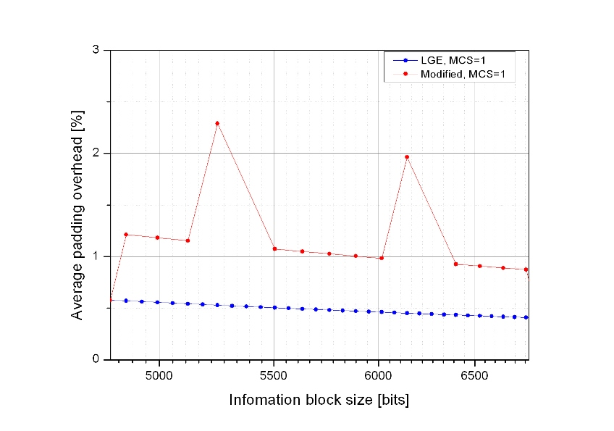
Figure 1. Padding overhead of the usable information block sizes with MCS level of 1
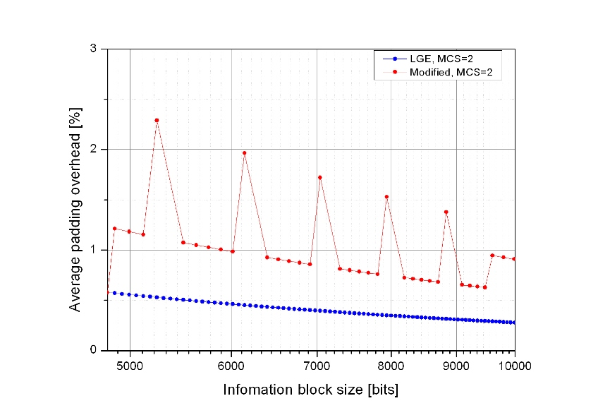
Figure 2. Padding overhead of the usable information block sizes with MCS level of 2
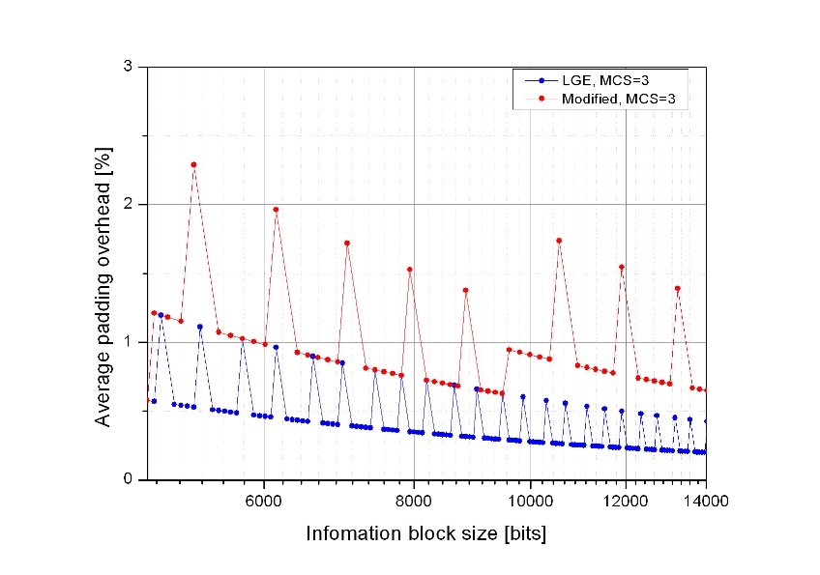
Figure 3. Padding overhead of the usable information block sizes with MCS level of 3
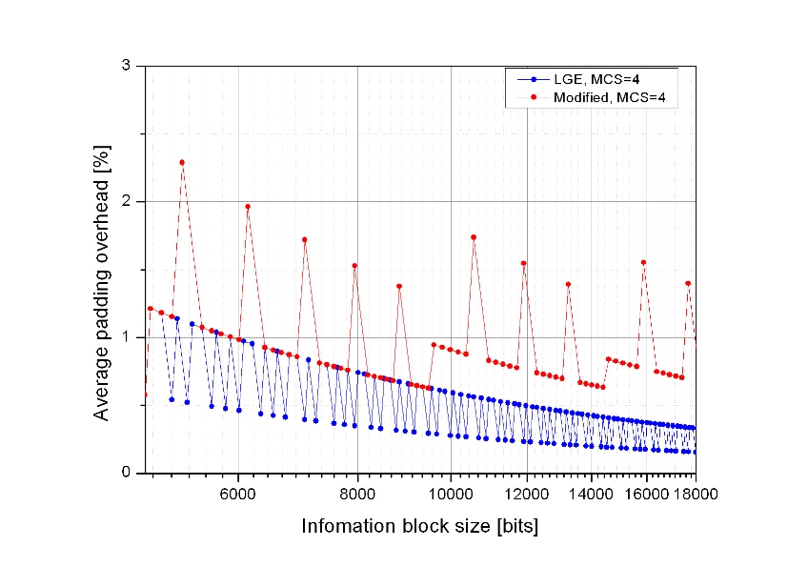
Figure 4. Padding overhead of the usable information block sizes with MCS level of 4
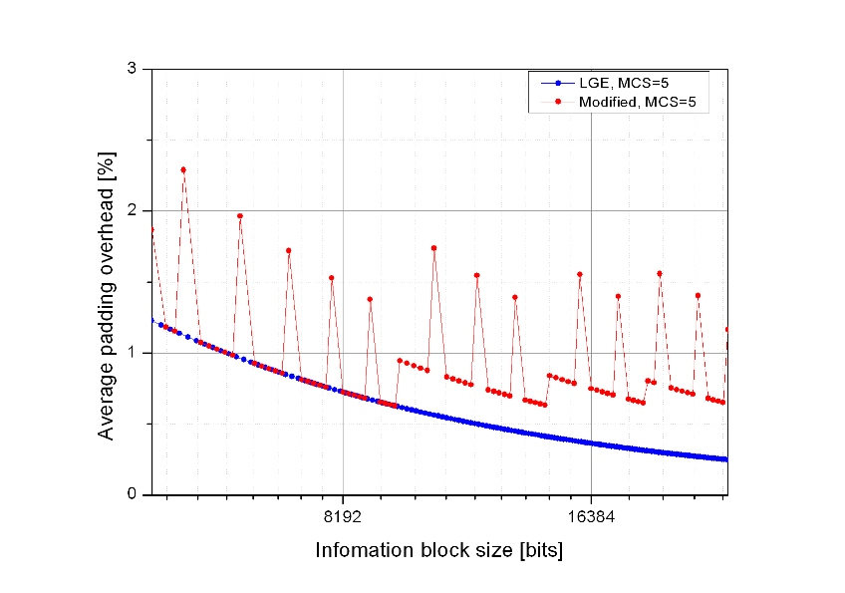
Figure 5. Padding overhead of the usable information block sizes with MCS level of 5
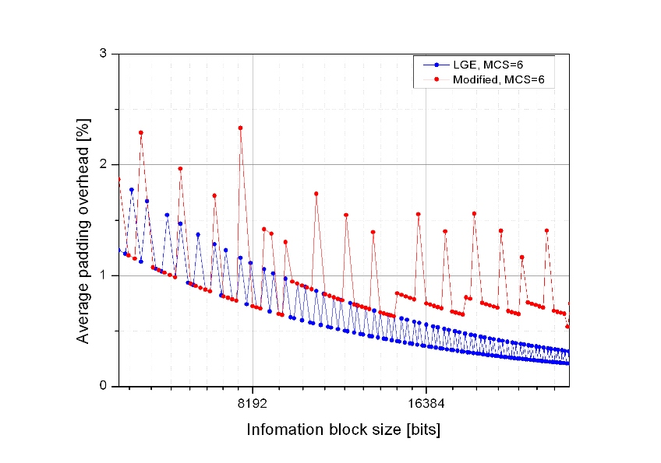
Figure 6. Padding overhead of the usable information block sizes with MCS level of 6
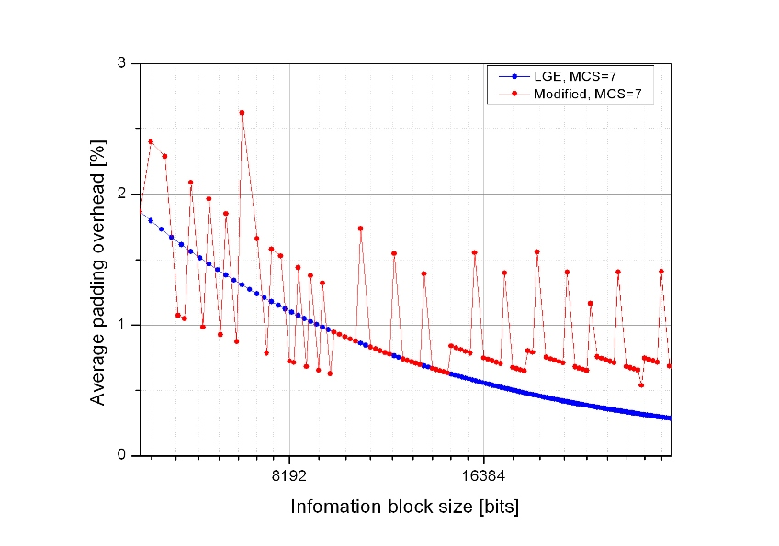
Figure 7. Padding overhead of the usable information block sizes with MCS level of 7
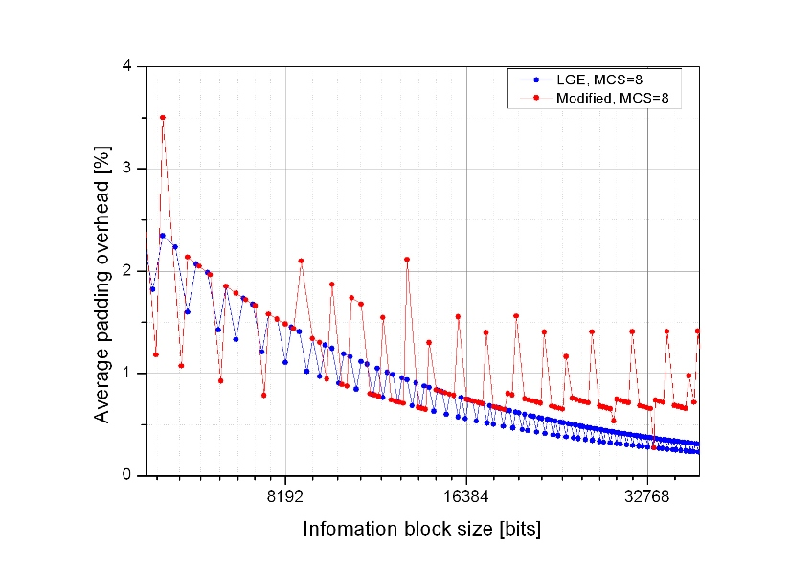
Figure 8. Padding overhead of the usable information block sizes with MCS level of 8
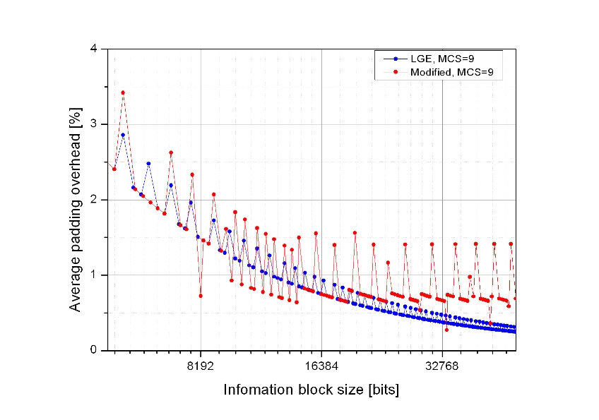
Figure 9. Padding overhead of the usable information block sizes with MCS level of 9
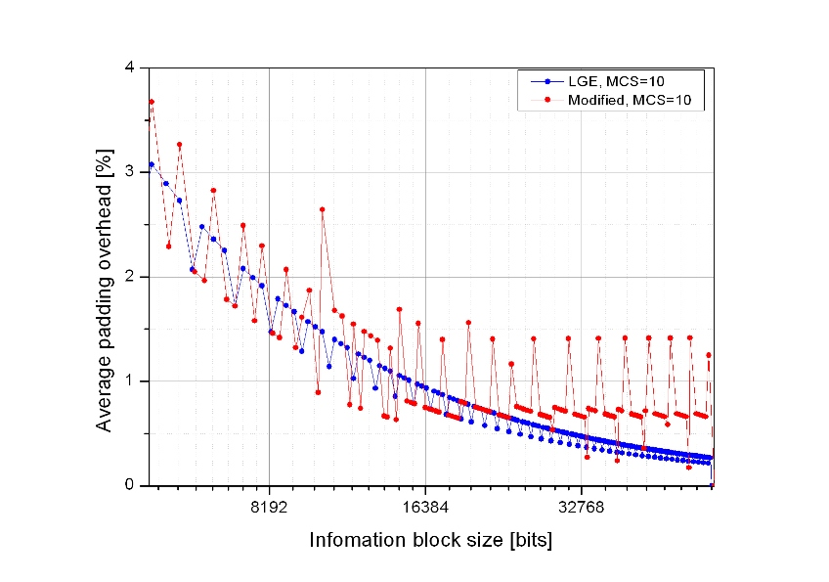
Figure 10. Padding overhead of the usable information block sizes with MCS level of 10
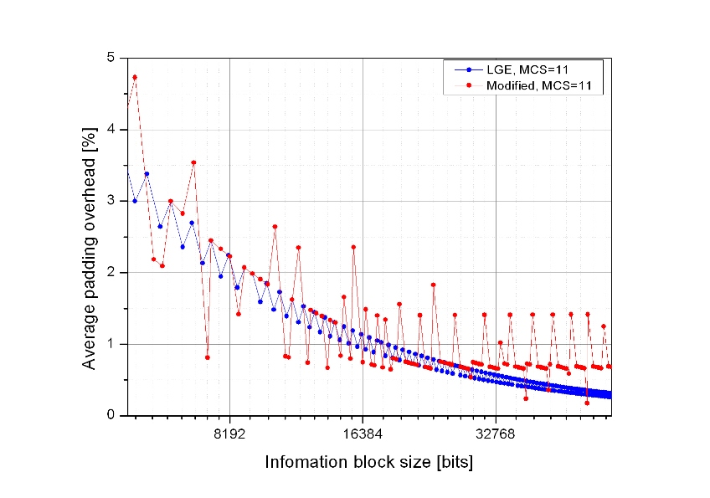
Figure 11. Padding overhead of the usable information block sizes with MCS level of 11
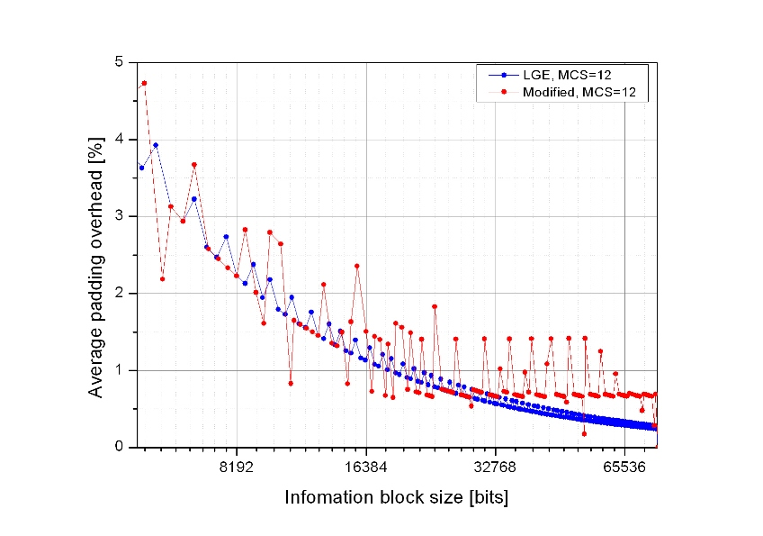
Figure 12. Padding overhead of the usable information block sizes with MCS level of 12
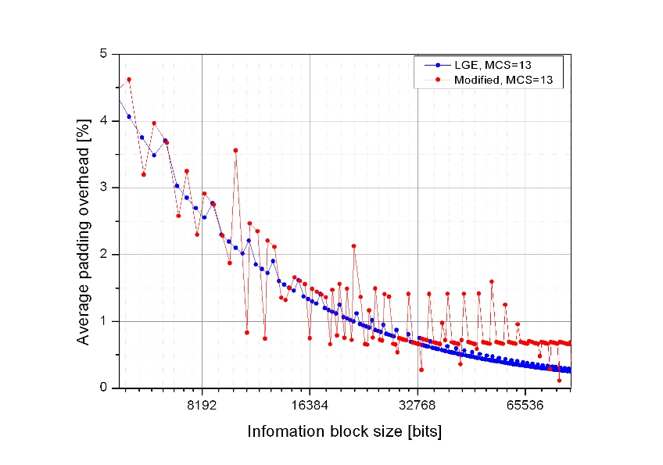
Figure 13. Padding overhead of the usable information block sizes with MCS level of 13
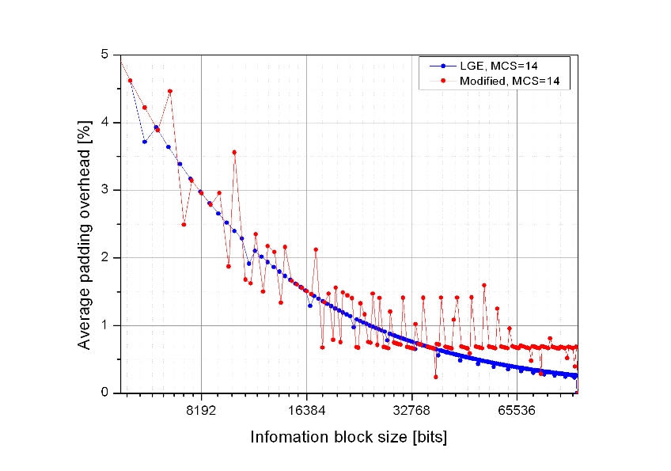
Figure 14. Padding overhead of the usable information block sizes with MCS level of 14
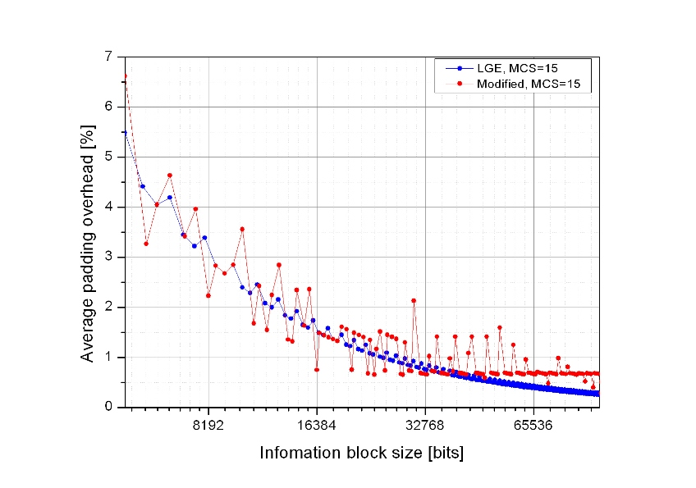
Figure 15. Padding overhead of the usable information block sizes with MCS level of 15

Conclusion
In this contribution, we have noticed the problem of the baseline burst partition rule. Also, we have introduced two burst partition rules and compared them. According to the padding overhead comparison in the section 4.1, the proposed burst partition rule would be better to be adopted in AWD.

Reference
[1] IEEE 802.16m-08/003r7, “The Draft IEEE 802.16m System Description Document”
[2] IEEE C802.16m-09/0510, “Proposed Text of Channel Coding and HARQ for the IEEE 802.16m Amendment”
[3] IEEE C802.16m-09/0314, “FEC block segmentation rule for IEEE 802.16m CTC”

Proposed text input
Replace the section “15.x.1.3 Burst partition” of DG text proposal [2] with the following text.
------------------------------------------------------ Text Start ------------------------------------------------------
      - Burst partition
        - Information block size and number of FEC blocks
When the burst size including 16 burst CRC bits exceeds maximum FEC block size, N_{FB_MAX}, the burst is partitioned into K_{FB} FEC blocks. The burst size N_{DB} including burst CRC (and FEC block CRC if N_{DB} > N_{FB_MAX}) is defined by the following equation.

$\begin{aligned}\text{If } (N_{\text{mod}}⋅R_{\text{FEC}}⋅N_{\text{RE}}⋅N_{\text{SM}})≤N_{\text{FB_MAX,}} \\ N_{\text{DB}}=\underset{X∈\left\{N_{\text{FB}}\right\}}{\text{argmin}} X≥(N_{\text{mod}}R_{\text{FEC}}N_{\text{RE}}N_{\text{SM}}) \\ \text{Else}, \\ N_{\text{DB}}=\left\lceil \frac{(N_{\text{mod}}R_{\text{FEC}}N_{\text{RE}}N_{\text{SM}})}{\text{64}}\right\rceil ⋅\text{64}\end{aligned}$

The value of K_{FB} is calculated by the following equation.

$$K_{\text{FB}}=\left\lceil \frac{N_{\text{DB}}}{N_{\text{FB_MAX}}}\right\rceil$$
, where
N_{mod} is the modulation order of the burst transmission, which is specified by MCS index.
R_{FEC} is the nominal code rate of the burst transmission, which is specified by MCS index.
N_{RE} is the number of resource elements allocated for burst transmission.
The calculation of N_{RE} shall exclude the resource elements used by pilot channels.
N_{SM} is the spatial multiplexing order of the resource elements allocated for burst transmission.
The value of N_{SM} depends on the MIMO transmission mode and is defined in section x.x.x.x.
N_{FB}__{MAX} is the maximum FEC block size, which equals to 4800 bits.
{N_{FB}} is a set of N_{FB} shown in Table 15.x.1-2.

The nominal MCS used in a data transmission shall be selected from Table 15.x.1-1.
Table 15.x.1-1. MCS table for downlink and uplink data channel
MCS index | Modulation | Code rate
‘0000’ | QPSK | 31/256
‘0001’ | QPSK | 47/256
‘0010’ | QPSK | 70/256
‘0011’ | QPSK | 98/256
‘0100’ | QPSK | 131/256
‘0101’ | QPSK | 166/256
‘0110’ | QPSK | 199/256
‘0111’ | 16QAM | 123/256
‘1000’ | 16QAM | 149/256
‘1001’ | 16QAM | 176/256
‘1010’ | 16QAM | 204/256
‘1011’ | 16QAM | 229/256
‘1100’ | 64QAM | 173/256
‘1101’ | 64QAM | 196/256
‘1110’ | 64QAM | 218/256
‘1111’ | 64QAM | 234/256

The FEC block size N_{FB,i} is calculated as follows, where i= 0… (K_{FB} -1):

- The base FEC block size N_{Base} is calculated first

$N_{\text{Base}}=\left\lfloor \frac{N_{\text{DB}}}{K_{\text{FB}}⋅\text{64}}\right\rfloor ⋅\text{64}$

$$\text{If } N_{\text{Base}}\text{mod} 7 =0, N_{\text{Base}}=N_{\text{Base}}−\text{64}$$

- The parameters α and k is specified.

$$α=\left\{\begin{matrix}\text{128}, \text{If } ({N_{\text{Base}}}/{\text{64}})\text{mod} 7 =6 \\ \text{64}, \text{Otherwise } \end{matrix}\right.$$

$k=\left\lfloor \frac{(N_{\text{DB}}−K_{\text{FB}}⋅N_{\text{Base}})}{α}\right\rfloor$

- Initialize N_{FB,i} , where i=0… (K_{FB} -1)

$$N_{\text{FB, i}}=\left\{\begin{matrix}N_{\text{Base}}+α , \text{If} i < k \\ N_{\text{Base}} , \text{Otherwise}\end{matrix}\right.$$

- $\text{If } (N_{\text{DB}}−K_{\text{FB}}⋅N_{\text{Base}})\text{mod} α=\text{64},$ Modify N_{FB,i}

$\begin{aligned}\text{If }k =0, \\ N_{\text{FB,0}}=N_{\text{FB,0}}+\text{128} ,N_{\text{FB, }(K_{\text{FB}}\text{-1})}=N_{\text{FB, }(K_{\text{FB}}\text{-1})}−\text{64} \\ \text{Else,} \\ N_{\text{FB,0}}=N_{\text{FB,0}}+\text{64}\end{aligned}$

Table 15.x.1-2. FEC block size table for downlink and uplink data channels
Index | N_{FB} | Index | N_{FB} | Index | N_{FB} | Index | N_{FB} | Index | N_{FB}
0 | 48 | 30 | 328 | 60 | 720 | 90 | 1424 | 120 | 2752
1 | 64 | 31 | 344 | 61 | 736 | 91 | 1448 | 121 | 2816
2 | 72 | 32 | 352 | 62 | 752 | 92 | 1480 | 122 | 2880
3 | 80 | 33 | 360 | 63 | 768 | 93 | 1504 | 123 | 2944
4 | 88 | 34 | 368 | 64 | 776 | 94 | 1536 | 124 | 3008
5 | 96 | 35 | 376 | 65 | 800 | 95 | 1560 | 125 | 3072
6 | 104 | 36 | 384 | 66 | 824 | 96 | 1600 | 126 | 3200
7 | 120 | 37 | 400 | 67 | 848 | 97 | 1640 | 127 | 3264
8 | 128 | 38 | 416 | 68 | 872 | 98 | 1672 | 128 | 3328
9 | 136 | 39 | 432 | 69 | 888 | 99 | 1712 | 129 | 3392
10 | 144 | 40 | 440 | 70 | 912 | 100 | 1752 | 130 | 3456
11 | 152 | 41 | 456 | 71 | 936 | 101 | 1784 | 131 | 3520
12 | 160 | 42 | 472 | 72 | 960 | 102 | 1824 | 132 | 3648
13 | 176 | 43 | 480 | 73 | 984 | 103 | 1864 | 133 | 3712
14 | 184 | 44 | 496 | 74 | 1000 | 104 | 1896 | 134 | 3776
15 | 192 | 45 | 512 | 75 | 1024 | 105 | 1920 | 135 | 3840
16 | 200 | 46 | 528 | 76 | 1048 | 106 | 1952 | 136 | 3904
17 | 208 | 47 | 544 | 77 | 1072 | 107 | 2000 | 137 | 3968
18 | 216 | 48 | 552 | 78 | 1096 | 108 | 2048 | 138 | 4096
19 | 232 | 49 | 568 | 79 | 1112 | 109 | 2096 | 139 | 4160
20 | 240 | 50 | 584 | 80 | 1136 | 110 | 2144 | 140 | 4224
21 | 248 | 51 | 600 | 81 | 1160 | 111 | 2192 | 141 | 4288
22 | 256 | 52 | 608 | 82 | 1184 | 112 | 2232 | 142 | 4352
23 | 264 | 53 | 624 | 83 | 1216 | 113 | 2280 | 143 | 4416
24 | 272 | 54 | 640 | 84 | 1248 | 114 | 2328 | 144 | 4544
25 | 288 | 55 | 656 | 85 | 1280 | 115 | 2368 | 145 | 4608
26 | 296 | 56 | 664 | 86 | 1312 | 116 | 2432 | 146 | 4672
27 | 304 | 57 | 680 | 87 | 1336 | 117 | 2496 | 147 | 4736
28 | 312 | 58 | 696 | 88 | 1368 | 118 | 2560 | 148 | 4800
29 | 320 | 59 | 712 | 89 | 1392 | 119 | 2624

The payload size excluding burst CRC and FEC block CRC is defined by the following equation:
N_{PL} = N_{DB} – (I_{MFB}×N_{FB-CRC}) – N_{DB-CRC}
, where
I_{MFB} equals 0 when K_{FB} =1, K_{FB} when K_{FB} >1,
N_{FB-CRC} equals 16, which is the size of FEC block CRC,
N_{DB-CRC} equals 16, which is the size of burst CRC.

------------------------------------------------------ Text End ------------------------------------------------------

