Project | IEEE 802.16 Broadband Wireless Access Working Group <http://ieee802.org/16>
Title | High Fidelity Sub-band CQI Feedback
Date Submitted | 2009-03-06
Source(s) | Vinod Ramachandran, Suresh Kalyanasundaram, John Harris, Hua Xu  Motorola | Hua.xu@motorola.com
Re: | IEEE 802.16m-09/0012: Call for Contributions and Comments on Project 802.16m AWD, IEEE 80216m-08/050, ULCtl Draft
Abstract | This contribution proposes solution for high fidelity sub-band CQI feedback.
Purpose | For review and adoption of proposed text in AWD
Notice | This document does not represent the agreed views of the IEEE 802.16 Working Group or any of its subgroups. It represents only the views of the participants listed in the “Source(s)” field above. It is offered as a basis for discussion. It is not binding on the contributor(s), who reserve(s) the right to add, amend or withdraw material contained herein.
Release | The contributor grants a free, irrevocable license to the IEEE to incorporate material contained in this contribution, and any modifications thereof, in the creation of an IEEE Standards publication; to copyright in the IEEE’s name any IEEE Standards publication even though it may include portions of this contribution; and at the IEEE’s sole discretion to permit others to reproduce in whole or in part the resulting IEEE Standards publication. The contributor also acknowledges and accepts that this contribution may be made public by IEEE 802.16.
Patent Policy | The contributor is familiar with the IEEE-SA Patent Policy and Procedures:  <http://standards.ieee.org/guides/bylaws/sect6-7.html#6> and <http://standards.ieee.org/guides/opman/sect6.html#6.3>.  Further information is located at <http://standards.ieee.org/board/pat/pat-material.html> and <http://standards.ieee.org/board/pat>.

High Fidelity Sub-band CQI Feedback

Vinod Ramachandran, Suresh Kalyanasundaram, John Harris, Hua Xu
Motorola Inc.,

1. Introduction

In this contribution, we propose a sub-band CQI reporting solution based on differential reporting that increases the granularity of CQI feedback with a fixed overhead per sub-band. We also propose a text for the amendment working document.

2. Proposed Technique

The CQI reporting generally consists of a wideband CQI and sub-band CQI. The wideband CQI is the average CQI experienced by the mobile station across the entire bandwidth. Given a wideband CQI, it is possible to determine, using order statistics and as a function of the number of sub-bands, the probability distributions of the CQI of the best sub-band, second best sub-band, and so on. For example, Figure 1 shows the PDF of the CQI (SNR, in linear scale) corresponding to the three best sub-bands for a wideband CQI of 3 dB assuming that there are 50 sub-bands and that the SNRs across sub-bands are i.i.d. Typically, the CQI can span a range of 0.1 to 100 (-10 dB to 20 dB), but the figure shows that given the wideband CQI of 3 dB (2 in linear scale), the range of CQIs for the three best sub-bands spans from 3 to 21. In addition, the range of CQI spanned by each sub-band is limited to an even narrower band. For example, the whole range of CQI spans from 3 to 21, but the second best sub-band CQI spans only from 4 to 14.

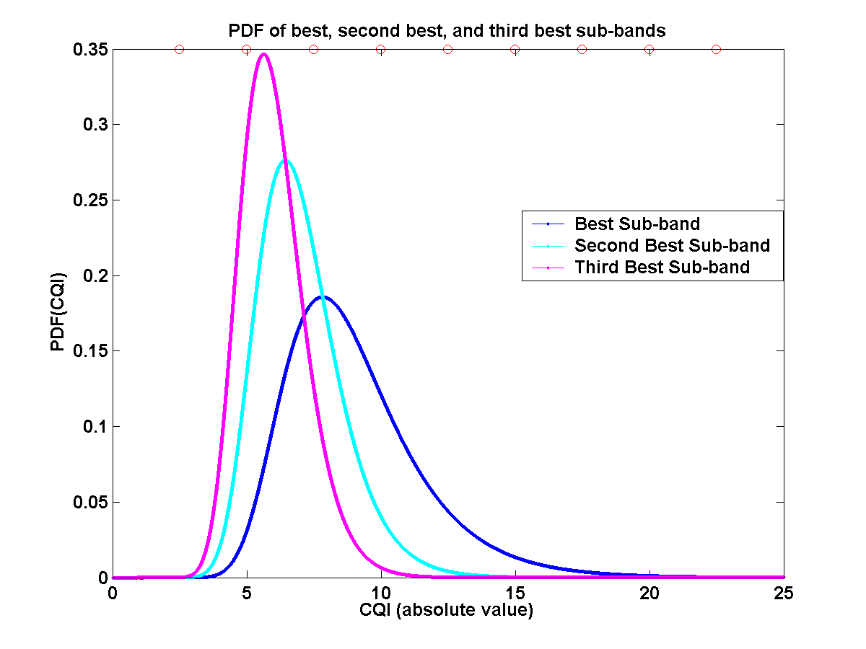
Figure 1: Probability distributions of CQI of the best three sub-bands

Let us now assume that only three bits are allowed for conveying the CQI of each sub-band. This implies that we can convey one of eight levels of CQI for each sub-band. Instead of quantizing the entire range of CQI in to eight levels, we can now quantize the expected range of CQI of each sub-band to eight levels thereby obtaining fine granular CQI. For example, for the best sub-band, the CQI range from 4 to 20 can be divided in to eight levels. Similarly, for the second best sub-band, the CQI range from 3 to 13 can be quantized in to eight levels, and so on. In other words, the three bits are used to convey a CQI value within a smaller range (e.g., 3 to 13) instead of a CQI value within a larger range (0.1 to 100). The specifications can standardize the range for the sub-bands as a function of the realized (quantized) values of the wideband CQI.

In addition to the above, the quantization of the CQI of any sub-band can also depend on the realized CQI value of the sub-band better than it. For example, if it turns out that the CQI of the best sub-band is equal to six, then the second best sub-band can only have a value that is less than or equal to six. Therefore, for the second best sub-band, the three bits can be used to specify one of eight levels in the range of 3 to 6, instead of 3 to 13. The same explanation can hold for the third best sub-band i.e., its quantization will depend on the realized CQI value of the second best sub-band.

To summarize, the quantization of the CQI levels for any sub-band depends on the following two factors:

- Wideband CQI – Wideband CQI decides the probability distributions of the CQI of the best sub-band, second best sub-band, etc.
- Realized CQI of the sub-band that is better (immediately above) the current sub-band – The range of the CQI for the current sub-band is constrained based on the observed value of the CQI of the sub-band that is just better than it.

The sub-band CQI reporting is generally accompanied by a wideband CQI report. In this case, the accompanying wideband report decides the range for the sub-band CQI. Otherwise, the last reported wideband CQI can be used to decide the range.

2. Proposed Text

Based on the discussion above, we propose that the following text be added to the amendment working document.

x.x.x Channel quality feedback

x.x.x.3 CQI quantization

The interpretation of the CQI of each of the reported K best sub-bands of a mobile station shall depend on the accompanying or last reported wideband CQI and the CQI value of the sub-band that is just better than it. The wideband CQI refers to the average channel quality observed by the mobile station across the entire bandwidth and is represented by four bits. Each value of wideband CQI gives the corresponding range of the CQI of the best sub-band, second best sub-band, etc. These ranges are FFS as shown in Table Y1. The sub-band CQI for each of the sub-bands are also represented using four bits. The quantization of the best sub-band CQI in to 16 levels for each of the wideband CQI indices is standardized and the values are shown in Table Y2.

At the opportunity of sending a periodic sub-band CQI report or as response to an on-demand CQI request, the mobile station shall perform the following:

- Use four bits to convey one of the 16 CQI levels for the best sub-band based on Table Y2 using the most recent wideband CQI report
- Determine the revised range of the CQI of the second best sub-band based on the observed value of the CQI of the best sub-band. The left end of the CQI range of the second best sub-band is the lower value of the original range of second best sub-band CQI as determined from Table Y1. The right end of the CQI range of the second best sub-band is the minimum of the higher value of the original range of second best sub-band CQI as determined from Table Y1 and the observed CQI value of the best sub-band.
- Quantize this revised range of the second best sub-band in to 16 levels. The exact quantization technique is FFS
- Use four bits to convey one of these 16 levels for the second best sub-band
- Repeat from Step 2 for all subsequent sub-bands up to and including the K-th sub-band

Upon reception of a sub-band CQI report from a mobile station, the base station shall perform the following:
- Use the accompanying or last reported wideband CQI index from that mobile station to determine the ranges of the best sub-band, second best sub-band, etc. from Table Y1
- Determine the best sub-band CQI from the four bits used to convey the best sub-band CQI
- Determine the revised range of the CQI of the second best sub-band based on the received value of the CQI of the best sub-band. The left end of the CQI range of the second best sub-band is the lower value of the original range of second best sub-band CQI as determined from Table Y1. The right end of the CQI range of the second best sub-band is the minimum of the higher value of the original range of second best sub-band CQI as determined from Table Y1 and the observed CQI value of the best sub-band
- Quantize this revised range of the second best sub-band in to 16 levels. The exact quantization technique is FFS
- Determine the second best sub-band CQI from the four bits used to convey the second best sub-band CQI
- Repeat from Step 3 for determining the CQI of all subsequent sub-bands up to and including the K-th sub-band

Table Y1. Ranges of the sub-bands CQI for different wideband CQI indices
Wideband CQI index | Best sub-band CQI range (in dB) | Second best sub-band CQI range (in dB) | … | Nth best sub-band CQI range (in dB)
0000 | FFS – FFS | FFS - FFS | FFS - FFS | FFS - FFS
0001 | FFS – FFS | FFS - FFS | FFS - FFS | FFS - FFS
0010 | FFS – FFS | FFS - FFS | FFS - FFS | FFS - FFS
0011 | FFS – FFS | FFS - FFS | FFS - FFS | FFS - FFS
0100 | FFS – FFS | FFS - FFS | FFS - FFS | FFS - FFS
0101 | FFS - FFS | FFS - FFS | FFS - FFS | FFS - FFS
0110 | FFS - FFS | FFS - FFS | FFS - FFS | FFS - FFS
0111 | FFS - FFS | FFS - FFS | FFS - FFS | FFS - FFS
1000 | FFS - FFS | FFS - FFS | FFS - FFS | FFS - FFS
1001 | FFS - FFS | FFS - FFS | FFS - FFS | FFS - FFS
1010 | FFS - FFS | FFS - FFS | FFS - FFS | FFS - FFS
1011 | FFS – FFS | FFS – FFS | FFS – FFS | FFS – FFS
1100 | FFS - FFS | FFS - FFS | FFS - FFS | FFS - FFS
1101 | FFS - FFS | FFS - FFS | FFS - FFS | FFS - FFS
1110 | FFS - FFS | FFS - FFS | FFS - FFS | FFS - FFS
1111 | FFS - FFS | FFS - FFS | FFS - FFS | FFS - FFS

Table Y2. Best sub-band CQI quantization for different wideband CQI indices
 | Wideband CQI index
Best sub-band CQI index |  | 0000 | 0001 | 0010 | 0011 | 0100 | 0101 | 0110 | 0111
Best sub-band CQI index | 0000 | FFS-FFS | FFS-FFS | FFS-FFS | FFS-FFS | FFS-FFS | FFS-FFS | FFS-FFS | FFS-FFS
Best sub-band CQI index | 0001 | FFS-FFS | FFS-FFS | FFS-FFS | FFS-FFS | FFS-FFS | FFS-FFS | FFS-FFS | FFS-FFS
Best sub-band CQI index | 0010 | FFS-FFS | FFS-FFS | FFS-FFS | FFS-FFS | FFS-FFS | FFS-FFS | FFS-FFS | FFS-FFS
Best sub-band CQI index | 0011 | FFS-FFS | FFS-FFS | FFS-FFS | FFS-FFS | FFS-FFS | FFS-FFS | FFS-FFS | FFS-FFS
Best sub-band CQI index | 0100 | FFS-FFS | FFS-FFS | FFS-FFS | FFS-FFS | FFS-FFS | FFS-FFS | FFS-FFS | FFS-FFS
Best sub-band CQI index | 0101 | FFS-FFS | FFS-FFS | FFS-FFS | FFS-FFS | FFS-FFS | FFS-FFS | FFS-FFS | FFS-FFS
Best sub-band CQI index | 0110 | FFS-FFS | FFS-FFS | FFS-FFS | FFS-FFS | FFS-FFS | FFS-FFS | FFS-FFS | FFS-FFS
Best sub-band CQI index | 0111 | FFS-FFS | FFS-FFS | FFS-FFS | FFS-FFS | FFS-FFS | FFS-FFS | FFS-FFS | FFS-FFS
Best sub-band CQI index | 1000 | FFS-FFS | FFS-FFS | FFS-FFS | FFS-FFS | FFS-FFS | FFS-FFS | FFS-FFS | FFS-FFS
Best sub-band CQI index | 1001 | FFS-FFS | FFS-FFS | FFS-FFS | FFS-FFS | FFS-FFS | FFS-FFS | FFS-FFS | FFS-FFS
Best sub-band CQI index | 1010 | FFS-FFS | FFS-FFS | FFS-FFS | FFS-FFS | FFS-FFS | FFS-FFS | FFS-FFS | FFS-FFS
Best sub-band CQI index | 1011 | FFS-FFS | FFS-FFS | FFS-FFS | FFS-FFS | FFS-FFS | FFS-FFS | FFS-FFS | FFS-FFS
Best sub-band CQI index | 1100 | FFS-FFS | FFS-FFS | FFS-FFS | FFS-FFS | FFS-FFS | FFS-FFS | FFS-FFS | FFS-FFS
Best sub-band CQI index | 1101 | FFS-FFS | FFS-FFS | FFS-FFS | FFS-FFS | FFS-FFS | FFS-FFS | FFS-FFS | FFS-FFS
Best sub-band CQI index | 1110 | FFS-FFS | FFS-FFS | FFS-FFS | FFS-FFS | FFS-FFS | FFS-FFS | FFS-FFS | FFS-FFS
Best sub-band CQI index | 1111 | FFS-FFS | FFS-FFS | FFS-FFS | FFS-FFS | FFS-FFS | FFS-FFS | FFS-FFS | FFS-FFS

 | Wideband CQI index
Best sub-band CQI index |  | 1000 | 1001 | 1010 | 1011 | 1100 | 1101 | 1110 | 1111
Best sub-band CQI index | 0000 | FFS-FFS | FFS-FFS | FFS-FFS | FFS-FFS | FFS-FFS | FFS-FFS | FFS-FFS | FFS-FFS
Best sub-band CQI index | 0001 | FFS-FFS | FFS-FFS | FFS-FFS | FFS-FFS | FFS-FFS | FFS-FFS | FFS-FFS | FFS-FFS
Best sub-band CQI index | 0010 | FFS-FFS | FFS-FFS | FFS-FFS | FFS-FFS | FFS-FFS | FFS-FFS | FFS-FFS | FFS-FFS
Best sub-band CQI index | 0011 | FFS-FFS | FFS-FFS | FFS-FFS | FFS-FFS | FFS-FFS | FFS-FFS | FFS-FFS | FFS-FFS
Best sub-band CQI index | 0100 | FFS-FFS | FFS-FFS | FFS-FFS | FFS-FFS | FFS-FFS | FFS-FFS | FFS-FFS | FFS-FFS
Best sub-band CQI index | 0101 | FFS-FFS | FFS-FFS | FFS-FFS | FFS-FFS | FFS-FFS | FFS-FFS | FFS-FFS | FFS-FFS
Best sub-band CQI index | 0110 | FFS-FFS | FFS-FFS | FFS-FFS | FFS-FFS | FFS-FFS | FFS-FFS | FFS-FFS | FFS-FFS
Best sub-band CQI index | 0111 | FFS-FFS | FFS-FFS | FFS-FFS | FFS-FFS | FFS-FFS | FFS-FFS | FFS-FFS | FFS-FFS
Best sub-band CQI index | 1000 | FFS-FFS | FFS-FFS | FFS-FFS | FFS-FFS | FFS-FFS | FFS-FFS | FFS-FFS | FFS-FFS
Best sub-band CQI index | 1001 | FFS-FFS | FFS-FFS | FFS-FFS | FFS-FFS | FFS-FFS | FFS-FFS | FFS-FFS | FFS-FFS
Best sub-band CQI index | 1010 | FFS-FFS | FFS-FFS | FFS-FFS | FFS-FFS | FFS-FFS | FFS-FFS | FFS-FFS | FFS-FFS
Best sub-band CQI index | 1011 | FFS-FFS | FFS-FFS | FFS-FFS | FFS-FFS | FFS-FFS | FFS-FFS | FFS-FFS | FFS-FFS
Best sub-band CQI index | 1100 | FFS-FFS | FFS-FFS | FFS-FFS | FFS-FFS | FFS-FFS | FFS-FFS | FFS-FFS | FFS-FFS
Best sub-band CQI index | 1101 | FFS-FFS | FFS-FFS | FFS-FFS | FFS-FFS | FFS-FFS | FFS-FFS | FFS-FFS | FFS-FFS
Best sub-band CQI index | 1110 | FFS-FFS | FFS-FFS | FFS-FFS | FFS-FFS | FFS-FFS | FFS-FFS | FFS-FFS | FFS-FFS
Best sub-band CQI index | 1111 | FFS-FFS | FFS-FFS | FFS-FFS | FFS-FFS | FFS-FFS | FFS-FFS | FFS-FFS | FFS-FFS

============================== End of Proposed Text ===============

