Project | IEEE 802.16 Broadband Wireless Access Working Group <http://ieee802.org/16>
Title | Additional material related to the “Recommended AWD Text Proposals #4 and #9” in “C802.16m-09_0386.doc” (Ranging Channel for Non-synchronized AMSs)
Date Submitted | 2009-03-08
Source(s) | Xinrong Wang  Yang-Seok Choi  Jong-Kae Fwu  Hujun Yin  Xiangying Yang  Apostolos Papathanassiou  Intel Corporation | E-mail: {xinrong.wang, yang-seok.choi, jong-kae.fwu, hujun.yin, xiangying.yang, apostolos.papathanassiou} @intel.com  *<http://standards.ieee.org/faqs/affiliationFAQ.html>
Re: | 802.16m amendment working document
Abstract | Propose text to ranging for non-synchronized AMSs
Purpose | Discussion and adoption by TGm
Notice | This document does not represent the agreed views of the IEEE 802.16 Working Group or any of its subgroups. It represents only the views of the participants listed in the “Source(s)” field above. It is offered as a basis for discussion. It is not binding on the contributor(s), who reserve(s) the right to add, amend or withdraw material contained herein.
Release | The contributor grants a free, irrevocable license to the IEEE to incorporate material contained in this contribution, and any modifications thereof, in the creation of an IEEE Standards publication; to copyright in the IEEE’s name any IEEE Standards publication even though it may include portions of this contribution; and at the IEEE’s sole discretion to permit others to reproduce in whole or in part the resulting IEEE Standards publication. The contributor also acknowledges and accepts that this contribution may be made public by IEEE 802.16.
Patent Policy | The contributor is familiar with the IEEE-SA Patent Policy and Procedures:  <http://standards.ieee.org/guides/bylaws/sect6-7.html#6> and <http://standards.ieee.org/guides/opman/sect6.html#6.3>.  Further information is located at <http://standards.ieee.org/board/pat/pat-material.html> and <http://standards.ieee.org/board/pat>.
Additional Material Related to the “Recommended AWD Text Proposals #4 and #9” in “C802.16m-09_0386.doc” (Ranging Channel for Non-synchronized AMSs)

Xinrong Wang, Yang-Seok Choi, Jong-Kae Fwu, Hujun Yin, Xiangying Yang, Apostolos Papathanassiou
Intel Corporation

Introduction
UL PHY Control Draft Group submitted a contribution [1] to the March IEEE meeting and some comments to recommend the adoption of harmonized text in [1]. This contribution provides additional material for UL PHY Control Drafting Group contribution’s proposal #4 (comment #206) and proposal #9 (comment #211) for the IEEE 802.16m Amendment Working Document.

Discussion
The following table and figure illustrate two options of ranging channel for non-synchronized AMSs in channel bandwidths of 5 MHz, 10 MHz, and 20 MHz.

Format No. | Ranging Channel Format | T_{RCP} | T_{RP} | T_{GT} | ∆f_{RP} | coverage
0 | Structure 3 | 3T_{g}+0.5T_{b} | 3T_{b} | 3T_{g}+2.5T_{b} | ∆f | 9 to 37 km
1 | Structure 3 | T_{g}+8T_{b} | 8T_{b} | 2T_{b}+17T_{g} or3T_{b}+18T_{g} | ∆f/8 | 108 km

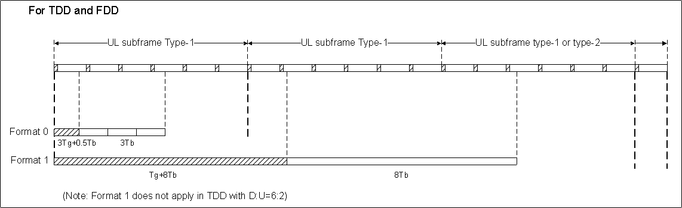

One ranging channel for non-synchronized AMSs is periodically allocated every k (TBD) super-frames as a baseline (with allocation information broadcast in DL control channel), and it can also be allocated dynamically on demand to reduce latency for operations such as handover ranging (in which the allocation information may or may not be broadcast in DL control channel). Due to the general low average load to ranging channel, it is not necessary to allocate two ranging channels into one sub-frame.
RP in Format 0 is constructed using repetition, and RCP in Format 0 is the copy of part of RP. There is no phase discontinuity.
Format 0 has the same subcarrier spacing as the data subcarrier spacing. It can support about 9 km cell size. If 3T_{g}+1.5T_{b} is used as the actual RCP, it can support about 23 km cell size. If 3T_{g}+2.5T_{b} is used as the actual RCP, it can support about 37 km cell size. The ranging opportunity duration of Format 0 is one subframe.
Format 1 has a subcarrier spacing which is eight times smaller than the data subcarrier spacing. It can support about 108 km cell size. Format 1 can fit into 3 sub-frames with some degradation in performance.

References
- Proposed Text for the Draft P802.16m Amendment on the PHY Structure for UL Control, IEEE C802.16m-09/386.

Proposed Amendment Text
The following text is proposed for inclusion in the UL PHY Control Draft Group contribution [1] for AWD proposals #4 and #9.

For Drafting Group Text Proposal # 4 (Comment # 206)

Ranging Channel Structure for Non-synchronized AMSs
[Replace the table in section 15.3.9.1.4.1 in C802.16m-09/386 with the following table]
Table UL- , Ranging Channel Formats and Parameters.
Format No. | Ranging Channel Format | T_{RCP} | T_{RP} | ∆f_{RP}
0 | Structure 3 | 3T_{g}+0.5T_{b} | 3T_{b} | ∆f
1 | Structure 3 | T_{g}+8T_{b} | 8T_{b} | ∆f/8

[Modify the text in section 15.3.9.1.4.1 in C802.16m-09/386]
In the ranging channel Format 0, RP is constructed using repetition and RCP is the copy of part of RP. There is no phase discontinuity. the repeated RCPs and RPs are used as a single time ranging opportunity within a subframe in Error: Reference source not found. Format 1 consists of a single RCP and repeated RPs within a subframe. Format 2 consists of a single RCP and RP.

For Drafting Group Text Proposal # 9 (Comment # 211)

Ranging channel configurations
[Insert the following text and figure in section 15.3.9.2.4.1.2 in C802.16m-09/386]
The ranging opportunity durations of Format 0 and Format 1 are one sub-frame and three sub-frames, respectively. The following figure illustrates their allocations in time domain in channel bandwidths of 5 MHz, 10 MHz, and 20 MHz.

