Project | IEEE 802.16 Broadband Wireless Access Working Group <http://ieee802.org/16>
Title | Proposed Text Related to Group resource allocation for the IEEE 802.16m Amendment
Date Submitted | 2009-03-09
Source(s) | Jeongki Kim, Kiseon Ryu, Ronny Yongho Kim, Jinsoo Choi, Jin Sam Kwak  LG Electronics | E-mail: {chegal, ksryu, ronnykim}@lge.com
Re: | 802.16m Amendment Working Document
Abstract | The contribution proposes the text of group resource allocation to be included in the 802.16m amendment.
Purpose | To be discussed and adopted by TGm for the 802.16m amendment.
Notice | This document does not represent the agreed views of the IEEE 802.16 Working Group or any of its subgroups. It represents only the views of the participants listed in the “Source(s)” field above. It is offered as a basis for discussion. It is not binding on the contributor(s), who reserve(s) the right to add, amend or withdraw material contained herein.
Release | The contributor grants a free, irrevocable license to the IEEE to incorporate material contained in this contribution, and any modifications thereof, in the creation of an IEEE Standards publication; to copyright in the IEEE’s name any IEEE Standards publication even though it may include portions of this contribution; and at the IEEE’s sole discretion to permit others to reproduce in whole or in part the resulting IEEE Standards publication. The contributor also acknowledges and accepts that this contribution may be made public by IEEE 802.16.
Patent Policy | The contributor is familiar with the IEEE-SA Patent Policy and Procedures:  <http://standards.ieee.org/guides/bylaws/sect6-7.html#6> and <http://standards.ieee.org/guides/opman/sect6.html#6.3>.  Further information is located at <http://standards.ieee.org/board/pat/pat-material.html> and <http://standards.ieee.org/board/pat>.
Proposed Text Related to Group resource allocation
for the IEEE 802.16m Amendment

Jeongki Kim, Kiseon Ryu, Ronny Yongho Kim, Jinsoo Choi, Jin Sam Kwak
LG Electronics.

- Introduction
This contribution is to provide the group resource allocation scheme for IEEE 802.16m system. In group resource allocation users are assigned to each group based on similar MCS and/or resource block size. Group resource allocation information (e.g. GRA A-MAP IE) includes several bitmaps (e.g. user bitmap, resource assignment bitmap) to reduce the signaling overhead for group resource allocation. GRA A-MAP IE is of variable size according to the number of active users belonging to the group. GRA A-MAP IE will be encoded by the lowest MCS level in the group. If GRA A-MAP IE is encoded with lower MCS, the resource of the A-MAP IE is of larger size. If the resource size for GRA A-MAP IE exceeds the maximum resource block size of A-A-MAP IE (e.g. 8 MLRU or 16 MLRU) because of A-MAP IE with low MCS level or an increment of active users, AMS cannot decode the A-MAP IE. Therefore, the group resource allocation scheme should support the extension of GRA A-MAP IE as shown in Figure 1.

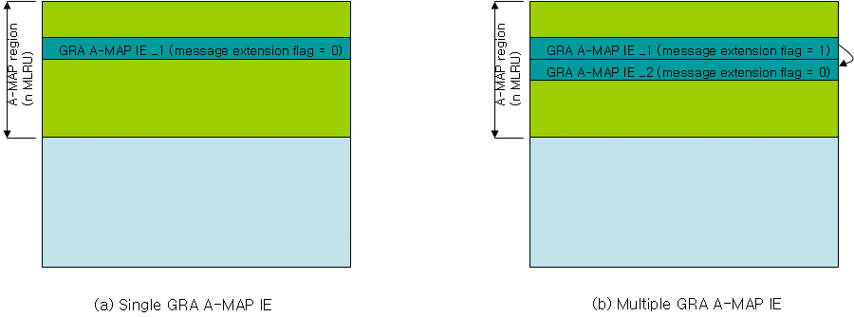
Figure 1. An example for the extension of GRA A-MAP IE

- Text proposal for the 802.16m amendment

-----------------------------------------------------------Start of the Text---------------------------------------------------------

Assignment A-MAP IE
Group Resource Allocation A-MAP IE
Group resource allocation (GRA) A-MAP IE is used to allocate resources and/or configure resources to one or multiple mobile stations within a user group. The GRA A-MAP IE contains bitmaps to indicate scheduled user and also signal resource assignment, MCS, resource size. ABS may use GRA A-MAP IE to allocate DL resources to one or multiple mobile stations within a user group.
For initial transmission, multiple GRA A-MAP IEs (e.g. a Common GRA A-MAP IE and one or more Extended GRA A-MAP IEs) for the same group may be transmitted in an A-MAP region. If the resource size of GRA A-MAP IE is the maximum size of resource block which AMS can decode (e.g. 8 MLRU or 16 MLRU), ABS shall set the message extension indicator to 1. If each message extension indicator included in Common GRA A-MAP IE or Extended GRA A-MAP IE is set to 1, Extended GRA A-AMP IE shall follow them. Although the message extension indicator included in Common/Extended GRA A-MAP IE is set to 1, if the MCS and resource size bitmap of AMS is included in this GRA A-MAP IE, the AMS shall stop decoding the next Extended GRA A-MAP IE. If there are one or more Extended GRA A-MAP IEs, the AMS shall store total number of active users belonging to the group indicated by active_user_bitmap of a Common GRA A-MAP IE and shall use it to calculate the number of active users of the last Extended GRA A-MAP IE. Extended GRA A-MAP IEs shall be encoded with the same MCS level as Common GRA A-MAP IE of the same group.

Common GRA A-MAP IE
Syntax | Size | Notes
Common GRA A-MAP IE {
A-MAP IE type | TBD
Group-allocation start offset | TBD bits | Starting point in terms LRU of the group allocation.
active_users_bitmap size | 5 bit | Size of active_user_bitmap
active_users_bitmap | TBD bits | Indicates which users are active in a group
Message extension indicator | 1 bits | 0: No extension  1: Extended GRA A-MAP IE follows this A-MAP IE.
If (message extension indicator = 1) {
E_GRA A-MAP IE size | TBD | The resource size of Extended GRA A-MAP IE (Units: MLRU)
for (n=0; n < NOAT ; n++) { |  | NOAT: The number of information of active users included in this A-MAP IE  An AMS can implicitly know the number of information of active users included in this A-MAP IE because the AMS knows the size of this A-MAP IE.
MCS and resource size bitmap | TBD | Indicates the MCS and resource size of an active user
}
}
Else {
for (n=0; n < the number of active users ; n++) { |  | The number of active users is indicated in active user bitmap
MCS and resource size bitmap | TBD | Indicates the MCS and resource size of an active user
}
}
padding | variable
}
Message extension indicator – This field is used for the extension of A-MAP IE. If this field is set to 1, an Extended GRA A-MAP IE follows this A-MAP IE.
NOAT (Number Of information of Active users included in This MAP IE) – Indicates the number of information of active users included in this A-MAP IE.
E_GRA A-MAP IE size – Indicates the resource size of Extended GRA A-MAP IE which follows this A-MAP IE if message extension indicator is set to 1. The unit is MLRU.
Extended GRA A-MAP IE
Syntax | Size | Notes
Extended GRA A-MAP IE {
Message extension indicator | 1 bits | 0: No extension  1: Extended GRA A-MAP IE follows this IE.
If (message extension indicator= 1) {
E_GRA A-MAP IE size | TBD | The resource size of Extended GRA A-MAP IE (Units: MLRU)
for (n=0; n < NOAT ; n++) { |  | NOAT: The number of information of active users included in this A-MAP IE  An AMS can implicitly know the number of information of active users included in this MAP IE because the AMS knows the size of this A-MAP IE.
MCS and resource size bitmap | TBD | Indicates the MCS and resource size of an active user
}
}
Else {
for (n=0; n < NOAT ; n++) { |  | NOAT: The number of information of active users included in this A-MAP IE  An AMS can implicitly know the number of information of active users included in this MAP IE because the AMS knows the total number of active users by active_user_bitmap and the number of active users included in the previous A-MAP IEs.
MCS and resource size bitmap | TBD | Indicates the MCS and resource size of an active user
}
}
padding | variable
}

GRA management message
GRA management message is used for adding a AMS in a specific group and releasing the group which have already been allocated by ABS.

Syntax | Size | Notes
GRA management message {
Message type | 4
Group ID | 5 | Group identifier
Allocation flag | 1 | 0: allocation  1: deallocation
If (Allocation flag = 0) {
Index of resource location | 5 | Indicates the resource location in the User bitmap
N_ACID | 3 | The number of HARQ channel for GRA operation
}
padding | variable
}

-----------------------------------------------------------End of the Text---------------------------------------------------------

