Project | IEEE 802.16 Broadband Wireless Access Working Group <http://ieee802.org/16>
Title | Inter-cell/sector Interference Mitigation based on CSSI
Date Submitted | 2009-04-18
Source(s) | Xin Su, Tsinghua Univ.  Hanyi Zhang, Tsinghua Univ.  Yi Xu, Tsinghua Univ.  Xibin Xu, Tsinghua Univ.  Jing Wang, Tsinghua Univ.  Shidong Zhou, Tsinghua Univ.  Yunzhou Li, Tsinghua Univ.  Xiaofeng Zhong, Tsinghua Univ.  Xiaolu Dong, CATR  Ying Du, CATR  Shanpeng Xiao, CMCC  Wenqi Liao, CMCC  Lian Yang, Huawei Technologies  Shiqiang Suo, Datang Mobile  Zhongkai Wang, Tianjin Hi-Tech Industrial Park, Tianjin, China  Weijun Xu, Tianjin Municipal Government,  Tianjin, China  Tim Ma, Legend Silicon Corp., Fremont,  CA, USA | suxin@tsinghua.edu.cn  zhanghy@wireless.mdc.tsinghua.edu.cn  yi-xu07@mails.tsinghua.edu.cn  xuxb@tsinghua.edu.cn  wangj@tsinghua.edu.cn  zhousd@tsinghua.edu.cn  liyunzhou@tsinghua.edu.cn,  zhongxf@tsinghua.edu.cn  dongxiaolu@mail.ritt.com.cn  duying@mail.ritt.com.cn  xiaoshanpeng@chinamobile.com  liaowenqi@chinamobile.com  yang.lian@huawei.com  suoshiqiang@datangmobile.cn  wangzk@thip.gov.cn  xwj@tipp.gov.cn  tim.ma@legendsilicon.com
Re: | Response to IEEE 80216m-09_0010r1a “ IEEE 802.16m Amendment Working Document (AWD)”
Abstract | This document proposes a new approach to randomize inter-cell interference based on cell/sector-specific interleaver pattern.
Purpose | For discussion and approval by TGm.
Notice | This document does not represent the agreed views of the IEEE 802.16 Working Group or any of its subgroups. It represents only the views of the participants listed in the “Source(s)” field above. It is offered as a basis for discussion. It is not binding on the contributor(s), who reserve(s) the right to add, amend or withdraw material contained herein.
Release | The contributor grants a free, irrevocable license to the IEEE to incorporate material contained in this contribution, and any modifications thereof, in the creation of an IEEE Standards publication; to copyright in the IEEE’s name any IEEE Standards publication even though it may include portions of this contribution; and at the IEEE’s sole discretion to permit others to reproduce in whole or in part the resulting IEEE Standards publication. The contributor also acknowledges and accepts that this contribution may be made public by IEEE 802.16.
Patent Policy | The contributor is familiar with the IEEE-SA Patent Policy and Procedures:  <http://standards.ieee.org/guides/bylaws/sect6-7.html#6>and <http://standards.ieee.org/guides/opman/sect6.html#6.3>.  Further information is located at <http://standards.ieee.org/board/pat/pat-material.html> and  <http://standards.ieee.org/board/pat>.
Inter-cell/sector Interference Mitigation based on CSSI
Xin Su, Hanyi Zhang, Xibin Xu, Jing Wang, Shidong Zhou, Yunzhou Li, Xiaofeng Zhong
Tsinghua Univeristy
Dong Xiaolu, Du Ying
CATR
Xiao Shanpeng, Liao Wenqi
China Mobile
Lian Yang
Huawei Technologies
Shiqiang Suo
Datang Mobile
Zhongkai Wang
Tianjin Hi-Tech Industrial Park, Tianjin, China
Weijun Xu,
Tianjin Municipal Government, Tianjin, China
Tim Ma,
Legend Silicon Corp., Fremont, CA, USA

1. Introduction
According to the requirements for IEEE 802.16m, suppressing the inter-cell/sector interference is a key issue. Cell/Sector-Specific Interleaving (CSSI) can made a substantial performance gain in suppressing the inter-cell/sector interference, following with the increasing of cell/sector edge transmission rate and the increasing of average user-throughput further. So it is presented to address the key issue of “interference mitigation”.
A special benefit of CSSI is that it allows a very simple (and near-optimal) chip-by-chip iterative multi-cell/sector detection strategy. The normalized cost (per user) of this algorithm is independent of the number of users. Furthermore, such low complexity and high performance attributes can be maintained in a multipath environment.
In this document, a basic introduction to CSSI is given, the principle and characteristics of CSSI is further clarified. Some useful conclusion will be drawn out.

2. Principle of CSSI
The principle of CSSI is to employ distinct interleaving patterns in the neighbouring cells/sectors so that the UE (in downlink) or Node B (in uplink) can distinguish the signals from different cells/sectors by means of cell/sector-specific interleavers.

3. How to use CSSI

3.1 Using CSSI in the Downlink and Uplink cases
Fig. 1(a) illustrates the use of CSSI in the downlink case, in which UE1 and UE2 are respectively served by NodeB1 and NodeB2 but allocated the same time-frequency resource (chunk). Suppose NodeB1 interleaves the signal for UE1 with interleaving pattern1, while NodeB2 interleaves the signal for UE2 with interleaving pattern2 (different from pattern1), then UE1 (UE2) may distinguish the signals from the two NodeBs by means of different interleavers. In case of using the single-cell/sector receiver, the interference from the other NodeB will be whitened to a noise. In case of employing iterative multi-cell/sector receiver, the interference could be effectively cancelled. Note that CSSI can be employed not only between neighboring NodeBs, but also potentially between neighboring sectors.
Similarly, CSSI can also be employed in uplink, as shown in Fig.1(b). Two UEs from two neighboring cells/sectors can share the same chunk, but interleave their signals with distinct interleaving patterns.
Fig.1(a) using CSSI in downlink to suppress inter-cell/sector interference
Fig.1(b) using CSSI in uplink to suppress inter-cell/sector interference

3.2 Transmitter of CSSI-based system
As shown in Fig. 2, users employ CSSI patterns, which would be used to extract multiple users’ signals from received signal. All redundancy in system can be utilized in encoder, so the more coding gain can be achieved.
Fig.2. Illustration of transmitter of CSSI-based system
The input data sequence of users in cell/sector-k is encoded by a low-rate code (a spreading operation can be incorporated) into, where J is the frame length. A chip level interleaver is then used, producing .The key principle of the scheme is that the interleavers {} should be different for users in different cells/sectors.

3.3 Receiver of CSSI-based system
The two types of receivers in CSSI-based system are showed in Fig. 3.
Single-cell/sector detection treats the interference as noise. It has a low complexity and can achieve a similar performance with the traditional scrambling in whitening the inter-cell/sector interference when conventional “single-user (NodeB)” receiver is used.
Comparing with single-cell/sector detection, multi-cell/sector detection also demodulates the interfering signal, and improves the detection of the wanted signal. It would make a substantial performance gain over scrambling for suppressing the inter-cell/sector interference at the cost of complexity. Especially, the iterative multi-cell/sector detection is regarded as an attractive technique because it can continuously improve the receiver performance with increasing number of iterations.
Fig.3. Illustration of two kind of detection mode in receiver of CSSI-based system.
In Fig. 3(b), the multi-cell/sector demodulators calculate and output the soft information based on the received signal, channel information and extrinsic information for each cell/sector. The decoders calculate the decision information and the extrinsic information based on the signal delivered from the multi-cell/sector demodulator. Then the decision information and extrinsic information are fed back to the multi-cell/sector demodulator. The interleaver and de-interleaver in Fig. 3(b) would be able to remove the correlation between the multi-cell/sector demodulator and the decoders, just like the role of the interleaver in Turbo codes.

4. How CSSI outperforms scrambling
In this section, the difference of CSSI and scrambling is interpreted by means of analysis and simulations.
Here we consider an iterative multi-cell receiver based on the interference cancellation and iterative decoding. Here we consider a two-cell case. In the first iteration, the single-cell decoding is performed for the Cell 1. Assuming after the decoding, a given information bit in the frame is relatively unreliable (log-likelihood ratio (LLR) is small), as shown in Fig.4 (a). Then the information bits will be re-encoded. Thus the unreliable information bit is converted to a number (in the sample, the number is 4) of unreliable code bits, as shown in Fig. 4 (b). As in Fig.4 (c), the 4 unreliable code bits will be scrambled to distributed positions after re-interleaving for Cell 1. Then the Cell 2’s signal is obtained by subtracting the Cell 1’s from the received signal. After the interference subtraction, the 4 unreliable bits in the Cell 1’s frame will affect the corresponding bits in the Cell 2’s frame, as shown in Fig.4 (d). Then the Cell 2’s signal will be fed to the de-interleaver of Cell 2. In the case of scrambling, since the two cells use the same interleaver pattern, the 4 unreliable bits will be re-assembled together, as shown in Fig.4 (e). However, if CSSI is used, the Cell 2 is employing a different interleaver pattern from Cell 1. Hence the 4 unreliable in the frame will be scrambled to another series of distributed positions, as shown in Fig.4 (f). As well known, a number of adjacent bit errors (as in Fig.4 (e)) are more difficult to be corrected than a number of distributed bit errors (as in Fig.4 (f)). Hence in the second iteration, an CSSI-based system will have a better decoding performance than a scrambling system
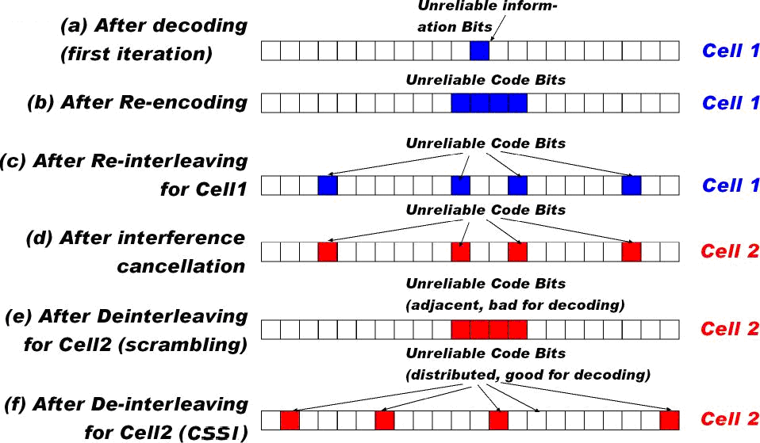
Fig. 4 How CSSI outperforms scrambling in iterative receiver

5. Simulation Results

5.1 Performance of OFDM/CSSI
Fig.5 illustrates the performance of inter-cell interference mitigation in an OFDM/CSSI system. In this simulation, the following parameters are assumed:
The number of cells | K
Channel Model | ITU. M 1225E channel model, Vehicular A, Block fading
Modulation Mode | QPSK
Number of subcarriers | 7 OFDM symbol 300 subcarriers/OFDM symbol = 2100
Total Bits | 2000*2100
Coding method | Turbo code (5,7), MAP decoding algorithm
Detection Algorithm | GMCE
Iteration numbers (outloop innerloop) | $3×5$ for K>1, $1×5$for K=1
Fig.5 the SNR-BLER (Block Error Rate) performance of CSSI-OFDM system under fading channel
The simulation results showed that the performance of CSSI-based multi-cell system can approach to the single-cell bound (SNR gap of 1-2dB at convergence point).

5.2 Comparison between CSSI and scrambling (against interference power)
Fig.6 illustrates the performance of CSSI and scrambling with different interference powers.
In this simulation, we fix the SNR of desired signal to 9dB, and vary the SNR of interfering signal from 0 dB to 10dB and investigate the receiver performance for the desired cell. The following simulation conditions are assumed:
The number of cells | 2
Channel Model | ITU. M 1225E channel model, Vehicular A, Block fading
Modulation Mode | QPSK
Number of subcarriers | 7 OFDM symbol 300 subcarriers/OFDM symbol = 2100
Total Bits | 5000*2100
Coding method | Turbo code (5,7), coding rate=1/2  MAP decoding algorithm
Channel interleaver | Random interleaving for interleaving system;  $\text{30}×\text{70}$block interleaving for Scrambling system
Detection Algorithm | GMCE
Iteration numbers (outloop innerloop) | $3×5$ for K>1, $1×5$for K=1
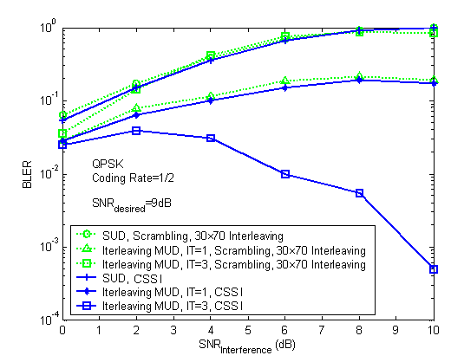
Fig.6 The performance of the desired cell at SNR of 9dB, varying the SNR of interference cells from 0 dB to 10dB
From the simulation results showed in Fig.6, we can draw the following conclusions:
- When a single-cell detection is employed, CSSI and scrambling nearly achieve the same performance.
- When a single-stage multi-cell detection is employed, both CSSI and scrambling achieve a better performance over the performance of single-cell detection. CSSI slightly outperforms scrambling.
- In the CSSI-based system, the three-iteration multi-cell detection achieves a substantial performance gain over the single-stage detection. While in the scrambling-based system, the three-iteration detection even suffers an obvious degradation over the single-stage detection due to positive feedback (error propagation), and approaches to the performance of single-cell detection.

5.3 Comparison between CSSI and scrambling (two interferers)
In the system with frequency reuse 1, an edge-area UE may receive interference from two strong interferers. The performance comparison between CSSI and scrambling for the 3-cell system is shown in Fig.7. The following simulation conditions are assumed:
The number of Users | K=3, equal SNR
Channel Model | ITU. M 1225E channel model, vehicular A, Block fading
Modulation Mode | QPSK
Number of subcarriers | 7 OFDM symbol 300 subcarriers/OFDM symbol = 2100
Total Bits | 5000*2100
Coding method | Turbo code (5,7), coding rate=1/3  MAP decoding algorithm
Channel interleaver | Random interleaving for interleaving system;  $\text{30}×\text{70}$ block interleaving for Scrambling system
Detection Algorithm | GMCE
Iteration numbers (outloop innerloop) | $3×5$ for K>1, $1×5$for K=1
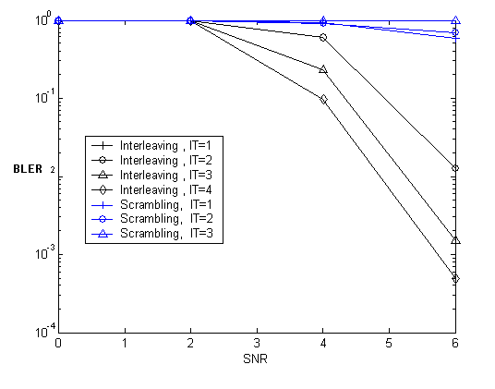
Fig.7. The SNR-BLER performance of both CSSI-based and scrambling-based systems with 3 equal SNR users
The simulations suggest that the CSSI-based system achieves a substantial performance gain with a three-iteration multi-cell detection, whereas the scrambling-based system can hardly improve its performance with the iterative receiver.

6. Conclusion
According to all above analysis and simulation, the following conclusions can be obtained:
- Scrambling and CSSI are effective techniques for signal randomization. The inter-cell/sector interference is whitened when employing single-cell/sector detection in CSSI or scrambling-based OFDM systems. In this case the two techniques achieve nearly same performance.
- Further interference-mitigation performance improvement could be obtained if iterative multi-cell/sector detection is used at receivers. Simulation results show that the iterative receiver in CSSI-based systems can achieve a substantial performance gain over the single-cell/sector detection, whereas no improvement is obtained in scrambling-based systems..

7. Proposed Text for AWD
Insert the following text into Advanced Air Interface (i.e. Chapter 15 in [X]):
------------------------------- Text Start ---------------------------------------------------
15.3.12.1.6 Interleaving
15.3.12.1.6.x Interference mitigation using cell/sector-specific interleaving
Cell/Sector Specific Interleaving (CSSI) may be used to randomize the transmitted signal, in order to allow interference suppression at the receiver.
15.3.12.1.6.x.1 Principle of CSSI-based system
As shown in Fig. 15.3.12.1.6.x.1-1, in the transmitter of CSSI-based system, the input data sequence of users in cell/sector-k is encoded by a low-rate code (a spreading operation can be incorporated) into , where J is the frame length. A chip level interleaver is then used, producing .The key principle of the scheme is that the interleavers {} should be different for users in different cells/sectors.
Fig. 15.3.12.1.6.x.1-1. Illustration of transmitter of CSSI-based system
------------------------------- Text End ---------------------------------------------------

