Project | IEEE 802.16 Broadband Wireless Access Working Group <http://ieee802.org/16>
Title | Change Request for the multiplexing scheme for E-MBS Zone Specific Pilot in 802.16m SDD
Date Submitted | 2009-04-24
Source(s) | Takaaki KISHIGAMI,  Isamu YOSHII  Panasonic Corporation | Voice: + 81-46-840-5123  E-mail: kishigami.takaaki@jp.panasonic.com  yoshii.isamu@jp.panasonic.com
Re: | Category: SDD comments / Area: Chapter 11 (PHY)  “Comments on SDD 11.5.3.2 E-MBS zone specific pilot for MBSFN ”
Abstract | We propose the E-MBS zone specific scrambled pilot scheme in order to reduce inter-zone interference.
Purpose | For 802.16m discussion and adoption
Notice | This document does not represent the agreed views of the IEEE 802.16 Working Group or any of its subgroups. It represents only the views of the participants listed in the “Source(s)” field above. It is offered as a basis for discussion. It is not binding on the contributor(s), who reserve(s) the right to add, amend or withdraw material contained herein.
Release | The contributor grants a free, irrevocable license to the IEEE to incorporate material contained in this contribution, and any modifications thereof, in the creation of an IEEE Standards publication; to copyright in the IEEE’s name any IEEE Standards publication even though it may include portions of this contribution; and at the IEEE’s sole discretion to permit others to reproduce in whole or in part the resulting IEEE Standards publication. The contributor also acknowledges and accepts that this contribution may be made public by IEEE 802.16.
Patent Policy | The contributor is familiar with the IEEE-SA Patent Policy and Procedures:  <http://standards.ieee.org/guides/bylaws/sect6-7.html#6> and <http://standards.ieee.org/guides/opman/sect6.html#6.3>.  Further information is located at <http://standards.ieee.org/board/pat/pat-material.html> and <http://standards.ieee.org/board/pat>.

Change Request for the multiplexing scheme
for E-MBS Zone Specific Pilot in 802.16m SDD

Takaaki KISHIGAMI, Isamu YOSHII
Panasonic Corporation

Introduction
In current SDD[1], the E-MBS zone specific pilot is defined such as common inside one E-MBS zone but different between neighboring E-MBS zones for improving channel estimation accuracy. However, the detail definitions of it are still FFS.
Our discussion point is how to avoid the inter-E-MBS zone interference among neighboring E-MBS zones which provide different MBSFN services. Followings are potential multiplexing schemes [2].
  - Scrambled pilot scheme : E-MBS zone-specific scrambling code is multiplied to the basic pilot pattern.
  - Interlaced pilot scheme : E-MBS zone-specific frequency/time offset is applied to the basic pilot pattern.
In following discussions, we use two kinds of the basic pilot pattern which were proposed at the previous session, and show the performance gain comparing between those multiplexing schemes by the link level simulation based on the MBSFN channel model[3].

E-MBS Zone Specific Pilot structure
2.1 Scrambled pilot scheme
Figure 1 shows a scrambled pilot scheme. The example is a scrambling code using phase rotation in a E-MBS zone with three E-MBS zones and a basic pilot pattern based on the 802.16e Downlink PUSC[4]. In the figure, the phase rotation for P_{k} illustrates the pilot symbol transmitted for stream #k. The maximum number of streams within the E-MBS zone is two[1]. The phase rotation($φ$) of 0, 2/3, and 4/3 is added every adjacent pilot subcarrier to the E-MBS zone #1, #2, and #3, respectively.
When the proposed scrambled pilot scheme is used, the inter-E-MBS zone interference on the pilot channel from the neighboring E-MBS zones can be avoided by de-spreading among neighbor pilot subcarrier, leading to accurate channel estimation.
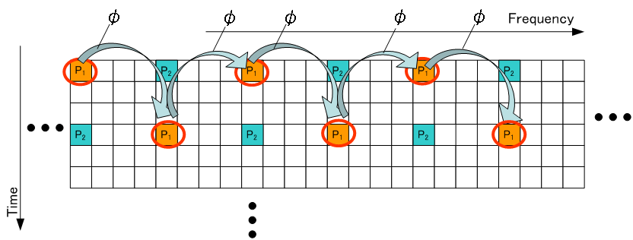$φ=\left\{\begin{matrix} 0 (\text{for} \text{Zone} & 1)\begin{matrix} \\ \\ \end{matrix}2) \\ \frac{4π}{3} (\text{for} \text{Zone} & 3)\end{matrix}\right.$

Figure 1 – Example of scrambled pilots for E-MBS zone specific pilot

2.2 Interlaced pilot scheme
Figure 2 shows an interlaced pilot scheme. The E-MBS zone specific offset is applied to the basic pilot pattern which is defined as the pilot pattern in E-MBS zone #1. The offset in the E-MBS zone #k is (k-1)ΔSC. (Figure 2 shows the case of ΔSC =1.) The offset of pilot positions is given in frequency/time direction for the basic pilot pattern as shown in Figure 1. The E-MBS zone specific offset is applied to all pilot symbols for up to two streams(P₁, P₂).
In the non-orthogonal pilot structure using the interlaced scheme, the inter-E-MBS zone interference with the boosted pilot signals can be reduced compared to the non-orthogonal pilot structure without the interlaced scheme, although the interference from the pilot channel to the data channel is increased at the same time.
E-MBS Zone
#1
E-MBS Zone
#2
E-MBS Zone
#3
Figure 2 – Example of interlaced pilots for E-MBS zone specific pilot

Simulation Evaluation
We compare three pilot schemes as shown in Figure 3 and evaluate two kinds of the basic pilot pattern which are the lowest and highest pilot density pattern of the previously proposed E-MBS pilot patterns as shown in Figure 4.
E-MBS Zone
#k
E-MBS Zone
#(k+1)
(a)Scrambled pilots (b)Non zone-specific pilots (c)Interlaced pilots
Figure 3– Evaluated pilot scheme

The scrambled pilot scheme:
Figure 5 shows the scrambled pilot scheme (Type 1) which uses one kind of the orthogonal codes ($φ_{1}$). In the case of the scrambled pilot scheme (Type 1), the phase rotation [$φ_{1}$(k)] in the E-MBS zone #k is added every adjacent pilot tone to basic pilot pattern.
Figure 6 shows another scramble pilot scheme (Type 2) which uses two kinds of orthogonal codes ($φ_{1}$,$φ_{2}$) . The scrambled pilot scheme (Type 2) divides pilot tone symbols into two pilot blocks (PB₁, PB₂[n]) as shown in Figure 6. For the PB₁ in the E-MBS zone #k, the phase rotation [$φ_{1}$(k)] is added every adjacent pilot tone. For the PB₂[n] in the E-MBS zone #k, the phase rotation [$φ_{2}$(n, k)] is added every adjacent pilot tone, where n=1,…,N , N is the number of RUs.
The scrambled pilot scheme (Type 2) is evaluated only for the Pilot Pattern A, since the Pilot Pattern A is relatively low pilot density for the MBSFN channel which is assumed the large delay spread.
The interlaced pilot scheme:
We evaluate the case with cyclic time offset within PRU(ΔSC =1 [OFDM symbol]) for interlaced pilots.
We investigate the effect of the E-MBS zone specific pilots from the viewpoint of the BLER performance in a E-MBS zone with three E-MBS zone. Table 1 lists the radio parameters assumed in the link-level simulations. The transmission power of the pilot symbol is set to 5dB higher than that of the data symbol.
Figure 7 shows the interference model among E-MBS zones. The parameter of inter-E-MBS zone interference [I=P_{zone#1}/ (P_{zone#2} + P_{zone#3})] represents the difference in the average received signal power at a MS in E-MBS zone #1, corresponding to the difference in the distances from the neighboring BSs in two E-MBS zones(#2, #3).
Figure 8 plots the BLER performance in case of I =6, 9, 12 and 15 dB.
We find that the scrambled pilot scheme is better throughput performance compared to that of the interlaced pilot scheme. The scrambled pilot scheme (Type 2) is more effective than the Type 1 scheme when the pilot density is relatively low like Pattern A in SDD.

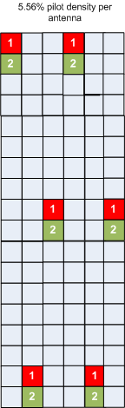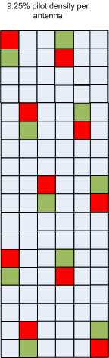
(a) Pattern A in SDD[1] (b) LGE’s proposal[5]
Figure 4 – Basic pilot pattern used for the evaluation

$φ_{1}(k)=\left\{\begin{matrix} 0 , \text{when} k=1 (\text{for} \text{Zone} & 1) \\ \frac{2π}{3}, \text{when} k=2 (\text{for} \text{Zone} & 2) \\ \frac{4π}{3}, \text{when} k=3 (\text{for} \text{Zone} & 3)\end{matrix}\right.$ 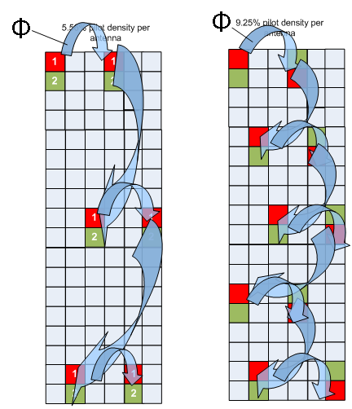
(a) Pattern A in SDD[1] (b) LGE’s proposal[5]
Figure 5 – Scrambled pilots (Type 1) used for the evaluation

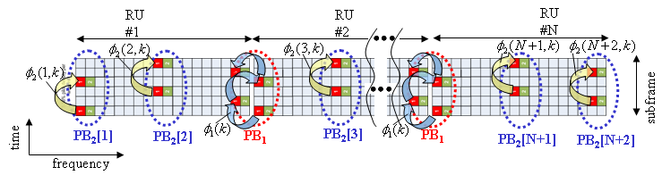

$φ_{1}(k)=\left\{\begin{matrix} 0 , \text{when} k=1 (\text{for} \text{Zone} & 1) \\ \frac{2π}{3}, \text{when} k=2 (\text{for} \text{Zone} & 2) \\ \frac{4π}{3}, \text{when} k=3 (\text{for} \text{Zone} & 3)\end{matrix}\right.$ …. (1), $φ_{2}(n,k)=\left\{\begin{matrix}π , \text{when} \text{mod}(n+k+1,3)=0 \\ 0 , \text{when} \text{mod}(n+k+1,3)≠0\end{matrix}\right.$ …(2)

N : the number of RUs , n=1,…,N, k : the zone number (#1,#2 and #3).

Figure 6 – Scrambled pilots (Type 2) used for the evaluation

Figure 7 – Simulation model considering inter-E-MBS zones interference

Table 1 – Simulation Parameters

Parameter | Value
OFDM parameters | 10 MHz (1024 subcarriers)
Number of OFDM symbols per subframe | 6
Data burst size | 4 PRUs distributed over 48 PRUs
Permutation | Tone based LDRU
Number of total RU in one subframe | 48
Number of Antennas | 2 transmitter antennas, 2 receiver antennas [2Tx,2Rx]
Transmission mode | Rate 1 transmission scheme : SFBC
Modulation/Coding | QPSK, R=1/2,3/4; 16QAM, R=1/2,3/4  with CTC FEC (8 Turbo decoding iterations)
Channel model | MBSFN channel models for 1.5km ISD  with MS speed of 120km/h
Channel estimation | MMSE channel estimator with 3 PRU level CE
Pilot boosting | 5dB
MIMO detector | LMMSE for rate 2 scheme
Scenarios | Interference Limited (Inter-zone interference is two interfering zone signals with equal power ratio.)  The inter-E-MBS zone interference: ΔI=6, 9 , 12, 15 dB
(a-1)Pattern A in SDD, 2x2 SFBC, QPSK R=1/2 ,120km/h

(a-2)Pattern A in SDD, 2x2 SFBC, 16QAM R=1/2 ,120km/h

=6dB
=9dB
=12dBB
=15dBdB
Scrambled zone pilots
Non zone specific pilots
Interlaced zone pilots
CDM pilots
(b-1)LGE’s Pattern, 2x2 SFBC, QPSK R=1/2 ,120km/h

=6dB
=9dB
=12dBB
=15dBdB
Scrambled zone pilots
Non zone specific pilots
Interlaced zone pilots
CDM pilots
(b-2)LGE’s Pattern, 2x2 SFBC, 16QAM R=1/2 ,120km/h

Figure 8 – BLER performance

Conclusions
We presented the superior performance of the E-MBS zone-specific scrambled scheme compared to the interlaced pilot scheme by link-level simulation evaluation considering inter-E-MBS zone interference.
The E-MBS zone-specific scrambled pilot scheme is effective to reduce the inter-E-MBS zone interference when the pilot density is relatively low like the Pilot Pattern A in SDD.
Hence, we propose to use the scrambled (or CDM) pilot scheme for E-MBS zone specific pilot in TGm SDD.

Proposed Change Text in 16m SDD[1]
Section 11.5.3.2 E-MBS zone specific pilot for MBSFN, page 81, line 17
- Replace the following text
“The definitions of the E-MBS zone specific pilots are FFS.”
with
“The E-MBS zone specific pilots use the E-MBS zone specific scrambled structure to reduce the inter-E-MBS zone interference.”

References
[1]IEEE 802.16m-08/003r8, “The Draft IEEE 802.16m System Description Document”
[2]IEEE C802.16mDL_PHY-08/716, Panasonic, “Sector-Specific Common Pilot Structure in IEEE802.16m Downlink.”
[3]IEEE C80216m-09/0089r2, “Modeling MBSFN Channels”
[4]IEEE Std 802.16e-2005.
[5]IEEE C802.16m-09/0127, LGE, ” Considerations on the E-MBS in 802.16m : Pilot patterns for 1 and 2 MBS data streams”

