Project | IEEE 802.16 Broadband Wireless Access Working Group <http://ieee802.org/16>
Title | Vector Quantization of the Transmit Correlation Matrix
Date Submitted | 2009-04-27
Source(s) | Ron Porat, Simon Pun, Phil Orlik, Ramesh Annavajjala, Zhifeng (Jeff) Tao  Mitsubishi Electric Research Labs  Toshiyuki Kuze  Mitsubishi Electric Corporation  5-1-1 Ofuna Kamakura, Kanagawa 2478501, JAPAN | Voice:  E-mail: poratron@yahoo.com; {mpun, porlik, annavajjala, tao}@merl.com  E-mail : kuze.Toshiyuki@ah.MitsubishiElectric.co.jp  *<http://standards.ieee.org/faqs/affiliationFAQ.html>
Re: | Category: AWD comments / Area: Chapter 15.3.7.2.6.6.3 (DL-MIMO)  “Comments on AWD 15.3.7.2.6.6.3 DL-MIMO”
Abstract | This document describes a proposal for AWD Section 15.3.7.2.6.6.3 Adaptive Codebook Based Feedback Mode
Purpose | To be discussed and adopted by 802.16m
Notice | This document does not represent the agreed views of the IEEE 802.16 Working Group or any of its subgroups. It represents only the views of the participants listed in the “Source(s)” field above. It is offered as a basis for discussion. It is not binding on the contributor(s), who reserve(s) the right to add, amend or withdraw material contained herein.
Release | The contributor grants a free, irrevocable license to the IEEE to incorporate material contained in this contribution, and any modifications thereof, in the creation of an IEEE Standards publication; to copyright in the IEEE’s name any IEEE Standards publication even though it may include portions of this contribution; and at the IEEE’s sole discretion to permit others to reproduce in whole or in part the resulting IEEE Standards publication. The contributor also acknowledges and accepts that this contribution may be made public by IEEE 802.16.
Patent Policy | The contributor is familiar with the IEEE-SA Patent Policy and Procedures:  <http://standards.ieee.org/guides/bylaws/sect6-7.html#6> and <http://standards.ieee.org/guides/opman/sect6.html#6.3>.  Further information is located at <http://standards.ieee.org/board/pat/pat-material.html> and <http://standards.ieee.org/board/pat>.

Vector Quantization of the Transmit Correlation Matrix
Ron Porat, Simon Pun, Phil Orlik
Mitsubishi Electric Research Labs

Background

This contribution follows [1] where several vector quantization schemes of the transmit correlation matrix were proposed and analyzed. The fundamental idea simply follows the logic behind general codebooks construction.
In this contribution a vector quantization scheme for the adaptive mode is proposed and shown to perform well in MU-MIMO. The proposal is for 4-antenna BS. Extension to 8-antenna BS is straightforward in principle but requires performance verification.
It is shown in the simulations that vector quantization provides comparable performance and sometimes even better performance than element-wise quantization at one third to one half the feedback overhead.

Due to the reduced overhead, the same scheme can be utilized in other applications e.g. feedback of the interference correlation matrix or feedback of a narrowband correlation matrix for improved CL-MIMO (SU or MU) performance.

2. Proposed Scheme

The proposed scheme uses rank-1 codebooks to quantize the two strongest singular vectors of the transmit correlation matrix. Using the rank-2 codebook didn’t perform nearly as well in simulations due to reduced accuracy.

Algorithm 1:

- Find the strongest singular vector by maximizing where is a rank-1 singular vector taken from a codebook and is the approximated strongest singular value of . Denote by m the index of the winning codeword.
- Find the second strongest singular vector by maximizing where is the orthogonalized rank-1 singular vector with respect to . Orthogonalization is defined in section 15.3.7.2.6.6.3. Denote by n the index of the winning codeword.
  - An explicit formula that can be used follows Gram-Schmidt
- Quantize the ratio into a predefined set of thresholds. Denote by q that value.

Alternatively, the metric in stage 2 can be replaced by minimization of the error between and its vector quantized estimation by following this algorithm 2:

- As in algorithm1
- Compute the orthogonalized singular vector , the singular vector and the quantized ratio q as in algorithm 1. Find the codeword that minimizes

The specific algorithm is left for vendor implementation.
The feedback includes the two indices of the winning singular vectors and the index of the quantized singular value.

Codebook choice

The fundamental choice of codebook is somewhat different than the typical codeword construction. First, only rank-1 is used and second, the adaptive mode is used for correlated arrays, hence codebooks that are designed to perform better in correlated antennas are preferable.
In addition, it was found by simulations that the strongest singular vector has much more importance in providing accurate vector quantization of R than the second. This is to be expected since correlated arrays where the adaptive more is useful tend to have low ratio of the singular values .
Hence, an optimal ‘bit allocation’ will require larger codebook for the first singular vector.
As is shown in [2], the 6bit rank-1 codebook chosen for 802.16m exhibits good performance in correlated and uncorrelated and is therefore a good choice. The 4bit subset codebook didn’t perform sufficiently well in simulations.
However, as can be seen in the plots below, a 4 bit steering vector (defined in the proposed text) performs very well for ULA and is therefore proposed in order to educe computation and feedback overhead eve further.
The BS can send a message to the MS indicating that a closely spaced ULA is used and asking to use the steering vector as the baseline codebook. Alternatively or additionally the MS can compute the vector quantized R using the steering vector and if the MSE is below a threshold use that instead of the 802.16m codebook.

Other possible enhancements to improve the accuracy of the strongest singular vector which are FFS:
- Better rank-1 codebooks for semi-correlated arrays like the dual cross-pol XX with potentially more than 6bits.
- Compute the unquantized strongest singular vector of R and feed back in addition to the above method the difference relative to in an analog fashion.

3. Simulation Assumptions

MUZF simulations based on rank-1 feedback are used. DL spectral efficiencies are calculated assuming an MMSE receiver at the MS and assuming the interference is perfectly known.

- DL channel – SCM Suburban Macro and Urban Macro (15 degrees angular spread).
- Antenna Configuration –
  - 4 lambda/2 spaced antennas [| | | |]
  - 2 lambda/2 spaced cross-pols [XX]
- DL Band BW – 4 PRB (assuming one precoder per band)
- DL speed and feedback delay – 3kmph, 5mS
- DL midamble estimation – perfect
- User selection: 4 random users with exhaustive selection

Histograms of the ratio of the second to first singular values of the transmit correlation for the antenna configurations and environments used is shown in the appendix. Note that the Suburban Macro environment exhibits almost rank-1which is due to the narrow angular spread.

4. Simulation Results

The simulations use the 802.16m rank-1 codebook. The ratio of the second to first singular values was quantized to the nearest point in [0.25, 0.5] and requires 1bit feedback.

A comparison is made relative to the 4bit subset of the rank-1 4-antenna codebook.

In the legends:
- ‘6 bit’ uses the 6bit PMI
- ‘4bit+R’ uses the 4bit subset transformed by the unquantized R,
- ‘4bit+Quantized R’ uses 16m element wise quantization,
- ‘4bit +VQ(6+6+1)’ uses vector quantization of R using the 6bit 16m rank-1 PMI,
- ‘4bit+(4+4+1)’ uses vector quantization of R using a steering vector (defined in the proposed text) and similar to the 8-antenna rank-1 codebook
- ‘Perfect SV’ uses the strongest unquantized singular vector of the average narrowband transmit correlation matrix.

The poor performance seen in Suburban Macro of the element wise quantization of can be attributed to figure 3 in [1] where it is shown that the MSE of this method is highest for rank-1.

On the other hand, it can be seen that in this scenario and antenna configuration, a 4bit steering vector performs slightly better while reducing the feedback overhead.

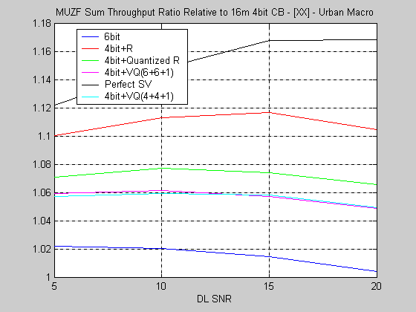

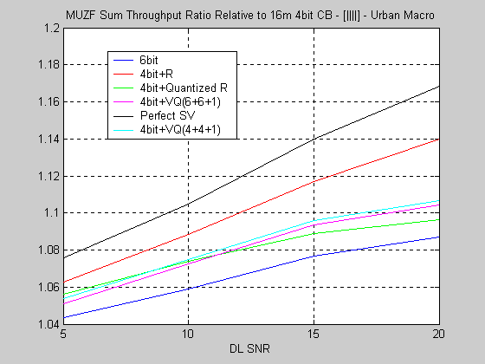

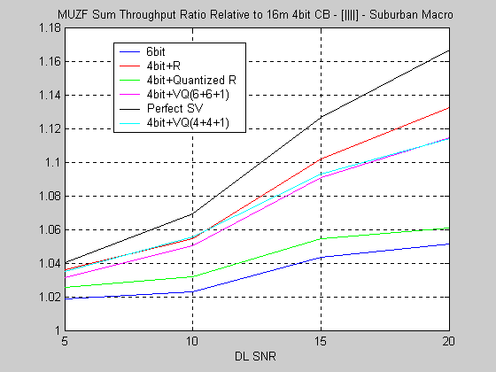

References

- C802.16m-09/516r1 – “Reduced-Overhead Covariance Matrix Feedback”
- C802.16m-09/588 –“ Performance Evaluation of Codebooks Proposed for IEEE 802.16m Amendment”

Appendix

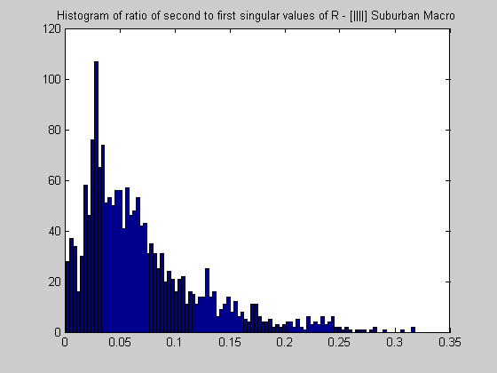

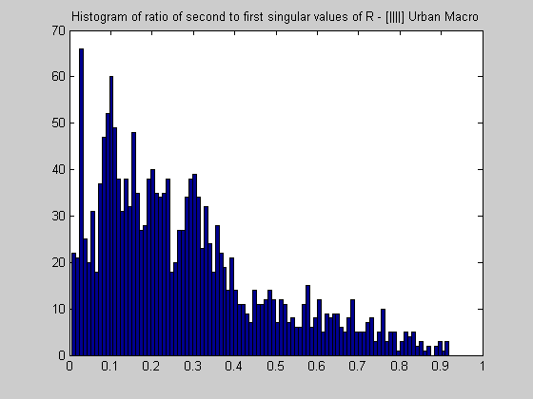

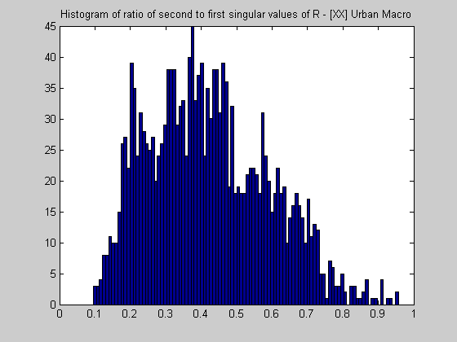

Proposed text

15.3.7.2.6.6.3 Adaptive codebook based feedback mode

Add at the end of the section:

Thematrix for 4-antenna BS can be vector quantized into its singular vectors and values. The two strongest singular vectors and the ratio of the second to first singular values are fed back.
The singular values are quantized using the 6bit rank-1 codebooks as defined in section 15.3.7.2.6.6.2.2.1.
The ratio of singular values is quantized to the nearest element in [ 0.25 , 0.5 ].
The total feedback overhead is 13bits.
The BS can signal the MS to use a 4-bit steering vector based approach such that the feedback overhead associated with the signaling of the two singular vectors and their ratio is reduced to 9bits.

The steering vector is defined as:

