Project | IEEE 802.16 Broadband Wireless Access Working Group <http://ieee802.org/16>
Title | Parametric Compression of Rank-1 Analog Feedback
Date Submitted | 2009-04-27
Source(s) | Ron Porat, Simon Pun, Phil Orlik, Ramesh Annavajjala, Zhifeng (Jeff) Tao  Mitsubishi Electric Research Labs  Toshiyuki Kuze  Mitsubishi Electric Corporation  5-1-1 Ofuna Kamakura, Kanagawa 2478501, JAPAN | Voice:  E-mail: poratron@yahoo.com; {mpun, porlik, annavajjala, tao}@merl.com  E-mail : kuze.Toshiyuki@ah.MitsubishiElectric.co.jp  *<http://standards.ieee.org/faqs/affiliationFAQ.html>
Re: | Category: AWD comments / Area: Chapter 15.3.7.2.6.7.2 (DL-MIMO)  “Comments on AWD 15.3.7.2.6.7.2 DL-MIMO”
Abstract | This document describes a proposal for AWD Section 15.3.7.2.6.7.2 Analog Feedback
Purpose | To be discussed and adopted by 802.16m
Notice | This document does not represent the agreed views of the IEEE 802.16 Working Group or any of its subgroups. It represents only the views of the participants listed in the “Source(s)” field above. It is offered as a basis for discussion. It is not binding on the contributor(s), who reserve(s) the right to add, amend or withdraw material contained herein.
Release | The contributor grants a free, irrevocable license to the IEEE to incorporate material contained in this contribution, and any modifications thereof, in the creation of an IEEE Standards publication; to copyright in the IEEE’s name any IEEE Standards publication even though it may include portions of this contribution; and at the IEEE’s sole discretion to permit others to reproduce in whole or in part the resulting IEEE Standards publication. The contributor also acknowledges and accepts that this contribution may be made public by IEEE 802.16.
Patent Policy | The contributor is familiar with the IEEE-SA Patent Policy and Procedures:  <http://standards.ieee.org/guides/bylaws/sect6-7.html#6> and <http://standards.ieee.org/guides/opman/sect6.html#6.3>.  Further information is located at <http://standards.ieee.org/board/pat/pat-material.html> and <http://standards.ieee.org/board/pat>.

Parametric Compression of Rank-1 Analog Feedback
Ron Porat
Mitsubishi Electric Research Labs

Background

The idea of analog feedback was proposed in the past [1][2][3][4][5] in order to facilitate CL-MIMO.
In [4] section 2, extensive simulations were carried out of various options of analog feedback. It was found that feeding back the rank adapted channel singular vectors (in a similar fashion to codebook based feedback) is superior to all other analog feedback options that were investigated for SU-MIMO.
In [4] section 4, analog feedback was also found to be robust to colored interference regardless of channel conditions, SNR and interference color when compared to codebook based feedback when both options used the same UL resources.

In addition to pure analog feedback options, [4] section 5 and [5] proposed to use analog feedback for the differential mode (the difference between the optimal singular vector and the best codeword is fed back unquantized).

While improvement in SU-MIMO performance was shown in [4] section 7, the main appeal of analog feedback is for MU-MIMO applications or Multi-BS MIMO applications (including Femto and Relay deployments) where joint processing of multiple BS is performed in order to achieve coherent combining and interference nulling to multiple cell edge users.
This is mainly due to results in [6] that show that the channel feedback accuracy must increase linearly with SNR increase in dB in order to remain within fixed amount of dB from the MU-MIMO channel capacity.
Analog feedback is best suited for this task as its accuracy naturally grows with SNR and can provide simple and unified feedback for typical Macro deployments as well as Femto/Pico or Relay to BS links where the typical SNR is expected to be much higher.
On the other hand, 16m based codebook feedback will limit the performance due to channel quantization at the mobile station. The authors of [9] reached a similar conclusion.

The current 802.16m SDD assumes rank-1 feedback for MU-MIMO and we therefore focus here on optimizations of analog feedback of the strongest singular vector.

2. General Analog Rank-1 Feedback

In general, assuming an N antenna BS, N complex valued numbers are needed to represent the strongest singular vector. Those numbers can be mapped to N subcarriers using AM modulation. Repetition can be used to improve reliability at the low SNR range, however it is important to remember that increasing the number of BS antenna improves the UL performance and typically with 4 or 8 antenna BS no repetition will be required for most SNR range.
It is possible to feed back only N-1 complex numbers by rotating all elements by the negative of the angle of the first element (thus making the first element real) and not transmitting the first element. At the BS, the first element can be computed by noting that the sum power of all elements is 1. This scheme however makes the feedback more sensitive to power normalizations.

Since feedback in cellular systems and in particular 802.16m is done per band (1-4 PRBs) two possibilities were shown to provide good results:

- Compute the strongest singular vector of the average transmit covariance matrix in that band.
  - Computation of the transmit covariance matrix is simple and needed for the adaptive mode.
  - General computation of the strongest singular vector can be facilitated in most cases using the power method [7] or via the general SVD algorithm as in [7][8].
- In most cases mobiles will have two receive antennas. In this case [2] gives a simple closed form formula for the per subcarrier channel SVD (for any number N of BS antennas) and [3] shows how to average the singular vectors in a given band. In simulations, the performance of method 2 was seen to be similar to method 1.
  - In particular for rank-1 feedback, [2] shows that the strongest singular vector is simply a linear combination of the two channel rows and in [3] the singular vectors are phase aligned before being averaged across the band of interest (a second averaging iteration was used for improved performance)
  - In addition for future MS with 4 antennas, an ML receiver is likely to be used for spatial multiplexing. Typical implementations use sphere decoders which use the QR decomposition to create the search tree. Once QR is performed, SVD is just another stage of the same algorithm.

3. Parametric Compression of Analog Rank-1 Feedback

In practical cellular deployments, closely spaced antennas are likely to be used in order to reduce BS deployment cost by placing the antennas under one radome. Neighborhood restrictions and zoning laws may also require small antenna footprints.

Other advantages of closely spaced calibrated arrays stem from the increased antenna correlation which in turn reduces the variability across frequency and time of the spatial signature of mobiles and enables improved MU-MIMO and multi-BS MIMO performance with smaller channel feedback overhead.

High correlation helps reduce the dimensionality of the rank-1 feedback space and allows the compression of the feedback below N complex values (for N antenna BS) by defining and feeding back only several parameters.

The following antenna configurations and feedback structures are proposed here and are applicable for the serving cell as well as the interfering cells (for multi-BS MIMO) :

- spaced 2, 4 or 8 vertically polarized antennas (| | or | | | | or | | | | | | | |). In this case the strongest singular vector is approximated as a steering vector and one real number is fed back by using phase modulation mapping onto one subcarrier.

- spaced 2 or 4 cross polarized antennas (XX or XXXX) or two widely spaced clusters of antenna configuration 1. In this case the strongest singular vector is approximated as two steering vectors with gain and phase offset between them (applied to the first steering vector): . The feedback includes one complex value which is mapped to one subcarrier ( on average) and two real values which are mapped to two subcarriers as in 1.

- spaced 2 cross polarized antennas (XX). In this case further compression of the previous feedback structure is possible with minimal loss in performance. Given that there are only 2 closely spaced antennas, inaccuracies in or have reduced performance degradation. Hence, it is proposed to amplitude modulate the subcarrier carrying by a real parameter that it proportional to the deviation of from and equals 1 when. On average this deviation is zero as the long term AoD for either polarization is the same. The feedback and is mapped onto two subcarriers with the strongest singular vector approximated as

- Two widely spaced clusters of antenna configuration 3 (XX XX). This antenna configuration is practical as well since it simply replaces the typical two-antenna diversity configuration found in may cell sites. The feedback is now comprised of five subcarriers carrying:

  - Four real phases corresponding to the four spaced groups of antennas which are mapped onto two subcarriers as in 3 - and .
  - Three complex numbers corresponding to the gain and phase offset of three groups relative to the first.

The strongest singular vector is approximated as:

All in all, 4 antenna configurations classes are defined with mappings to one, three or five subcarriers for 8 antennas and one or two for 4 antennas. In all cases the feedback overhead fits into half of an FMT and repetition coding with mapping onto different FMTs belonging to the same SFBCH can be applied for improved robustness at low SNR.

While it’s possible for the MS to detect the amount of antenna correlation using the long term transmit covariance matrix (used for the adaptive mode) and signal if compressed mode feedback will be used, it’s recommended that the BS broadcasts the antenna configuration to facilitate this operation and furthermore that correlated antennas are allocated consecutive numbers. In this case if the BS uses four spaced cross polarized antennas, antennas 1-4 belong to one polarization and antennas 5-8 belong to the second. Without loss of generality, this order of antennas is used throughout.

The broadcast message can include information on the antenna configurations of neighboring BS.

Based on this message the BS can ask the MS to use a compressed feedback form and the MS can recommend what the best feedback compression for the specific antenna configuration is.

While the specific algorithm implementation is vendor specific, following is a description of the various approaches used in the simulations:

Antenna Configuration 1 - One steering vector:

- Assuming the optimal singular vector column V is calculated as explained in section 2 it’s easy to estimate where
- Using the transmit covariance matrix R, the objective is to find a steering vector V that maximizes . Denoting the elements of the steering vector V by , we get where for k>0 and .

It can be clearly seen that thethat maximizes the above expression can be found to any degree of accuracy by taking an FFT of the N values .

- Using the transmit covariance matrix R, a simple exhaustive search of the steering vector that maximizes can be done. It is found that a search space of 64 options provides very good performance for 8 antennas.

Antenna Configuration Two - Two steering vectors:

- Assuming the optimal singular vector column V is calculated as explained in section 2 it’s easy to estimate where and where . Those estimates are then used to estimate the gain and phase offset between the two halves as

- Using the transmit covariance matrix R we first estimate the gain imbalance as and then assuming the two steering vectors are known the phase offset is estimated using the top right quadrant of R which represents the cross talk between the polarizations:
where .

The two steering vectors can be found separately by maximizing each one with its respective quadrant

as was done in the case of one steering vector or jointly by exhaustive maximization of where

V=.

Separate maximization performs just slightly worse than joint maximization but can be augmented with a small joint search around the steering vectors found in the initial separate stage.

Antenna Configuration Three - Compressed Two steering vectors for XX:

The algorithm proceeds similarly to antenna configuration two with the proposed estimation of as . The square root operation is intended to compress the amplitude closer to 1.

Antenna Configuration Four - Four steering vectors:

Assuming the optimal singular vector column V is calculated as explained in section 2, it is straightforward to compute the four steering vectors per group and the three complex ratios by following the steps of antenna configuration three.

3.1 Alternative mapping approach

While the mapping of the parameters in this contribution is done in an analog fashion by using simple AM and PM, other mappings are possible. For example the first n (n=2 or more) MSB of the parameters can be sent digitally on a control channel and the difference in an analog fashion as before.

4. Adaptive Mode

Similarly to the codebook approach whereby a long-term transmit correlation matrix is used in the adaptive mode to transform the codebook and improve performance, we can improve the performance of the compressed analog feedback mode.

Denoting the long term transmit correlation matrix used in the adaptive mode as and keeping as before for the narrow band transmit correlation matrix, the general objective becomes of finding V that maximizes where V is of one of the parameterized structures as before.

5. Simulation Assumptions

Unidirectional simulations where the UL is assumed error free and bi-directional simulations with real UL channel were carried out. In bi-directional simulations the DL spectral efficiencies are computed using singular vectors estimated from an UL transmission.
Uplink error free simulations serve as an upper bound on performance. Note that while pure analog feedback will always have some loss (albeit very small at high SNR), compressed analog feedback can be quantized and carried out digitally in a similar fashion to codebooks and will therefore meet the performance upper bound.

DL spectral efficiencies are calculated assuming an MMSE receiver at the MS and assuming the interference is perfectly known.

- Channel configuration is assumed Nx2 in DL and 1xN in UL (N=4,8).
- DL and UL channels – SCM Suburban and Urban Macro (15 degrees angular spread). Spacing is 0.5 lambda or 4 lambda between clusters
- DL Band BW – 4 PRB (assuming one precoder per band)
- DL speed and feedback delay – 3kmph, 5mS
- UL channel estimation – Real.
- CSI Feedback information –
  - Rank-1 4 bit PMI of the baseline 16m codebook (4 and 8 antennas) was mapped into 8 subcarrier via rate ¼ hamming code. Note for comparison that current 16m proposals call use coding rate of 1/5 or 2/5 requiring 10/5 subcarriers per 4bit PMI or 15/7.5 subcarries per 6bit PMI.
  - Rank-1 Analog –
    - Full information is mapped into N subcarriers for N antennas
    - Compressed information is mapped into 1,2,3 or 5 subcarriers without repetition
- Mapping of PMI and Analog was done onto one FMT
- DL midamble estimation – perfect
- DL/UL SNR per subcarrier difference – 0dB. This is a result of the following assumptions:
  - Total power difference between BS and MS - 23dB
  - Power concentration ratio of 48:1 in the UL buys back 17dB (note that this assumes transmission on 3 SFBCH which are 9 FMTs).
  - UL Noise figure lower by 4dB
  - UL IoT lower by 2dB
- User selection: 4 random users with exhaustive search

Note that while the simulations here assume 1Tx at the MS side, it is reasonable to expect 2Tx in mobiles implementing 802.16m given that this feature is already optional in WiMAX Rel1.5.
It is also reasonable to expect that UL beamforming will be used when DL CL-MIMO is used, hence improving the UL performance and the accuracy of any form of analog feedback.

6. Simulation results

Three 8 antenna configurations and two 4 antenna configurations were simulated. Note that as specified in section 5, the feedback overhead was not the same for analog and codebook based methods with compressed analog feedback overhead of 1 or 2 subcarriers for 4 antennas and 1,3 or 5 subcarriers for 8 antennas.

The antenna configuration is shown in the title of each plot.
In the legends, ‘Analog’ means uncompressed rank-1 analog feedback, ‘Compressed Analog’ uses the appropriate compression for the antenna configuration as described before and ‘Perfect’ means noiseless feedback channel and serves to show an upper bound of the compressed feedback performance. That upper bound can easily be achieved in most cases by use of repetition coding.

Plots with 4 antennas assumed the usage of the quantized transmit correlation matrix as defined in 802.16m AWD. The performance advantage of perfect compressed analog feedback is clearly seen.

Plots with 8 antennas show clear advantage for cross polarized antennas.

When it comes to 8 closely spaced antennas, the analog compression scheme and rank-1 codebook have the same structure. Hence potential benefit could come from lower feedback overhead or better performance at the high SNR.
As can be seen in the Suburban Macro case both are achieved with repetition 3. In this case the correlation between the antennas reduces the estimation reliability of the compressed analog feedback and repetition 2 or 3 is required to get better performance than the baseline codebooks.

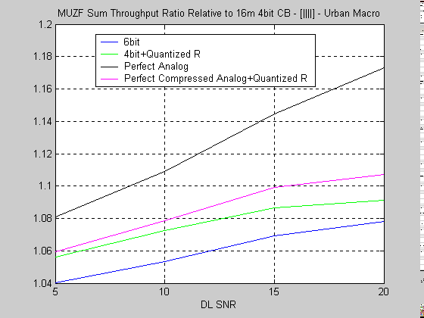

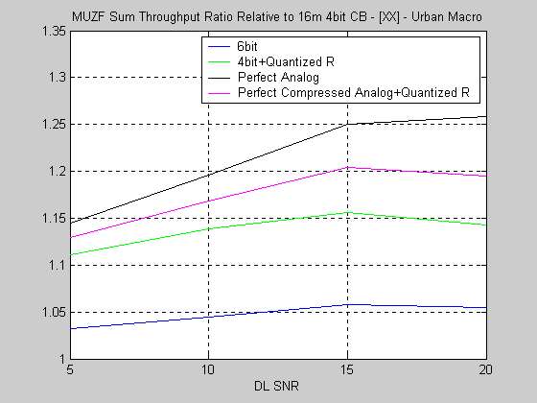

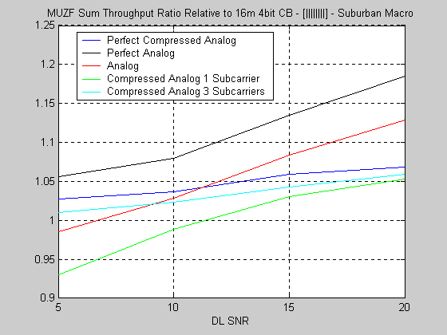

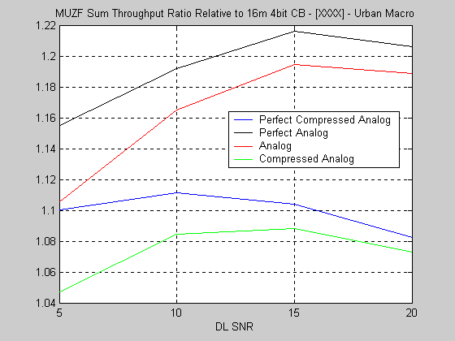

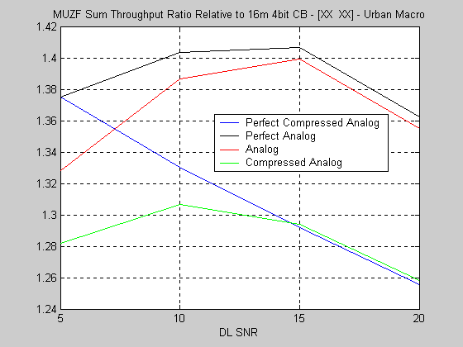

7. Summary

It is shown that compressed rank-1 analog feedback provides excellent tradeoff of feedback overhead and DL MU-MIMO performance and can be calculated at the MS with low complexity.

References

- C802.16m-08/529r1 – “Analog vs. Codebook Feedback Performance Comparison”
- C802.16m-08/522r1 – “Analog Feedback Complexity Clarification”
- C802.16m-08/526r1 – “Analog Feedback per Band - A proposal “
- C802.16m-08/914 - “Hybrid Analog/Digital Feedback for CL-MIMO”
- C802.16m-08/1264r1 – “Achievable MU-MIMO Sum Rates with Hybrid Codebook/Analog Feedback and Superposition Mapping”
- N. Jindal, “MIMO Broadcast Channels with Finite-Rate Feedback”, IEEE Trans. Info. Theory, vol. 52, NO. 11, Nov. 2006.
- Matrix Computations - Golub and Van Loan
- “Matrix Decomposition Architecture for MIMO Systems: Design and Implementation Trade-offs” - C. Studer, P. Blosch, P. Friedli, and A. Burg
- C802.16m-09/461r3 – “MIMO Support at Relay Stations”

Proposed text

Section 15.3.7.2.6.7.2 Analog Feedback

An MS feeds back the rank-1 unquantized narrowband or wideband strongest channel singular vector of the serving cell and interfering cells to support DL single and multi-BS precoding.

Three modes of operation exist:

- Full mode – For a BS with N antennas, N complex numbers are amplitude modulated onto N subcarriers

- Compressed mode – The MS feeds back one of the following four options:

  - One real number mapped using phase modulation as onto one subcarrier. The rank-1 feedback is defined as

  - One complex number mapped using amplitude modulation onto one subcarrier and two real numbers mapped using phase modulation, onto two subcarriers. The rank-1 feedback is defined as

  - Two complex numbers and mapped using amplitude modulation onto two subcarriers. The rank-1 feedback is defined as

  - Five complex numbers and, mapped using amplitude modulation onto five subcarriers. The rank-1 feedback is defined as

- Adaptive compressed mode – In this mode the rank-1 precoder is transformed by the long term correlation matrix as defined in section 15.3.7.2.6.6.3. The feedback is identical to mode 2 but the parameters are chosen to optimize performance with a transformed rank-1 precoder

Repetition coding is used for enhanced reliability by repeating the information in subcarriers belonging to different FMTs of a SFBCH.

