Project | IEEE 802.16 Broadband Wireless Access Working Group <http://ieee802.org/16>
Title | Improvement for Bit Grouping in IEEE 802.16m
Date Submitted | 2009-04-27
Source(s) | Jin Xu ,Sun Bo, Qianzi Xu, Zhifeng Yuan, Robert Xu  ZTE Corporation | xu.jin7@zte.com.cn  sun.bo1@zte.com.cn
Re: | Category: AWD comments / Area: Chapter 15.3.12 (Channel coding HARQ-PHY)  “Comments on AWD 15.3.12 Channel coding HARQ-PHY”
Abstract | The contribution proposes the text of Channel Coding and HARQ section to be included in the 802.16m amendment.
Purpose | To be discussed and adopted by TGm for the 802.16m amendment.
Notice | This document does not represent the agreed views of the IEEE 802.16 Working Group or any of its subgroups. It represents only the views of the participants listed in the “Source(s)” field above. It is offered as a basis for discussion. It is not binding on the contributor(s), who reserve(s) the right to add, amend or withdraw material contained herein.
Release | The contributor grants a free, irrevocable license to the IEEE to incorporate material contained in this contribution, and any modifications thereof, in the creation of an IEEE Standards publication; to copyright in the IEEE’s name any IEEE Standards publication even though it may include portions of this contribution; and at the IEEE’s sole discretion to permit others to reproduce in whole or in part the resulting IEEE Standards publication. The contributor also acknowledges and accepts that this contribution may be made public by IEEE 802.16.
Patent Policy | The contributor is familiar with the IEEE-SA Patent Policy and Procedures:

Improvement for Bit Grouping in IEEE 802.16m
Jin Xu, Bo Sun, Qianzi Xu, Zhifeng Yuan, Robert Xu
ZTE Corporation
- Back ground
In 802.16m SDD, the subpacket generation consists of bit separation, subblock interleaver, bit grouping and bit selection. After the CTC encoder with rate of 1/3, there are six blocks in bit separation process: systematic subblocks A and B, parity subblocks Y1, Y2, W1 and W2.
A good mapping rule always tries to map the same position bits of Y1 and W1 into different levels, as well as bits of Y2 and W2. Further more, this rule should prevent contiguous bits from being mapped into same level. Obviously, in 802.16e standard the bits of subblocks are always allocated into worse or better level.
Figure 1 the block diagram of 16e subpacket generation
- Existing algorithm
A bit grouping algorithm has been proposed by MediaTek in the offline discussion, which can be described as the below figure 2 shows. This proposal employs a 1 bit left Circle-shift operation for interleaved B Subblock and k bits left Circle-shift operation for interlaced W1/W2 Subblock. When the FEC block size Nep is equal to multiple of the modulation order, k is set as 1. Otherwise, let k be 0.

Figure 2 the block diagram of proposed bit grouping algorithm by MediaTek
Drawbacks:
This design has improved the bit mapping performance in 64 QAM. However, for 16-QAM It can not always map the contiguous bits into the different bit reliability level, especially when the code rate is larger than 1/2. Thus, performance degradation can be found in the first transmission.
- Proposed algorithm
In our proposed interleaving scheme, after bit grouping for circular buffer by using MediaTek’s method, a symbol level interleaving is appended. This symbol level interleaving contains an intra symbol circular shifting (ISC). The shift number is associated with symbol index.
Let m denotes the symbol index of the buffer for the k-th FEC block, and let n denotes the bit index within the symbol. The n-th element in the m-th symbol in the buffer for the k-th FEC block can be expressed as:
where, , N_{FB_Buffer,k} is the buffer size for the k-th FEC block, N_{mod} is the modulation order, 2 for QPSK, 4 for 16-QAM, 6 for 64-QAM. N_{FB,k} is the size of k-th FEC block.
Comparing to results of existing symbol permutation scheme, our solution makes the Y1 and Y2 distribution much more reasonable. The figure 3 shows the bit reliability distribution of Y1 and Y2 with proposal scheme and existing scheme.
The figure 4 and figure 5 show the first transmission simulation results of existing schemes and of proposal scheme based on AWGN channel. Where the blue line is MediaTek bit grouping method and the red line is MediaTek bit grouping plus our suggested intra symbol circular shifting (ISC).
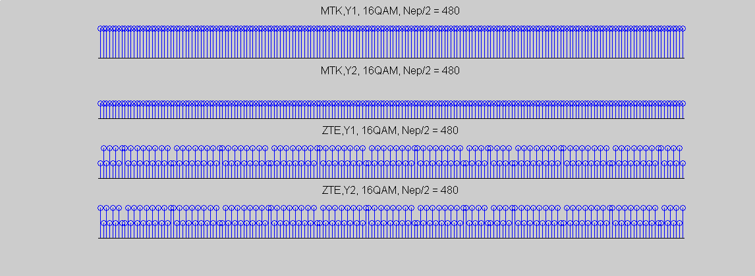
Figure 3 the Y1 block and Y2 block bit reliability distribution

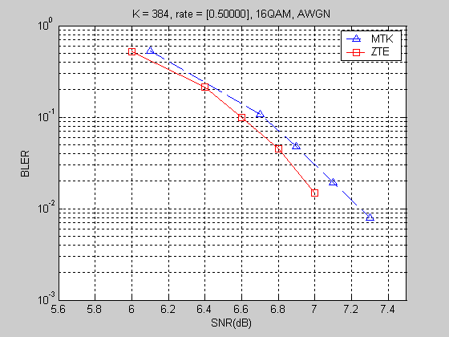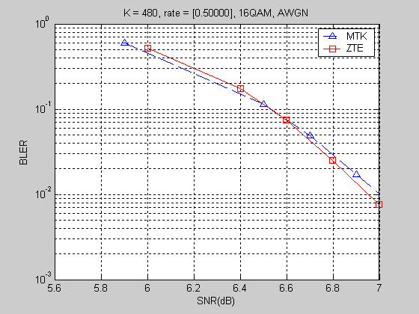

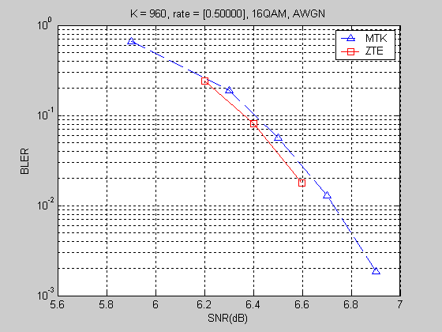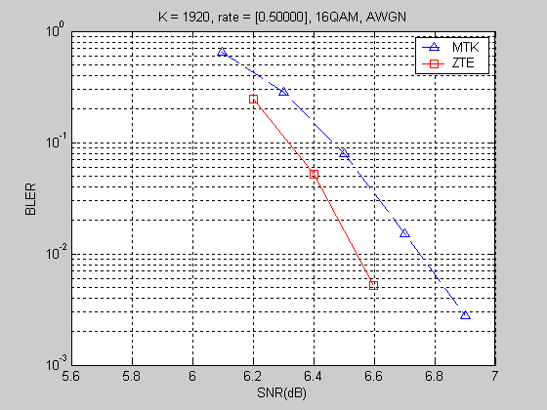

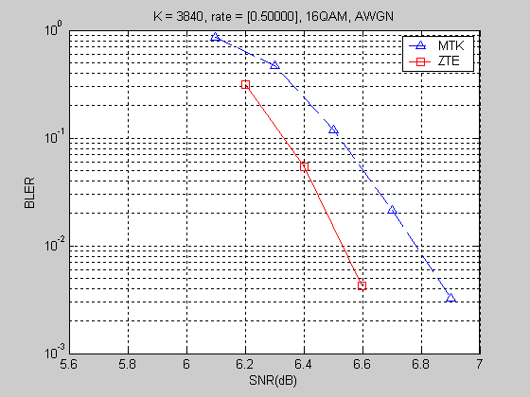
Figure 4 16QAM FER performances of the first transmission

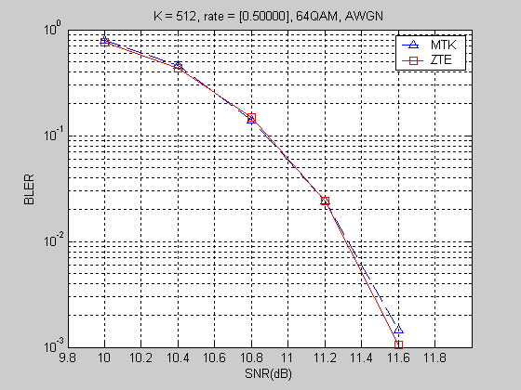
Figure 5 64QAM FER performances of the first and second transmissions
- Proposed amendment text on constellation
15.x.1.5.1.7 Bit grouping
Corresponding to section 8.4.9.2.3.4.3.
The interleaved subblocks shall be multiplexed into four blocks; those four blocks consist of an interleaved A subblock, an interleaved B subblock, a bit-by-bit multiplexed sequence of the interleaved Y1 and Y2 subblock sequences, which is referred to Y, and a bit-by-bit multiplexed sequence of the interleaved W1 and W2 subblock sequences, which is referred to W. Information subblocks, A and B, are by-passed while parity subblocks are multiplexed bit by bit. The bit-by-bit multiplexed sequence of interleaved Y1 and Y2 subblock sequences shall consist of the first output bit from the Y1 subblock interleaver, the first output bit from the Y2 subblock interleaver, the second output bit from the Y1 subblock interleaver, the second output bit from the Y2 subblock interleaver, etc. The bit-by-bit multiplexed sequence of interleaved W1 and W2 subblock sequences shall consist of the first output bit from the W1 subblock interleaver, the first output bit from the W2 subblock interleaver, the second output bit from the W1 subblock interleaver, the second output bit from the W2 subblock interleaver, etc.
After multiplexing subblocks into four blocks, Subblock B is circularly left-shifted by 1 bit. The multiplexed subblock W is circularly left-shifted by k bits. When the FEC block size Nep is equal to multiple of the modulation order, k is set as 1. Otherwise, let k be 0. Figure 15.1-1.x shows interleaving scheme as explained above.
Figure 15.1-1.x Block diagram of interleaving scheme
Let m denotes the symbol index of the buffer for the k-th FEC block, and let n denotes the bit index within the symbol. The n-th element in the m-th symbol in the buffer for the k-th FEC block can be expressed as:
where, , N_{FB_Buffer,k} is the buffer size for the k-th FEC block, N_{mod} is the modulation order, 2 for QPSK, 4 for 16-QAM, 6 for 64-QAM. N_{FB,k} is the size of k-th FEC block.

References

[1] C80216m-09_0665r1.doc

[2] C80216m-09_0010r1a.pdf

