Project | IEEE 802.16 Broadband Wireless Access Working Group <http://ieee802.org/16>
Title | Proposed Modification for Amendment Working Document on Frame Structures
Date Submitted | 2009-04-27
Source(s) | Tsung-Pao Chen, Yu-Tao Hsieh,  Pang-An Ting  ITRI | Voice:  E-mail: ythsieh@itri.org.tw
Re: | IEEE 802.16m-09/0010r1a, “IEEE 802.16m Amendment Working Document.”
Abstract | This contribution corrects the TDD and FDD frame structure for the 7 MHz channel bandwidth with a CP of 1/16 T_{b} in Section 15.3.3.3
Purpose | Discussion and adoption by TG m.
Notice | This document does not represent the agreed views of the IEEE 802.16 Working Group or any of its subgroups. It represents only the views of the participants listed in the “Source(s)” field above. It is offered as a basis for discussion. It is not binding on the contributor(s), who reserve(s) the right to add, amend or withdraw material contained herein.
Release | The contributor grants a free, irrevocable license to the IEEE to incorporate material contained in this contribution, and any modifications thereof, in the creation of an IEEE Standards publication; to copyright in the IEEE’s name any IEEE Standards publication even though it may include portions of this contribution; and at the IEEE’s sole discretion to permit others to reproduce in whole or in part the resulting IEEE Standards publication. The contributor also acknowledges and accepts that this contribution may be made public by IEEE 802.16.
Patent Policy | The contributor is familiar with the IEEE-SA Patent Policy and Procedures:  <http://standards.ieee.org/guides/bylaws/sect6-7.html#6> and <http://standards.ieee.org/guides/opman/sect6.html#6.3>.  Further information is located at <http://standards.ieee.org/board/pat/pat-material.html> and <http://standards.ieee.org/board/pat>.

Proposed Modification for Amendment Working Document on Frame Structures

Tsung-Pao Chen, Yu-Tao Hsieh, Pang-An Ting,
ITRI

Introduction
In this contribution, we would like to correct the TDD and FDD frame structure for the 7 MHz channel bandwidth with a CP of 1/16 T_{b} in Section 15.3.3.3 of the AWD [1].

The current text in AWD mentions that there are seven type-1 subframes for FDD, six type-1 subframes, and one type-3 subframe for TDD, for a frame with a channel bandwidth of 7 MHz and a CP of 1/16 T_{b}.

The two types of subframes are defined as:
- The type-1 subframe consists of six OFDMA symbols,
- The type-2 subframe consists of seven OFDMA symbols.

In this case, there will be 42 OFDMA symbols in total for FDD, and 41 OFDMA symbols in total for TDD. According to Table 647 of [1], the OFDMA symbol duration is 136 for the system with 7 MHz channel bandwidth and a CP of 1/16 T_{b}. Therefore, the frame durations for FDD and TDD are calculated as

for FDD,
for TDD.

Both of them exceed the defined frame duration of 5ms.

Based on Table 647 of [1], the total number of OFDMA symbols with 7 MHz channel bandwidth and a CP of 1/16 T_{b} should be 36 and 35 for FDD and TDD respectively. Hence, to fit the defined frame duration of 5ms, there should be six type-1 subframes for FDD, five type-1 subframes and one type-3 subframe for TDD, in one frame.
for FDD,
for TDD.

Text Proposal

We suggest to revise the paragraph (starting from line 37 of page 24) and Figure 401 as follows.
---------------------------------------------------------Start of the Text--------------------------------------------------------
For a channel bandwidth of 7 MHz, a frame shall have six type-1 subframes for FDD, and five type-1 subframes and one type-3 subframes for TDD. In the TDD frame, the subframe preceding a DL to UL switching point is a type-3 subframe.

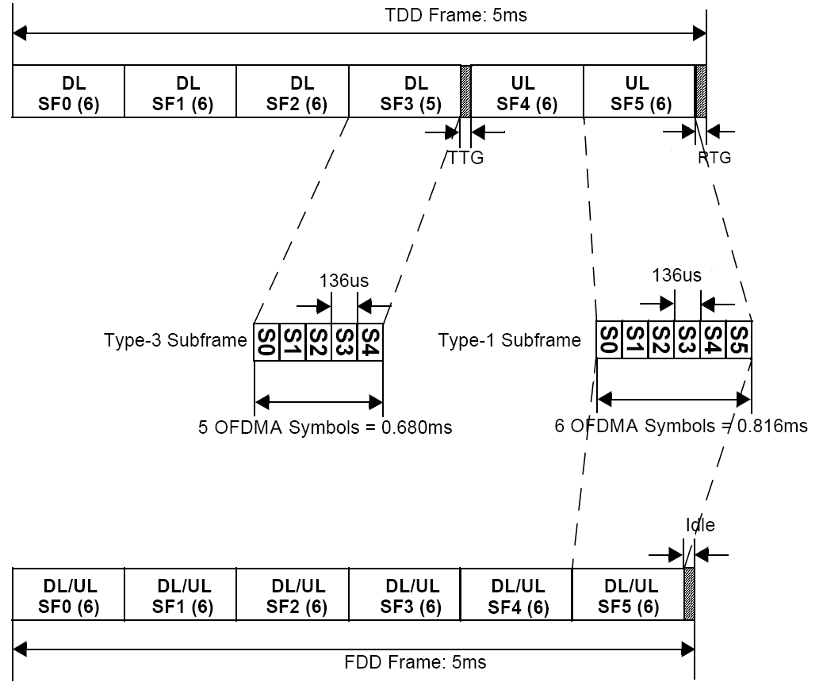

Figure 401－Frame structure for type-1 and type-3 subframe in TDD and FDD modes,
with a channel bandwidth of 7 MHz, a CP of 1/16 T_{b} , and DL to UL ratio of 4:2 in TDD

---------------------------------------------------------End of the Text---------------------------------------------------------

References

[1] IEEE 802.16m-09/0010r1a, “IEEE 802.16m Amendment Working Document.”

