Project | IEEE 802.16 Broadband Wireless Access Working Group <http://ieee802.org/16>
Title | Proposed Figures Modifications for Amendment Working Document on Frame Structures
Date Submitted | 2009-04-27
Source(s) | Tsung-Pao Chen, Yu-Tao Hsieh,  Pang-An Ting  ITRI | Voice:  E-mail: ythsieh@itri.org.tw
Re: | IEEE 802.16m-09/0010r1a, “IEEE 802.16m Amendment Working Document.”
Abstract | This contribution corrects some errors in figures 395, 396, 397, 398, 399, 400, and 402 in Section 15.3.3
Purpose | Discussion and adoption by TG m.
Notice | This document does not represent the agreed views of the IEEE 802.16 Working Group or any of its subgroups. It represents only the views of the participants listed in the “Source(s)” field above. It is offered as a basis for discussion. It is not binding on the contributor(s), who reserve(s) the right to add, amend or withdraw material contained herein.
Release | The contributor grants a free, irrevocable license to the IEEE to incorporate material contained in this contribution, and any modifications thereof, in the creation of an IEEE Standards publication; to copyright in the IEEE’s name any IEEE Standards publication even though it may include portions of this contribution; and at the IEEE’s sole discretion to permit others to reproduce in whole or in part the resulting IEEE Standards publication. The contributor also acknowledges and accepts that this contribution may be made public by IEEE 802.16.
Patent Policy | The contributor is familiar with the IEEE-SA Patent Policy and Procedures:  <http://standards.ieee.org/guides/bylaws/sect6-7.html#6> and <http://standards.ieee.org/guides/opman/sect6.html#6.3>.  Further information is located at <http://standards.ieee.org/board/pat/pat-material.html> and <http://standards.ieee.org/board/pat>.

Proposed Figures Modifications for Amendment Working Document on Frame Structures

Tsung-Pao Chen, Yu-Tao Hsieh, Pang-An Ting
ITRI

Introduction
In this contribution, we would like to correct some mistakes in Figures 395, 396, 397, 398, 399, 400, and 402 in Section 15.3.3 of the AWD [1].
The renewed figures and the associated captions are shown below.

Proposal 1

---------------------------------------------------------Start of the Text--------------------------------------------------------

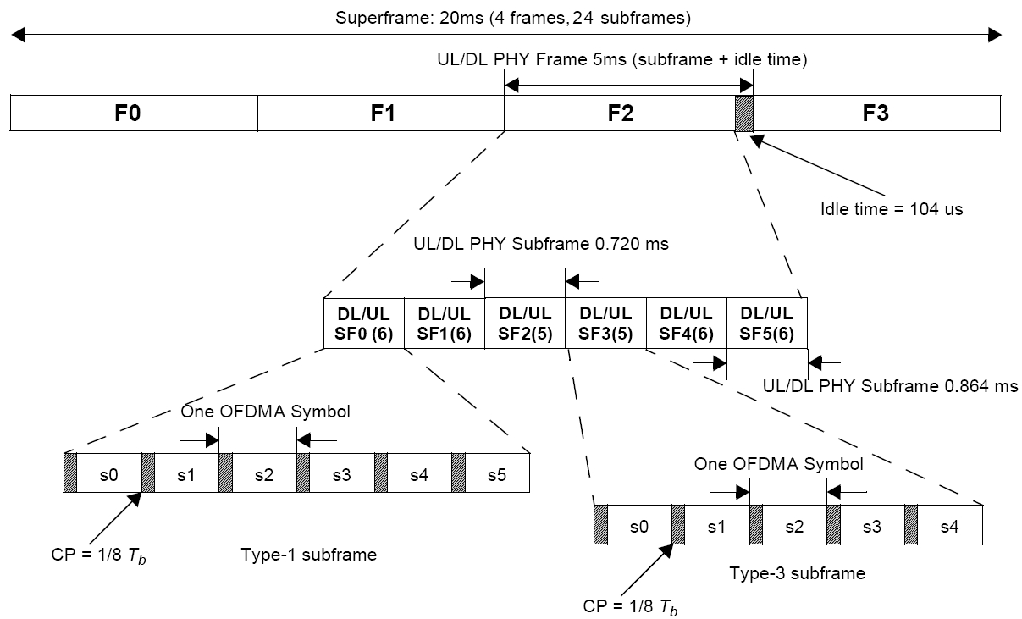

Figure 395－Frame structure for type-1 and type-3 subframe in FDD mode with a
channel bandwidth of 7 MHz and a CP of 1/8 T_{b}

---------------------------------------------------------End of the Text---------------------------------------------------------

Proposal 2
---------------------------------------------------------Start of the Text--------------------------------------------------------

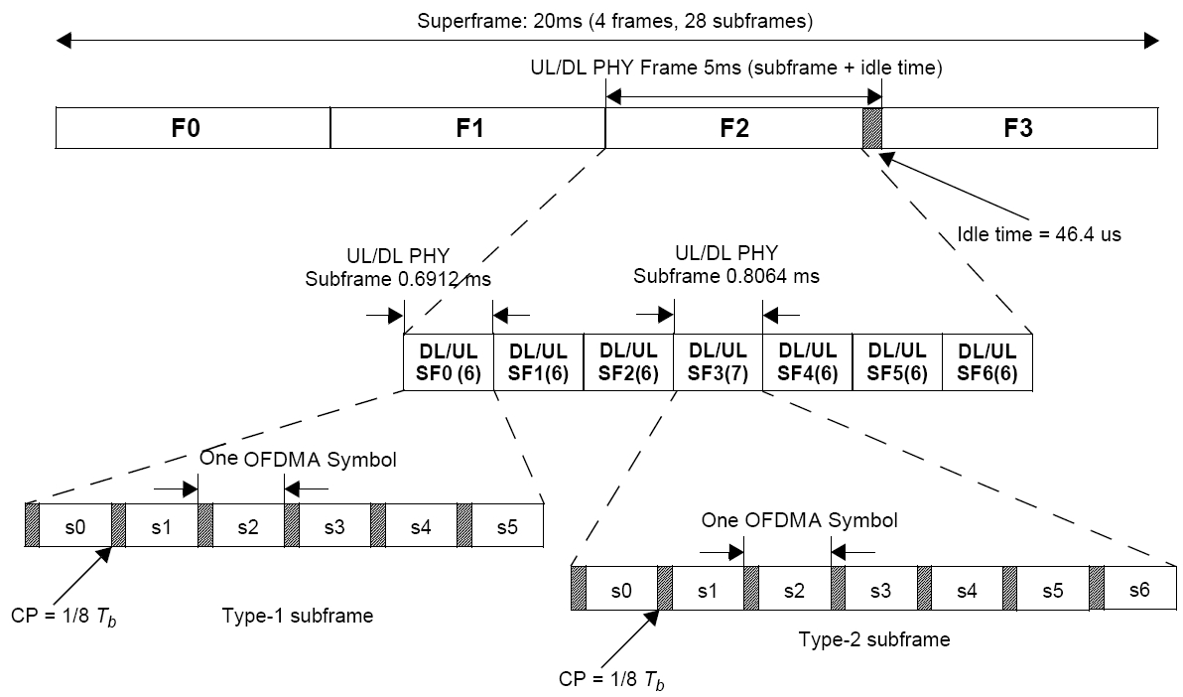
Figure 396－Frame structure for type-1 and type-2 subframe in FDD mode
with a channel bandwidth of 8.75 MHz and a CP of 1/8 T_{b}

---------------------------------------------------------End of the Text---------------------------------------------------------

Proposal 3
---------------------------------------------------------Start of the Text--------------------------------------------------------

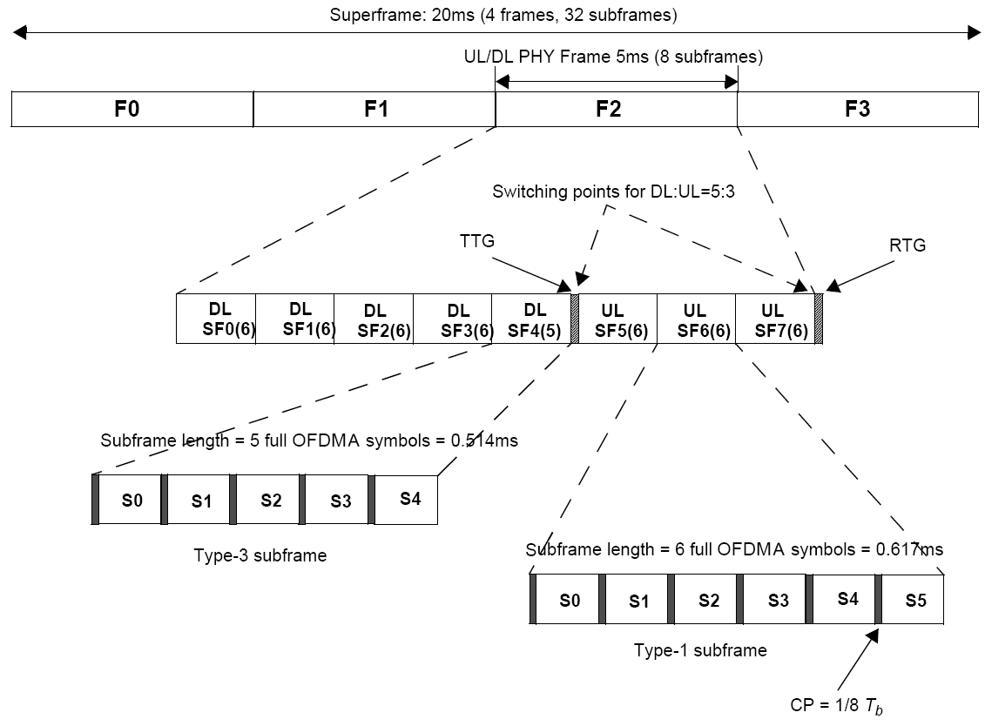

Figure 397－Frame structure for type-1 and type-3 subframe in TDD mode with 5,
10, and 20 MHz channel bandwidths, a CP of 1/8 T_{b} , and a DL to UL ratio of 5:3

---------------------------------------------------------End of the Text---------------------------------------------------------
Proposal 4
---------------------------------------------------------Start of the Text--------------------------------------------------------

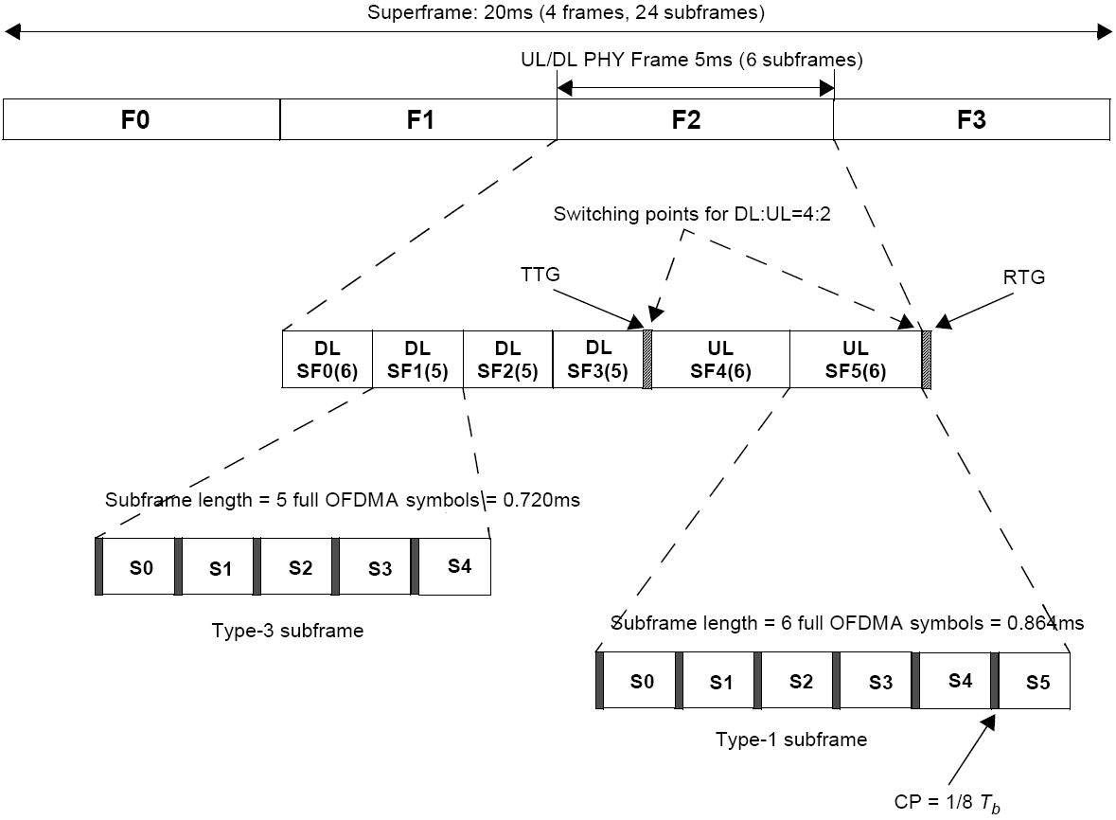
Figure 398－Frame structure for type-1 and type-3 subframe in TDD mode with
a channel bandwidth of 7 MHz, a CP of 1/8 T_{b} , and a DL to UL ratio of 4:2

---------------------------------------------------------End of the Text---------------------------------------------------------

Proposal 5
---------------------------------------------------------Start of the Text--------------------------------------------------------

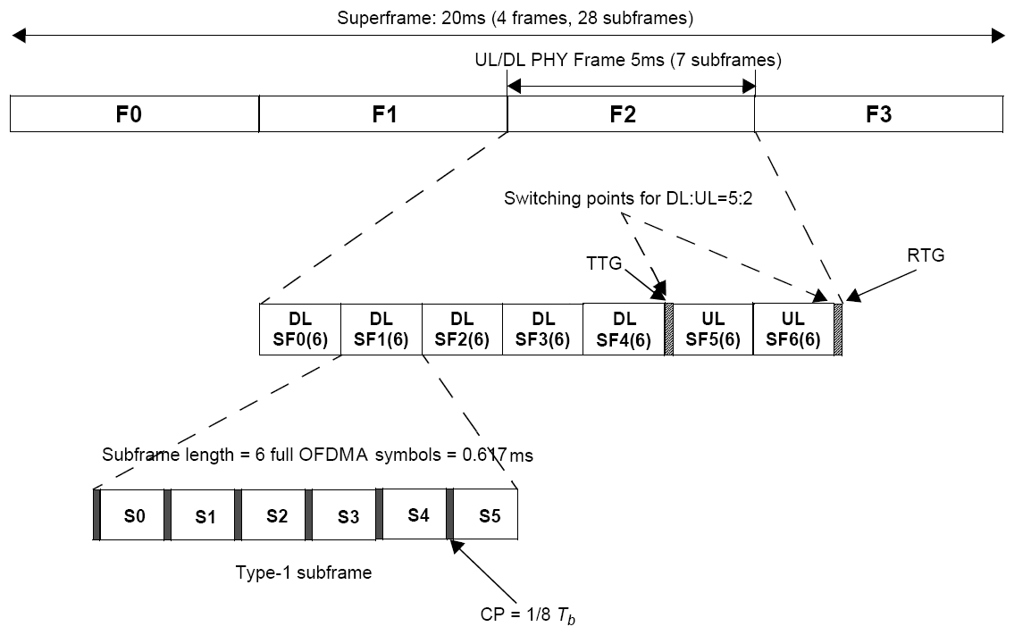
Figure 399－Frame structure for type-1 subframe in TDD mode
with a channel bandwidth of 8.75 MHz, a CP of 1/8 T_{b} , and a DL to UL ratio of 5:2

---------------------------------------------------------End of the Text---------------------------------------------------------
Proposal 6
---------------------------------------------------------Start of the Text--------------------------------------------------------

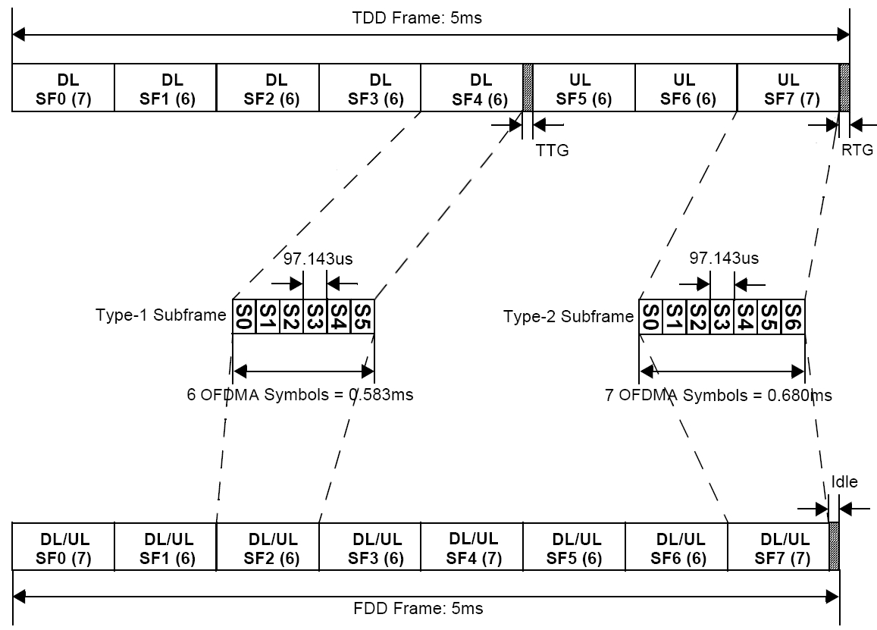
Figure 400－Frame structure for type-1 and type-2 subframe in TDD and FDD modes with 5,
10 and 20 MHz channel bandwidths, a CP of 1/16 T_{b} , and a DL to UL ratio of 5:3 in TDD

Proposal 7
---------------------------------------------------------Start of the Text--------------------------------------------------------

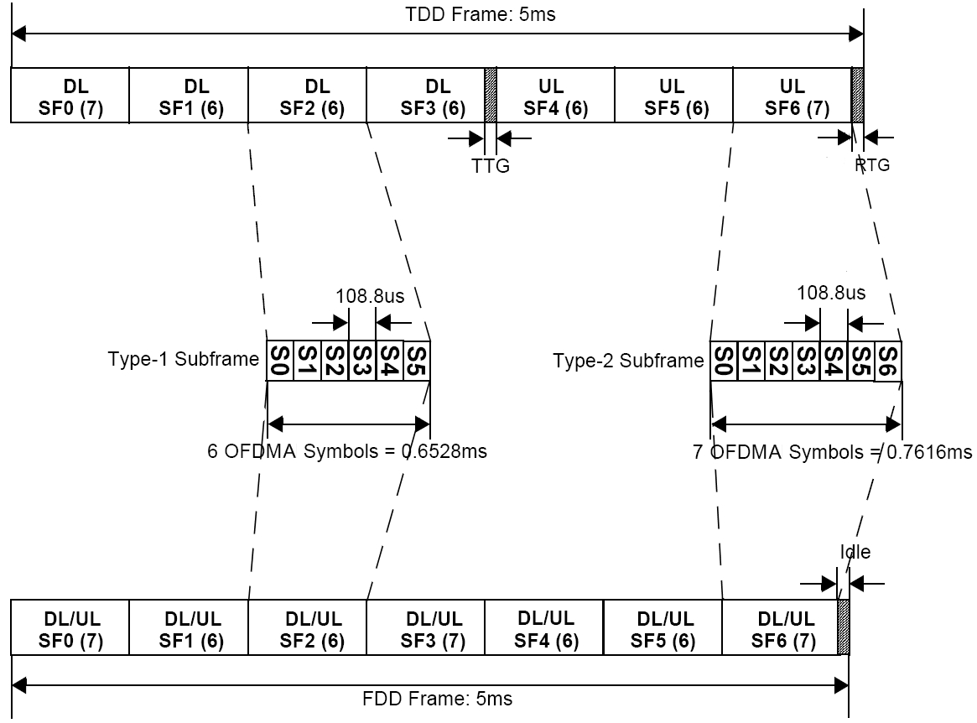
Figure 402－Frame structure for type-1 and type-2 subframe in TDD and FDD modes
with a channel bandwidth of 8.75 MHz, a CP of 1/16 T_{b} , and a DL to UL ratio of 4:3 in TDD

---------------------------------------------------------End of the Text---------------------------------------------------------

References

[1] IEEE 802.16m-09/0010r1a, “IEEE 802.16m Amendment Working Document.”

