Project | IEEE 802.16 Broadband Wireless Access Working Group <http://ieee802.org/16>
Title | Per-Stream MIMO Downlink Power Control
Date Submitted | 2009-04-27
Source(s) | Toshiyuki Kuze, Shigeru Uchida, Kentaro Sawa, Hiroki Iura  Mitsubishi Electric Corp  Philip Orlik, Zhifeng (Jeff) Tao, Ramesh Annavajjala, Jinyun Zhang  Mitsubishi Electric Research Lab | Voice: +81-467-41-2885  Fax: +81-467-41-2486  Kuze.Toshiyuki@ah.MitsubishiElectric.co.jp  Voice: 617-621-7557  Fax: 617-621-7550  tao@merl.com
Re: | “802.16m AWD”:  IEEE 802.16m-09/0020, “Call for Contributions on Project 802.16m Amendment Working Document (AWD) Content”.  Target topic: “Power Control/Link Adaptation”
Abstract | This contribution proposes a per-stream MIMO downlink power control to be included in the 802.16m amendment working document.
Purpose | To be discussed and adopted by TGm for 802.16m amendment working document.
Notice | This document does not represent the agreed views of the IEEE 802.16 Working Group or any of its subgroups. It represents only the views of the participants listed in the “Source(s)” field above. It is offered as a basis for discussion. It is not binding on the contributor(s), who reserve(s) the right to add, amend or withdraw material contained herein.
Release | The contributor grants a free, irrevocable license to the IEEE to incorporate material contained in this contribution, and any modifications thereof, in the creation of an IEEE Standards publication; to copyright in the IEEE’s name any IEEE Standards publication even though it may include portions of this contribution; and at the IEEE’s sole discretion to permit others to reproduce in whole or in part the resulting IEEE Standards publication. The contributor also acknowledges and accepts that this contribution may be made public by IEEE 802.16.
Patent Policy | The contributor is familiar with the IEEE-SA Patent Policy and Procedures:  <http://standards.ieee.org/guides/bylaws/sect6-7.html#6> and <http://standards.ieee.org/guides/opman/sect6.html#6.3>.  Further information is located at <http://standards.ieee.org/board/pat/pat-material.html> and <http://standards.ieee.org/board/pat>.

Per-Stream MIMO Downlink Power Control

Toshiyuki Kuze, Shigeru Uchida, Kentaro Sawa, Hiroki Iura
Mitsubishi Electric Corp

Philip Orlik, Zhifeng (Jeff) Tao, Ramesh Annavajjala, Jinyun Zhang
Mitsubishi Electric Research Lab

Introduction
This contribution proposes the text of MIMO downlink power control to be included in the IEEE 802.16m amendment [1]. The technical text is inherited from the IEEE 802.16m SRD [2], SDD [3], and IEEE P802.16 Rev2/D9 [4].

Problem Statement
Generally, the different streams generated by an ABS undergo random small scale fading due to multi-path, as well as large scale fading due to path loss and shadowing of the RF signals due to the environment. Q. Li, et al have shown in IEEE C802.16e-04/529r3 that the difference between the greatest and the smallest eigenvalues increases with the number of spatial streams, and this difference can become substantial for a 4x4 configuration.
The eigenvalue distributions of 4x1, 4x2, 4x3, and 4x4 are shown in Figure 1 [6].

The difference among channel eigenvalues would lead to a power imbalance at the receiver of the MS. This power imbalance causes degradation in the performance of the receiver since each data stream interferes with other streams and the Signal to Interference plus Noise Ratio (SINR) of each stream can vary widely. We observed that the power imbalance at the receiver leads to a reduction in the decoding accuracy at the output of a forward error-correction (FEC) decoder. This is shown in the plot below, where for a power imbalance of 3 dB between two streams, the loss relative to a perfectly balanced reception is about 1 dB.

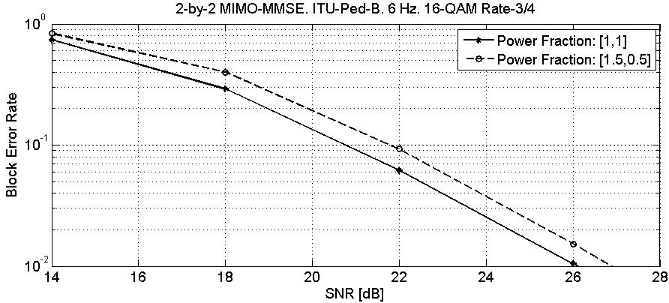
Figure 1: Example of FEC imbalance

Proposed Solution
This imbalance problem is best observed at the receiver side. Therefore, it is natural for receiver (AMS in DL transmission) to determine the power adjustment for each stream and report them to ABS.

Proposed Text
[-------------------------------------------------Start of Text Proposal---------------------------------------------------]
[Insert the subclause 15.3.x.1.1 as follows]

15.3.x.1.1 DL Power Control Feedback
ABS can request AMS to report the DL power control information by using the DL_Power_Control_REQ message. The format of the DL_Power_Control_REQ message is shown in Table x.

Table x: DL Power Control REQ message

Syntax | Size (bit) | Notes
DL_Power_Control_REQ message format () { | — | —
Management Message Type = xx | 8 | —
DL Power Control Mode | 2 | 0b00 : all streams  0b01 : each stream  0b10-0b11 : reserved
Reserved | 6 | shall be set to zero
Num_Logicalbands | 5 | “Number of Logical Bands” is this field value plus 1.
if(DL Power Control Mode == 0b01) {
Num_Streams | 3 | “Number of Streams” is this field value plus 1.
} else{
Reserved | 3 | shall be set to zero
}
for (i = 0; i < Number of Logical Bands; i++){
Logical Band Index | 8
}
Padding | variable
}

Logical Band Index: The Index number of Logical Band in which the ABS requests the AMS to report the DL power control information.

AMS reports the DL power adjust information of all streams or each stream by using the DL_Power_Control_RSP message. The format of DL_Power_Control_RSP message is shown in Table y.

Table 2: DL Power Control RSP message

Syntax | Size (bit) | Notes
DL_Power_Control_RSP message format () { | — | —
Management Message Type = xx | 8 | —
DL Power Control Mode | 2 | 0b00 : all stream  0b01 : each stream  0b10-0b11 : reserved
Reserved | 6 | shall be set to zero
Power measurement frame | 8 | 8 LSB of the frame number of power measurement frame.
Num_Logicalband | 5 | “Number of Logical Bands” is this field value plus 1.
Num_Stream | 3 | “Number of Streams” is this field value plus 1.
for (i = 0; i < Number of Logical Bands; i++){ | — | —
Logical Band Index | 8 | —
if(DL Power Control Mode == 0b00) {
Power adjust | 8 | —
} else {
for (j = 0; j < Number of Streams; j++){
Power adjust | 8
}
}
}
Padding | variable
}

Power measurement frame: The 8 LSBs of the frame number of power measurement frame.

Power Adjust: Signed integer, which expresses the change in power level (in multiples of 0.25 dB) that the BS may apply to its current transmission power. This field is set in stream index order.

[-------------------------------------------------End of Text Proposal----------------------------------------------------]

Reference
[1] IEEE P802.16 Rev2/D9, “Draft IEEE Standard for Local and Metropolitan Area Networks: Air Interface
for Broadband Wireless Access,” Jan. 2009.
[2] IEEE 802.16m-07/002r8, “802.16m System Requirements”
[3] IEEE 802.16m-08/003r8, “The Draft IEEE 802.16m System Description Document”
[4] IEEE 802.16m-08/043, “Style guide for writing the IEEE 802.16m amendment”
[5] IEEE 802.16m-09/0010r1a, “Part 16: Air Interface for Fixed and Mobile Broadband Wireless Access Systems – Advanced Air Interface (working document)”
[6] IEEE C802.16e-04/529r3, “Per-Stream Bit Loading for MIMO Precoding”

