Project | IEEE 802.16 Broadband Wireless Access Working Group <http://ieee802.org/16>
Title | MaxMt in MU-MIMO/SU-MIMO
Date Submitted | 2009-04-27
Source(s) | Wookbong Lee, Bin-Chul Ihm  LG Electronics | wbong@lge.com
Re: | Category: AWD comments / Area: Chapter 15.3.7 (DL-MIMO) “Comments on AWD 15.3.7 DL-MIMO”
Abstract | The contribution proposes adoption of MaxMt parameter
Purpose | To be discussed and adopted by TGm for the 802.16m amendment.
Notice | This document does not represent the agreed views of the IEEE 802.16 Working Group or any of its subgroups. It represents only the views of the participants listed in the “Source(s)” field above. It is offered as a basis for discussion. It is not binding on the contributor(s), who reserve(s) the right to add, amend or withdraw material contained herein.
Release | The contributor grants a free, irrevocable license to the IEEE to incorporate material contained in this contribution, and any modifications thereof, in the creation of an IEEE Standards publication; to copyright in the IEEE’s name any IEEE Standards publication even though it may include portions of this contribution; and at the IEEE’s sole discretion to permit others to reproduce in whole or in part the resulting IEEE Standards publication. The contributor also acknowledges and accepts that this contribution may be made public by IEEE 802.16.
Patent Policy | The contributor is familiar with the IEEE-SA Patent Policy and Procedures:  <http://standards.ieee.org/guides/bylaws/sect6-7.html#6> and <http://standards.ieee.org/guides/opman/sect6.html#6.3>.  Further information is located at <http://standards.ieee.org/board/pat/pat-material.html> and <http://standards.ieee.org/board/pat>.

MaxMt in MU-MIMO/SU-MIMO

Wookbong Lee, Bin-Chul Ihm
LG Electronics

- Introduction
- In the DL MIMO control parameter table, table 672 in [1], the parameters includes bit-filed. However, DL control section also has this. It will be very confusion if only one of the table is change while the other is not changed.
- In current AWD document [1], MaxMt (maximum number of streams) is TBD
- In MU-MIMO, MaxMt is required to reduce CQI mismatch
- In SU-MIMO, MaxMt may be required to
  - reduce number of MIMO feedback mode (MFM)
  - limit the feedback rank for scheduling users in DRU
  - limit the feedback rank for scheduling users in CRU with rank-1 precoding

- MaxMt for MU-MIMO
When BS operates in MU-MIMO mode, BS will allocate K number of MS to a resource depending on scheduler decision. This K will be varying depending on the MS feedback. But MS does not know how many MSs (K) will be multiplexed when it calculates CQI. Currently efficient CQI estimation method (orthogonal pairing assumption) has been adopted. But if BS indicates maximum number of multiplexed MS, we can reduce unnecessary CQI mismatch further.

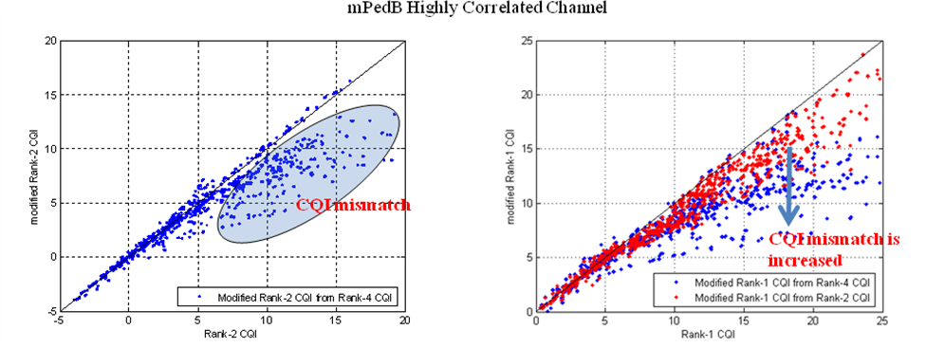
Note that rank-K CQI is generated assuming (K-1) orthogonal interferences.

- MaxMt for OL-SU-MIMO
There are two diversity permutation, one is DRU and the other is miniband CRU. In DRU, MIMO mode 1 (OL-SU-MIMO) is limited to M_{t}=2, while in miniband CRU, MIMO mode 1 is fully supported. MS has to know whether the feedback is for DRU or miniband CRU or the maximum number of streams for OL-SU-MIMO.
There are two solutions to handle this issue.
- Use different MIMO feedback mode
- Include MaxMt in Feedback_Allocation_IE

- References
[1] IEEE 802.16m-09/010r1a, “IEEE 802.16m Amendment Working Document (AWD)”

- Proposed Remedy

Remedy: Move table 672 under section 15.3.7.2.6.5, deleting value column and modify the table as follows;

------------------------------- Text Start ---------------------------------------------------
15.3.7.2.6.5. Downlink signaling support of DL-MIMO modes
Table 672 – DL MIMO control parameters
Parameter | Description | Control channel  (IE) | Notes
Broadcast Information
N_{t} | Number of transmit antennas at the BS | SFH (system information) | N_{t} must be known before decoding the DL A-MAP IE
OL_Region [TBD] | OL MIMO region, which signaling is used to indicate MS where is the predefined OL MIMO region and number of streams (1 or 2) | Broadcast information
SU_CT | SU base codebook type | Broadcast information | SU base codebook subset indication
MU_CT (TBD) | MU base codebook type | Broadcast Information | MU base codebook subset indication
BC_SI | Rank-1 base codebook subset indication | Broadcast information | Rate-1 codebook element restriction/recommendation information  It shall be ignored if CCE = 0b0
MaxMt (TBD) | Maximum number of streams | Broadcast information | If MFM indicates a MU feedback mode: the maximum number of users scheduled on each RU
Unicast Information
MEF | MIMO encoder format | A-MAP IE (unicast) | MIMO encoder format.  [MEF bitfield may not be explicitly indicated in DL A-MAP IE]
M_{t} | Number of streams in transmission | A-MAP IE (unicast) | Number of streams in the transmission.  When MEF=0b00: Mt =2  MEF=0b10, M_{t} <= 4  [Bit-field length is variable, depending on the number of Tx at BS]
RU allocation (TBD) | RU [and stream] indicator for the burst of data | A-MAP IE (unicast) | Refer to DL control group.
SI (TBD) | Index of pilot stream allocation | A-MAP IE (unicast) | SI shall be indicated if MEF = 0b010  [Bit-field length is variable, depending on the number of Tx at BS]  RU allocation and SI can be merged together depending on other DG’s decision
Feedback Allocation IE
MFM | MIMO feedback mode | Feedback allocation IE (unicast) | To decide the feedback content and related MS processing
DLRU (TBD) | Downlink RU, indicating  which RUs or which type of RU (DRU or miniband-based CRU) to work on for feedback | Feedback allocation IE (unicast) | To process CQI (PMI) estimation for the indicated RUs  Refer to other DG
FT | MIMO feedback type | Feedback allocation IE (unicast)
CM | Codebook feedback mode | Feedback allocation IE (unicast) | Enabled when FT = 0b00
CCE | Codebook Coordination Enable | Feedback allocation IE (unicast) | CCE = 0b0: MS finds PMI within whole broadcasted codebook type entry  CCE = 0b1: When MS finds rate-1 PMI, it finds within broadcasted codebook entries indicated by BC_ST, [SU_CT [and MU_CT]
MaxMt | Maximum number of streams | Feedback allocation IE (unicast) | If MFM indicates a MU feedback mode: the maximum number of users scheduled on each RU.  If MFM indicates a SU feedback mode: the maximum number of streams scheduled for the user.

------------------------------- Text End ---------------------------------------------------

