Project | IEEE 802.16 Broadband Wireless Access Working Group <http://ieee802.org/16>
Title | IEEE 802.16m Amendment Text Proposal for Sounding Allocation and Indication
Date Submitted | 2009-04-27
Source(s) | Wookbong Lee, Jinyoung Chun, Bin-Chul Ihm  LG Electronics. | wbong@lge.com
Re: | Category: AWD comments / Area: Chapter 15.3.6 (DL-CTRL)  “Comments on AWD 15.3.6 DL-CTRL”
Abstract | In this contribution, we propose to adopt sounding allocation and indication method.
Purpose | To be discussed and adopted by TGm for the 802.16m amendment
Notice | This document does not represent the agreed views of the IEEE 802.16 Working Group or any of its subgroups. It represents only the views of the participants listed in the “Source(s)” field above. It is offered as a basis for discussion. It is not binding on the contributor(s), who reserve(s) the right to add, amend or withdraw material contained herein.
Release | The contributor grants a free, irrevocable license to the IEEE to incorporate material contained in this contribution, and any modifications thereof, in the creation of an IEEE Standards publication; to copyright in the IEEE’s name any IEEE Standards publication even though it may include portions of this contribution; and at the IEEE’s sole discretion to permit others to reproduce in whole or in part the resulting IEEE Standards publication. The contributor also acknowledges and accepts that this contribution may be made public by IEEE 802.16.
Patent Policy | The contributor is familiar with the IEEE-SA Patent Policy and Procedures:  <http://standards.ieee.org/guides/bylaws/sect6-7.html#6> and <http://standards.ieee.org/guides/opman/sect6.html#6.3>.  Further information is located at <http://standards.ieee.org/board/pat/pat-material.html> and <http://standards.ieee.org/board/pat>.

IEEE 802.16m Amendment Text Proposal for Sounding Allocation and Indication

- Introduction

- Reference
[1] 80216m-09/0010r1, “IEEE 802.16m Amendment Working Document”

- Text proposal for inclusion in the 802.16m amendment

Remedy #1. Line 37-65, page 57. Modify S-SFH SP4 IE as follows;
------------------------------- Text Start ---------------------------------------------------

Syntax | Size | Notes
S-SFH SP4 IE () {
…
Uplink subframe bitmap Sounding Region | 8 | Uplink subframe index with sounding symbol
Sounding Multiplexing Type (SMT) [TBD] | 1 | 0b0: Frequency division multiplexing (FDM)  0b1: Code division multiplexing (CDM)
If (SMT == 0) {
Decimation value D | [2] or [3] | [TBD]
} else {
Max Cyclic Shift Index P | [2] or [3] | [TBD]
}
…
}
------------------------------- Text End ---------------------------------------------------

Remedy #2. Line 58, page 67. Create Sounding Allocation A-MAP IE section. And adopt proposed SOUNDING_ALLOC_IE;
------------------------------- Text Start ---------------------------------------------------

15.3.6.4.2.x Sounding Allocation A-MAP IE
Table 1 describes the fields in a Sounding Allocation A-MAP IE used for sounding resource assignment in the UL.
Table 1: Sounding Allocation A-MAP IE (SOUNDING_ALLOC_IE)
Syntax | Size in bits | Description/Notes
Sounding Alloc IE () {
A-MAP IE Type | 4 | Sounding Alloc IE
Sounding Region | 3 | Indicate which subframe to transmit sounding signals
Sounding Resource Unit (SRU) | 12 | This field is indicating sounding subband bitmap (SSB)  In 2048 FFT, 1bit represents 2 consecutive subbands
If (SMT == 0) {
Decimation offset (FS_CH) | [4] or [5] | Unique decimation offset
} else {
Cyclic time shift (FS_CH) | [4] or [5] | Unique cyclic shift
}
Multi-Antenna Index | 2 | If the number of transmit antennas, N_{t}, is one, then this field shall be ignored, and the MS transmits sounding signals via sounding channel indicated by FS_CH.  If the number of transmit antennas, N_{t}, is two, then this field indicates which transmit antennas to transmit sounding channel and G == 1.  If i-th bit of this field is ‘1’, then the MS transmits sounding signals of i-th transmit antennas.  If i-th bit of this field is ‘0’, then the MS does not transmit sounding singals of i-th transmit antennas.  If the number of transmit antennas, N_{t}, is four, then this fields indicates which transmit antenna groups to transmit sounding channel and G == 2.  If i-th bit of this field is ‘1’, then the MS transmits sounding signals of i-th group of transmit antennas which are G·i and G·i +1.  If i-th bit of this field is ‘0’, then the MS does not transmit sounding singals of i-th group of transmit antennas.
Antenna Switching | 1 | 0b0: No antenna switching  If M = addition of ‘1’s in Multi-Antenna Index, then the MS transmits sounding signals via sounding channels indicated by FS_CH to FS_CH+G·M.  0b1: Antenna switching  When the number of AMS’ antennas is T and the number of AMS RF Tx chain is R, AMS should transmit the sounding signal with antenna switching during the consecutive ⎡T/R⎤ frames starting from every periodic frame corresponding to periodicity and sounding relevance. At the i^{th} (i = 0,1, … , ⎡T/R⎤−1) frame out of the consecutive ⎡T/R⎤ frames, the index of antenna of MS for sounding transmission is chosen as: from ‘(i☓R)’ to ‘((i☓R) + R−1)’. For periodic sounding allocation, BS should set the periodicity larger than or equal to ⎡T/R⎤.  MS transmits sounding signals via sounding channels indicated by FS_CH to FS_CH+R.
Periodicity (n) | 3 | 0b000 = Single command, not periodic, or terminate the periodicy. Otherwise, repeat sounding once per 2^{(n-1)} frames, where n is decimal value of the periodicity field
Padding | [TBD] | Padding to reach byte boundary
MCRC | [16] | 16 bit CRC masked by Station ID
}
------------------------------- Text End ---------------------------------------------------

Remedy #3. Line 25-33, page 111. Modify texts as follows;
------------------------------- Text Start ---------------------------------------------------

15.3.9.1.3.1 Sounding PHY structure
The sounding signal occupies a single OFDMA symbol in the UL sub-frame. The sounding symbol in the UL sub-frame is located in the first symbol. Each UL sub-frame can contain only one sounding symbol. For type-1 subframe, the sounding signal shall not be transmitted in the LRU which contains other control channels. For type-2 subframe, sounding signals can be transmitted in any resource unit. For the six-symbol PRU case, the remaining 5 consecutive symbols are formed to be a five-symbol PRU used for data transmission, as shown in Figure x(a). For the seven-symbol PRU case, the remaining 6 consecutive symbols are formed to be a six-symbol PRU for data transmission, as shown in Figure x(b). Multiple UL subframes in a 5-ms radio frame can be used for sounding. The number of subcarriers for the sounding in a PRU is 18 adjacent subcarriers.
The UL subframes containing the sounding symbol shall be configured by Uplink subframe bitmap, which is transmitted in S-SFH Sub-packet 4.
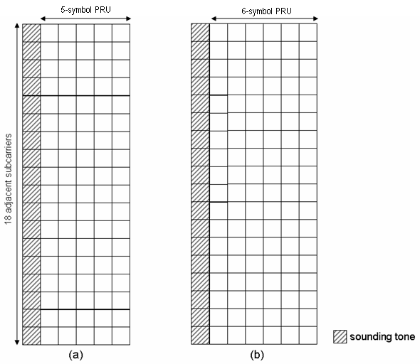
Figure x. Sounding PHY structures for (a) 6-symbol PRU and (b) 7-symbol PRU cases.

------------------------------- Text End ---------------------------------------------------

