Project | IEEE 802.16 Broadband Wireless Access Working Group <http://ieee802.org/16>
Title | Multi-Carrier Configurations supported by IEEE 802.16m
Date Submitted | 2009-04-27
Source(s) | I-Kang Fu, Pei-Kai Liao, Paul Cheng  MediaTek Inc. | IK.Fu@mediatek.com
Re: | IEEE 802.16m-09/0020, “Call for Contributions on Project 802.16m Amendment Working Document (AWD) Content” – AWD New Contribution for Multi-Carrier
Abstract | This contribution discusses the frequency bands supported by current IEEE 802.16e based WiMAX R1.0 system and investigates the possible multi-carrier configurations need to be supported by IEEE 802.16m based WiMAX R2.0 system.
Purpose | For member’s review and adoption into P802.16m Amendment Working Document
Notice | This document does not represent the agreed views of the IEEE 802.16 Working Group or any of its subgroups. It represents only the views of the participants listed in the “Source(s)” field above. It is offered as a basis for discussion. It is not binding on the contributor(s), who reserve(s) the right to add, amend or withdraw material contained herein.
Release | The contributor grants a free, irrevocable license to the IEEE to incorporate material contained in this contribution, and any modifications thereof, in the creation of an IEEE Standards publication; to copyright in the IEEE’s name any IEEE Standards publication even though it may include portions of this contribution; and at the IEEE’s sole discretion to permit others to reproduce in whole or in part the resulting IEEE Standards publication. The contributor also acknowledges and accepts that this contribution may be made public by IEEE 802.16.
Patent Policy | The contributor is familiar with the IEEE-SA Patent Policy and Procedures:  <http://standards.ieee.org/guides/bylaws/sect6-7.html#6> and <http://standards.ieee.org/guides/opman/sect6.html#6.3>.  Further information is located at <http://standards.ieee.org/board/pat/pat-material.html> and <http://standards.ieee.org/board/pat>.
Multi-Carrier Configurations supported by IEEE 802.16m

I-Kang Fu, Pei-Kai Liao, Paul Cheng
MediaTek Inc.

- Motivation

In order to provide continuous backward support on IEEE 802.16e based WiMAX Release 1.0 system, IEEE 802.16m based WiMAX Release 2.0 system is expected to be possibly deployed at existing frequency bands supported by current WiMAX system. In addition, IEEE 802.16m based WiMAX Release 2.0 system will also be deployed in the possible new spectrum identified for IMT-Advanced systems. The possible frequency band configurations possibly be supported by IEEE 802.16m will be complicated. This contribution tries to investigate the possible frequency bands to be supported and identify the possible configurations need to be supported by multi-carrier operation in IEEE 802.16m.

- Introduction

In current WiMAX ecosystem, most of the WiMAX network is deployed at 2.3GHz, 2.5GHz and 3.5GHz frequency bands (i.e. called legacy bands in the following). In the future, 700MHz, 1.8GHz and 2GHz frequency bands may also possibly be considered for IEEE 802.16m based WiMAX deployment (i.e. called new bands in the following). Therefore, the following scenarios are identified that may be considered by the future operators who plan to deploy IEEE 802.16m based WiMAX system:
    - Operator upgrade their network at legacy bands
    - Operator upgrade their network at legacy bands and also deploy 16m network at new bands
    - Operator deploy 16m network at new bands
Figure 1 is an example on the possible roadmap for system operator to upgrade their WiMAX network, which is based on example in WiMAX Forum SPWG Requirements on WiMAX Air Interface System Profile Release 2.0 [1]. Currently there are three deployment examples under consideration: Mixed Deployment – Carrier Reuse, Mixed Deployment – Carrier Overlay and Greenfield Deployment. According to the situation of each system operator, different stages of network upgrade will be considered at different time.
For example, the operators who already own the spectrum for IEEE 802.16e based WiMAX R1.0 system deployment may chose to upgrade his network by Stage #1 → #2 → #3 or #2 → #3. For the system operator who owns the spectrum for IEEE 802.16e based WiMAX R1.0 system and IEEE 802.16m based WiMAX R2.0 system at different frequency bands (e.g. one at 3.5GHz band and one at IMT-Adv. band) may choose Stage #2 → #3 since the carriers for 16e zone and 16m zone are not contiguous. For the system operator who directly bid the 4G license and then deploy IEEE 802.16m based WiMAX R2.0 system, directly jump to Stage#3.

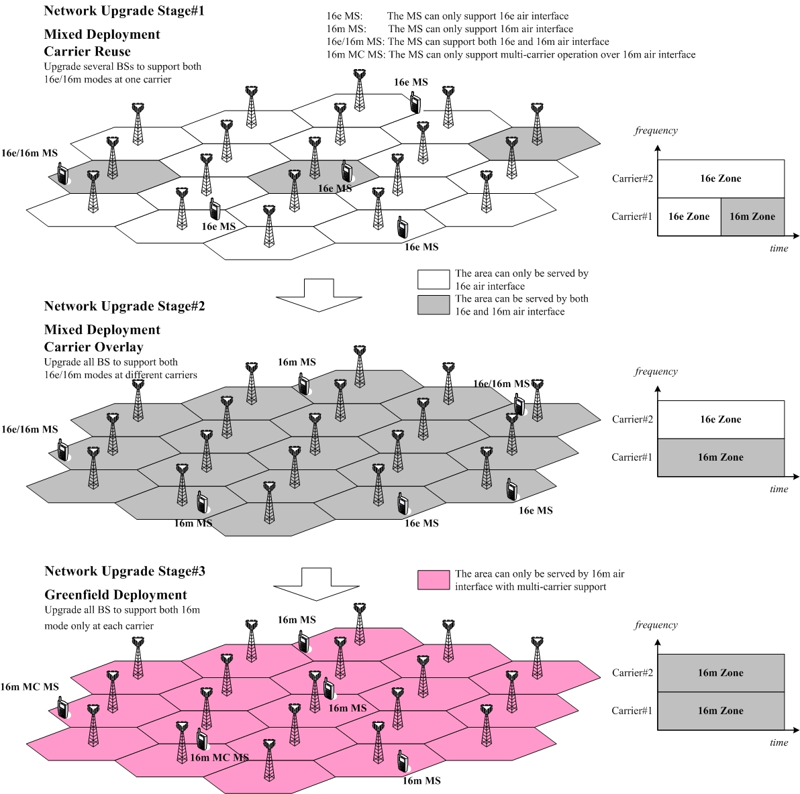
Figure 1 Example on WiMAX Network Evolution (assume 2 available carriers)

People can anticipate that the deployment scenarios need to be considered by IEEE 802.16m is complicated. It will be difficult to use simple equation to identify all the possible scenarios. In order to keep flexibility for future uncertainty, it is recommended to develop a look up table in standard. Members can keep updating the lookup table when the system operator found new deployment scenarios need to be considered by standard. This allows the MAC management message simply send the index according to this lookup table to represent the pre-defined multi-carrier configurations and the associated PHY parameters. The MAC overhead can be substantially reduced compare with explicitly broadcast detailed parameters over the air.
From a system operator perspective, the most complicated scenario is that it owns different frequency bands to deploy this system, where each frequency band includes several carriers are available. Figure 2 shows the most complicated carrier distribution by an operator:

Figure 2 Example on the complicated multi-carrier configuration face by system operator

It is really hard to find a unified equation which can easily describe all various carrier distribution faced by system operator. In response to such special situation of WiMAX system, it is recommended to indicate the multi-carrier configuration in per band class basis. Within each band class, the lookup table can be used to identify the detail carrier configurations and the corresponding PHY parameters.
The lookup table should be good is because the number of carrier and the combination of carrier configurations is limited with each band class. On the other hand, lookup table keeps the flexibility for future extension on unpredictable deployment condition happen to the 16m systems. Detail message format design please refers to the text proposal.

- Proposed Text Input to P802.16m System Description Document

---------------------------------------------------------Start of the Text-----------------------------------------------------------
[Adopt the following text modification into IEEE 802.16m-09/0010r1a]

15.2.4 MAC Management Messages
15.2.4.x MOB_MC-ADV (Multi-Carrier Advertisement) message
BS’s supporting multi-carrier functionality shall be capable of transmitting an MOB_MC-ADV management message at a periodic interval (MOB_MC-ADV interval) to identify the multi-carrier configuration and define the physical layer parameters associated with the available carriers of the serving and neighboring ABSs to the potential AMS seeking initial network entry or HO.
Table xxx MOB_MC-ADV message format
Syntax | Size (bit) | Notes
MOB_MC-ADV_Message_format() { | - | -
Management Message Type = xx | 8 | -
N_NEIGHBORS | 8 | -
For (i=0; i< N_NEIGHBORS; i++) { | - | i=0 refers to serving ABS
Multi-Carrier Capability | 4 | 00: Support Single Carrier Only  01: Support Multi-Carrier Aggregation  10: Support Multi-Carrier Switching  11: Reserved
Support Guard Sub-Carrier Data Transmission | TBD | TBD
Reference Carrier Index | TBD | The carrier where AMS received this message, which refers to the following configuration with j=0.
N_BANDCLASSES | 3 | -
For (j=0; j< N_BANDCLASSES; j++) {
Band Class Index | 3 | Index refers to Table xxx
Lowest FA Index | TBD | The FA index associated with the carrier with the lowest center frequency in this band class
Multi-Carrier Configuration Indx | TBD | Index refers to Table 648, which is sorted from the carrier associated with the lowest FA index.
}
}

[Adopt the following text modification start from line#32, page#30 of IEEE 802.16m-09/0010r1a]
15.3.3.5.2 Subcarrier alignment for multi-carrier operation
When contiguous carriers are involved in multi-carrier operation, the overlapped guard sub-carriers shall be aligned in frequency domain. The 250 KHz raster shall be maintained for both legacy system and IEEE 802.16m system. In order to align the overlapped sub-carriers of the OFDMA signals transmitted over adjacent carriers, a permanent frequency offset (Δf’) will be applied over the original center frequency. The basic principle is shown by the example in Figure 407.

[Adopt the following text modification start from line#38, page#31 of IEEE 802.16m-09/0010r1a]

Based on the center frequency of the carrier that AMS is currently receiving this information and the bandwidth of each carrier, the center frequency of each carrier before sub-carrier alignment can be derived. Then the AMS can obtain the frequency offset (∆f’) to be applied over each carrier based on the multi-carrier configuration index, the reference carrier index and Table xxx. So that AMS can obtain the correct center frequency of each carrier including the sub-carrier alignment effect.
The multi-carrier configuration of each band class is indicated to the AMS by the lookup table as shown in Table 648, where the configuration is vector to represent the bandwidths of each carrier sorted from the carrier with lowest FA index. The center frequency of the first carrier in each configuration shall be located on the frequency defined by 250kHz channel raster. The center frequencies of the rest carriers will be shifted from the channel raster by a fraction of sub-carrier spacing because of sub-carrier alignment. The frequency offset value (∆f’) to be applied over each carrier is shown in Table 648.
The index in Table 648 will be sent out by ABS through the MOB_MC-ADV message, where the Reference Carrier Index refers to Table 648 to indicate from which carrier the AMS received this message. For example, the multi-carrier configuration [5, 10, 5] with Reference Carrier Index = 2 means the AMS received this MOB_MC-ADV message from the 2nd carrier which has 10MHz bandwidth.

Table 648 – Center Frequency of Adjacent Carriers with Sub-Carrier Alignment Effect

# | Multi-Carrier Configuration (MHz) | Reference Carrier Index | Frequency Offset ∆f’ (kHz) | Contiguous Channel Bandwidth (MHz)
1

# | Multi-Carrier Configuration (MHz) | Frequency Offset ∆f’ (kHz)
1 | [5] | [0]
2 | [10] | [0]
3 | [20] | [0]
4 | [5, 5] | [0, -1.5629]
5 | [10, 10] | [0, -3.1248]
6 | [5, 10, 5] | [0, -7.8127, -9.3745]
7 | [10, 5] | [0, -7.8127]
8 | [20, 10] | [0, -4.6875]
9 | [10, 10, 10] | [0, -3.1248, -6.25]
10
11
12
13
14
15
16

----------------------------------------------------------End of the Text-----------------------------------------------------------

Note that the detail calculation to obtain those frequency offset values can refer to C802.16m-09/0561r3. The table 648 is designed for contiguous carrier case. For the non-contiguous carrier but within the same band class, it can be identified by changing the band class usage for identifying the isolated carriers with index #1, #2 or #3. But whether this is reasonable or not for each band class still needs member’s further discussion.

Reference
[1] WiMAX Forum Service Provider Working Group (SPWG), “Requirements for WiMAX Air Interface System Profile 2.0, v0.2,” Mar. 2009.

Appendix

By utilizing the above message design, the multi-carrier configuration as depicted in Figure 2 can be easily identified by the setting as shown in Figure 3.

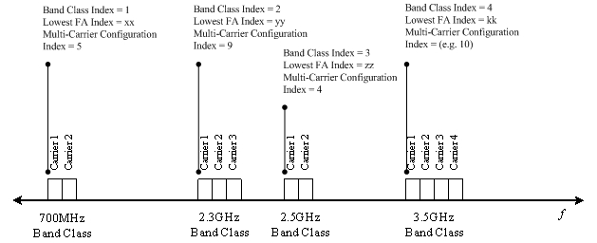
Figure 3 Example on message setting to identify the multi-carrier configuration depicted in Figure 2

