Project | IEEE 802.16 Broadband Wireless Access Working Group <http://ieee802.org/16>
Title | Collaborative Zone to Support Multi-Cell MIMO Operation in IEEE 802.16m
Date Submitted | 2009-04-27
Source(s) | Chu-Jung Yeh, Li-Chun Wang, I-Kang Fu, Paul Cheng  NCTU/MediaTek | teensky.cm93g@nctu.edu.tw  lichun@mail.nctu.edu.tw  IK.Fu@mediatek.com
Re: | IEEE 802.16m-09/0020, “Call for Contributions on Project 802.16m Amendment Working Document (AWD) Content” – AWD New Contribution for Interference Mitigation
AABStract | Multi-Cell MIMO transmission requires close coordination among neighboring cells. In order to simplify the coordination procedure, a pre-negotiated zone will be necessary to coordinate the collaborative MIMO transmission by multiple ABSs. This contribution introduces some background of Multi-Cell MIMO and its performance improvements. A collaborative MIMO zone is suggested for IEEE 802.16m standard to simplify the multi-cell coordination.
Purpose | For member’s review and adoption into P802.16m Amendment Working Document
Notice | This document does not represent the agreed views of the IEEE 802.16 Working Group or any of its subgroups. It represents only the views of the participants listed in the “Source(s)” field above. It is offered as a basis for discussion. It is not binding on the contributor(s), who reserve(s) the right to add, amend or withdraw material contained herein.
Release | The contributor grants a free, irrevocable license to the IEEE to incorporate material contained in this contribution, and any modifications thereof, in the creation of an IEEE Standards publication; to copyright in the IEEE’s name any IEEE Standards publication even though it may include portions of this contribution; and at the IEEE’s sole discretion to permit others to reproduce in whole or in part the resulting IEEE Standards publication. The contributor also acknowledges and accepts that this contribution may be made public by IEEE 802.16.
Patent Policy | The contributor is familiar with the IEEE-SA Patent Policy and Procedures:  <http://standards.ieee.org/guides/bylaws/sect6-7.html#6> and <http://standards.ieee.org/guides/opman/sect6.html#6.3>.  Further information is located at <http://standards.ieee.org/board/pat/pat-material.html> and <http://standards.ieee.org/board/pat>.
Collaborative Zone to Support Multi-Cell MIMO Operation in IEEE 802.16m
Chu-Jung Yeh, Li-Chun Wang, I-Kang Fu, Paul Cheng
National Chiao Tung University (NCTU)/MediaTek

- Motivation
Recently, the network multiple-input multiple-output (MIMO) technique becomes more and more attractive, which aiAMS to mitigate the inter-cell interference by coordinating the multi-cell transmission among a few geographically separated antennas (base stations, ABS). Although both the concept of FFR and inter-base station coordination already are considered for one of possible inter-cell interference cancellation technique in WiMAX, to our knowledge, combining network MIMO with FFR to mitigate inter-cell interference is still an open issue. Therefore, our objective is to propose a FFR-based network MIMO interference cancellation scheme for a multi-cell OFDMA system. A fundamental issue for network MIMO arises: how many cells should be coordinated to provide sufficient signal-to-interference plus noise ratio (SINR) performance. Intuitively, it is impractical to cooperate too many cells. The huge computational complexity and synchronization among a huge number of cells are quite challenging. In addition, a cluster of coordinated cells will still cause interference to neighboring coordinated cluster of cells with each other. We try to explore the potential gain of network MIMO by using a near minimum number of coordinated cells, i.e. only three cells.
Additionally, multi-cell system support self-organization is another way to improve system performance. Self-organizing network (SON) functions are intended for ABSs to automate the configuration of ABS parameters and to optimize network performance.
Figure 1 shows our considered self-organizing multi-cell network architecture. Some cells form a coordinative group to cooperate via SON server. The whole multi-cell network perforAMS inter-ABS communication through inter-ABS server and consists of those groups. Usually, the reported SON measurement from ABS/AMS may include
  - Signal quality of serving ABS and neighbor ABSs
  - Interference level from the neighbor ABSs
  - Cell information of neighbor ABSs
  - Load information of neighbor ABS
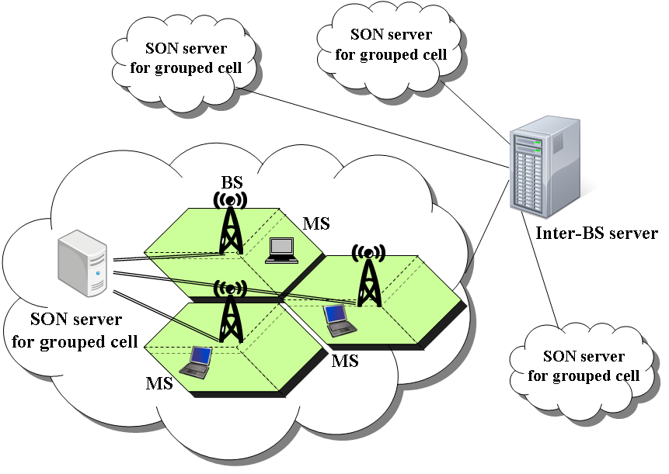
Fig. 1 An example of self-organizing multi-cell network architecture

- Problem Formulation

We propose a novel multi-cell architecture combined FFR with network MIMO for broadband OFMDA systeAMS. The whole frequency band are partitioned into different zones by FFR frequency planning. Usually, designing a larger cluster of cells to share the whole spectrum can mitigate the co-channel interference at the cost of lower frequency usage. Compared to conventional 19-cell layout, the tri-sector cellular system combined with FFR (shown in Fig. 2) can significantly reduce the interference sources, while fully utilizing the frequency band at each cell. As an example in Fig. 3, when a mobile user of cell 0 uses frequency band $f_{B_{1,n}}$, the interference comes from cells 4, 5, 12, 13, 14, 15, and 16. In the conventional systeAMS, the mobile is interfered by all the other 18 cells. Here, the question is how we can further improve the SINR on top of FFR? The solution proposed in this contribution is to integrate FFR with the network MIMO technique. Additionally, a fundamental issue for network MIMO arises: how many cells should be coordinated to provide sufficient signal to interference plus noise ratio (SINR) performance. Intuitively, it is impractical to cooperate too many cells. The huge computational complexity and synchronization among a huge number of cells are quite challenging. As a result, a cluster of coordinated cells will still cause interference to neighboring coordinated cluster of cells with each other. We call this issue as boundary problem.

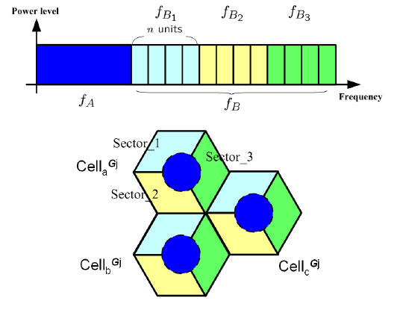
Fig. 2 Frequency partition for a tri-sector cell layout.

- Proposed Resolution

- 3-Cell FFR-based Network MIMO Architecture
From Fig. 3, we find that the seven interfering sources consists of two critical interferers comes form neighboring cells 4 and 5 and five weaker interferences due to larger path loss. Because the neighboring two cells may most likely cause most severe interference, we use the network MIMO technique to improve signal quality by interference canceling. As a result, we consider a coordination scheme with only three coordinated cells (inter-ABS coordination with neighboring cells) instead of huge number of coordinated cells. We define those coordinated cells as a group shown in Fig. 2. For arbitrary group $G_{j}$, we label the three cells as ${\text{Cell}}_{a}^{G_{j}}$, ${\text{Cell}}_{b}^{G_{j}}$, and ${\text{Cell}}_{c}^{G_{j}}$, respectively. For the 3-cell coordination structure, we can apply network MIMO transmission to each subband $f_{B_{i,n}}$for $i=1,2,3$ and $n=1,…,N$. Take Fig. 2 as an example, the channel matrix of $f_{B_{1,n}}$ is
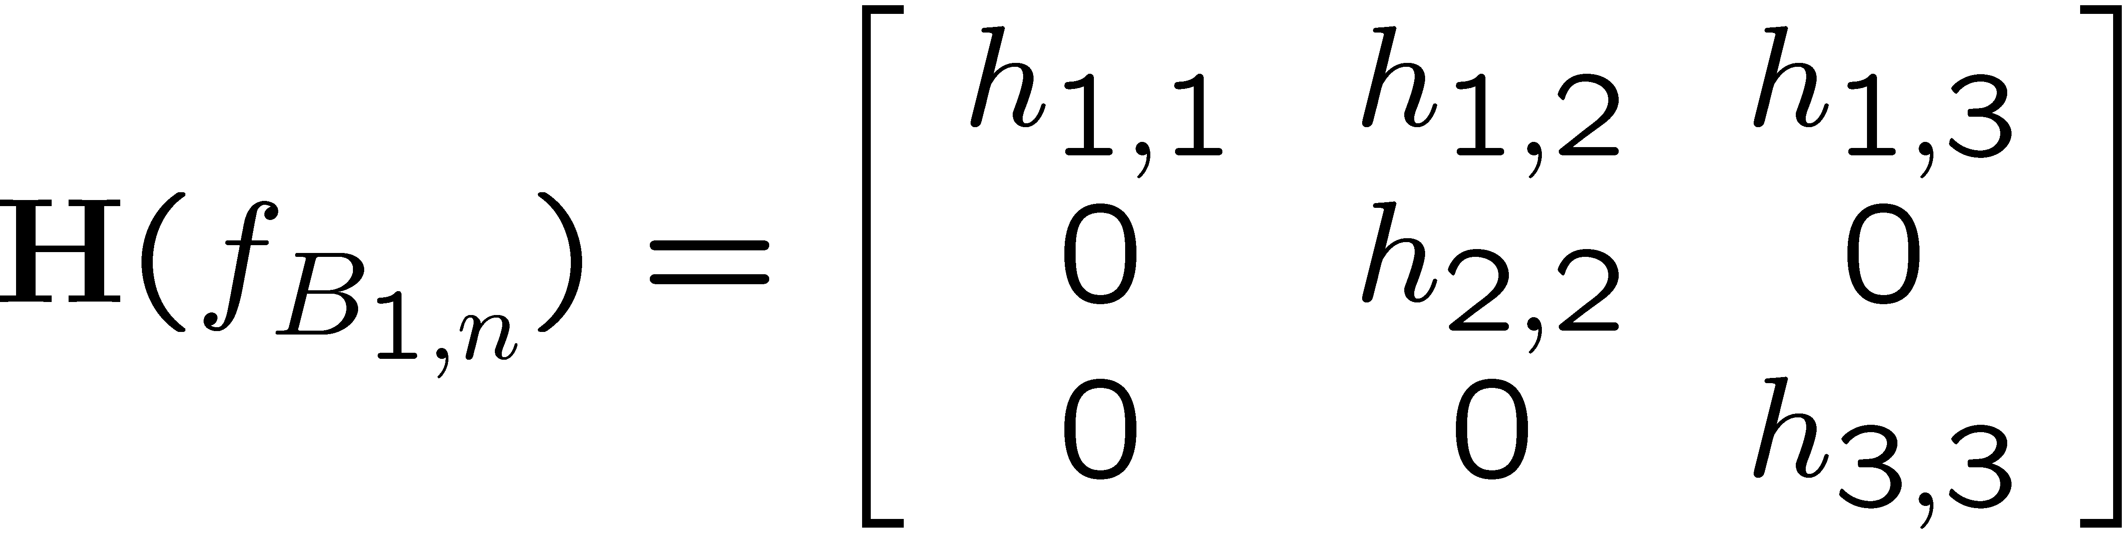
We eliminate the interference caused by $h_{1,2}$ and $h_{1,3}$ (comes from cells 4 and 5) by network MIMO [1]. As a result, the two most severe interference is cancelled through a small-size ($3×3$) matrix computation.

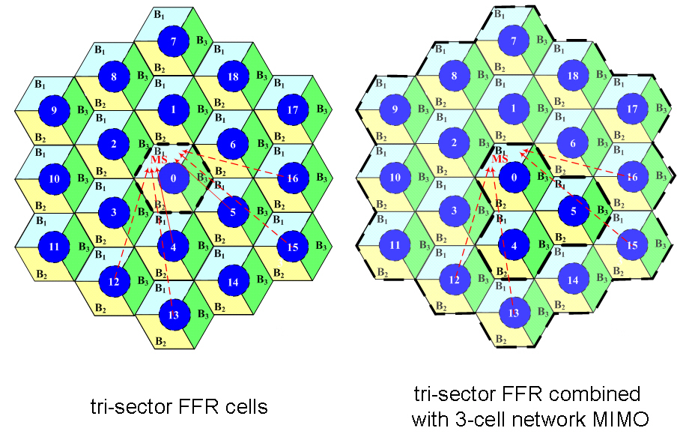
Fig. 3 Interference of a two-tier 19 cells layout with tri-sector FFR
and combined 3-cell network MIMO with FFR architectures.

- Cell Regrouping and Rotation (Cell reselection)
Note that ${\text{Cell}}_{a}^{G_{j}}$ can achieve interference free within whole subband $f_{B_{1}}$ under network MIMO. However, subbands $f_{B_{2}}$ and $f_{B_{3}}$ will still suffer from seven interferers. The inter-cluster interference from other groups is still existent. We therefore define $f_{B_{1}}$ as the primary band of ${\text{Cell}}_{a}^{G_{j}}$for arbitrary group $G_{j}$. Similarly, we define $f_{B_{2}}$ and $f_{B_{3}}$ as the primary band of ${\text{Cell}}_{b}^{G_{j}}$ and ${\text{Cell}}_{c}^{G_{j}}$, respectively. We propose a cells regrouping and rotation scheme to address the inter-cluster interference problem. Assume that cell 0 is grouped with cells 4 and 5 with primary band $f_{B_{1}}$ at certain time slot 0 (defined as service frame 0 later) as shown in Fig. 4. Cell 0 will regroup with cells 1 and 6 at the next time slot 1 by counterclockwise rotation. After this rotation, the primary band of cell 0 becomes $f_{B_{2}}$. Similarly, cell 0 regroups with cells 2 and 3 at time slot 3 by counterclockwise rotation again and the corresponding primary band becomes $f_{B_{3}}$. In this way, all cells will simultaneously rotate and regroup with two new neighboring cells at a new time slot. Each cell has the chance to cooperate with neighboring six cells in order and each sector has the opportunity to become the primary band under this kind of TDMA-based regrouping and rotation scheme.

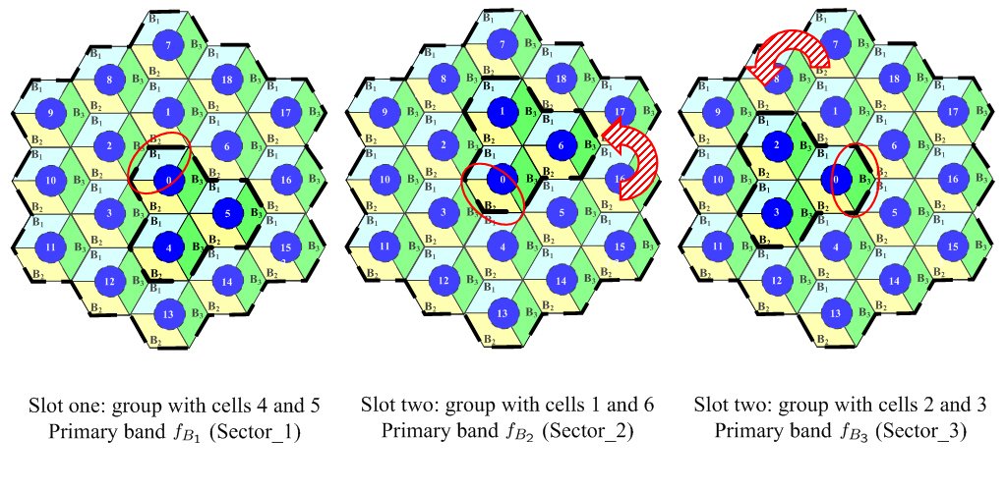
Fig. 4 Example of cells regrouping and rotation.

- Self-organizing Transmission

The grouped cells (sectors) will perform self-organizing process to transmission for each frequency partition. Fig. 5 shows the self-organizing transmission algorithm. At first, we denote $K_{i}^{\text{BSID}}$as the users priorities set of the $i$-th sector of the cell with ABSID (where ABSID = 1,…,19 for a two-tier 19 cells layout). User's priority is arranged in the ascend order within the set $K_{i}^{\text{BSID}}$which allows at most $n$ users belong to the set in each resource allocation unit, i.e., service frame. For a sector belong to arbitrary cell, users data will be scheduled according to priority and stored in queue block at ABS. As ${\text{Cell}}_{x}$ among a group has certain primary band $f_{B_{i}}$ within the corresponding service frame, we define $M_{x}=\text{min}\left\{ {\text{idle_Cell}}_{y}\right\}$ ($y≠x, \text{for} y=a,b,c$) where ${\text{idle_Cell}}_{y}$ represents the number of unused (idle) frequency units for ${\text{Cell}}_{y}$, i.e., the size of users priorities set of the $i$-th sector of ${\text{Cell}}_{y}$ is less than $N$. (*Recall that in each group ${\text{Cell}}_{a}$ has primary band $f_{B_{1}}$, ${\text{Cell}}_{b}$ has primary band $f_{B_{2}}$, and ${\text{Cell}}_{c}$ has primary band $f_{B_{3}}$) We assume that each sector of each cell will fully use $N$ frequency units during its primary period.
For the self-organizing transmission step 1, the $M_{x}$ higher priorities users for ${\text{Cell}}_{x}$ can choose its corresponding best frequency unit without the interference from the neighboring two cells due to the idle status. In step 2, the remaining frequency units of the frequency partition $f_{B_{i}}$ are used simultaneously among a group with/without network MIMO. Each user of cells will choose one of the remaining frequency units with best signal quality of serving ABS according to priority. The users in ${\text{Cell}}_{x}$ measure interference level from the neighbor ABSs via reported SON measurement. Assume inter-cell interference should be maintained below a certain maximal interference level $γ_{\text{threshold}}$. If its SINR < $γ_{\text{threshold}}$, the 3-cell network MIMO will be executed in the selected frequency unit to improve SINR quality. Otherwise, traditional tri-sector FFR transmission will be executed without neighboring interference cancellation.
One advantage of self-organizing transmission is to reduce the complexity of executing network MIMO. By reported interference level from the neighbor ABSs, the serving ABS can determine whether the coordinated group need to perform network MIMO at frequency units to improve SINR quality.

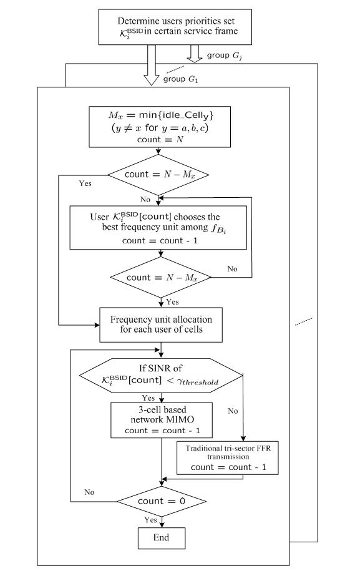
Fig. 5 Self-organizing transmission algorithm

- Algorithm Flowchart

Figure 6 illustrates the algorithm flow chart. At first, we partition frequency bands into inner band $f_{A}$ and outer band $f_{B}$. Then we determine the cell groups set $G_{1}$, $G_{2}$… of the multi-cell system. By means of FFR, we partition the tri-sector cellular system into inner and outer region. Since FFR is mainly designed for improving the signal quality of cell edge users, an obvious parameter will be the mobiles location distribution. Therefore, SINR distribution parameters should be considered when determining the inner circle radius. In this contribution, we mainly focus on the effect of jointly network MIMO and FFR scheme. For simplicity, we set the inner circle radius equal to $R/2$ ($R$ is the site-to-site distance). The block, 3-cell network MIMO FFR-based self-organizing transmission, contains the joint network MIMO and FFR scheme and self-organizing transmission mentioned before. Then cells regrouping and rotation address the boundary problem of network MIMO.

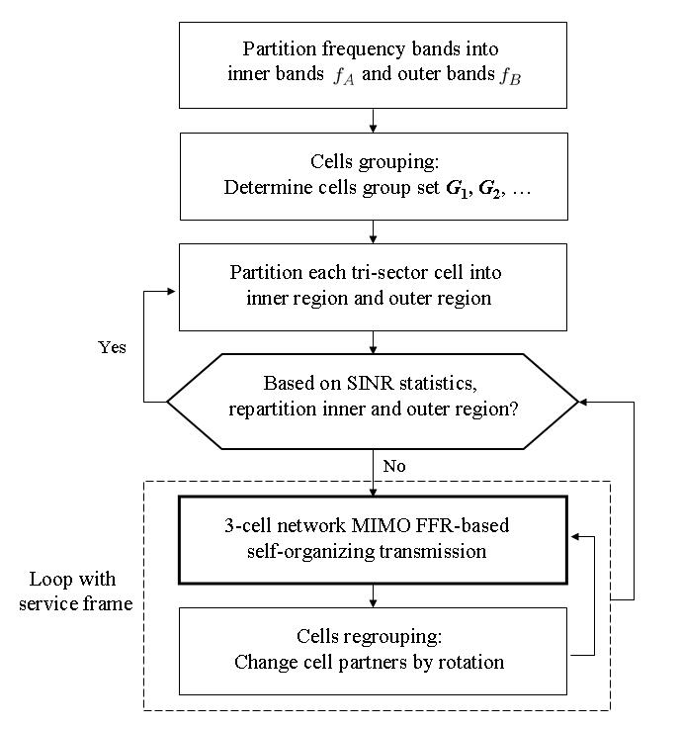
Fig. 6 The flowchart of the proposed algorithm..
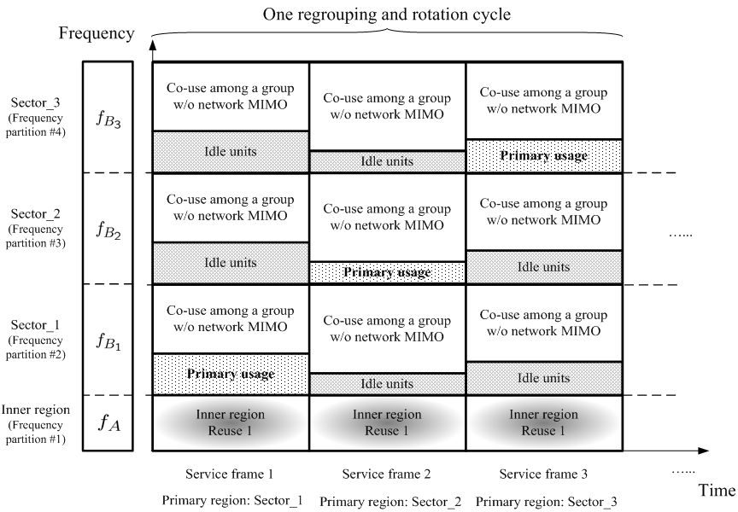
Fig. 7 Example of proposed algorithm for ${\text{Cell}}_{a}^{G_{j}}$of group $G_{j}$.

- Performance Evaluation

Here, we mainly investigate the effects of the tri-sector FFR, pure network MIMO, and jointly network MIMO and FFR by comparing their received SINR distributions. Figure 8 shows the cumulative distributed function (CDF) of the received SINR of three different cellular architectures including conventional 19-cell layout with pure reuse one, tri-sector FFR scheme, and fully 19-cell coordinated network MIMO. Comparing black dotted line with bold line, we find that the gain of interference sources reduction (from 18 reduce to 7) by tri-sector FFR is quite significant, which is about 11 dB improvement at 90 percentile of the received SINR. We also show the performance of network MIMO with full 19-cell coordination for two famous network MIMO precoding schemes: ZF (zero force, blue line) and ZF-DPC (zero force dirty-paper coding, red line) transmissions. We find that both schemes can indeed improve the received SINR especially for ZF-DPC scheme. However, the gain of ZF scheme is not very significant at the 90-th percentile of the received SINR, and is actually lower than that by using tri-sector FFR scheme. Because of the transmission power penalty of ZF, the actual data symbol power become weaker even if no interference achieved through cooperation. Note that there is no power penalty for ZF-DPC so that the gain at 90-th percentile of the received SINR is more than 20 dB compared with the tri-sector FFR scheme. Note that the outstanding gain comes from a large amount of cells coordination and ignores the interference from other 19-cell clusters.
Taking tri-sector FFR as a benchmark and 19-cell coordinated network MIMO as an upper bound, we present the proposed 3-cell coordination architecture in Fig. 9. From this figure, the ZF-DPC scheme obtains about 10 dB gain over the tri-sector FFR scheme at 90-th percentile of the received SINR under the proposed 3-cell coordination. Although the improvement is not as large as the 19-cell coordination, it implies that the potential benefit of using a small number of coordinated cells is already sufficient. Note that the power penalty of ZF causes the SINR performance degradation is similar to the tri-sector FFR scheme even if the most two severe interference have been eliminated. In fact, a larger number of coordinated cells may cause the symbol power weaker and results in poorer signal quality.
Fig. 8. The CDFs of received SINR for conventional, sectionized FFR,
and 19-cell coordinated cellular systeAMS.
Fig. 9. The CDFs of received SINR for conventional, sectionized FFR,
and proposed 3-cell coordinated cellular systeAMS.

- Collaborative MIMO Transmission Realized by Pre-defined Collaborative Zone

In IEEE 802.16m system, it will be difficult for multiple ABSs to include all of their serving AMSs be involved in the collaborative network MIMO transmission. It is because the number of AMSs, the traffic demand of each AMS and the channel coherence time of each AMS are usually different. For example, it will be difficult to coordinate the network MIMO operation if the sizes of radio resources required by each AMS are different. Another example is that the AMSs with higher speed are also hard to be involved in such operation because their channel response will be changed frequently, so that the signaling latency between different ABSs before enabling this operation may already be longer than AMS channel coherence time.
In order to enable the aforementioned network MIMO operation in IEEE 802.16m system, the following simplified procedure is recommended:
- ASN Gateway in backhaul network selects a group of ABSs to join collaborative network MIMO operation.
  - Only the ABS with this capability can join this operation. How to make this selection depends on vendor’s algorithm, but 3 BSs to compose a group is the most reasonable case.
- The ABSs in the same group negotiates a common radio resource region (i.e. composed by LRUs and sub-frames) which is defined as a collaborative zone for the subsequent collaborative network MIMO operation.
  - How to negotiate this collaborative zone is vendor specific. IEEE 802.16m standard only needs to define this zone and provides the supporting protocol.
  - One ABS may join different collaborative MIMO group by having multiple non-overlapped collaborative zone.
- Each ABS in the same group selects one of its serving AMS to be served by network MIMO transmission
- The reasonable criterion is to select the AMS with no mobility and under severe interfering situation.
- The ABSs in the same collaborative group and the their serving AMS involved in collaborative network MIMO operation perform necessary channel estimation and messaging exchange to construct the channel response matrix.
The channel estimation and reporting mechanism needs further discussion by TGm members, the following few some possible examples base on literatures:
- For TDD (Time Division Duplexing) mode, UL sounding can be used. The ABSs in the same collaborative group negotiates the UL resources for their serving AMSs involved in this network MIMO operation to transmit sounding signal over the designated radio resource region. So that each ABS in this cluster can estimate the channel response from the sounding signal transmitted from each AMS involved in network MIMO operation. Because the channel response is reciprocal in TDD system, the channel response matrix for both UL and DL can both be constructed by this method.
- For FDD (Frequency Division Duplexing) mode, DL channel estimation and reporting are required. Each ABS can estimate the Uplink channel response from the AMSs involved in network MIMO operation by the same sounding technique in TDD mode. For the DL channel response, the AMSs has to estimate the channel response by estimating the unique pilot pattern sequence transmitted by each ABS in the same group. This can be done because of the pilot pattern transmitted by each ABS is scrambled by PRBS. After channel estimation, each AMS need further reporting the estimated channel responses for each ABS. But the difficulty for FDD mode is in general higher than in TDD mode.
- The ABSs in the same collaborative group serving the selected AMSs over the collaborative zone.
  - How the ABSs in the same collaborative group derive the transmit vector over each data stream is vendor specific. ABSs only need to instructive AMS to receive data and keep estimating channel response over the collaborative zone.
- When the channel responses between those AMSs and ABSs changes due to user mobility, part of the ABSs may back to step 3 and reselect the AMSs to join collaborative network MIMO transmission.
- Text Proposal
----------------------------------------------------------------Start of the Text----------------------------------------------------
[to be updated]
-----------------------------------------------------------------End of the Text----------------------------------------------------

