Project | IEEE 802.16 Broadband Wireless Access Working Group <http://ieee802.org/16>
Title | Proposed Amendment Text for Sounding PHY Structure
Date Submitted | 2009-04-27
Source(s) | Chih-Yuan Lin, Pei-Kai Liao, Yu-Hao Chang, I-Kang Fu, Yih-Shen Chen, Kelvin Chou, Paul Cheng  MediaTek Inc.  Zheng Yan-Xiu, Yu-Chuan Fang, Chang-Lan Tsai, Chung-Lien Ho, Hsi-Min Hsiao, Ren-Jr Chen, Yutao Hsieh  ITRI  Alexei Davydov  Intel | chihyuan.lin@mediatek.com
Re: | Category: AWD comments / Area: Chapter 15.3.9 (Uplink Control Channel)  “Comments on AWD 15.3.9.1.3.1 (Sounding PHY Structure)”
Abstract | This contribution proposes some modifications on the sounding section of AWD.
Purpose | For member’s review and adoption into P802.16m Amendment Working Document
Notice | This document does not represent the agreed views of the IEEE 802.16 Working Group or any of its subgroups. It represents only the views of the participants listed in the “Source(s)” field above. It is offered as a basis for discussion. It is not binding on the contributor(s), who reserve(s) the right to add, amend or withdraw material contained herein.
Release | The contributor grants a free, irrevocable license to the IEEE to incorporate material contained in this contribution, and any modifications thereof, in the creation of an IEEE Standards publication; to copyright in the IEEE’s name any IEEE Standards publication even though it may include portions of this contribution; and at the IEEE’s sole discretion to permit others to reproduce in whole or in part the resulting IEEE Standards publication. The contributor also acknowledges and accepts that this contribution may be made public by IEEE 802.16.
Patent Policy | The contributor is familiar with the IEEE-SA Patent Policy and Procedures:  <http://standards.ieee.org/guides/bylaws/sect6-7.html#6> and <http://standards.ieee.org/guides/opman/sect6.html#6.3>.  Further information is located at <http://standards.ieee.org/board/pat/pat-material.html> and <http://standards.ieee.org/board/pat>.
Proposed Amendment Text for Sounding PHY Structure
Chih-Yuan Lin, Pei-Kai Liao, Yu-Hao Chang, I-Kang Fu, Yih-Shen Chen, Kelvin Chou, Yu-Hao Chang, Paul Cheng
MediaTek Inc.
Zheng Yan-Xiu, Yu-Chuan Fang, Chang-Lan Tsai, Chung-Lien Ho, Hsi-Min Hsiao, Ren-Jr Chen, Yutao Hsieh
ITRI
Alexei Davydov
Intel
- Background
In current AWD text, the sounding symbol is determined to be the first symbol of UL subframe. However, the text does not determine how to use the remaining five symbols for the 6-symbol PRU or six symbols for the 7-symbol PRU, when sounding mode is enabled. This contribution intends to add several sentences and figures in current AWD to address this issue.
- Proposed Text Input to P802.16m Amendment Working Document
[Add the texts marked in red and figures in IEEE 802.16m-09/0010r1a]
15.3.9.1.3.1 Sounding PHY Structure
The sounding signal occupies a single OFDMA symbol in the UL sub-frame. The sounding symbol in the UL sub-frame is located in the first symbol. Each UL sub-frame can contain only one sounding symbol. For the type-1 subframe, the sounding signals should not be transmitted in LRUs which contain other control channels.
When sounding channel is enabled, the remaining 5 consecutive symbols of the six-symbol PRU are formed to be a five-symbol PRU used for pilot and data transmissions, as shown in Figure x(a). The remaining 6 consecutive symbols of the seven-symbol PRU are formed to be a six-symbol PRU for pilot and data transmissions, as shown in Figure x(b). Multiple UL subframes in a 5-ms frame can be used for sounding. The number of subcarriers for the sounding in a PRU is 18 adjacent subcarriers.
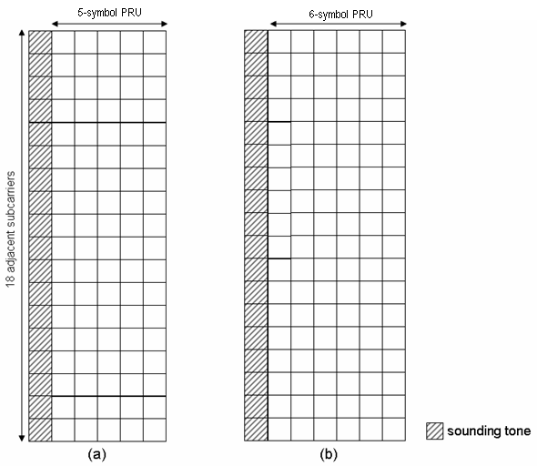
Figure x. Sounding PHY structures for (a) 6-symbol PRU and (b) 7-symbol PRU cases.

- Appendix: Illustration of Puncturing of Sounding Symbol

